Experiment 3 Survey of Emerging Trends in Low Code Development
CB23F35 Low Code Application Development using Zoho Creator
Loan Application Lab uses fictional coursework data. Observations below describe the actions and results verified during this lab.

Aim
Conduct a desk-based survey of low code trends and relate them to observed lab work.

Theory
This is a literature and platform survey, not a questionnaire study. No participant responses or market-growth estimates were collected. Official documentation and the observed Creator features provide the evidence base.
The surveyed themes are AI assistance, reusable integrations, visual analytics, governance, managed release environments and extensions through code. Their value depends on the use case and the quality of verification rather than on the amount of generated code alone.

Procedure
- Review official material on Zia, connections, environments and custom functions.
- Identify the feature corresponding to each theme in the lab application.
- Separate observed behavior from possible future uses.
- Record constraints and practical implications without inventing survey statistics.

Observations
- AI assistance: Zia produced guidance for comparing chart totals with report totals. Generated advice still required checking against the stored records.
- Integration: an OAuth connection supported a read-only Sheet API request. Authorization and app access were separate steps.
- Analytics: a chart grouped applications by status. A chart is useful only when its source form, filters and aggregation match the question.
- Governance: a permission profile, role hierarchy and personal-data classification were configured. A second-user access test remains a separate validation task.
- Managed delivery: development, Stage and Production versions make release changes visible.
- Inference: future low code work is likely to combine visual configuration with stronger testing, API skills and controlled use of AI; this is a reasoned outlook, not a measured prediction.
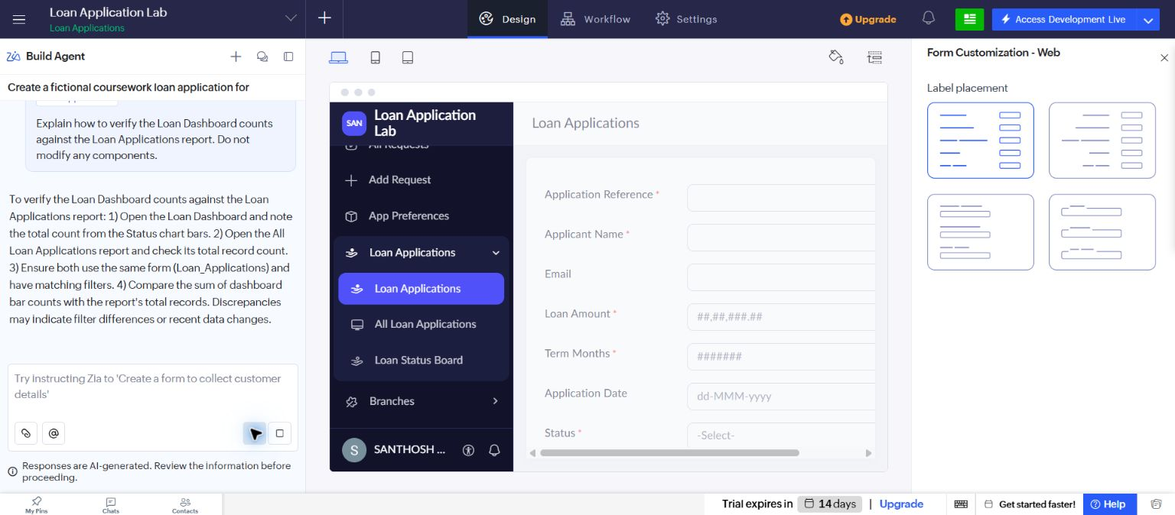
Figure 1 Actual Zia guidance in the account builder, showing the suggested checks for dashboard and report totals.

Result
The desk survey connected six trends to practical evidence and identified verification and governance as continuing responsibilities.

Sources
https://help.zoho.com/portal/en/kb/creator/developer-guide/operations/zia/articles/configuring-zia
https://www.zoho.com/deluge/help/connections.html

