Experiment 4 Business Data Modelling and Advanced Form Design
CB23F35 Low Code Application Development using Zoho Creator
Loan Application Lab uses fictional coursework data. Observations below describe the actions and results verified during this lab.

Aim
Create related forms, configure validation and demonstrate a lookup and a subform.

Theory
The business model separates a reusable branch entity from individual loan applications. Each application has a unique reference and can select a branch record through a lookup. Repeating supporting-document descriptions belong in a subform rather than in separate numbered columns.
Loan Applications contains Application Reference, Applicant Name, Email, Loan Amount, Term Months, Application Date, Status, Notes, Branches, Supporting Documents and Document Description. The subform has a Document Type column. Status choices are Submitted, Under Review and Reviewed. The amount is stored as INR currency.

Procedure
- Create Loan Applications with mandatory reference, applicant, amount, term and status fields.
- Enable no duplicate values for Application Reference.
- Create Branches with mandatory unique Branch Code and mandatory Branch Name.
- Save the fictional CHN branch named Chennai Demo Branch.
- Add a Branches lookup displaying Branch Name and a Supporting Documents subform.
- Submit LAB-004 with the Chennai branch and one Demo income statement row.

Observations
- The lookup displayed Chennai Demo Branch from the saved Branches form.
- LAB-004 used amount INR 200000 and term 24, with a supporting-document type and a sample-only description.
- The schema diagram shows the relationship between Loan Applications and Branches.
- All applicant records and document descriptions are fictional. No personal supporting files were uploaded.
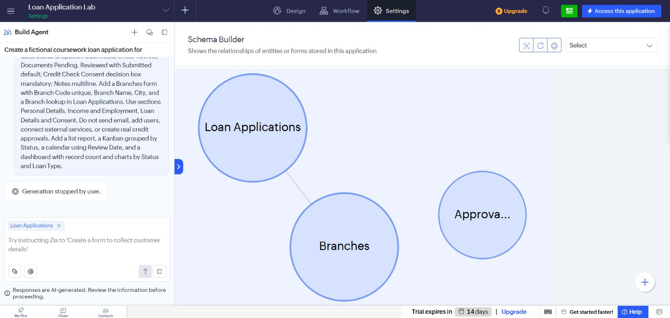
Figure 1 Schema Builder showing the relationship created in the account.
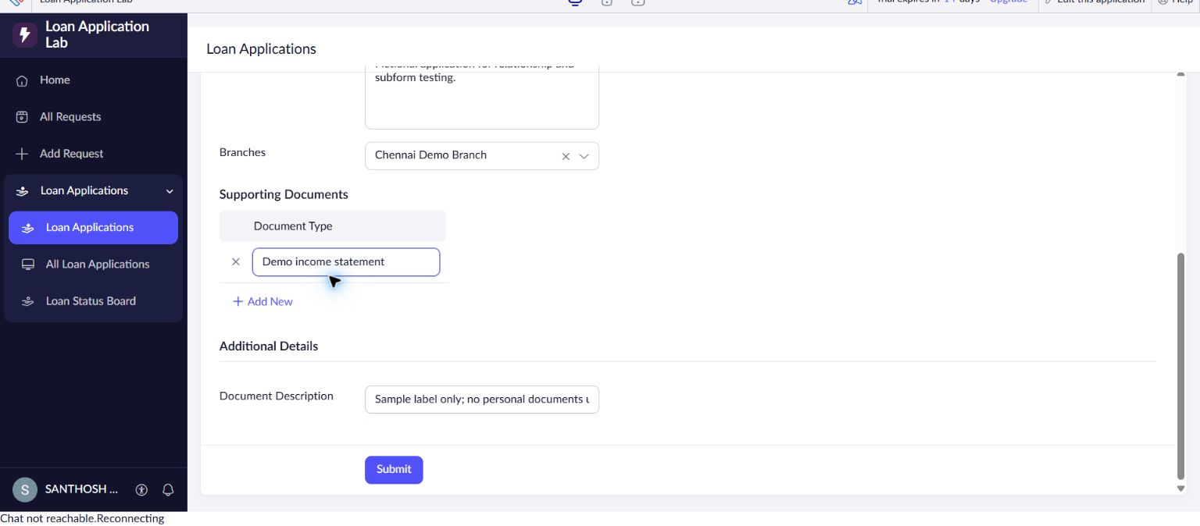
Figure 2 Advanced form populated with fictional relationship and subform data.

Result
The related forms, lookup and repeating subform were implemented and a linked sample application was saved.

Sources
https://www.zoho.com/creator/glossary.html

