Experiment 6 Deluge Workflows Testing and Debugging
CB23F35 Low Code Application Development using Zoho Creator
Loan Application Lab uses fictional coursework data. Observations below describe the actions and results verified during this lab.

Aim
Reject invalid submissions and verify that valid application data can be saved.

Theory
The Validate Loan Amount and Term workflow runs for Created or Edited records during Validations on form submission. This server-side check protects persisted data even when a user enters values that satisfy basic field types but violate business rules.
The conditions are Loan_Amount greater than zero and Term_Months between 6 and 60 inclusive. An alert explains the failure, and cancel submit prevents insertion. Field link names, not display labels or guessed type names, must be used in Deluge.

Procedure
- Create the workflow on Loan Applications for Created or Edited records.
- Select Validations on form submission and add a Deluge script.
- Use input.Loan_Amount and input.Term_Months in the conditions.
- Test LAB-002 with zero amount, then with term 3.
- Correct the amount to 300000 and term to 36, submit, and inspect the report row.

Observations
- Zero amount produced the actual message Loan amount must be greater than zero. Submission stayed in the form.
- A three-month term produced the actual message Term must be between 6 and 60 months.
- The corrected LAB-002 record was saved as Under Review with INR 300000 and 36 months.
- During debugging, guessed identifiers Currency and Number failed compilation. Inspecting the real field identifiers and replacing them resolved the error.
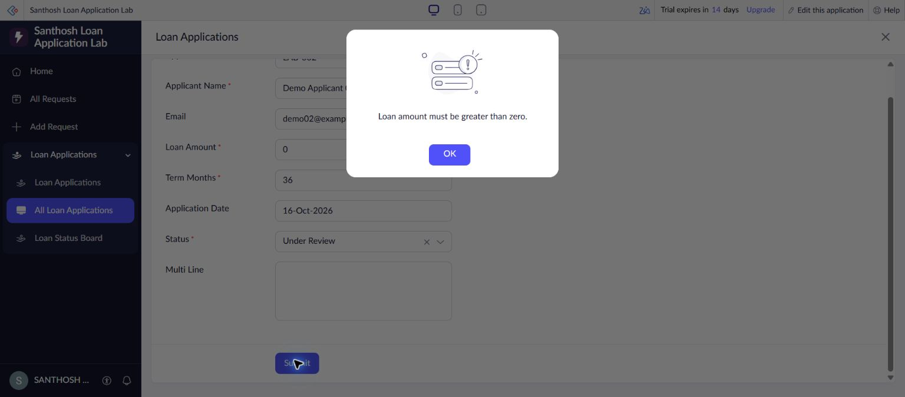
Figure 1 Actual server-side amount validation alert.
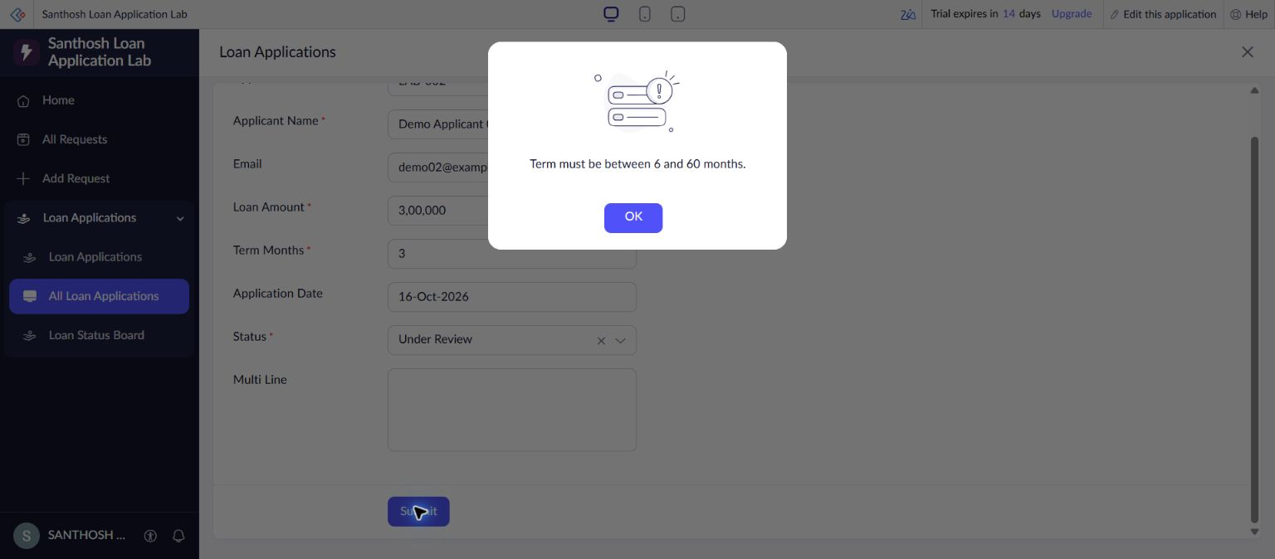
Figure 2 Actual server-side repayment-term validation alert.

Result
Both invalid-input tests were rejected and the corrected valid record was persisted. The workflow is enabled for create and edit events.

Sources
https://www.zoho.com/deluge/help/

