Experiment 8 User Permissions and Role Based Access Control
CB23F35 Low Code Application Development using Zoho Creator
Loan Application Lab uses fictional coursework data. Observations below describe the actions and results verified during this lab.

Aim
Configure a restricted permission profile and a reviewer role for the lab application.

Theory
A permission profile specifies permitted component actions, while a role places a user in an organizational hierarchy. A role name alone does not prove that access is restricted. The effective result must also be tested with an assigned non-administrator account.
Loan Viewer was configured for viewing loan reports and dashboard access, with edit and delete excluded. API access is disabled and personal-data visibility is set to Hide. Loan Reviewer is a role under CEO; sharing with peers was left off.

Procedure
- Open Settings and User Permissions.
- Create Loan Viewer and describe its intended read-only responsibility.
- Disable API access and hide PII and ePHI values in the profile.
- Select the loan list and status-board views without edit or delete rights.
- Create Loan Reviewer under CEO, leaving peer sharing off.
- Inspect the saved profile and role hierarchy.

Observations
- Loan Viewer appears in the saved permission list with its read-only description.
- Loan Reviewer appears below CEO in the saved hierarchy.
- No external user was invited, and no second account was assigned during this run.
- Configuration is verified; a separate-user sign-in test of allowed views and blocked edit/delete actions remains unexecuted. Administrator access is not evidence of the restricted user experience.
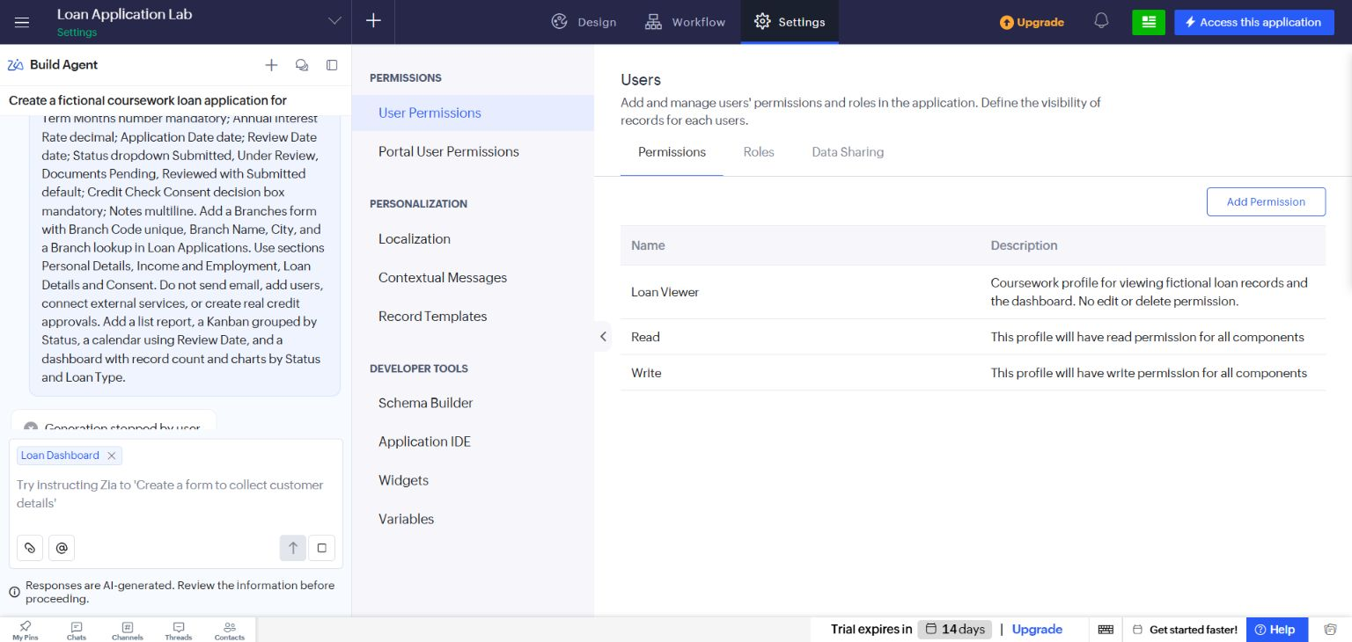
Figure 1 Saved Loan Viewer permission profile.
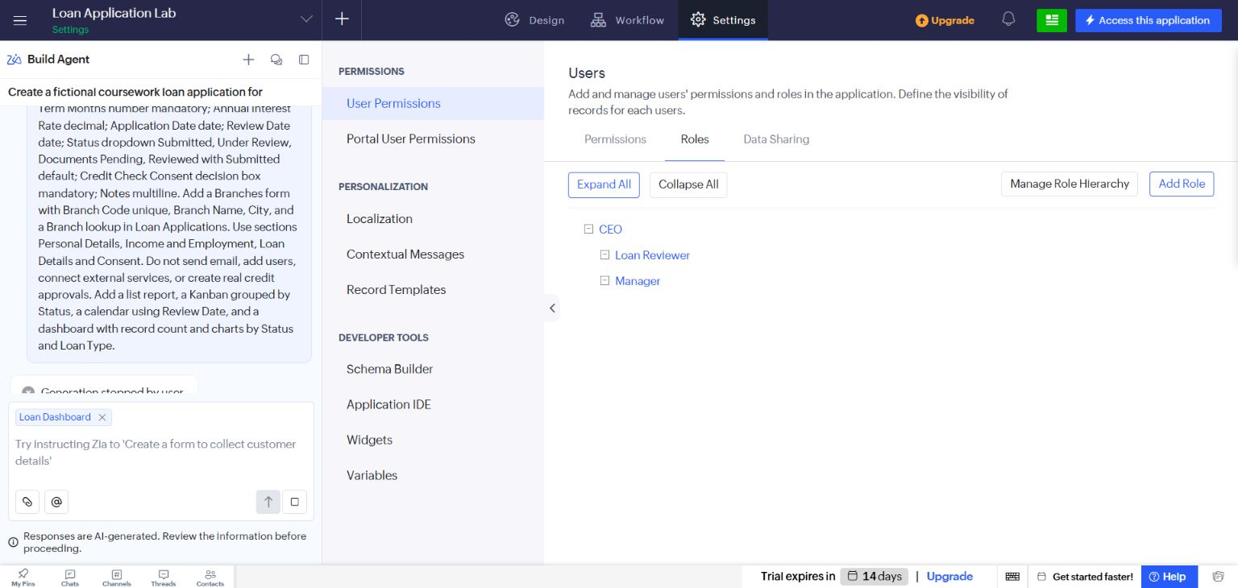
Figure 2 Saved Loan Reviewer role under CEO.

Result
The permission profile and role hierarchy were configured and saved. Cross-user enforcement testing is explicitly outside the evidence captured here.

Sources
https://www.zoho.com/creator/glossary.html

