Experiment 9 Zia Assistance and Built In Analytics
CB23F35 Low Code Application Development using Zoho Creator
Loan Application Lab uses fictional coursework data. Observations below describe the actions and results verified during this lab.

Aim
Use Zia to assist analytical verification and compare its advice with the live report.

Theory
AI assistance can explain a workflow or suggest changes, but its response is not proof that a component exists or that a total is correct. The lab therefore asks for verification guidance without authorizing component changes.
The prompt asks how to verify Loan Dashboard counts against the Loan Applications report. The analytical component itself is the configured Status column chart, with Count of Total Records. Real saved records provide the independent check.

Procedure
- Open Build Agent in the application builder.
- Ask how to verify dashboard counts against the application report, explicitly requesting no component changes.
- Read the response and identify its recommended source, filter and total checks.
- Compare the three-status chart snapshot with the report at that point in the lab.
- Use the portfolio function to verify the later four-record state.

Observations
- Zia responded with guidance to compare the sum of status bars with the list total and ensure matching source forms and filters.
- The response warned that recent data changes or different filters can explain discrepancies.
- The three-record chart snapshot matched one application per status. Later aggregation returned 2,1,1 after a fourth record was added.
- An earlier broad AI generation attempt was stopped after unsuccessful retries. The working forms and reports were built and tested manually; their existence is not inferred from that failed generation.
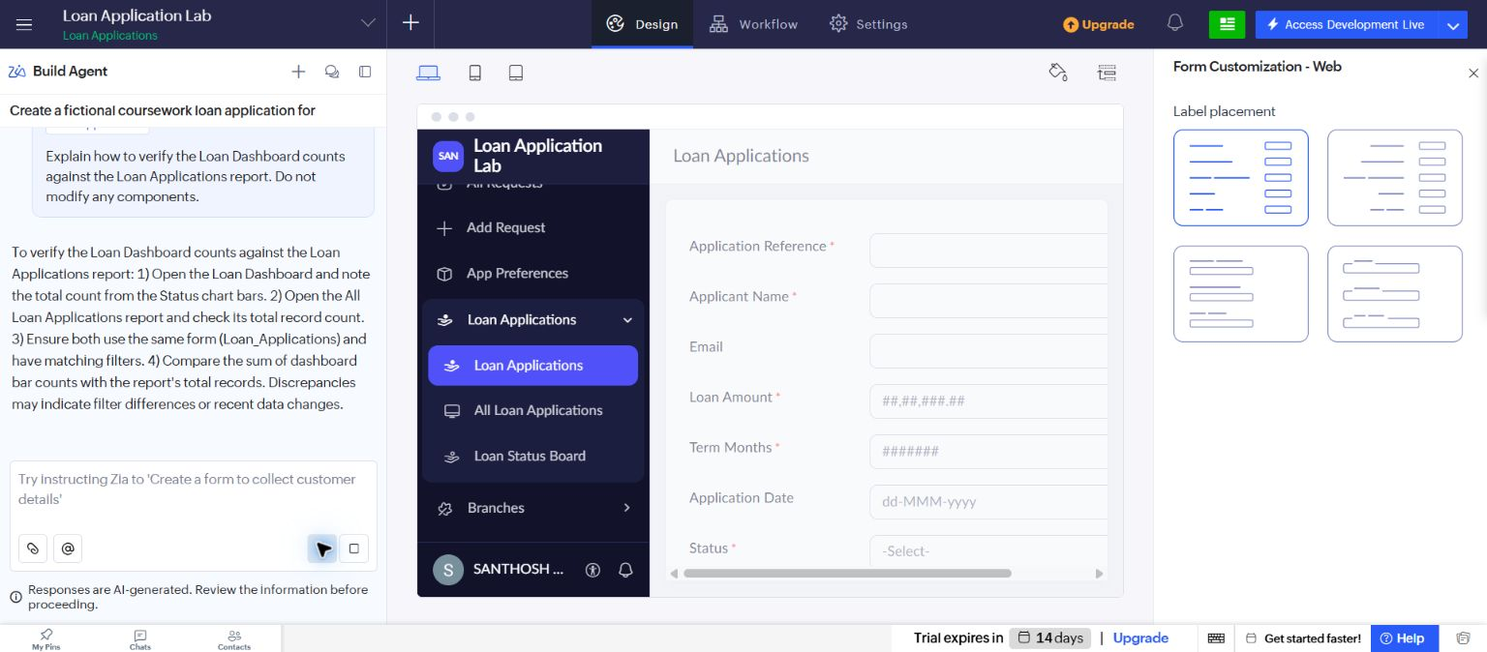
Figure 1 Zia response to the dashboard verification prompt.
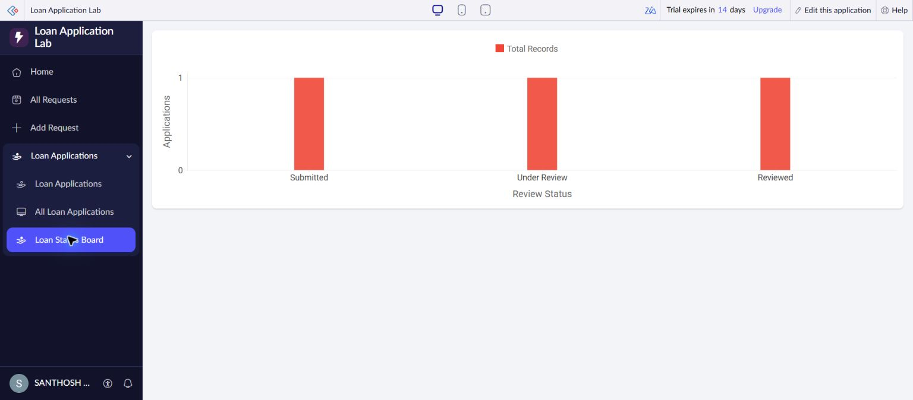
Figure 2 Built-in chart used for the independent comparison.

Result
Zia produced relevant verification guidance, and the analytical totals were checked using the actual application records.

Sources
https://help.zoho.com/portal/en/kb/creator/developer-guide/operations/zia/articles/configuring-zia

