Experiment 10 Subform Limits and Query Optimization
CB23F35 Low Code Application Development using Zoho Creator
Loan Application Lab uses fictional coursework data. Observations below describe the actions and results verified during this lab.

Aim
Apply bounded repeating data and aggregation queries, and explain the role of indexes accurately.

Theory
The lab uses a maximum of five Supporting Documents entries per application to keep repeating input bounded. The portfolio function asks Creator for count and sum aggregates with criteria rather than retrieving every record and calculating totals in a client-side loop.
A unique application reference supports identity and duplicate prevention. Creator manages its storage implementation; the lab did not create a database index through SQL or inspect a query execution plan. A unique-field setting must not be reported as proof of a manually created index or a measured speedup.

Procedure
- Enable Limit maximum entries on Supporting Documents and set the limit to 5.
- Retain the unique Application Reference field for identity.
- Use Loan_Applications criteria with count and sum operations in loanPortfolioSummary.
- Execute the function against the four saved applications.
- Record functional correctness separately from performance claims.

Observations
- The saved subform properties show a maximum of 5 entries.
- The function returned applications 4 and total_amount_inr 1100000, with status counts 2,1,1.
- No full-record client loop was needed for those totals. This reduces unnecessary data handling by design, but no latency benchmark was performed.
- Manual index creation, load testing and execution-plan analysis were not available or executed. A production evaluation would require representative data volume, repeated measurements and comparable conditions.
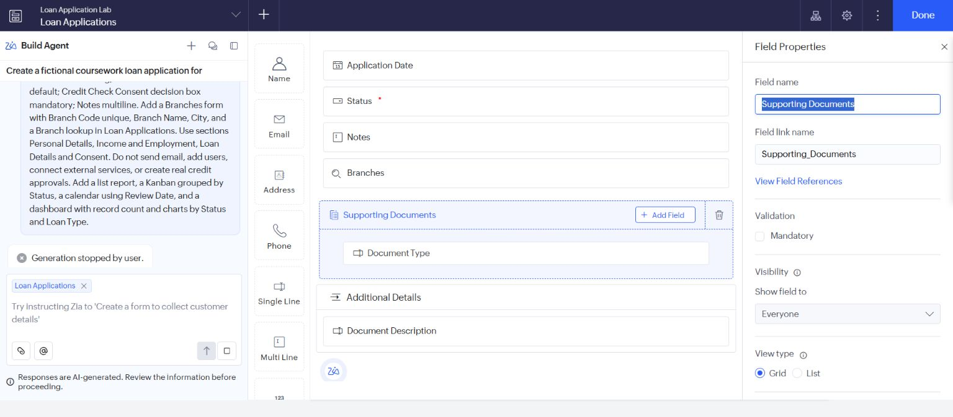
Figure 1 Saved maximum of five subform entries.
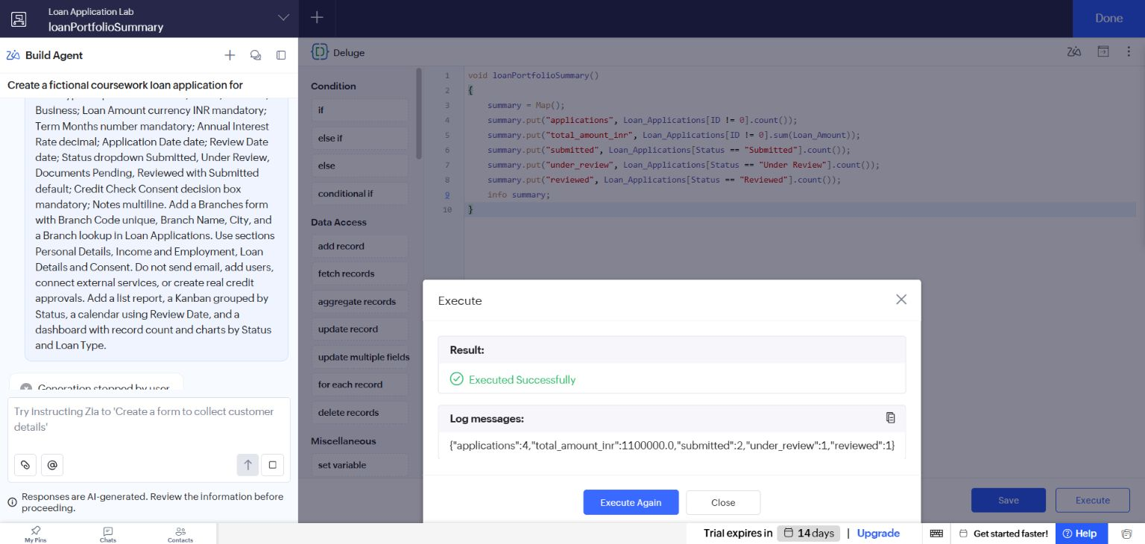
Figure 2 Correct aggregate output on four saved applications.

Result
A bounded subform and server-side aggregate queries were implemented and verified. No unsupported indexing or benchmark result is claimed.

Sources
https://www.zoho.com/deluge/help/

