Experiment 12 Security Privacy and Application Governance
CB23F35 Low Code Application Development using Zoho Creator
Loan Application Lab uses fictional coursework data. Observations below describe the actions and results verified during this lab.

Aim
Apply personal-data classification, restricted permissions and controlled integration access.

Theory
Security depends on identifying data, restricting actions and keeping an auditable record of change. Fictional lab records avoid exposing real financial or identity information. Personal-data flags and a permission profile are concrete settings, but they do not by themselves establish legal compliance or complete security assurance.
Applicant Name was classified as containing personal data. Loan Viewer hides PII and ePHI and disables API access. The external connection is restricted to spreadsheet listing and is authorized by the administrator. Secrets remain in the connection service rather than the Deluge source.

Procedure
- Inspect the Applicant Name properties and enable Contains personal data.
- Create the Loan Viewer profile with restricted operations and hidden personal values.
- Restrict the Zoho Sheet connector to its approved read-only action.
- Enable the connection only for the lab application needed by the integration function.
- Retain evidence of configuration, tests and deployment versions.

Observations
- The Applicant Name personal-data checkbox was saved as checked.
- The saved permission profile distinguishes view access from edit, delete and API rights.
- The Sheet integration log contains only success status, method and count.
- No claim is made that encryption, MFA, account-wide audit retention or a compliance certification was configured in this experiment. Those controls require their own evidence and administrative review.
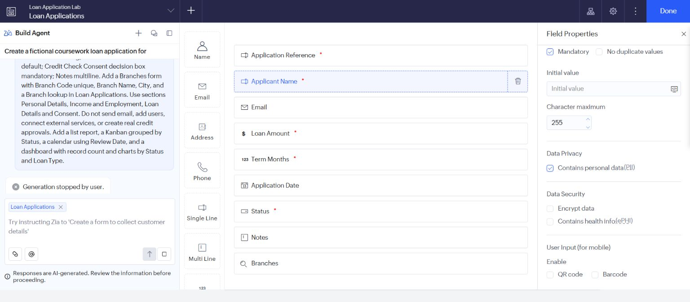
Figure 1 Applicant Name marked as containing personal data.
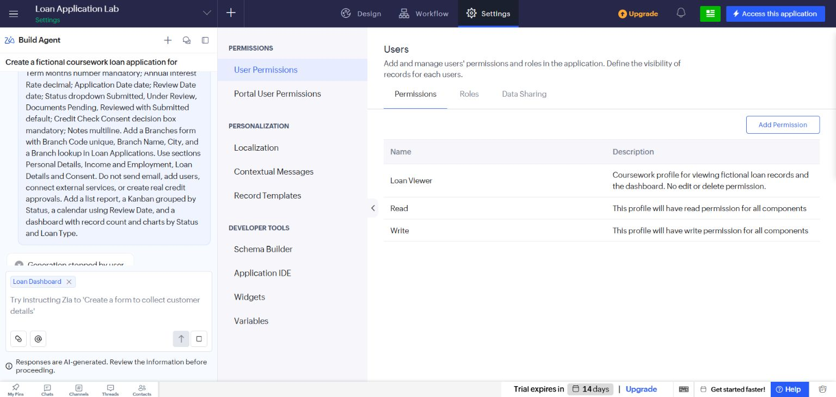
Figure 2 Saved restricted permission profile.

Result
The lab implemented and recorded specific privacy and access-control settings without exposing real applicant data or credentials.

Sources
https://www.zoho.com/deluge/help/connections.html

