Experiment 13 Enterprise Limitations Case Study
CB23F35 Low Code Application Development using Zoho Creator
Loan Application Lab uses fictional coursework data. Observations below describe the actions and results verified during this lab.

Aim
Evaluate where a loan-processing enterprise would need capabilities beyond the demonstrated lab.

Theory
The case study considers a hypothetical multi-branch lender requiring identity checks, regulatory review, fraud detection, document storage and high-volume integrations. Loan Application Lab is a teaching prototype with four fictional applications, not a lending system or an eligibility model.
The prototype demonstrates form entry, a branch relationship, a repeating document label, status analytics and simple validation. These are useful foundations. Their success on four records does not establish suitability for regulated decisions, large-scale throughput or recovery requirements.

Procedure
- Define the hypothetical enterprise requirements and distinguish them from the lab scope.
- Map demonstrated features to data entry, review tracking and reporting needs.
- Identify gaps in domain logic, integration reliability, access testing and operations.
- Recommend boundaries between low code configuration and specialist services.

Observations
- Domain logic: amount and term validation do not evaluate affordability, identity or credit risk. Human-reviewed policy and specialist validation would be needed.
- Scale: the four-record dataset cannot reveal large-volume query, API quota or concurrency behavior. Capacity tests must use representative workloads.
- Reliability: a successful empty Sheet listing proves authentication and request execution, not transaction consistency across services.
- Governance: a saved role/profile does not replace cross-user tests, incident response, retention policy or formal access review.
- Portability: visual components and Deluge are tied to platform capabilities. A team should document data export and extension boundaries before committing a critical process.
- Recommendation: use the low code app for structured tracking and dashboards, and integrate separately reviewed specialist services where necessary.
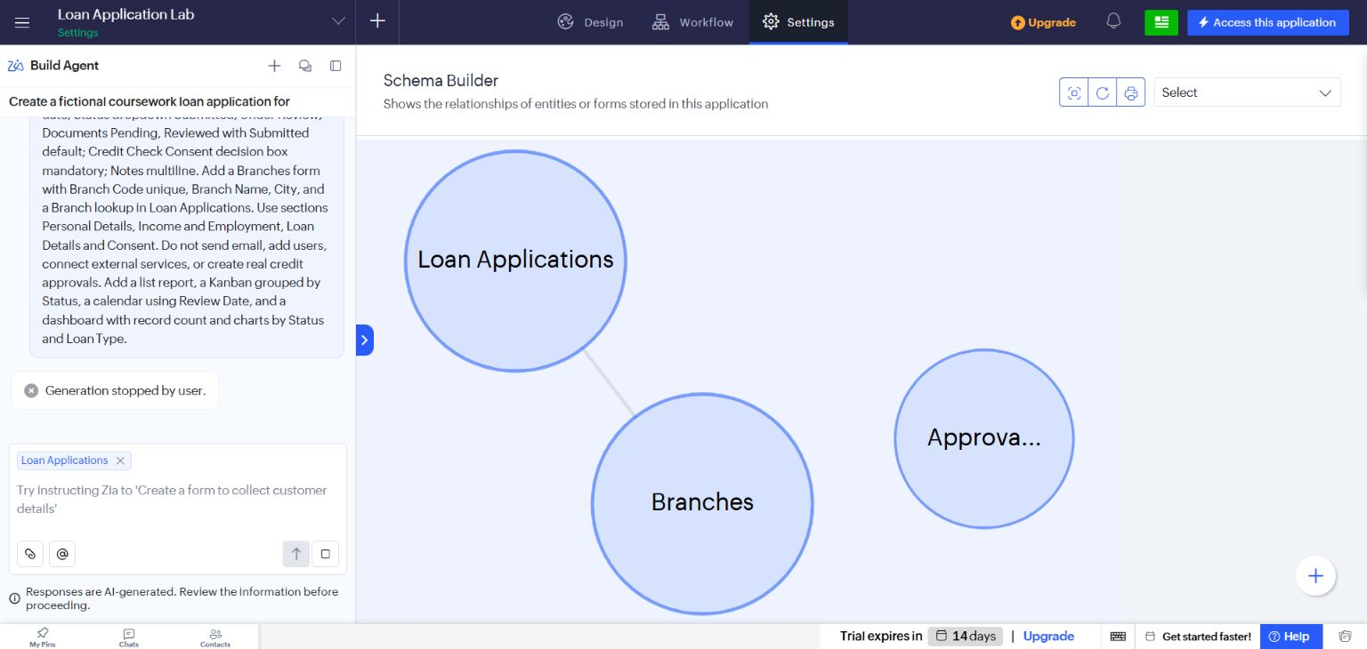
Figure 1 Actual Creator schema diagram showing the Loan Applications and Branches relationship.

Result
The case study defines a defensible prototype boundary and the additional engineering and governance work needed for an enterprise deployment.

Sources
https://help.zoho.com/portal/en/kb/creator/developer-guide/environments/articles/understand-environments
https://www.zoho.com/developer/

