Experiment 5 Reports and a Custom Loan Dashboard
CB23F35 Low Code Application Development using Zoho Creator
Loan Application Lab uses fictional coursework data. Observations below describe the actions and results verified during this lab.

Aim
Build and verify list, Kanban, dashboard and pivot views over the same application data.

Theory
A list report supports record inspection. A Kanban report groups records by a categorical field. A custom page combines analytical components. Pivot reports support grouped and aggregated analysis; the Creator integration opens the connected Zoho Analytics designer.
All Loan Applications is the saved-record list. Loan Status Board groups cards by Status. Loan Dashboard contains a column chart with Status as category and Count of Total Records as its measure. Loan Applications Pivot Chart counts applications by Status, and Loan Applications Pivot Table sums Loan Amount by Status.

Procedure
- Open the automatic All Loan Applications list report.
- Create Loan Status Board using Loan Applications and group columns by Status.
- Create a blank page named Loan Dashboard.
- Insert a column chart, bind it to Loan Applications and choose Status and Count of Total Records.
- Create a Pivot Chart from Loan Applications, place Status on the X-axis, set Application Reference aggregation to Count, and generate the chart.
- Create a Pivot Table from Loan Applications, place Status in the row grouping and Loan Amount in data with Sum.
- Compare the chart and table categories with the saved report rows and the underlying aggregation functions.

Observations
- The current Development report contains four fictional records: two Submitted, one Under Review and one Reviewed.
- The live Loan Status Board places DEV-001 and DEV-004 under Submitted, DEV-002 under Under Review, and DEV-003 under Reviewed.
- The live Loan Dashboard chart displays counts 2,1,1 respectively, matching the four visible report rows.
- The Analytics Pivot Chart was configured in Zoho Analytics with Status as the category and record count as the measure; the chart view is captured in the Analytics Designer.
- The Analytics Pivot Table sums fictional loan amounts by status: Reviewed INR 450000, Submitted INR 375000 and Under Review INR 300000; the grand total is INR 1125000.
- The Spreadsheet and Calendar views also display the same four records; the Map view loads but does not display geocoded markers in this account session.
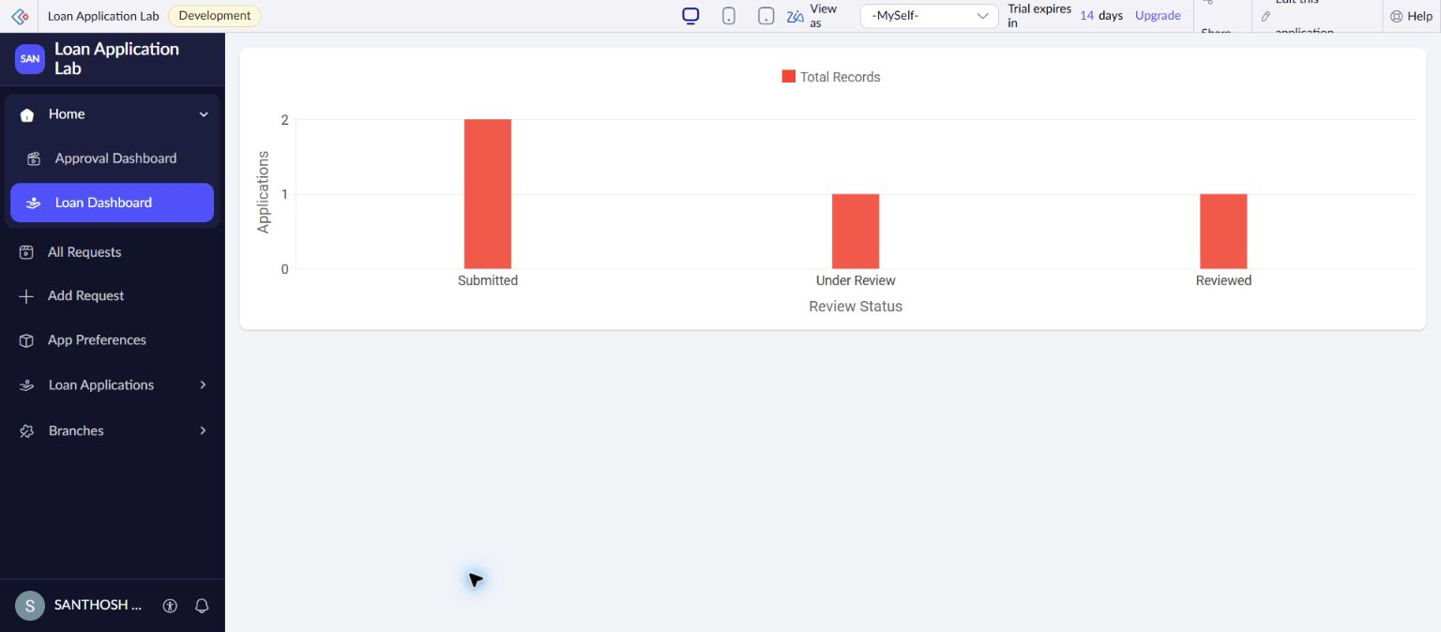
Figure 1 Live Creator dashboard chart matching the four fictional Development report rows.
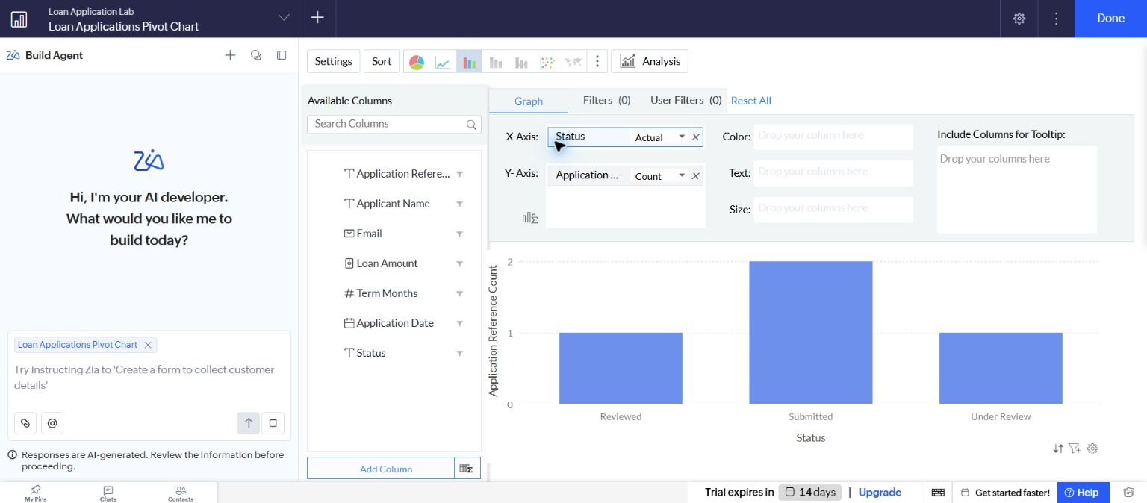
Figure 2 Zoho Analytics Pivot Chart showing application counts grouped by Status.
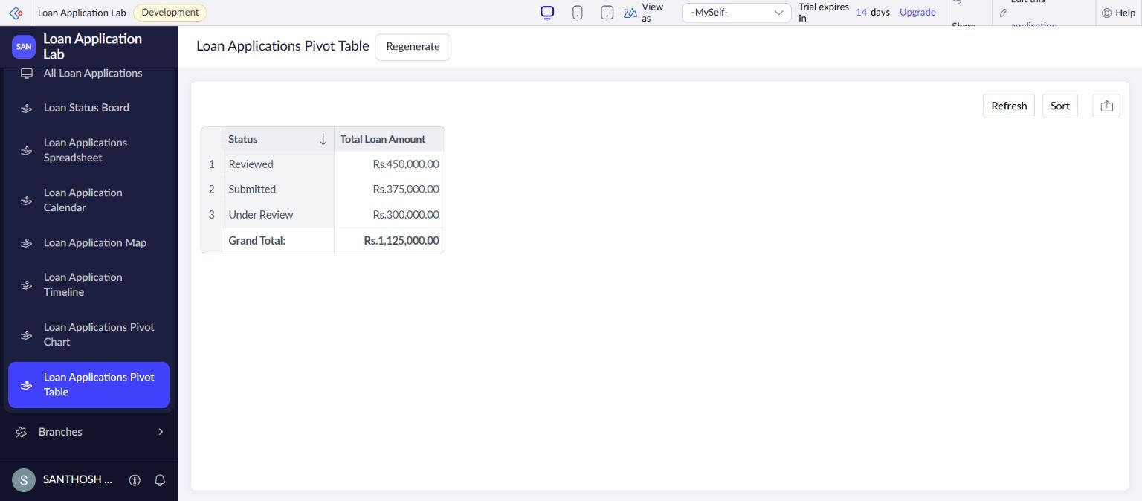
Figure 3 Live Creator Pivot Table with verified Analytics totals grouped by Status.

Result
The list, Kanban, custom dashboard, Analytics Pivot Chart and Pivot Table were created and their counts and totals were checked against the four fictional saved applications.

Sources
https://www.zoho.com/creator/glossary.html
https://www.zoho.com/analytics/help/pivot-table.html

