Experiment 11 Application Environments and Deployment
CB23F35 Low Code Application Development using Zoho Creator
Loan Application Lab uses fictional coursework data. Observations below describe the actions and results verified during this lab.

Aim
Use development, Stage and Production to manage release changes.

Theory
Environments separate application development from release testing and production use. Application definitions and operational data have different lifecycles. A new schema version does not imply that production records were copied into development.
The existing lab application was added to Environments. Zoho created development and Stage copies while preserving Production version 1.0. Later changes included a read-only integration function and personal-data classification.

Procedure
- Open Environments and add Loan Application Lab.
- Wait for development and Stage creation to finish.
- Verify version 1.0 in Stage and Production.
- Review the changed components before a subsequent release.
- Publish the two reviewed components as minor version 1.1 to Stage, then select that version and publish it to Production.

Observations
- The environment console showed a development application and Stage 1.0 and Production 1.0.
- The later release review listed changes to Loan Applications and the testSheetConnection function.
- Publication completed successfully. The final environment console shows Stage 1.1 and Production 1.1, with no development changes available.
- The original records were captured in the production application before environment creation. Production data and development test data must not be assumed identical.
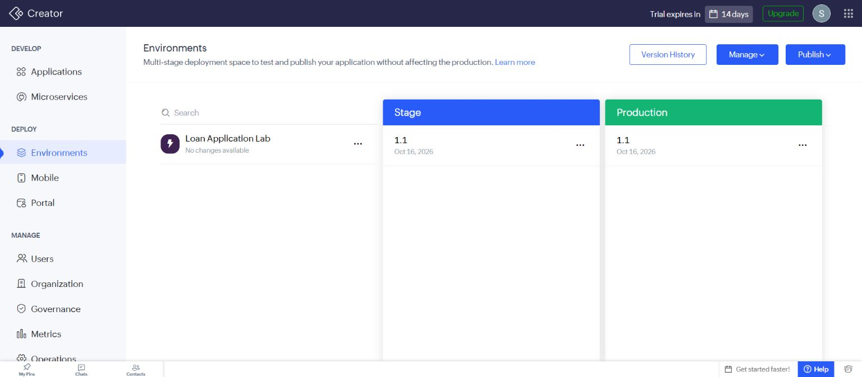
Figure 1 Verified Stage and Production versions 1.1 after publication.

Result
Development, Stage and Production were provisioned, and the reviewed version 1.1 was successfully published to both Stage and Production.

Sources
https://help.zoho.com/portal/en/kb/creator/developer-guide/environments/articles/understand-environments

