Experiment 14 Pro Code Extension Using a Custom Function
CB23F35 Low Code Application Development using Zoho Creator
Loan Application Lab uses fictional coursework data. Observations below describe the actions and results verified during this lab.

Aim
Extend the application with a reusable Deluge portfolio summary function.

Theory
A custom function encapsulates logic that can be executed independently and reused by other application components. This experiment uses the custom-function option in the syllabus. No Catalyst service or external runtime was deployed.
loanPortfolioSummary creates a map, populates it with server-side record aggregates and writes the map to the execution log. It reads the application collection without editing records. Criteria restrict the status-specific counts.

Procedure
- Open Workflow and Functions, then create loanPortfolioSummary in the default namespace.
- Use a void return type and no arguments.
- Add count and sum expressions over Loan_Applications and counts for the three status values.
- Save the function and execute it.
- Compare the output with the four records and the dashboard source.

Observations
- The function executed successfully in Creator.
- Actual output: applications 4; total_amount_inr 1100000.0; submitted 2; under_review 1; reviewed 1.
- The amount total equals 150000+300000+450000+200000. The status counts sum to 4.
- The independent function execution is verified. Automatic invocation from a page or workflow was not configured, and no Catalyst execution is claimed.
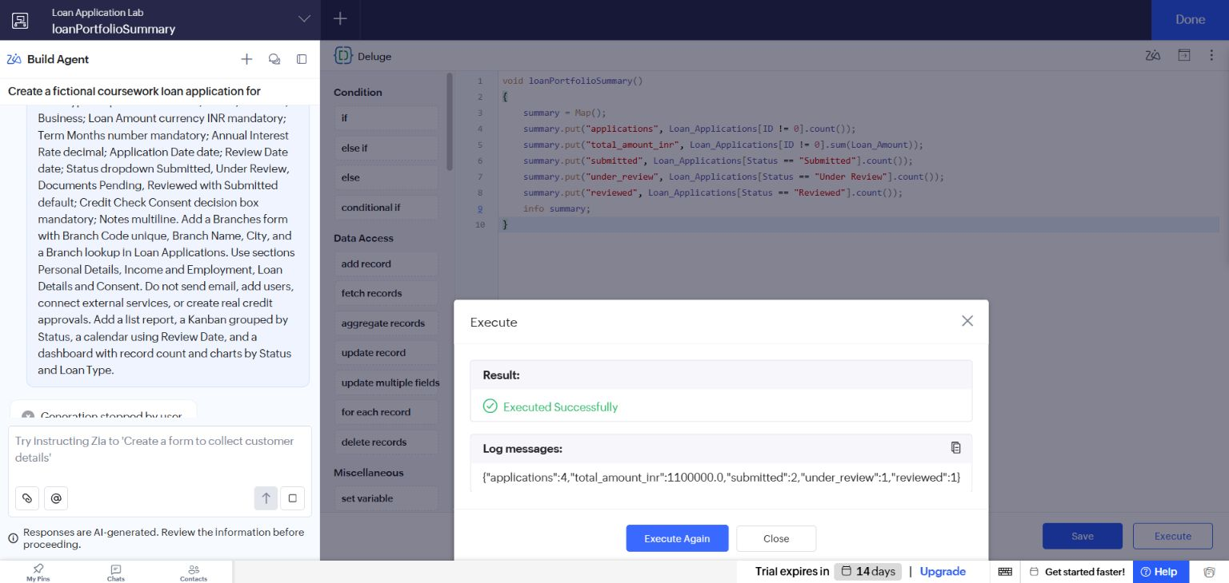
Figure 1 Creator execution log showing the successful custom-function output.

Result
A reusable custom function was implemented, saved and executed with correct aggregates over the actual fictional lab data.

Sources
https://help.zoho.com/portal/en/kb/creator/developer-guide/workflows/functions/articles/understand-functions

