The Impact of Inflation on Stock Market Index: A Time Series Analysis of CPI and NIFTY 50 Consumption Index

Satyabrata Chakra¹
12405335
Lovely Professional University
Phagwara, Punjab, India
satyabrata.chakra2004@gmail.com
7735566244

Vigyan Bhardwaj²
12417114
Lovely Professional University
Phagwara, Punjab, India
vigyanbharadwaj970@gmail.com
6205910564

Abstract— Inflation plays a crucial role in the economy, affecting financial markets and influencing consumer habits and investment behaviors. This research explores the connection between inflation, as indicated by the Consumer Price Index (CPI), and stock market consumption trends, represented by the NIFTY 50 Consumption Index, utilizing 11 years (2013–2024) of time series data. By using different statistical techniques, correlation analysis, time series analysis and forecasting models, this study aims to analyze the effect of inflation trends on stock market consumption.
The research uses different methods to assess whether changes in inflation significantly influence stock market consumption. Moreover, advanced forecasting methods are used to project future trends, providing insights that could inform investment strategies and guide economic policy decisions. The results help in understanding macroeconomic elements that affect stock markets, offering essential guidance for policymakers, investors, and financial analysts in navigating market variations driven by inflation.
Keywords-- CPI, NIFTY, Consumption, Inflation, volatility, Trends, Time Series.

Introduction
One of the key indicators of inflation is the Consumer Price Index (CPI), which tracks the price changes in required goods and services over a period of time. Inflation is a primary determinant of economic stability, influencing consumer purchasing power, business operations, and investment decisions. Changes in inflation influence financial markets significantly. The NIFTY 50 Consumption Index, which monitors leading consumer-based companies in India, serves as an indicator of how the stock market reacts to changes in consumption trends caused due to inflation.
It is important for investors, policymakers, and financial analysts to understand the relationship between inflation and stock market consumption. This study aims to analyze dataset of a decade (2013–2024) of CPI and NIFTY 50 Consumption Index data by conducting time series analysis to detect trends and volatility. Correlation and time series analysis will be used to see if inflation has any effect on consumption trends in the stock market. Moreover, different algorithms are used to enhance prediction accuracy and evaluate how effectively these techniques reveal complex market behaviors.
By integrating traditional statistical methods with time series and machine learning approaches, this study aims to deliver an in-depth understanding of the influence of inflation on stock market consumption. The knowledge acquired from this research can help investors refine their strategies, help policymakers in developing economic policies, and assist businesses in managing market trends driven by inflation more efficiently.

literature review
- Bezzar et al. (2022), [1] proposed the use of XGBoost machine learning technique, which demonstrates effectiveness in improving forecasting accuracy across different granularities. To evaluate the performance, the authors have used Root Mean Square Error (RMSE) and Mean Absolute Percentage Error (MAPE) as key metrics. The paper showed that the traditional statistical and machine learning models are outperformed by the XGBoost model due to its ability to capture complex relationships within time series data. Hyperparameter tuning was performed on XGBoost using a Grid Search to optimize the learning rate, number of estimators, which helped in improving the prediction accuracy.

- Agarwal and Sabitha (2016) [2] used time-series forecasting approaches to predict the SENSEX index, to analyze historical data and apply a windowing technique. Windowing allows models to detect temporal dependencies, which supports the results of earlier research, and highlights the significance of preprocessing data to improve the accuracy of predictive models.
Agarwal and Sabitha indicated that predicted closing and opening prices matched actual values quite well, ensuring the effectiveness of such advanced algorithms in stock price forecasting, as well as work also presents a discussion on how extrinsic elements such as investor psychology and economic policy impact stock prices. This is supported by available evidence that highlights the impact of macroeconomic factors, investor, behavior and stock market trends [2, 3].

- Mi Li et. al. (2023), [4] proposed an improved hybrid machine learning model that blends machine learning methods with time series models, that is, ARIMA. The fusion technique which used here to benefit from the strengths of both approaches. The authors used the Boruta algorithm for feature selection to obtain necessary features from the dataset.

- For energy consumption predictions the authors suggested using an Autoregressive Recurrent Neural Network (AR-RNN) model [5]. The model uses a Skip-GRU (Gated Recurrent Unit) architecture that learns both short-term and long-term dependencies in the data. Skip-GRU is designed to learn periodic features by adjusting certain jump values according to the periodicity of the dataset, so that the model can easily learn from both sequential and periodic temporal features. Researchers have used the Akima interpolation technique to enrich this dataset. This method helps to augment the volume of data by five times without losing the original properties of the dataset.

- Jouilil and Mentagui (2022) suggested that, in contrast to the conventional ARIMA method, the application of Long Short-Term Memory (LSTM) networks [6], a recurrent neural network (RNN) type that is well known for its capability to learn long-term dependencies in sequential data. This architecture was aimed at maximizing the accuracy of the forecasts for the univariate time series. The results revealed that although ARIMA models are easy and efficient in handling linear univariate data, LSTM models have better forecasting accuracy, exhibiting their viability in forecasting.

- Hun-Jeong Kang et. al. (2021), used an ensemble method. The authors used Long Short-Term Memory (LSTM) networks as base models to learn short-term relationships and deep neural networks (DNN) as a meta-model in order to combine the predictions of the base models. The two-layer structure enables the model to utilize both short-term and long-term relationships in the data and improve prediction accuracy. The authors compare its own proposed algorithm, SAMBA-TS, to the standard methods of forecasting including seasonal ARIMA (SARIMA) and TBATS. The SAMBA-TS beats these algorithms across multiple datasets and shows how effectively it handles multi-seasonal time series data while also offering better time complexity.
Table 1: Comparative Analysis of Related Work

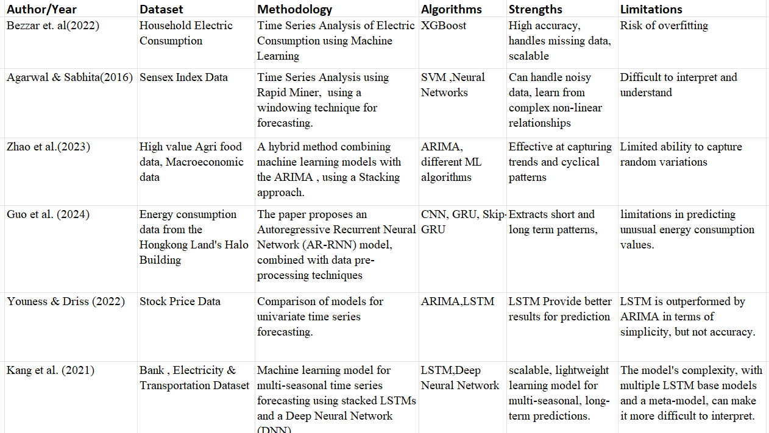

III. METHODOLOGY

In this paper we have used a quantitative time series analysis method to identify the relationship between consumer price index (CPI) which measures inflation and consumption patterns, which is represented by the Nifty 50 consumption index. Methodology involves a key four step process: data collection and preprocessing, stationary and decomposition analysis, autocorrelation check and exploration of casual or correlational relationships.

A. Data collection and Preprocessing

In our paper we have collected the two dataset for 11 years from January 2013 to January 2024. The first includes monthly CPI data of both rural and urban populations [7]. We have used the general index of both the rural and urban datasets. The second dataset is of monthly values of the Nifty 50 consumption Index, which tracks the performance of consumption-based companies listed on the Indian stock exchange.

After collection of data, both dataset indexes are set as date-time based indexes. Data cleaning is done by removing constant value or unwanted columns, missing values were imputed using mean substitution method. Standard date-time format is applied on both datasets to enable analyzing relationships between datasets based on similar date-times.

B. Stationarity and Decomposition Analysis

To identify any cyclic and irregular patterns, seasonal decomposition of each dataset was conducted using an additive model.
This helps in identifying long term trends, any seasonal patterns or stochastic error in datasets. This decomposition helps in understanding any initial relationship between inflation and consumption pattern.

Most of the statistical techniques require stationary time series data, the Augmented Dickey-Fuller(ADF) test was used to analyze the presence of unit roots in each series. Further differentiation is applied on the dataset to make it stationary.

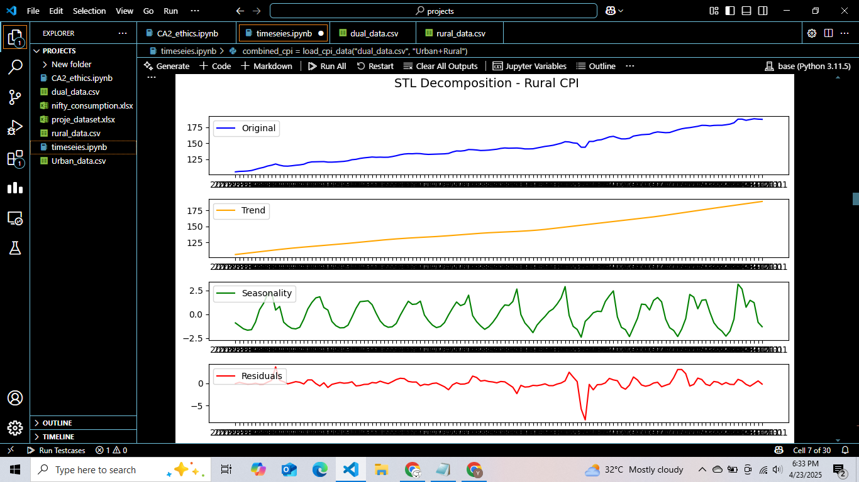
Fig 1: Seasonal Decomposition of Rural-CPI dataset

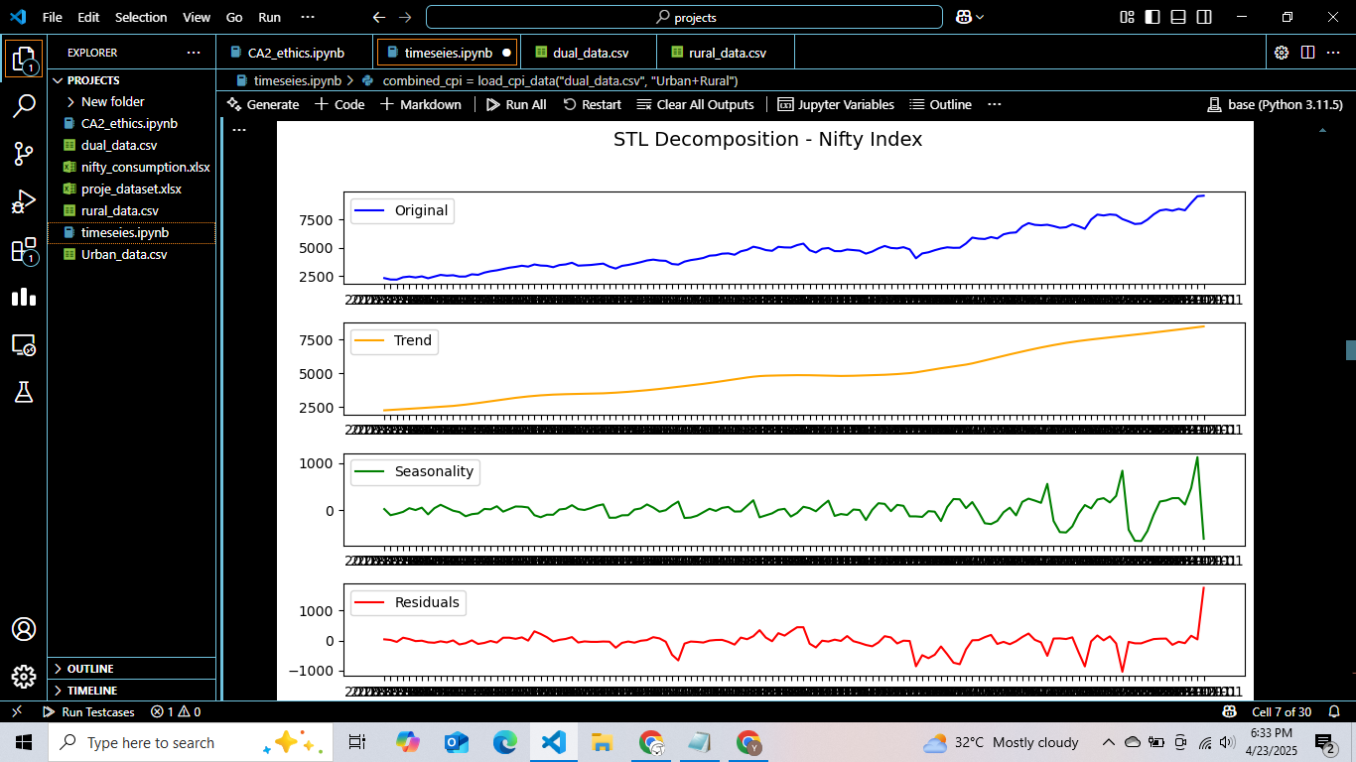
Fig 2: Seasonal Decomposition of NIfty 50 consumption index dataset

C. Autocorrelation and Lag Structure

To identify any dependencies, autocorrelation (ACF) and partial Autocorrelation (PACF) were applied. These metrics help in analyzing whether past datasets have influenced future values or not. The insights from this process stage helps in identifying the number of days should be used as lags to identify causality between datasets.

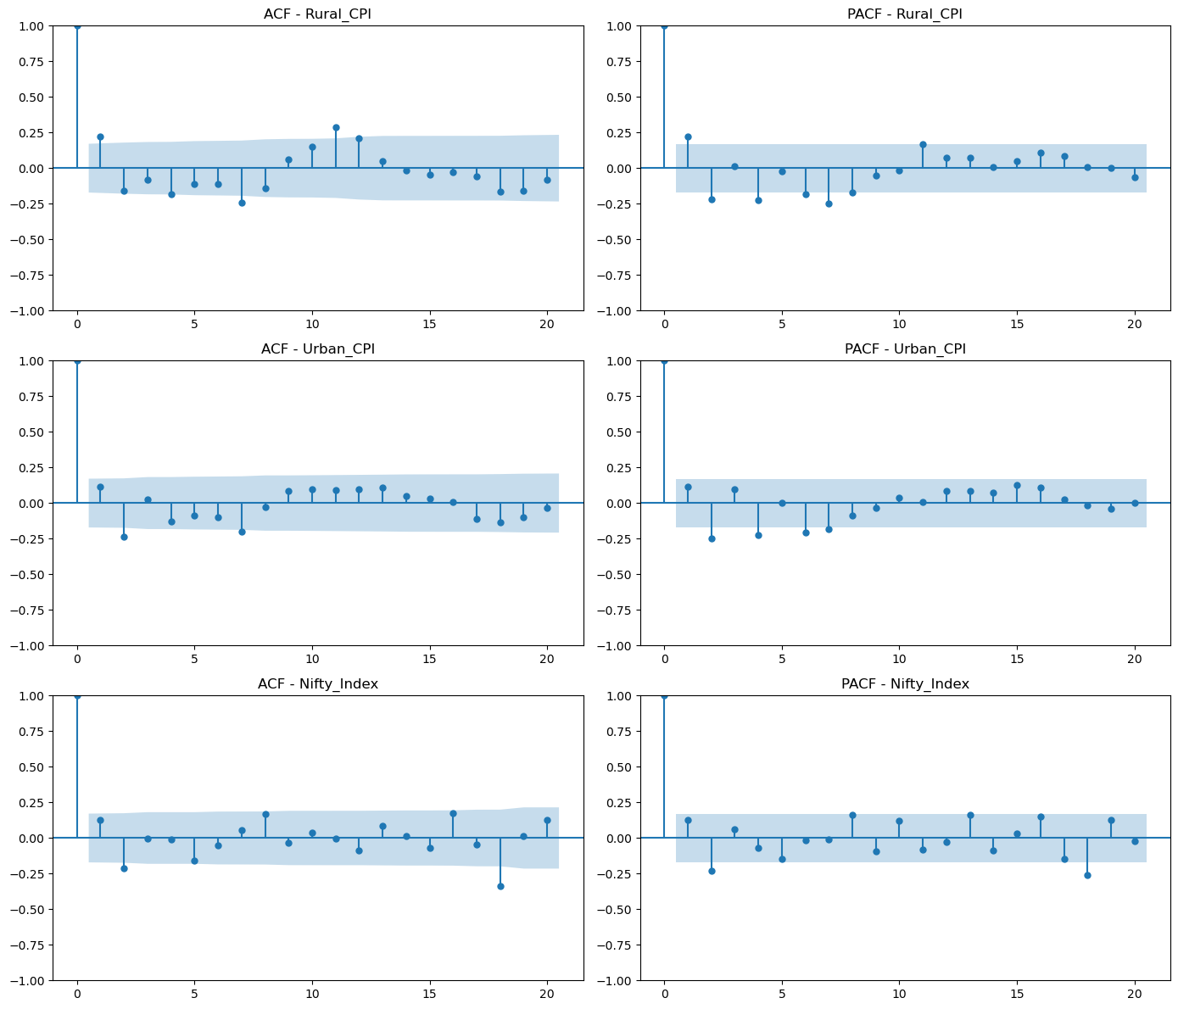
Fig 3.:- The ACF and PACF plots of the dataset suggest that a suitable lag to use is 1.

D. Correlation and Causal Analysis

In the final stage of analysis, correlation coefficients were calculated between each CPI and Nifty 50 consumption index. This helps in understanding quantitative linear relationships among data sets.

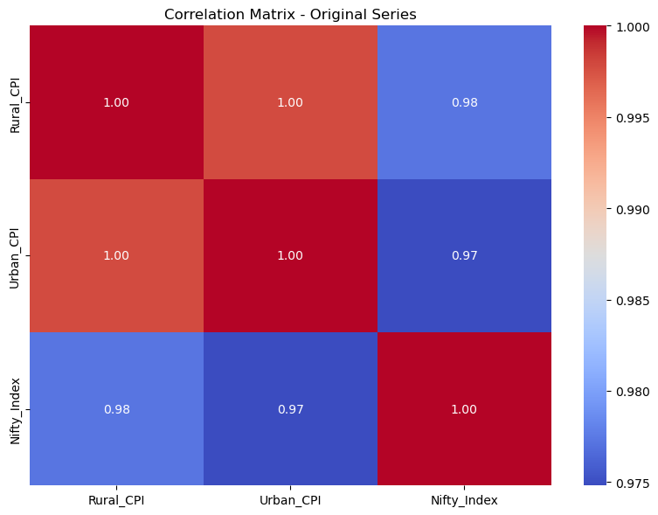
Fig. 4: Correlation heatmap of all three indexes

Though correlation alone can not help in understanding
the impact of each on one another, So Granger Causality test is applied to understand whether past value of CPI datasets, indicators of inflation have predictive power over Nifty 50 consumption index or not [8].

IV. Algorithms and Techniques

To identify relationship between CPI indicators and Nifty index data, this paper focuses on three key techniques, correlation coefficient, Vector Autoregression (VAR) and Granger Causality analysis. These methods are useful in identifying interdependencies in multiple time series variables without any prior assumptions [10].

1. Vector Autoregression (VAR) Model
VAR model uses a multiple variable time series method that generalizes the univariate AR model by allowing more than one variable [13]. Each variable is modelled in the form of linear function of its own past values. This makes VAR an appropriate method to analyze relationship between multiple components in the dataset. Before applying VAR model all data is transformed into stationary [9].

The VAR helps in further analysis of impulse response functions(IRFs) and predict error variance decompositions [12], which can be helpful in understanding how changes in inflation components affects the Nifty Consumption Index over a period of time.

2. Granger Causality Testing

Granger Causality does not helps in understanding true causality in real sense but it tests that whether past value of time series provides any important information about the future value of another series. Granger causality analysis uses two or more autoregressive models and compare the result using Hypothesis testing to identify causality analysis in a dataset.
The findings from this analysis offer important insight that under p value<0.05 , both CPI and Nifty index have significant relationships.

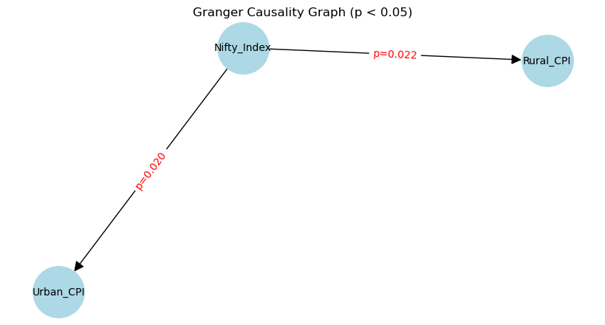

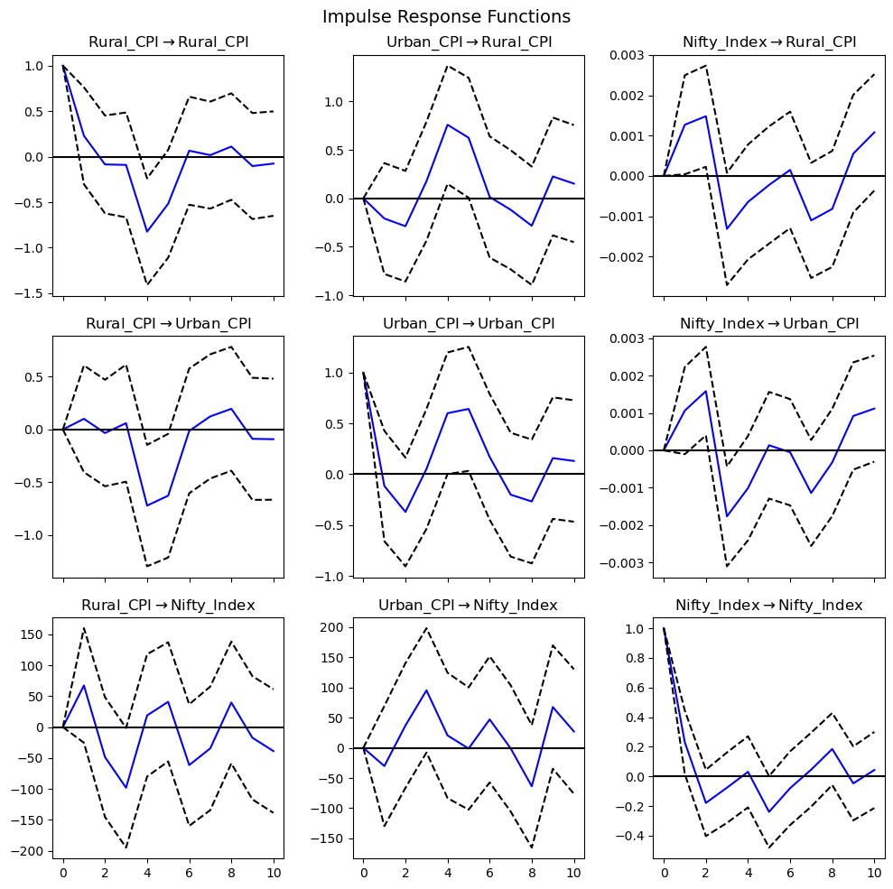
Fig 5:- The IRF plot helps in understanding how changes in the CPI affect the Nifty Consumption Index over a period of time.
Fig 6 :- Significant Granger Causality Graph among all three indexes (p<0.05)

V. FINDINGS AND OBSERVATIONS

A. Trend and Seasonality Patterns

The analysis revealed that there is a clear upward trend in all three indexes but there is a significant difference in seasonality patterns among different datasets. Annual cyclic patterns of CPI are mostly cyclic which shows repetition in inflation cycles mostly due to seasons. While the nifty Consumption index showed a more volatile and upward trend pattern.

B. Stationarity and Transformation Needs

All of the datasets will be found Non-stationary which requires transformation to prior time series modeling-stationarity of the data explains that price levels change over time rather than revolving around fixed mean.

C. Urban and Rural CPI Dynamics

Urban and rural CPI shows stronger correlation with each other, explaining that change in prices in any particular region also has a very high impact on other. It means inflation has a high impact on both the regions.

D. CPI comparison with NIFTY 50 Comparison Index

All three methods explain that there is a high correlation between Rural CPI, Urban CPI and NIFTY 50 consumption Index. It means they tend to move in the same direction because of high positive correlation. But the important point to notice here is that despite having an uptrend for inflation which means a rise in prices, the Nifty Consumption index still has an upward trend. It means despite the rise in price there is still an increase in consumption and demands of goods and services among consumers[13,14]. This explains the all recent analysis which shows the change in consumption pattern in Indian consumers(high consumption) despite high inflation rate [11].

VI. CONCLUSION

We conclude that the use of VAR and Granger Causality Analysis is very helpful in identifying relationship among multiple variable datasets as it does not presume anything from data, helps in understanding the effect of past on future data along with correlation and causality analysis. Understanding of past data is important because it explains the cyclic nature of data to understand future trends and patterns. For future scope it can be used on all the different indicators of CPI for in depth studies. Our conclusion states that there is change in consumption pattern over the period of time among Indian consumers despite having high inflation rates. Further studies with rise in income in households compared to Nifty Consumption Index can help in understanding a more clear picture. High Correlation along with upward trend indicates the potential upward movement of the Nifty Consumption Index.

VII. References

[1] “Bezzar, N. E. H., Laimeche, L., & Meraoumia, A. (2022). Time Series Analysis of Household Electric Consumption with XGBoost Model”.

[2] “Agarwal, U., & Sabitha, A. S. (2016). Time Series Forecasting of Stock Market Index.” IEEE International Conference on Data Mining.

[3] “Hendahewa, C., & Pavlovic, V. (2012). Analysis of Causality in Stock Market Data. In Machine Learning and Applications (ICMLA)”, 2012 11th International Conference. IEEE.

[4] “Zhao, Mi Li, Jingya Zhang, Qi (2023). A Demand Forecasting Method for High-value-Added Agri-Food based on Machine Learning and Time Series analysis.” Journal of Agricultural Informatics

[5] “Yilong Guo, Q. Wei, Y. Zhu, Q. Wang, Y. Liu, Building’s Energy Consumption Prediction with Limited Historical Data Via AR-RNN (2024)” IEEE

[6] “Jouilil Youness, Mentagui Driss, LSTM Deep Learning vs ARIMA Algorithms for Univariate Time Series Forecasting: A case study” IEEE (2022)

[7] “Hun-Jeong Kang, Christopher Kallas, Myung-Hwan Park, Jinoh Kim, A Scalable Learning Model for Multi-seasonal Time Series Forecasting “IEEE (2021)

[7] “National Statistical Office (NSO) CPI Database.”

[8] “Granger, C. W. J. (1969). Investigating Causal Relations by Econometric Models and Cross-spectral Methods.” Econometrica.

[9] Hamilton, J. D. (1994). Time Series Analysis. Princeton University Press.

[10] “Lütkepohl, H. (2005). New Introduction to Multiple Time Series Analysis.” Springer.

[11] McKinsey Global Institute (2023). India Consumer Demand Trends: A Decade of Growth.

[12] “Pesaran, M. H., & Shin, Y. (1998). Generalized Impulse Response Analysis in Linear Multivariate Models. Economics Letters”, 58(1), 17–29.

[13] “Balaji, M., & Srinivas, K. (2021). Dynamics Between Inflation and Stock Market Perform”

[14] “Goyal, A. (2011). Inflationary Expectations and Monetary Policy in India: An Empirical Exploration. Indian Economic Review.”

