**Git Operations and Commands**

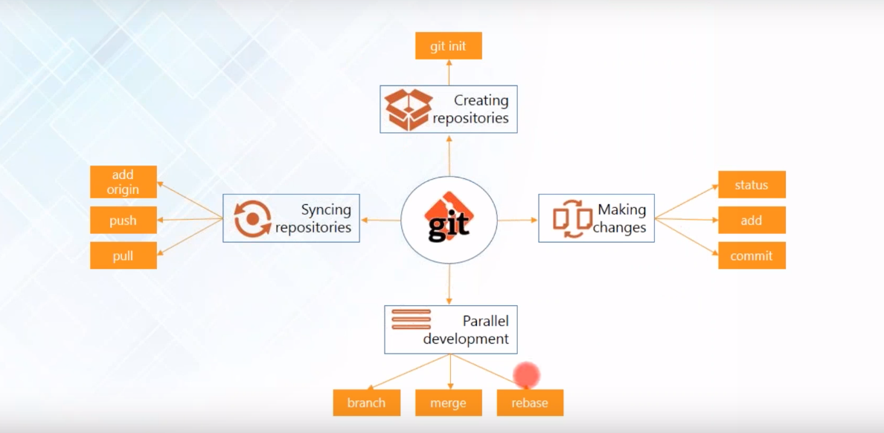

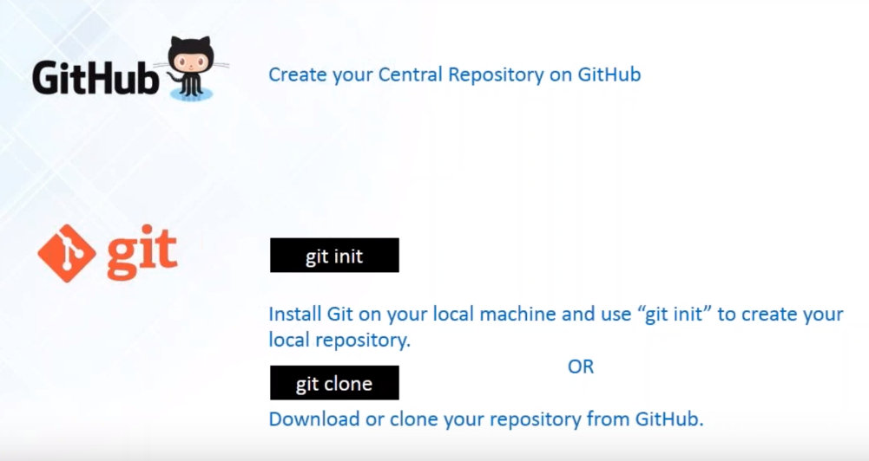

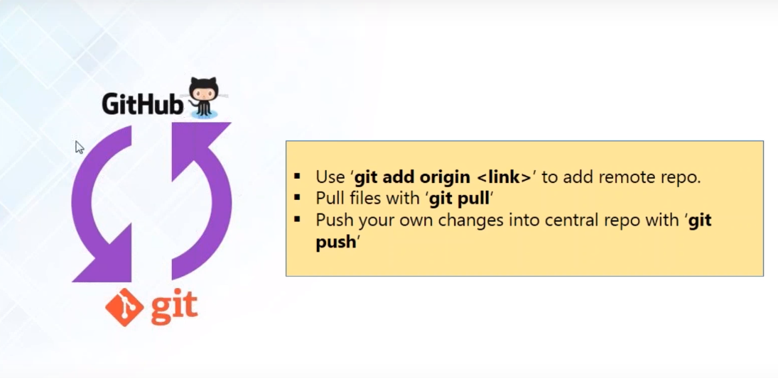

$ git remote add origin <https://github.com/sand92/abc.git>

$ git pull origin master

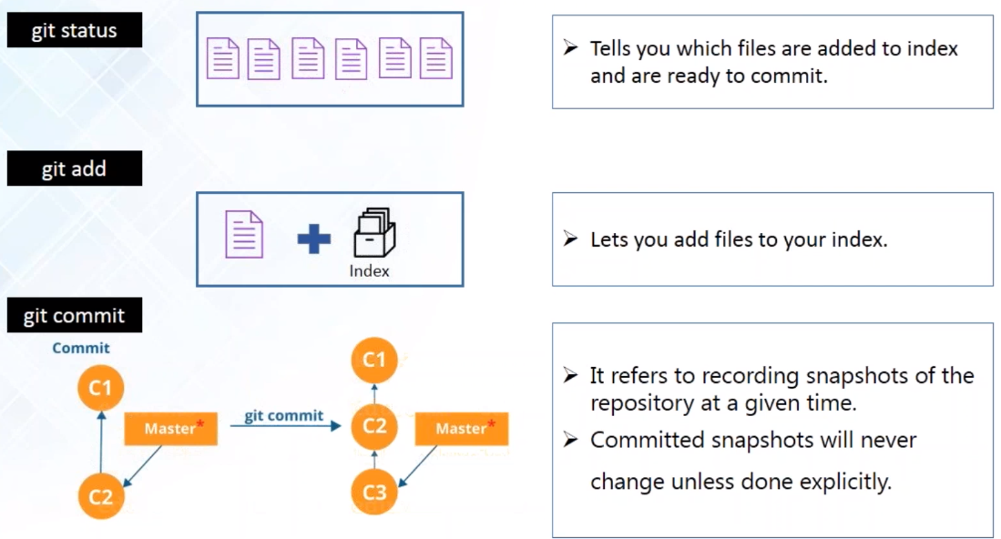

$ git status

$ git add . or abc.txt / git add -A

$ git commit -a -m ‘message by developer’

$ git log

**Parallel Development.**

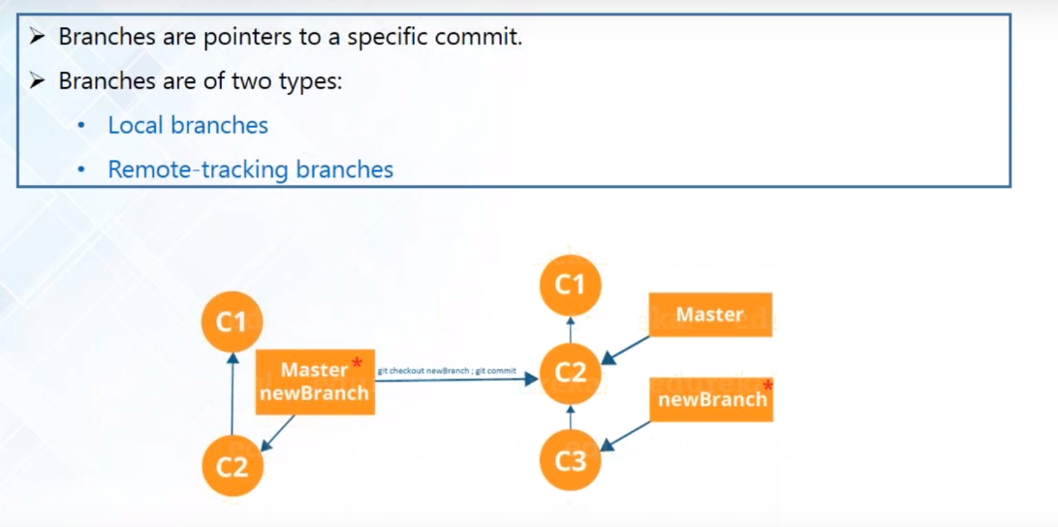

$ Git branch MyBranch

$ git checkout MyBranch

$ git status

$ ls

$ git checkout master

$ ls

**Merging**

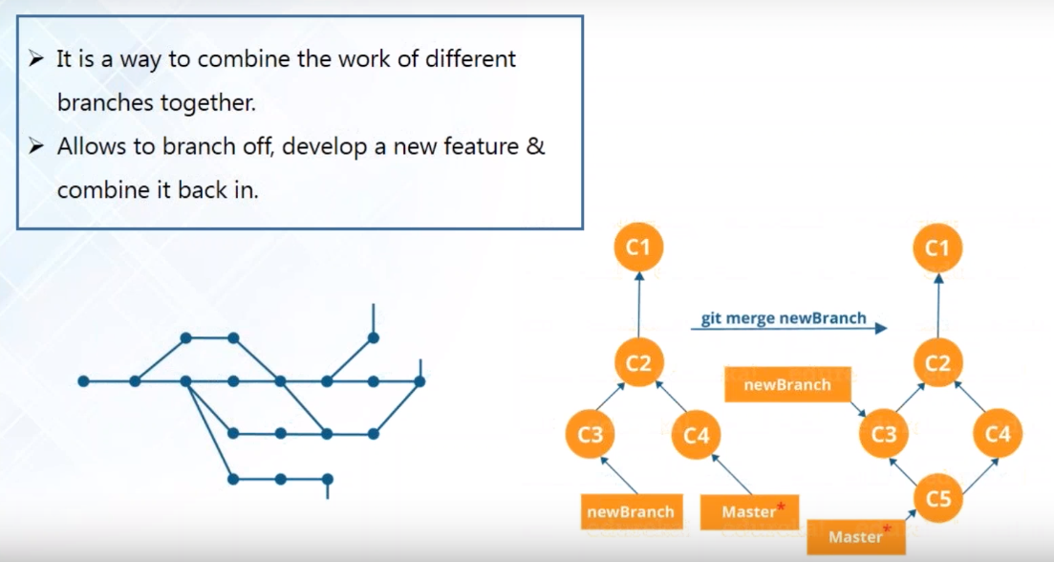

$ git merge MyBranch

$ ls

$ clear

$ cat abc.txt

**Rebasing**

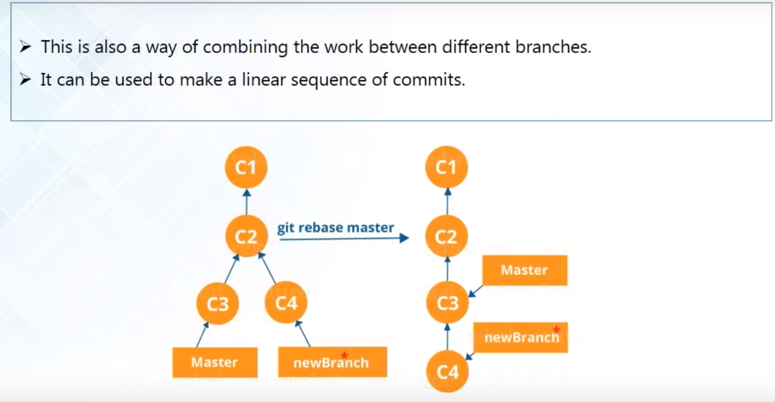

$ git checkout MyBranch

$ git add -A

$ git commit -a – m “adding for rebasing”

$ ls

$ git checkout master

$ ls

$ git checkout MyBranch

$ git rebase master

$ git checkout master

$ git rebase MyBranch

**How to generate ssh-key**

$ ssh-keygen

$ cat /c/user…/abc.pub

$ ssh -T [git@github.com](mailto:git@github.com)

Add ssh key to github add ssh-key with name under setting .

$ git push origin MyBranch

$ git checkout master

$ git push origin master

**Git Flow**

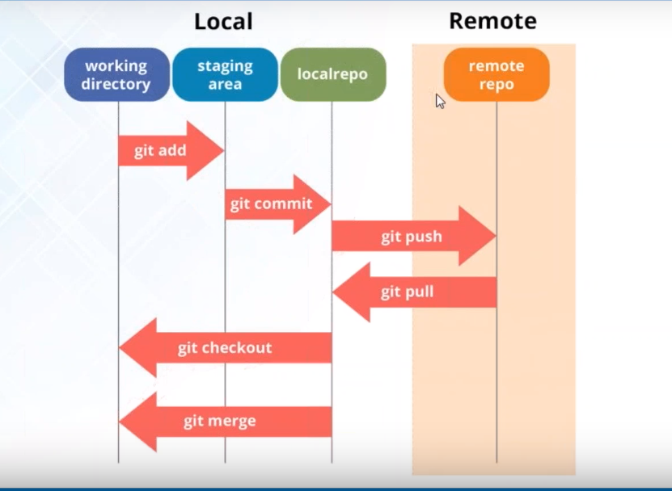

**Rollback into previous version**

$ git log

$ git checkout “8-digit commit hash” abc.txt

$ cat abc.txt

**Git bash command**

$ git init

$ git status

$ git add .

$ git commit -m ‘message’

$ git log

$ touch abc.txt

$ git branch MyBranch

$ git checkout MyBranch

$ git commit -a -m ‘message’

$ git merge tool

$ git stash

$ git stash apply

$ git remote

$ git clone

$ git remote -v

$ git fetch origin

$ git pull origin

$ git commit -a -m ‘message’

$ git push origin master