Node.js
Open source, cross platform, runtime environment for executing JavaScript code. We often use node to build back-end services’. API
Using node, we can build highly scalable, data -intensive and real-time apps.
Why node.js
- Great for prototype and agile development
- Superfast and highly scalable
- JavaScript everywhere
- Cleaner and more consistent codebase
- Large ecosystem of open source libs
Architecture of Node
Node is not a programming language not a framework, it is a runtime environment for executing JavaScript code.

How Node works
Node works as asynchronous/ non -blocking.
Asynchronous architecture
Single thread handles the all request.
Node is ideal for I/O -intensive apps
Do not use node for CPU- intensive apps
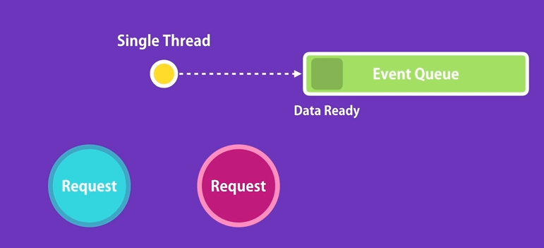

Example:
In restaurant there is a waiter who take order from one table and pass it to kitchen and move to another table. He need not to wait for kitchen. He just takes order and pass it to kitchen.

Install node and write some code
$ node -v

Node Built -in module
- os
- fs
- events
- http
Console.log(window) //shows error not working with DOM / window
Global Scope
Console.log (); //global
setTimeout ()
clearTimeout ()

setInterval ()
clearInterval ()

var message= ‘’;
console.log(global.message) // undefined

Modules in Node
Every file in node is consider as module.
Console.log(module); //returns the JSON file for module

Express.js

Build RESTful API with Node using Express.js

Install npm
Install node

How to create web server
$ mkdir express-demo
$ npm init –yes
$ npm install express
$ npm I -g nodemon -avoid restarting of server every time

const express = require('express');
const app = express();

app.get('/',function(req,res){

res.send('hello world');
});

app.get('/api/course',(req,res)=>{

res.send([1,2,3]);
});

app.listen(3000,function(){
console.log("listining on port 3000");
})

/* app.post();
app.put();
app.delete(); */

Environment variable
In production environment port is assigned dynamically so while deploying code on production the arbitrary port. i.e. 3000 is not going to work.
This is fixed by environment variable.
PORT is an environment variable
const port =process.env.PORT || 3000;
app.listen(port,function(){
console.log(`listining on port ${port}`);
})

In windows you can set port by
set PORT=5000
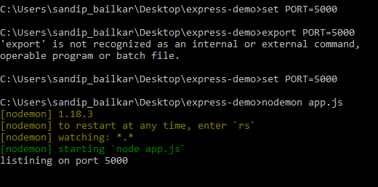

Route Parameter
app.get('/api/course/:id', (req,res) =>{
res.send(req.params.id);
});

How to read multiple parameter
Just use res.send(req.params);

Query string parameter
http://localhost:5000/api/posts/2018/1?sortBy=name
res.send(req.query);

TOPICS:
Node Package Manager
Asynchronous JavaScript
CRUD Operations
Data Validation
Authentication and Authorization
Handling and logging errors
Unit and integration testing
Test driven development
Deployment
Clean coding and refactoring
Security best practices
Useful libraries
Common mistakes you should avoided

Handling GET requests
const express = require('express');
const app = express();

const courses=[
{id:1 ,name:'c'},
{id:2 ,name:'c++'},
{id:3 ,name:'java'}
];

app.get('/',function(req,res){

res.send('hello world');
});

app.get('/api/course',(req,res)=>{

res.send(courses);
});
app.get('/api/course/:id', (req,res) =>{

let cid=courses.find(c=>c.id==req.params.id);
if(!cid) res.status(404).send(`course with given id ${req.params.id} is not available`);
res.send(cid);
});

const port =process.env.PORT || 3000;
app.listen(port,function(){
console.log(`listining on port ${port}`);
})

/* app.post();
app.put();
app.delete(); */

Handling POST Request
app.post('/api/course',(req,res)=>{

const course ={
id : courses.length+1,
name: req.body.name
}
courses.push(course);
res.send(course);
});

Input validation
$ npm I joi@13.1.0
Joi is popular input validation npm

Handling error without joi
app.post('/api/course',(req,res)=>{
if(!req.body.name || req.body.name<4){

res.status(404).send(`Input name should be enter and minimum 3 chracter`);
return;
}

const course ={
id : courses.length+1,
name: req.body.name
}
courses.push(course);
res.send(course);
});

With joi
app.post('/api/course',(req,res)=>{

const schema={
name: Joi.string().min(3).required()
}

const result = Joi.validate(req.body,schema);
console.log(result);
if(result.error){
res.status(404).send(result.error);
/* return; */
}

const course ={
id : courses.length+1,
name: req.body.name
}
courses.push(course);
res.send(course);
});

Handling PUT request:
Object Destructuring

app.put('/api/course/:id',(req,res)=>{

let cid=courses.find(c=>c.id==req.params.id);
if(!cid) res.status(404).send(`course with given id ${req.params.id} is not available`);

//const result = validateCourse(req.body)
const {error} = validateCourse(req.body)
if(error){
res.status(404).send(error);
/* return; */
}
console.log(courses.name);
console.log(req.body.name);
courses.find(data=>data.name=req.body.name)
//courses.name = req.body.name;
res.send(courses);
});

Handling HTTP DELETE Request
app.delete('/api/course/:id',(req,res)=>{
//look up the course
//Not existing ,return 404
//delete
//return the same course

});

