CONSTRAINT: 01

-- Give the name of the project as FIRSTPROJECT

-- Give the name of the application as FIRSTAPPLICATION

-- Allow views.py to be get properly mapped with urls.py file.

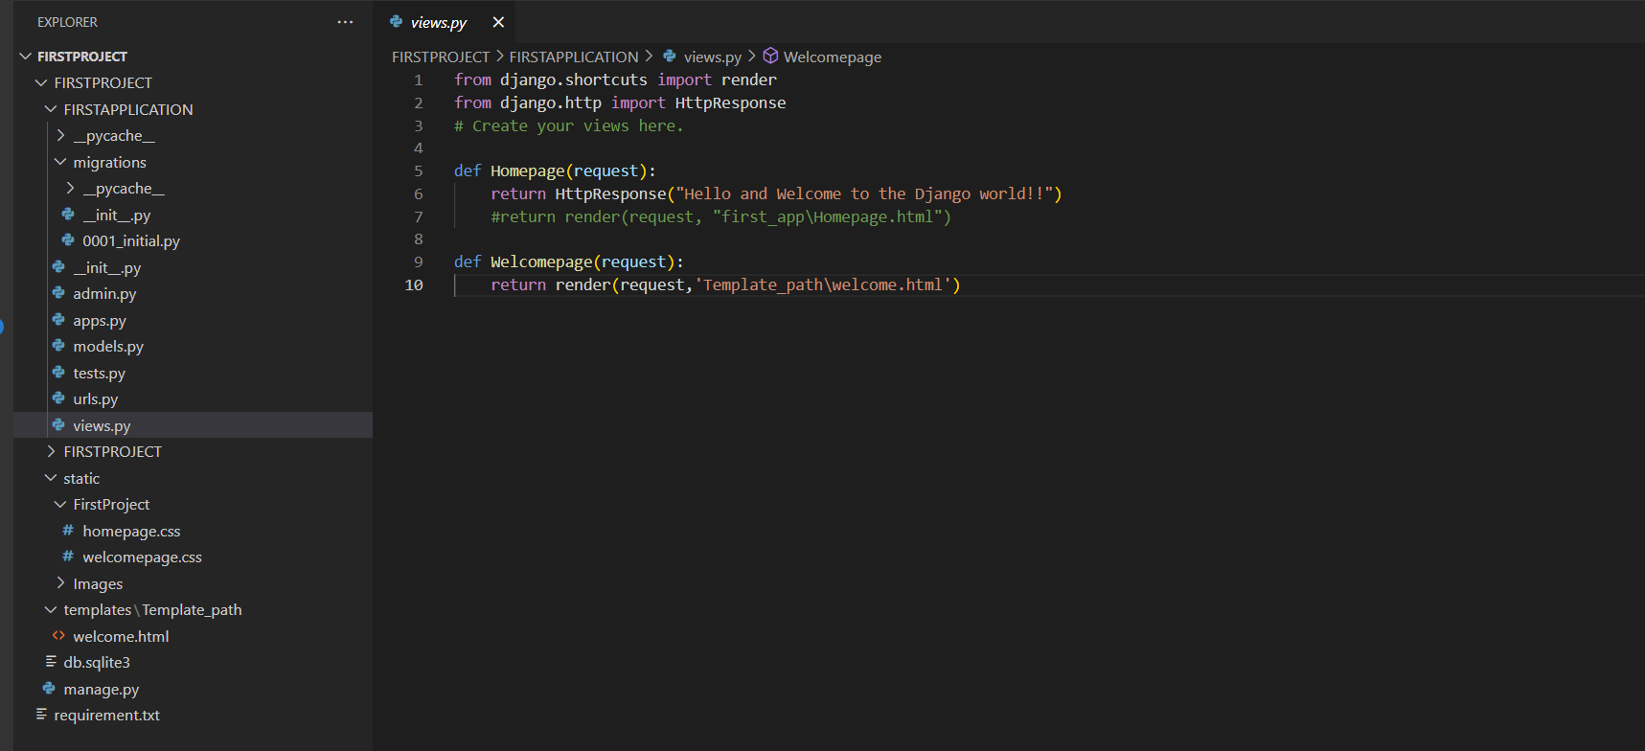

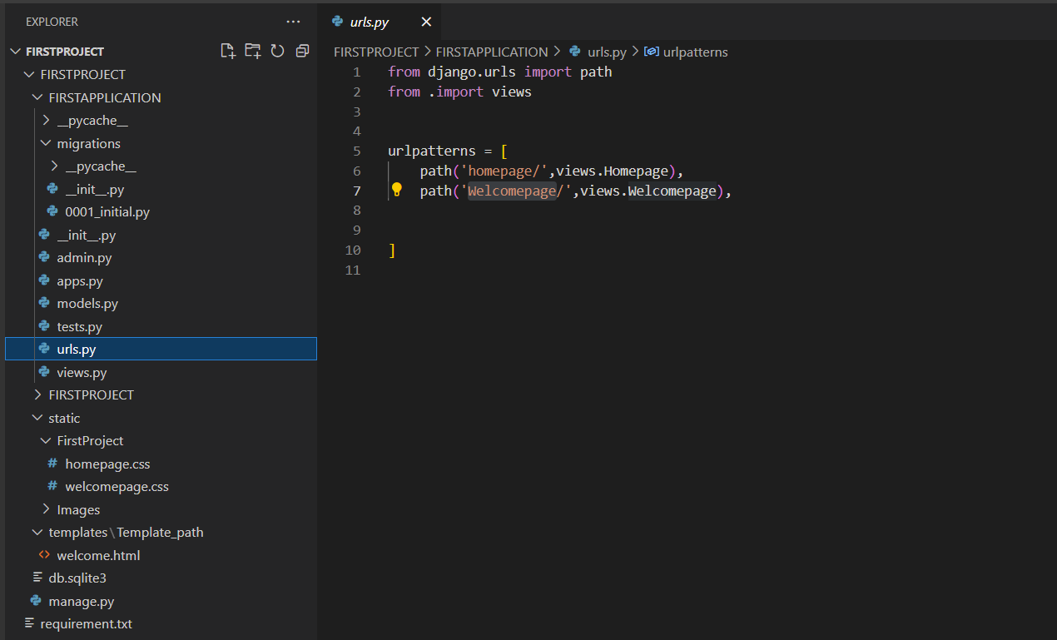

CONSTRAINT: 02

-- Use a template to create a generic HTML file that can display data like- Hi! Welcome to the innovation with python training.

-- While working with the template make sure you give the name "TEMPLATE_PATH" to actually connect to the os path.

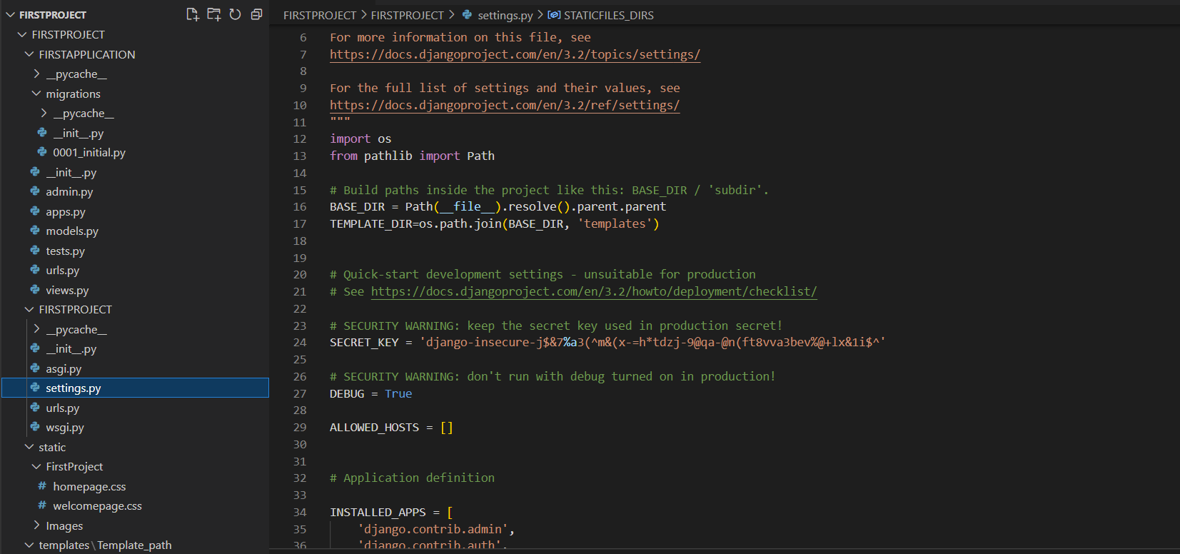

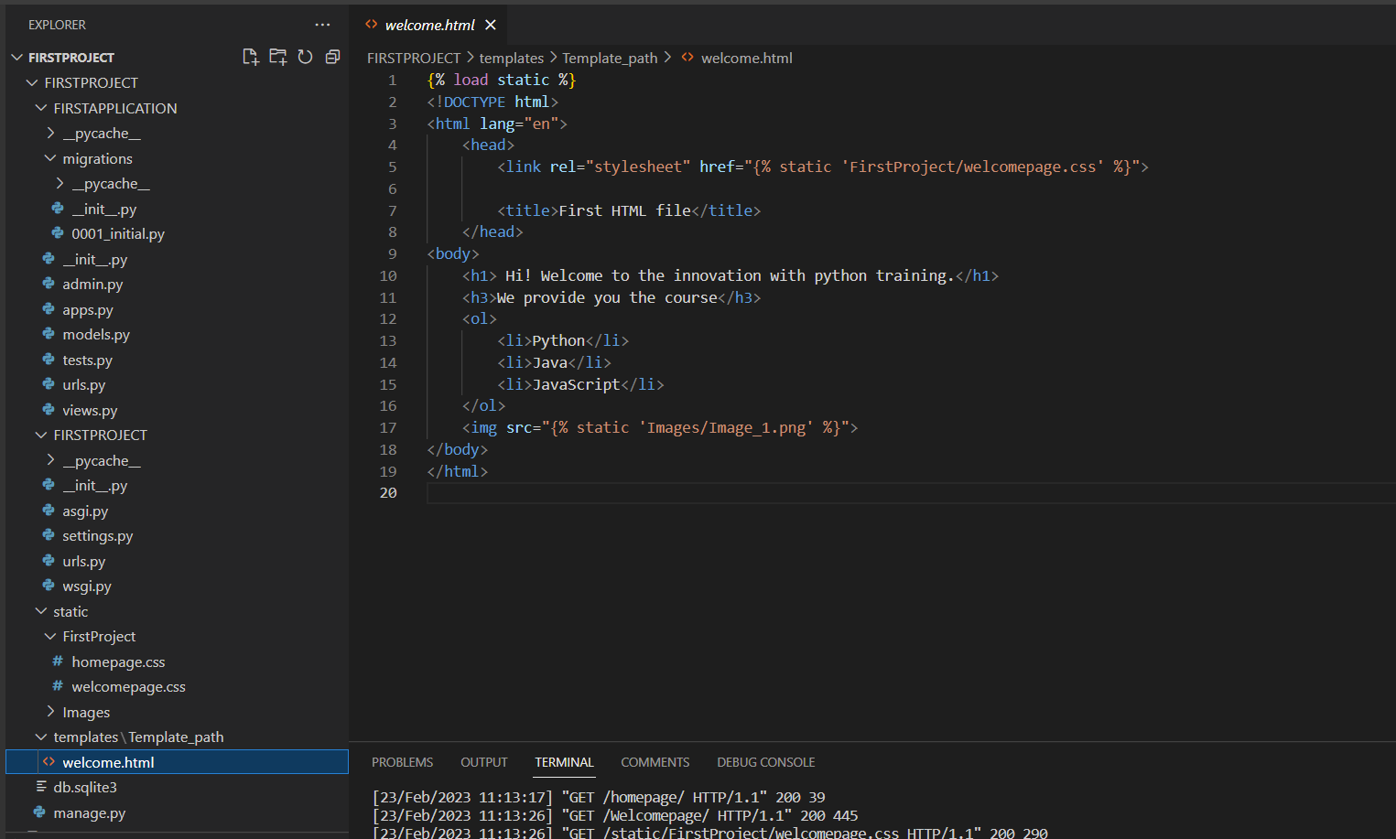

CONSTRAINT: 03

-- Make use of Static files concept to display jpg file on the web page.

-- Make use of some other static files like CSS or JavaScript to change font or color of the text. -- Create three models classes as - Name, ID, Contact, Address and migrate them into the database and at the end populate them with 30 random values

