**Python Task 1 & 2**

1. Create three variables in a single line and assign values to them in such a manner that each one of them belongs to a different data type,

E.g. : a = 1, b = 2.01, c = 'string'

**Output**-

1. 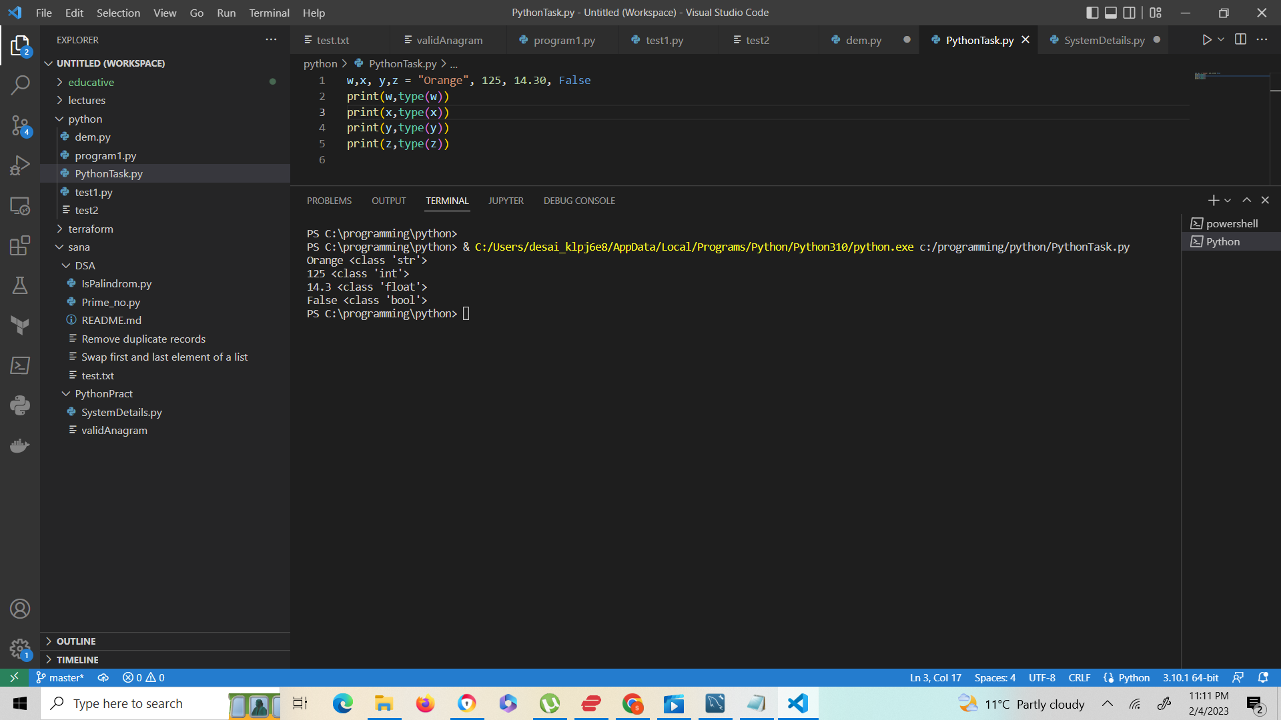Create a variable of type complex and swap it with another variable of type integer

Output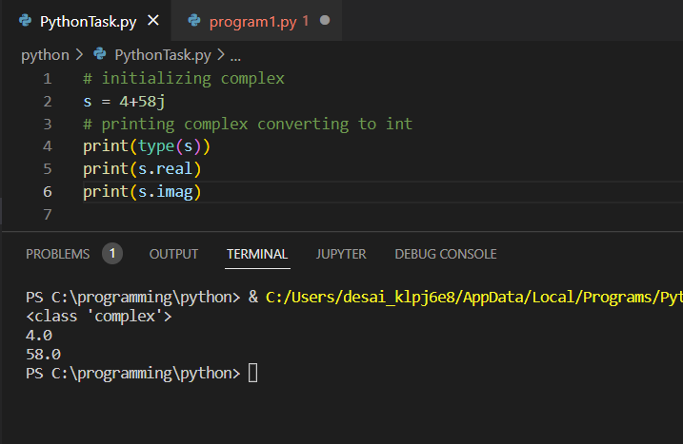

3) Swap two numbers using a third variable and do the same task without using any third variable.

Output-> with third variable

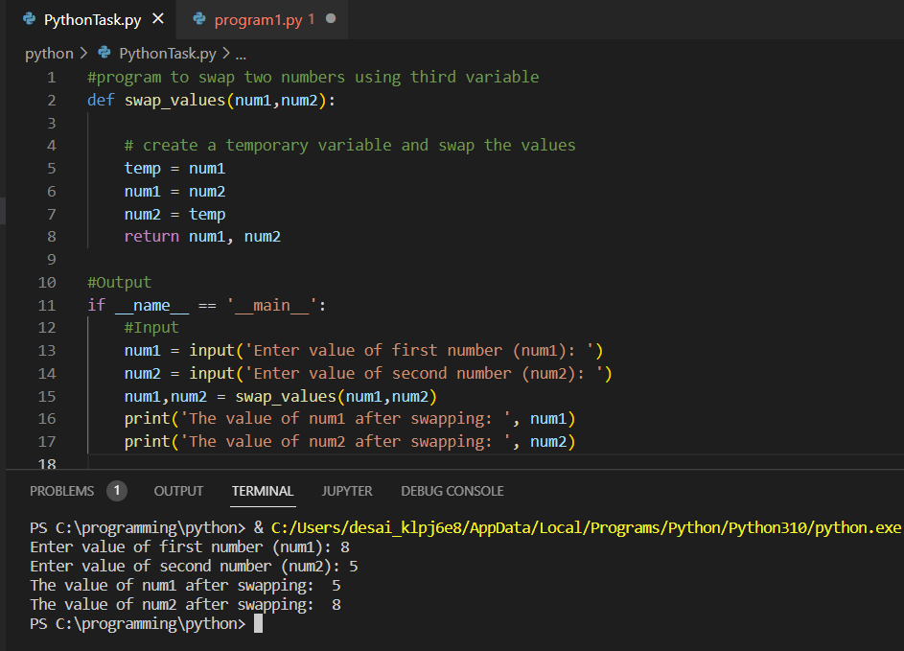

OutPut-> Without using third variable

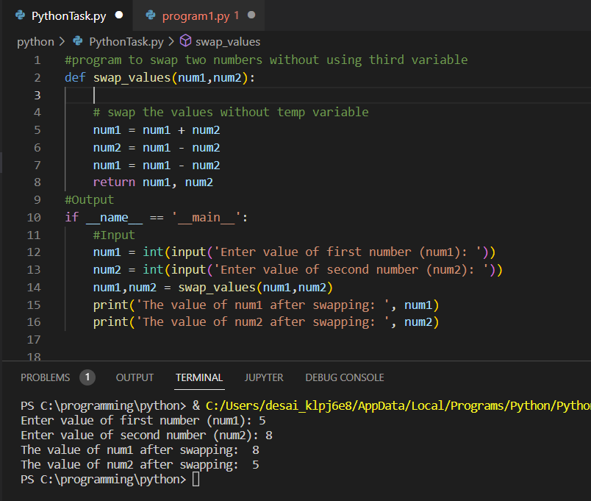

4) Write a program that takes input from the user and prints it using both Python 2.x and Python 3.x Version.

Otuput-> Python 3.x Version

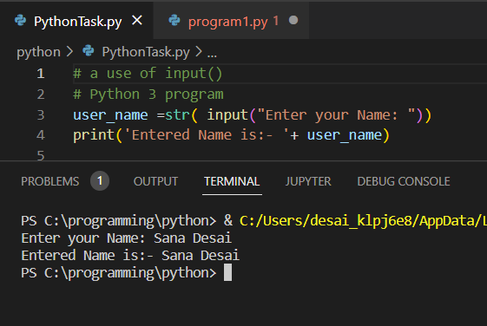

Python 2.x Version

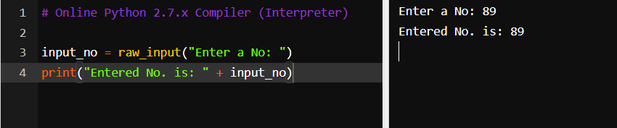

5) Write a program to complete the task given below: Ask users to enter any 2 numbers in between 1-10 , add the two numbers and keep the sum in another variable called z. Add 30 to z and store the output in variable result and print result as the final output.

**Output:-**

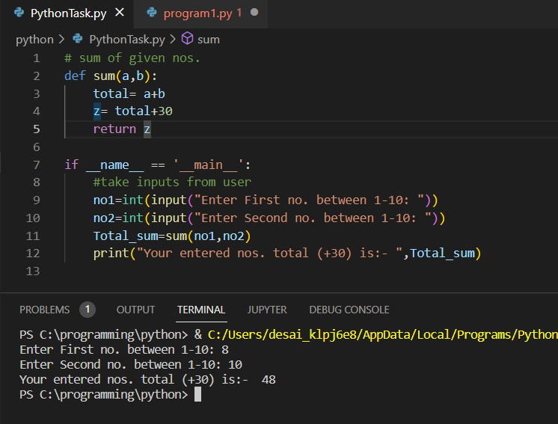

6) Write a program to check the data type of the entered values. HINT: Printed output should say - The data type of the input value is : int/float/string/etc

**Output**:-

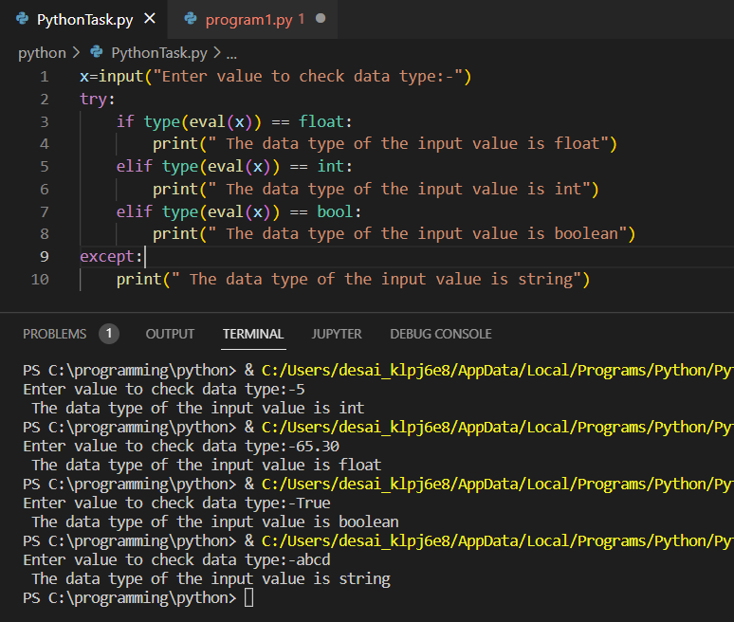

7) Create Variables using formats such as Upper CamelCase, Lower CamelCase, SnakeCase and UPPERCASE. (Refer: <https://capitalizemytitle.com/camel-case/>)

