**Data Manipulation Langage**

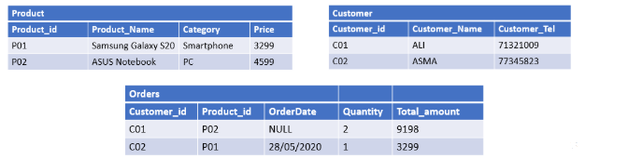

INSERT INTO Product (Product_id, Product_Name, Category, Price)

VALUES (‘P01’, ‘Samung Galaxy S20’, ‘Smartphone’, ‘3299’),

(‘P02’, ‘ASUS Notebook’, ‘PC’, ‘4599’) ;

INSERT INTO Customer (Customer_id, Customer_name,Customer_tel)

VALUES (‘C01’, ‘ALI’, ‘71321009’),

(‘C02’, ‘ASMA’, ‘77345829’) ;

INSERT INTO Orders (Customer_id, Product_id, OrderData, Quantity, Total_amount)

VALUES (‘C01’, ‘P02’, ‘NULL’, ‘2’, ‘9198’),

(‘C02’, ‘P01’, ‘28/05/2020’, ‘1’, ‘3299’)