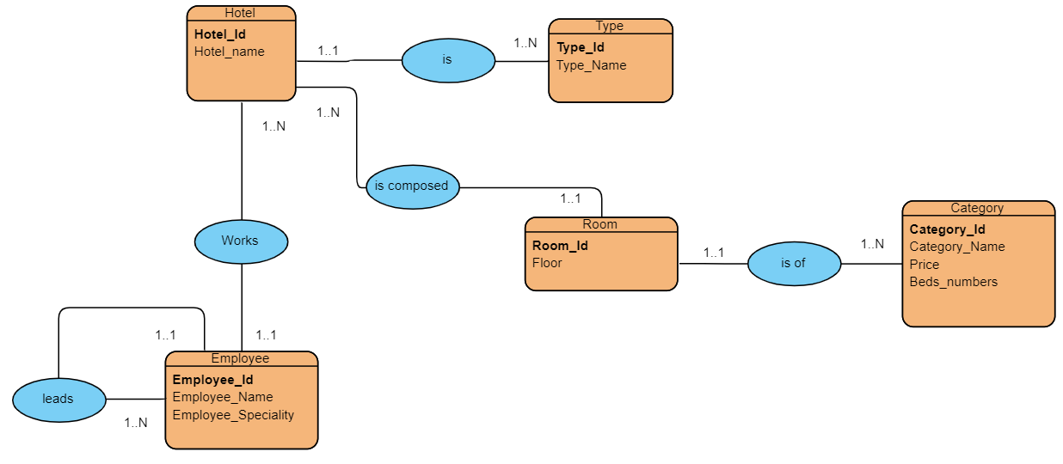

* **En modèle relationnel :**

Hotel (**hotel_id** ,hotel_name**,#type_id**)

Type(**type_id**, type_name ,)

Room(**room_id** , type_name, **#hotel_id,#category_id**)

Category(**category_id** , category_name,price,beds_numbers)

Employee(**employee_id**,employee_name,employee_speciality**,#hotel_id, ,#director_id**)