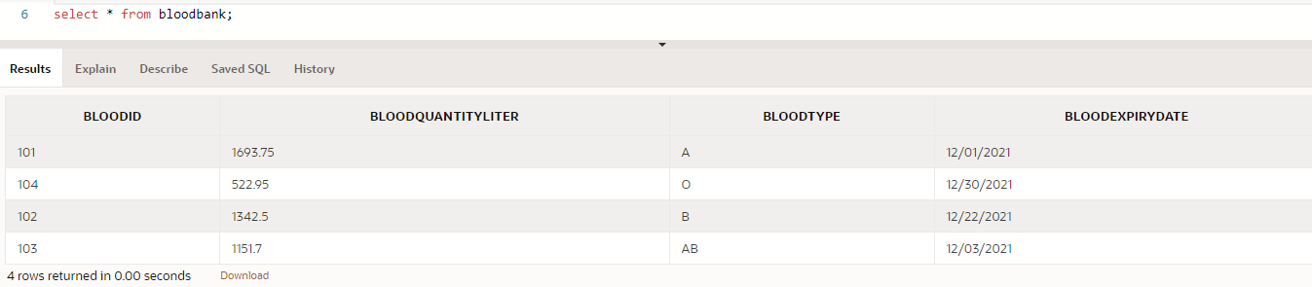Table:

where:

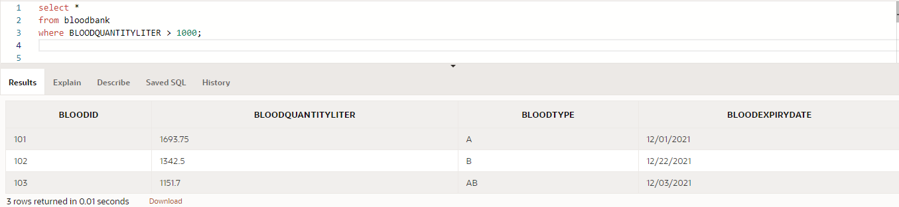

And:

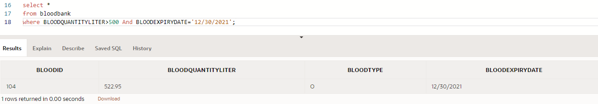

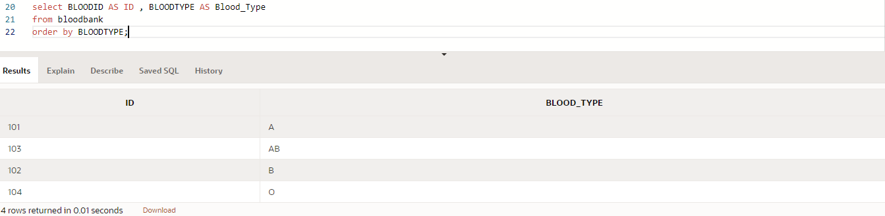order by + alias:

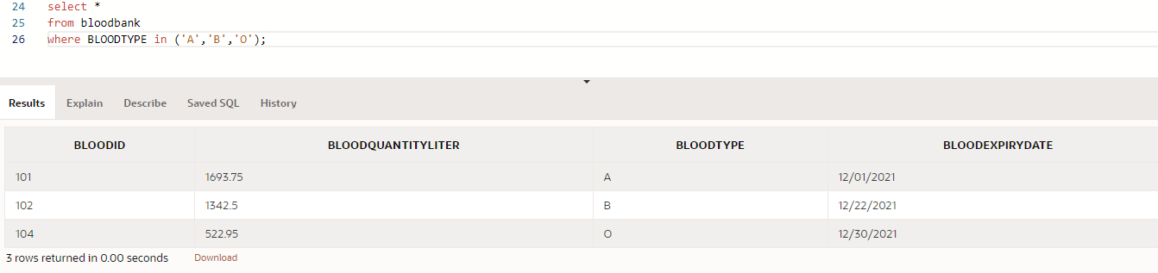in:

Max():

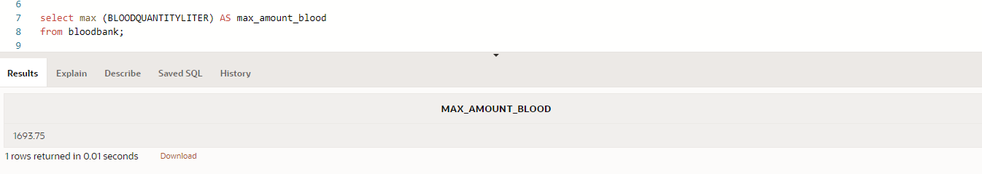

Create view:

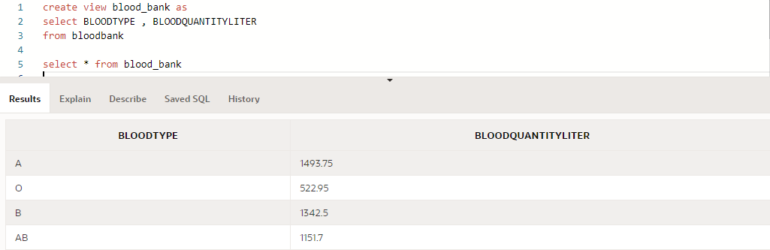

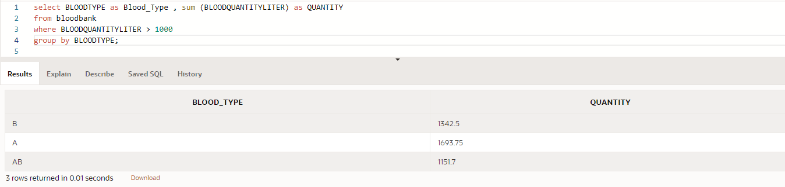Group by + sum():