Ops Assist Platform
Single Orchestrator with LOB-Specific Capabilities
Architecture, governance model, implementation approach and evolution to specialist subagents

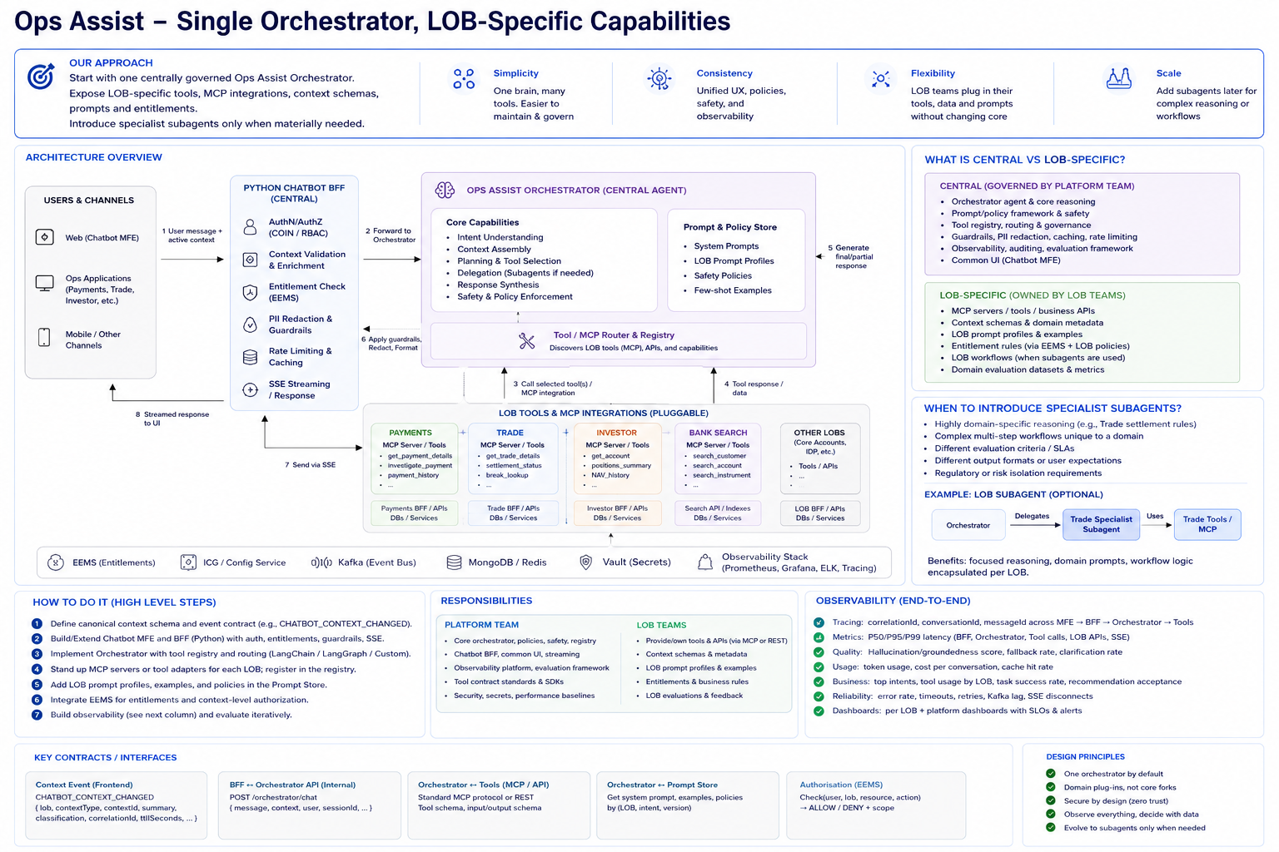
Recommended principle: Multi-LOB does not imply Multi-Agent.

1. Executive Recommendation
Start with one centrally governed Ops Assist orchestrator. Treat every LOB as a versioned capability package containing its context schema, prompt profile, approved tools or MCP integrations, entitlement mapping, business policies and evaluation set. Introduce specialist subagents only when an LOB has materially different reasoning, workflow, governance or quality requirements.
- One shared orchestrator gives a consistent user experience, guardrail model, audit model and observability model.
- LOB teams keep domain ownership through tools, prompts, context contracts, entitlements and evaluation packs.
- The frontend remains stable even when the backend evolves from one orchestrator to optional specialist subagents.
- Avoid the anti-pattern 'one LOB = one agent'; it increases prompt duplication, routing complexity, cost and operational burden.

Core operating model
Layer | Central platform responsibility | LOB responsibility
Frontend | Host shell, Chatbot MFE runtime, context event contract, SSE rendering | Emit safe domain context and provide approved UI extensions
Python BFF | Auth, EEMS orchestration, context validation, redaction, rate limits, response normalization | Expose LOB BFF/API adapters and domain-safe enrichment
Orchestration | Intent understanding, tool selection, delegation policy, response synthesis | LOB prompt profile, tools/MCP, domain policies, evaluations
Governance | Versioning, security controls, observability, kill switches, conformance tests | Tool ownership, domain SLAs, feedback and acceptance criteria

2. Target Architecture and Request Flow
High-level architecture: the Shared Ops UI Host Shell mounts the Chatbot MFE once. Business MFEs publish safe context events. The Python/FastAPI Chatbot BFF validates and enriches the request, then invokes the central orchestrator. The orchestrator dynamically loads the active LOB capability profile and can call only approved, entitlement-filtered tools.

End-to-end flow
1. User navigates within Payments, Trade, Bank Search or another MFE.
2. LOB MFE emits `CHATBOT_CONTEXT_CHANGED` containing only safe context references and summaries.
3. Chatbot MFE updates local runtime state; navigation alone does not trigger AI work.
4. User submits a natural-language message.
5. Chatbot MFE sends message + active context to the Python Chatbot BFF.
6. BFF validates authentication, resolves LOB/context, checks EEMS scope, applies redaction and rate limits.
7. BFF forwards a normalized request to the central Ops Assist orchestrator.
8. Orchestrator loads the LOB capability profile, selects allowed tools/MCP integrations, or asks for clarification.
9. Tool/MCP responses return through the orchestrator; BFF normalizes the response contract.
10. Frontend receives typed SSE events and renders answer, clarification, action request or rich artifact.

Typed response contract for the frontend
The frontend should not infer whether a turn is final, a clarification request or a confirmation step from natural-language text. The Python BFF should normalize AI/agent outcomes into a stable envelope:
{
"messageType": "answer | clarification | action_required | tool_result | error",
"turnStatus": "completed | needs_user_input | needs_confirmation | processing | failed",
"streamStatus": "started | streaming | completed | failed",
"content": "...",
"artifact": { "type": "table | chart | recommendation | download" }
}

3. LOB Capability Package Model
Each LOB should onboard through a versioned capability manifest. This is the main mechanism for federation. It lets LOBs customize domain behavior without forking the central orchestrator or Chatbot MFE.
Capability element | Purpose
Context schema | Defines allowed context shape, safe summary fields, classification and TTL
Prompt profile | LOB persona, domain instructions, few-shot examples and clarification rules
Tool/MCP registry | Approved tools, endpoints, schemas, risk class and confirmation requirements
Entitlement mapping | Maps actions such as view/investigate/approve to EEMS permissions
Evaluation pack | Golden queries and domain acceptance tests for quality and policy compliance
Observability metadata | LOB, use case, cost center, dashboard and SLO labels

Example LOB manifest
lob: payments
version: 1.2
context_schema: payments-context-v1
prompt_profile: payments-prompt-v3
tools:
- get_payment_details
- start_payment_investigation
entitlements:
- PAYMENT_VIEW
- PAYMENT_INVESTIGATE
agent_mode:
type: shared_orchestrator
observability:
dashboard: payments-ai
cost_center: payments-ops

How the central orchestrator uses the package
- Determine active LOB from trusted UI context first; otherwise use explicit identifiers or ask clarification.
- Load that LOB's prompt profile and context schema.
- Ask the BFF/policy layer for entitlement scope; never authorize inside the LLM.
- Expose only allowed tools to the orchestrator for that turn.
- Run the shared reasoning loop and return a structured outcome.
- Record model, prompt profile, tool version, policy decision and correlation ID for observability.

4. Concrete Use Cases

OnePay MTP Maker Recommendation
- Use current maker-task context already present in the OnePay MFE.
- No specialist agent is required for the initial showcase.
- No tool call is required if the recommendation can be produced from current context and approved prompt policy.
- Return a rich recommendation artifact with key facts, recommended next steps and optional actions.

Bank Search MFE
- Use current screen context plus a Bank Search MCP tool.
- Orchestrator classifies intent as a search request, checks entitlement, invokes the MCP tool and receives structured records.
- Return a rich table artifact with view, copy and download behaviors.
- Still no dedicated Bank Search agent is required initially; the domain capability package is sufficient.

5. When to Introduce Specialist Subagents
Create a specialist subagent only when the execution model is genuinely different. Recommended triggers:
Trigger | Why it justifies a specialist
Distinct reasoning | Example: trade settlement analysis requires SSI validation, cut-off reasoning and exception sequencing.
Unique multi-step workflow | A domain needs its own state machine or LangGraph subgraph rather than a shared tool loop.
Different evaluation/SLA | The LOB has unique quality measures, safety requirements or operational SLOs.
Regulatory isolation | The domain requires stronger isolation, dedicated policies or separate release control.
Independent ownership | A domain team owns prompt, tools, evaluation and release cadence end-to-end.

Recommended hierarchy
Central Orchestrator → optional specialist subagent → LOB tools/MCP. The parent keeps global conversation state, routing, cross-LOB boundaries and response normalization. The specialist owns domain reasoning and domain tool selection.

Evolution without frontend change
CAPABILITY_REGISTRY = {
"payments": {"mode": "shared_orchestrator"},
"trade": {
"mode": "specialist_agent",
"agent": "trade_settlement_specialist"
}
}

6. Technical Implementation Blueprint

Frontend stack
- React + TypeScript
- Webpack 5 Module Federation
- Context API and/or Redux for runtime state
- Typed `CHATBOT_CONTEXT_CHANGED` event contract
- SSE client for streamed responses
- Rich artifact renderer for tables, charts, recommendations, actions and downloads

Python BFF stack
- Python 3.x + FastAPI + Pydantic
- httpx for downstream LOB BFF / AI / EEMS calls
- Redis for active session state, rate limiting and safe cache
- MongoDB for conversation history where approved
- OpenTelemetry-compatible tracing and structured logs
- SSE via FastAPI StreamingResponse or equivalent

Suggested Python package structure
services/chatbot-bff/app/
api/chat.py
auth/authentication.py
auth/entitlement.py
context/resolver.py
context/enrichment.py
capabilities/registry.py
capabilities/loader.py
orchestration/orchestrator.py
orchestration/response_normalizer.py
guardrails/pii.py
guardrails/prompt_injection.py
clients/ai_platform.py
clients/eems.py
clients/lob_bff.py
clients/mcp.py
observability/tracing.py
observability/metrics.py

7. Delivery Roadmap
Phase | Primary outcome
Phase 0 — Contracts | Lock context schema, BFF OpenAPI, SSE envelope, capability manifest, tool/MCP registration and observability taxonomy.
Phase 1 — Shared Orchestrator MVP | Implement shell-mounted Chatbot MFE, Python BFF, EEMS integration skeleton, OnePay context-only recommendation and baseline SSE.
Phase 2 — LOB Capability Registry | Add versioned manifests, prompt profiles, entitlement-filtered tool registry, Bank Search MCP and rich artifact protocol.
Phase 3 — Enterprise Hardening | PII/restricted-data controls, prompt-injection defenses, audit replay, circuit breakers, performance tests and SLO alerts.
Phase 4 — First Specialist | Promote only the most complex domain, such as Trade settlement, to a specialist subagent and compare quality/cost against shared orchestration.
Phase 5 — Productization | Self-service LOB onboarding, extension marketplace, contract conformance tests, automated evaluation and release compatibility matrix.

Observability requirements
- Trace `MFE → Python BFF → EEMS → Orchestrator → Tool/MCP → LOB BFF/API → response` with a shared correlation ID.
- Track P50/P95/P99 latency, time to first token, full-response latency, SSE disconnects and downstream timeouts.
- Track intent accuracy, clarification rate, tool-selection accuracy, tool success/failure and specialist delegation rate.
- Track entitlement allow/deny decisions, PII redactions, prompt-injection detections and blocked tool calls.
- Track token usage, model cost, cache-hit ratio, active users, recommendation acceptance and business time saved.
- Provide central platform dashboards and per-LOB dashboards with drill-down by use case, model, agent, tool and deployment version.

Final design principle
Use one shared orchestrator for consistency. Treat LOBs as governed capability packages first. Promote an LOB to a specialist subagent only when its reasoning or workflow genuinely requires a separate execution model.

