Game Design Document

Fill up the following document

1. Write the title of your project.

THE MARATHON RUNNER GAME

1. What is the goal of the game?

HELPING PEOPLE TO GET FIT

1. Write a brief story of your game.

THERE IS A GIRL WHO IS VERY THICK AND WANTS TO REDUCE SOME WEIGHT MY RUNNING IN THE MARATHON AND IS TRYING TO REDUCE HER WEIGHT AS SHE CANT FIT IN HER FAVORITE DRESS.ONCE SHE REDUCES HER WEIGHT SHE WILL BE ABLE TO FIT IN HER FAVORITE DRESS.AND THROUGH HER JOURNEY SHE FACES A LOT OF OBSTACLES AND REWARDS.

1. Which are the playing characters of this game?

* Playing characters are the ones who respond to the user based on the input from the user.
* Cars, monkeys, dinos, wizards, etc., are the playing characters in the game.

|  |  |  |
| --- | --- | --- |
| Number | Character Name | What can this character do? |
| 1 | A THICK GIRL | WHO IS RUNNING TO REDUCE HER WEIGHT |
| 2 |  |  |
| 3 |  |  |
| 4 |  |  |
| 5 |  |  |
| 6 |  |  |
| 7 |  |  |
| 8 |  |  |

1. Which are the Non-Playing Characters of this game?

* Non-Playing characters are the ones that don't have an action or behavior when the user interacts with the game.
* Hurdles, stones, bananas, coins, etc., are non-playing characters in the game.

|  |  |  |
| --- | --- | --- |
| Number | Character Name | What can this character do? |
| 1 | WATER | TO BOOST UP THE THICK GIRLS ENERGY |
| 2 | STONES | WHICH CAN MAKE THE THICK GIRL FALL ON GROUND |
| 3 | SMALL ANIMALS | THE THICK GIRL IS VERY SCARED OF ANIMALS |
| 4 |  |  |
| 5 |  |  |
| 6 |  |  |
| 7 |  |  |
| 8 |  |  |

Draw your imagination of this game. What does this game look like?

* Draw the game either on your computer or on paper.
* Add images of the game scenes to show each of the playing and non-playing characters at least once.

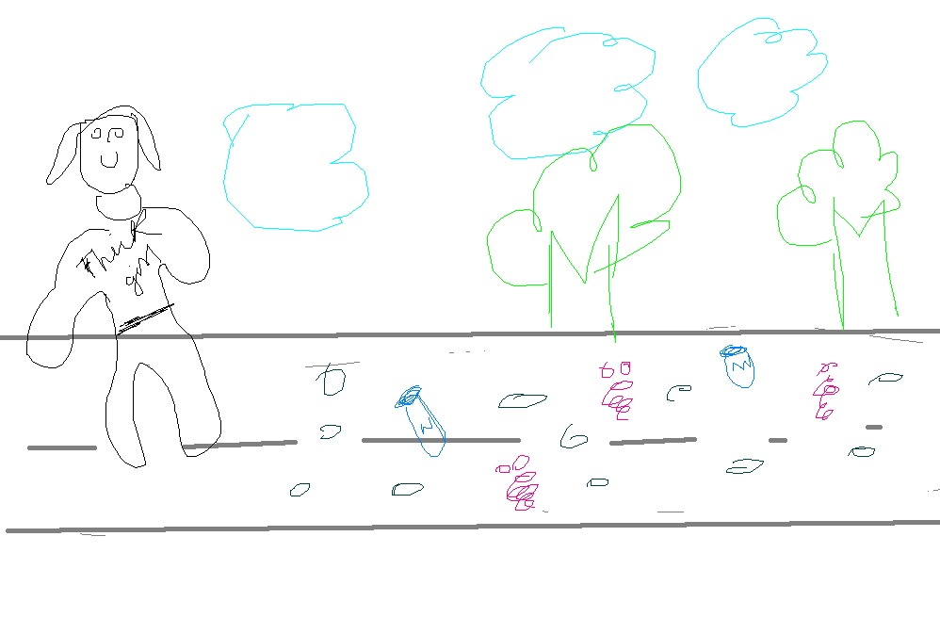

How do you plan to make your game engaging?

By adding nice aniamtion,having a moderate adaptivity,and some certain set of rules,and having a feedback.