**Comsats University Islamabad, Vehari Campus**



**Academic Year 2022 -23**

**Department: Computer Science**

**Full Name:** Sana Ahmad

**Roll No.:** SP22-BCS-129

**Section:** “B”

**Subject:** Data Structure and Algorithm

**Date:** 11/09/2023

**Submitted to:** Mam Yasmeen

#include <iostream>

int main() {

int num = 42; // Declare an integer variable 'num' and assign a value to it

int* ptr = &num; // Declare a pointer to an integer and assign the address of 'num' to it

// Print the value of 'num' and the value pointed to by 'ptr'

std::cout << "Value of num: " << num << std::endl;

std::cout << "Value pointed to by ptr: " << *ptr << std::endl;

// Modify the value of 'num' through the pointer 'ptr'

*ptr = 55;

// Print the updated value of 'num'

std::cout << "Updated value of num: " << num << std::endl;

return 0;

}

**Output:**

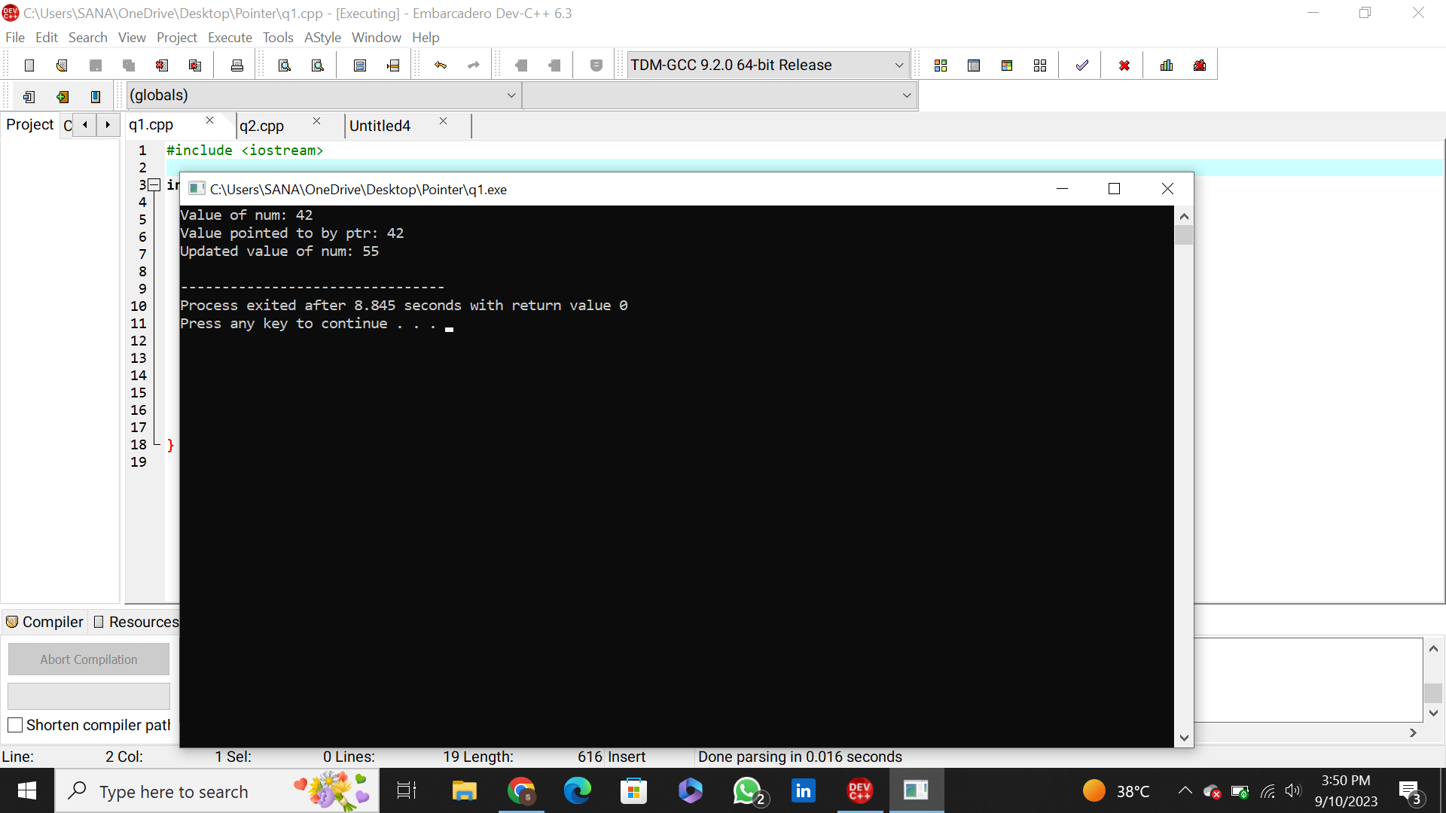

**Problem: 2**

#include <iostream>

int main() {

int arr[] = {10, 20, 30, 40};

int* ptr = arr;

std::cout << "First element: " << *ptr << std::endl;

ptr++; // Move to the next element

std::cout << "Second element: " << *ptr << std::endl;

return 0;

}

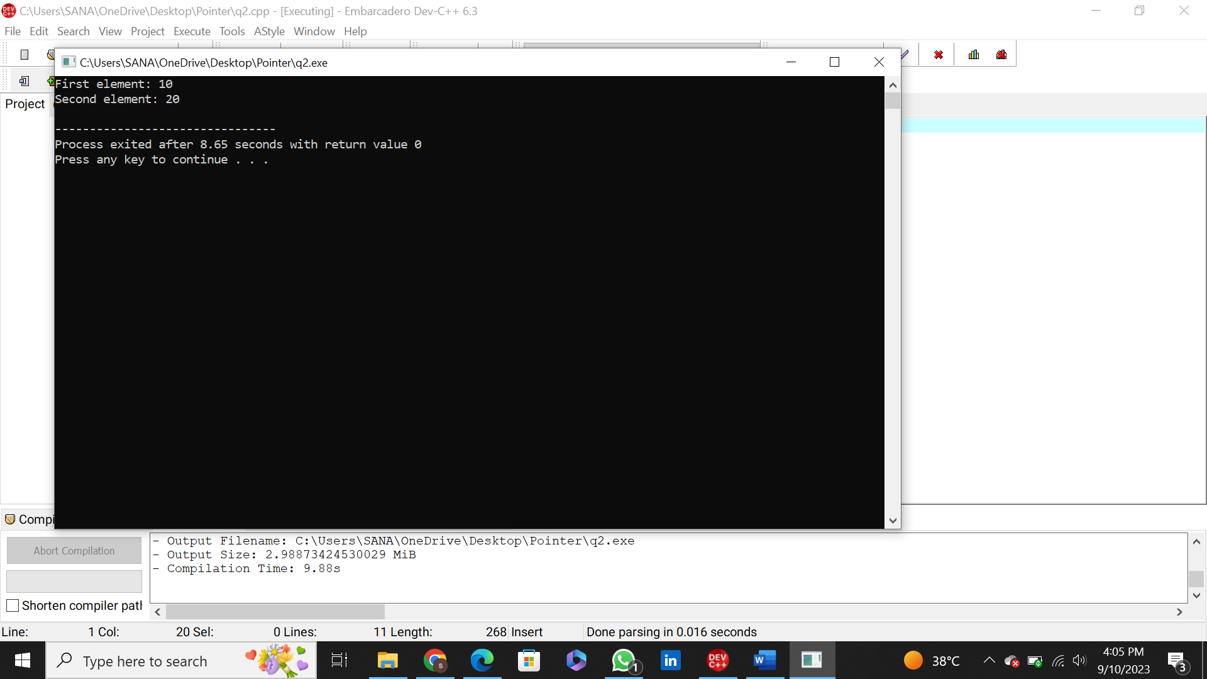**Output:**

**Problem: 3**

#include <iostream>

void greet() {

std::cout << "Hello, World!" << std::endl;

}

int main() {

void (*functionPtr)() = greet;

functionPtr(); // Call the function through the pointer

return 0;

}

**Output:** 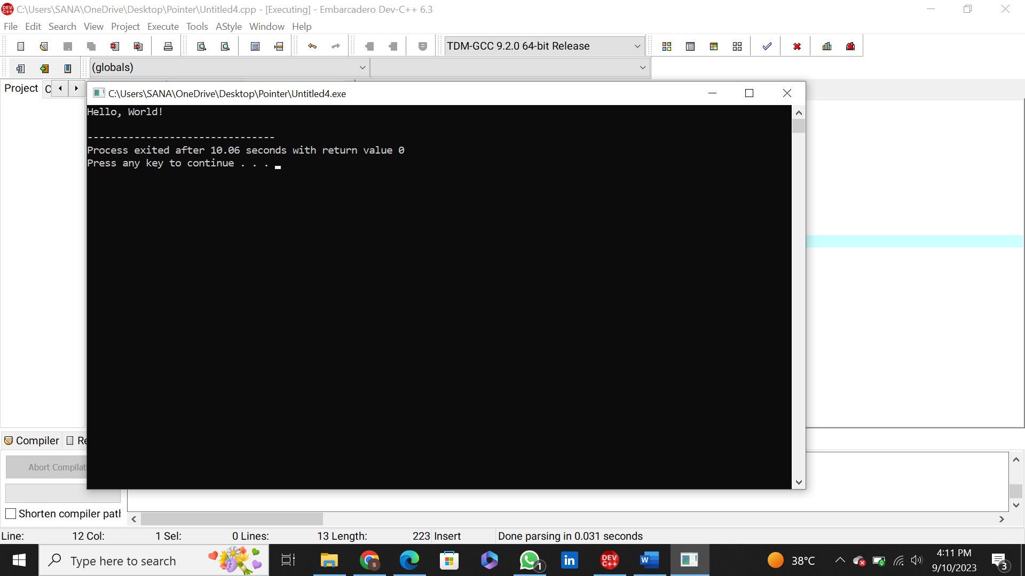

**Problem: 4**

#include <iostream>

int main() {

int* dynamicInt = new int(42);

std::cout << "Value of dynamicInt: " << *dynamicInt << std::endl;

delete dynamicInt; // Free the allocated memory

return 0;

}

**Output:**

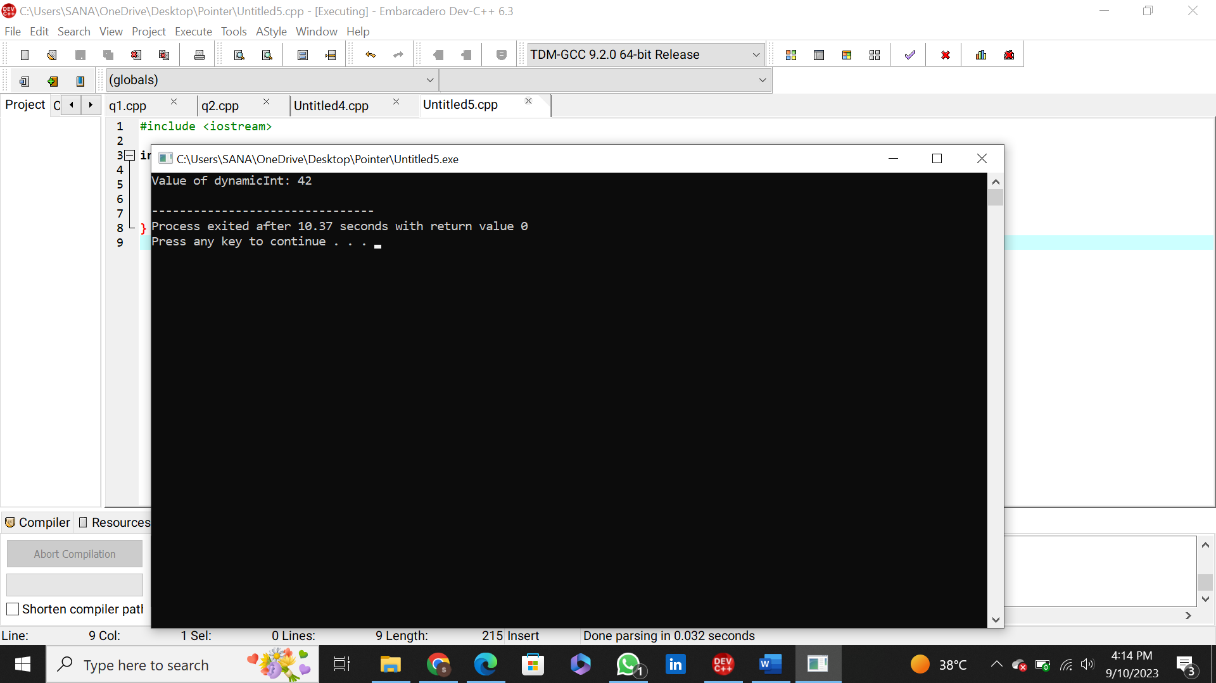

**Problem:5**

#include <iostream>

int main() {

int numbers[] = {1, 2, 3, 4, 5};

int* ptr = numbers;

for (int i = 0; i < 5; i++) {

std::cout << "Element " << i << ": " << *(ptr + i) << std::endl;

}

return 0;

}

**Output:** 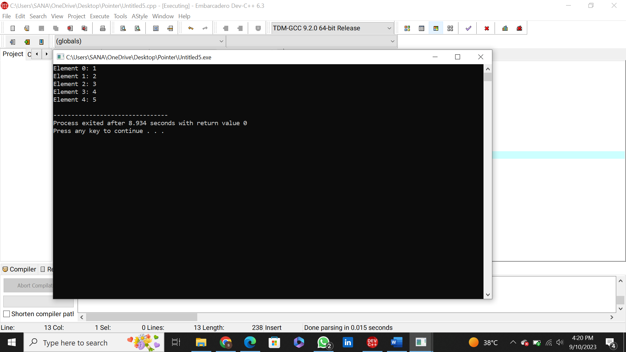

**Problem: 6**

#include <iostream>

int main() {

int* nullPtr = nullptr;

if (nullPtr == nullptr) {

std::cout << "nullPtr is a null pointer." << std::endl;

} else {

std::cout << "nullPtr is not a null pointer." << std::endl;

}

return 0;

}

**Output:**

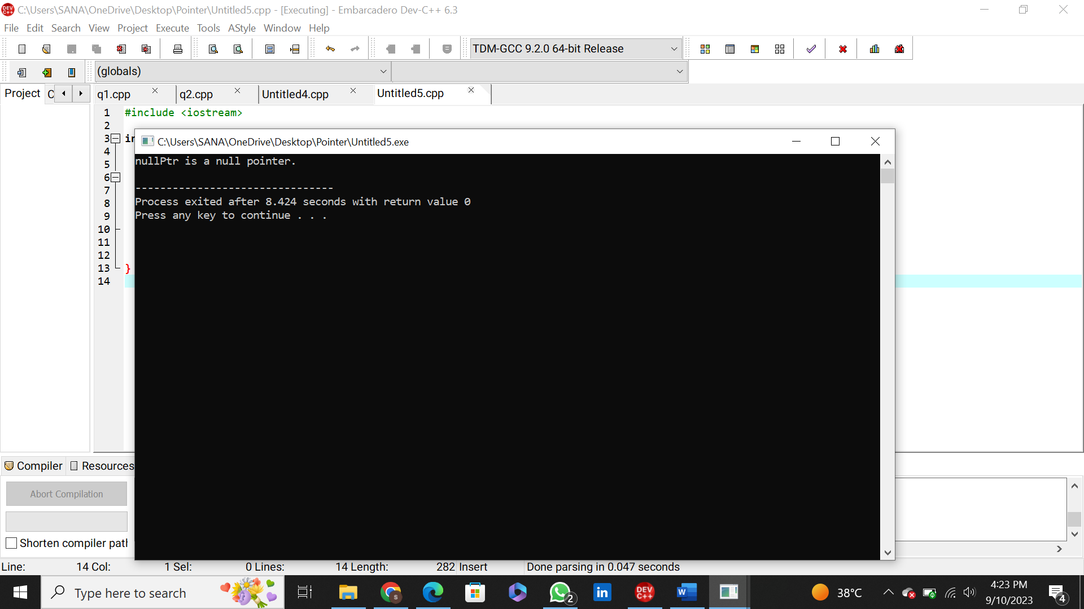

**Problem:7**

#include <iostream>

int main() {

int num = 42;

int* ptr1 = &num;

int** ptr2 = &ptr1;

std::cout << "Value of num: " << num << std::endl;

std::cout << "Value pointed to by ptr1: " << *ptr1 << std::endl;

std::cout << "Value pointed to by ptr2 (through two pointers): " << **ptr2 << std::endl;

return 0;

}

**Output:**

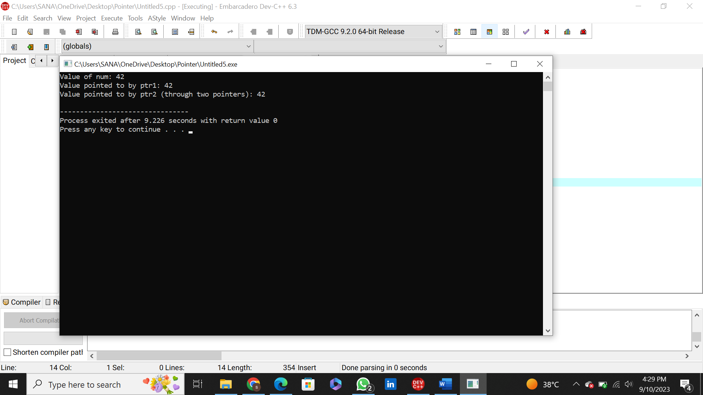

**Problem: 8**

#include <iostream>

void modifyValue(int* ptr) {

*ptr = 55;

}

int main() {

int num = 42;

modifyValue(&num);

std::cout << "Modified value of num: " << num << std::endl;

return 0;

}

**Output:**

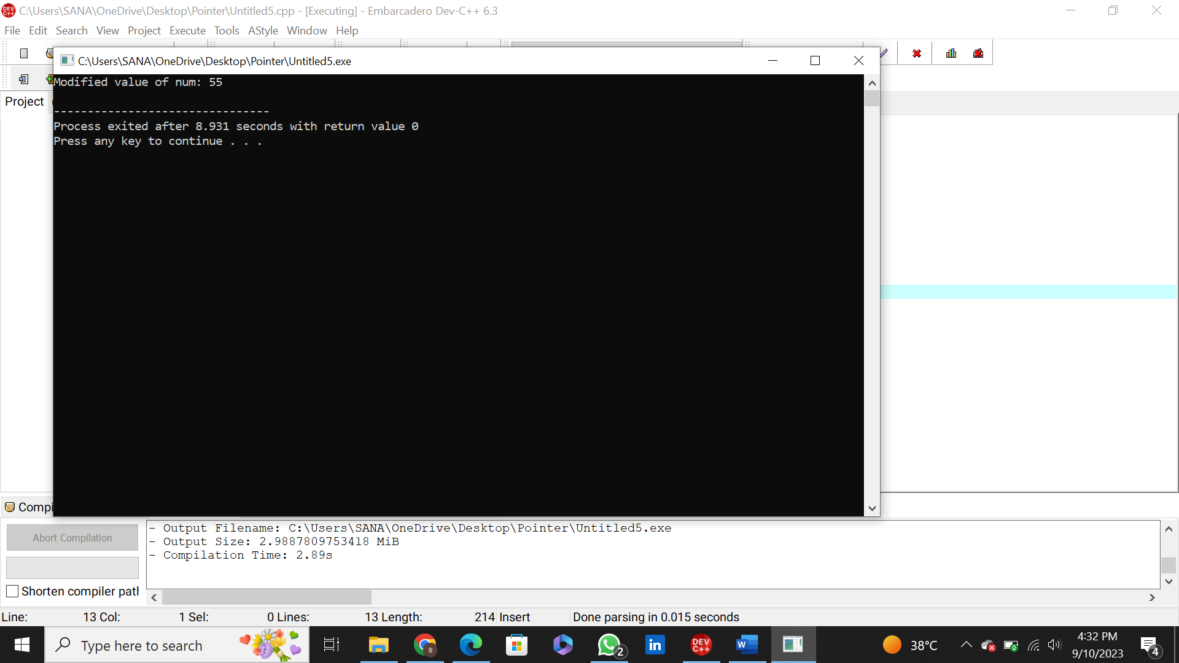

**Problem: 9**

#include <iostream>

int main() {

int num1 = 10, num2 = 20, num3 = 30;

int* arr[3] = {&num1, &num2, &num3};

for (int i = 0; i < 3; i++) {

std::cout << "Element " << i << ": " << *arr[i] << std::endl;

}

return 0;

}

**Output:**

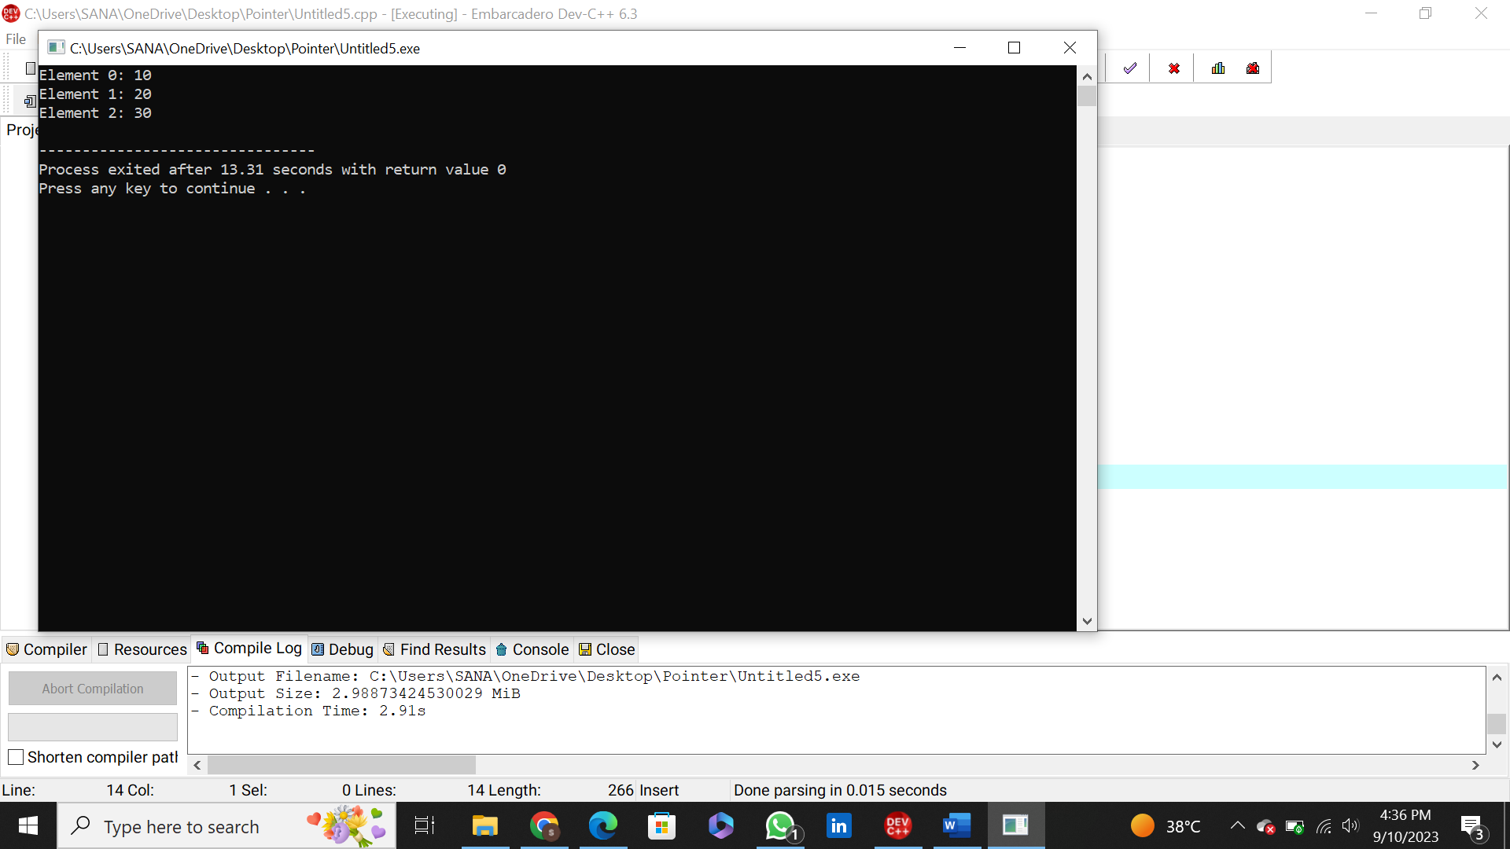

**Problem: 10**

#include <iostream>

int main() {

const int num = 42;

const int* ptr = &num; // Pointer to a constant integer

std::cout << "Value of num: " << num << std::endl;

std::cout << "Value pointed to by ptr: " << *ptr << std::endl;

// Uncommenting the line below would result in a compilation error.

// *ptr = 55; // Error: Cannot modify a constant through a pointer

return 0;

}

**Output:**

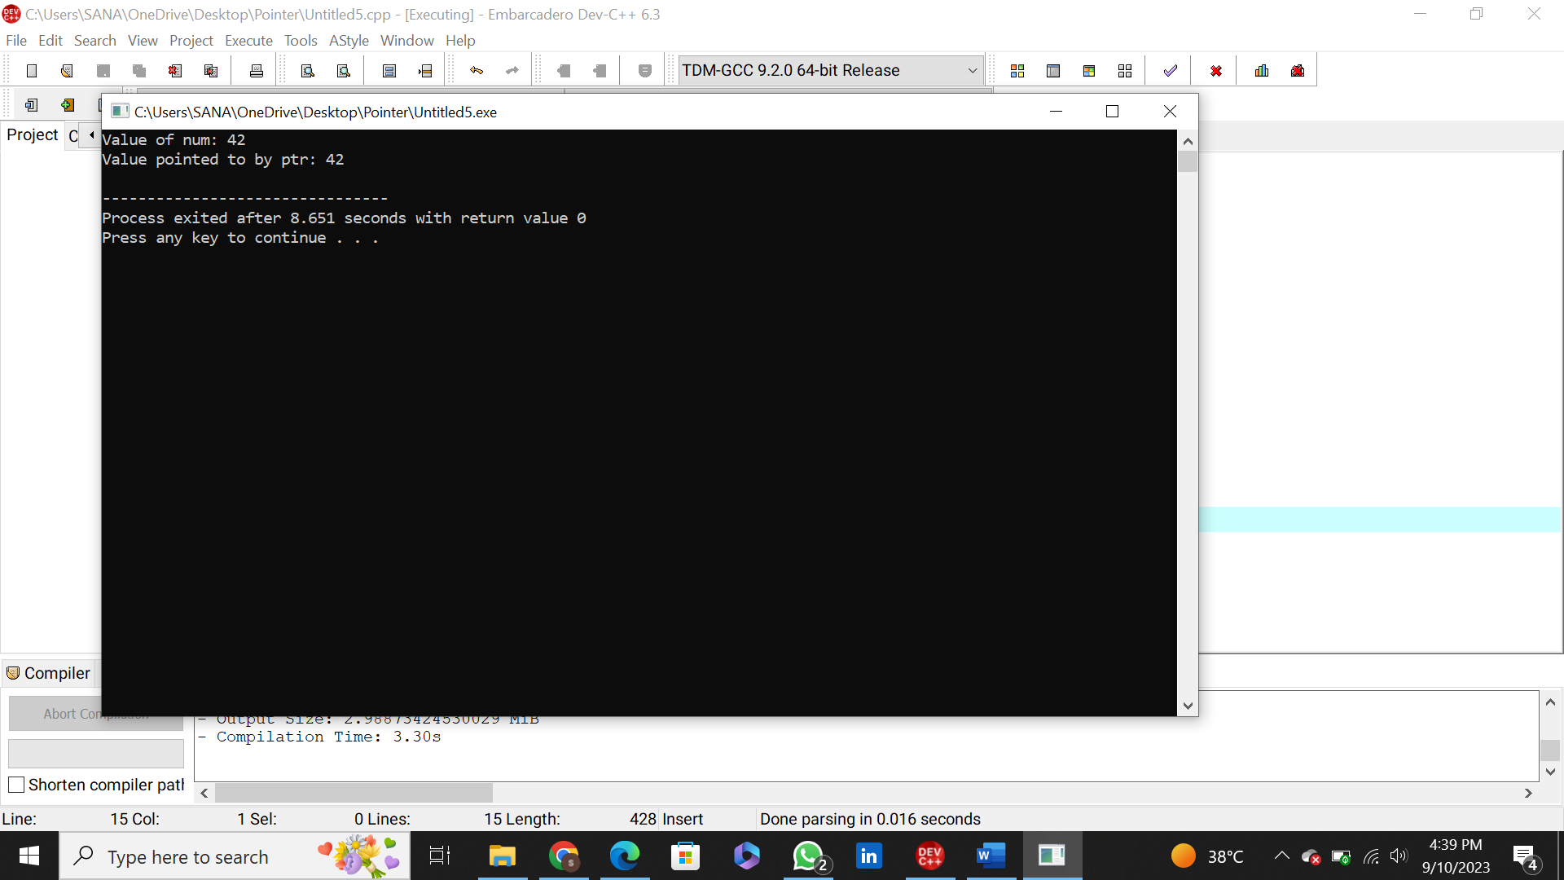

**Problem:11**

#include <iostream>

int main() {

int num = 42;

int* const ptr = &num; // Constant pointer to an integer

std::cout << "Value of num: " << num << std::endl;

std::cout << "Value pointed to by ptr: " << *ptr << std::endl;

// Uncommenting the line below would result in a compilation error.

// ptr = nullptr; // Error: Cannot change the value of a constant pointer

return 0;

}

**Output:**

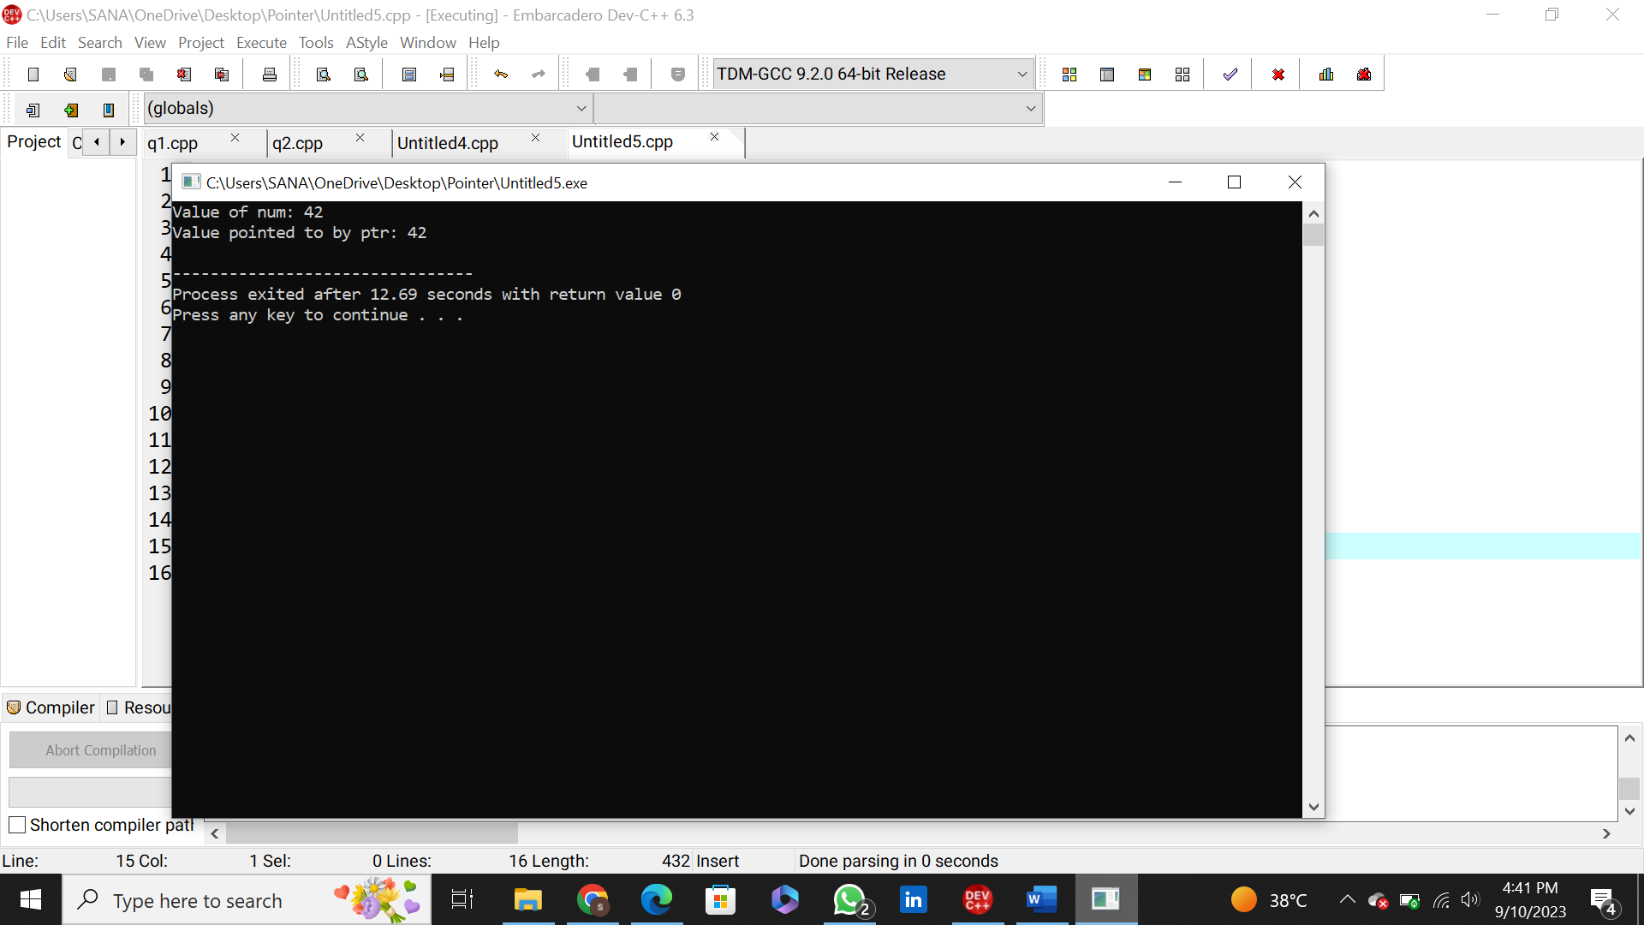

**Problem: 12**

#include <iostream>

int main() {

const int num = 42;

const int* const ptr = &num; // Constant pointer to a constant integer

std::cout << "Value of num: " << num << std::endl;

std::cout << "Value pointed to by ptr: " << *ptr << std::endl;

// Uncommenting either of the lines below would result in a compilation error.

// *ptr = 55; // Error: Cannot modify a constant through a pointer

// ptr = nullptr; // Error: Cannot change the value of a constant pointer

return 0;

}

**Output:**

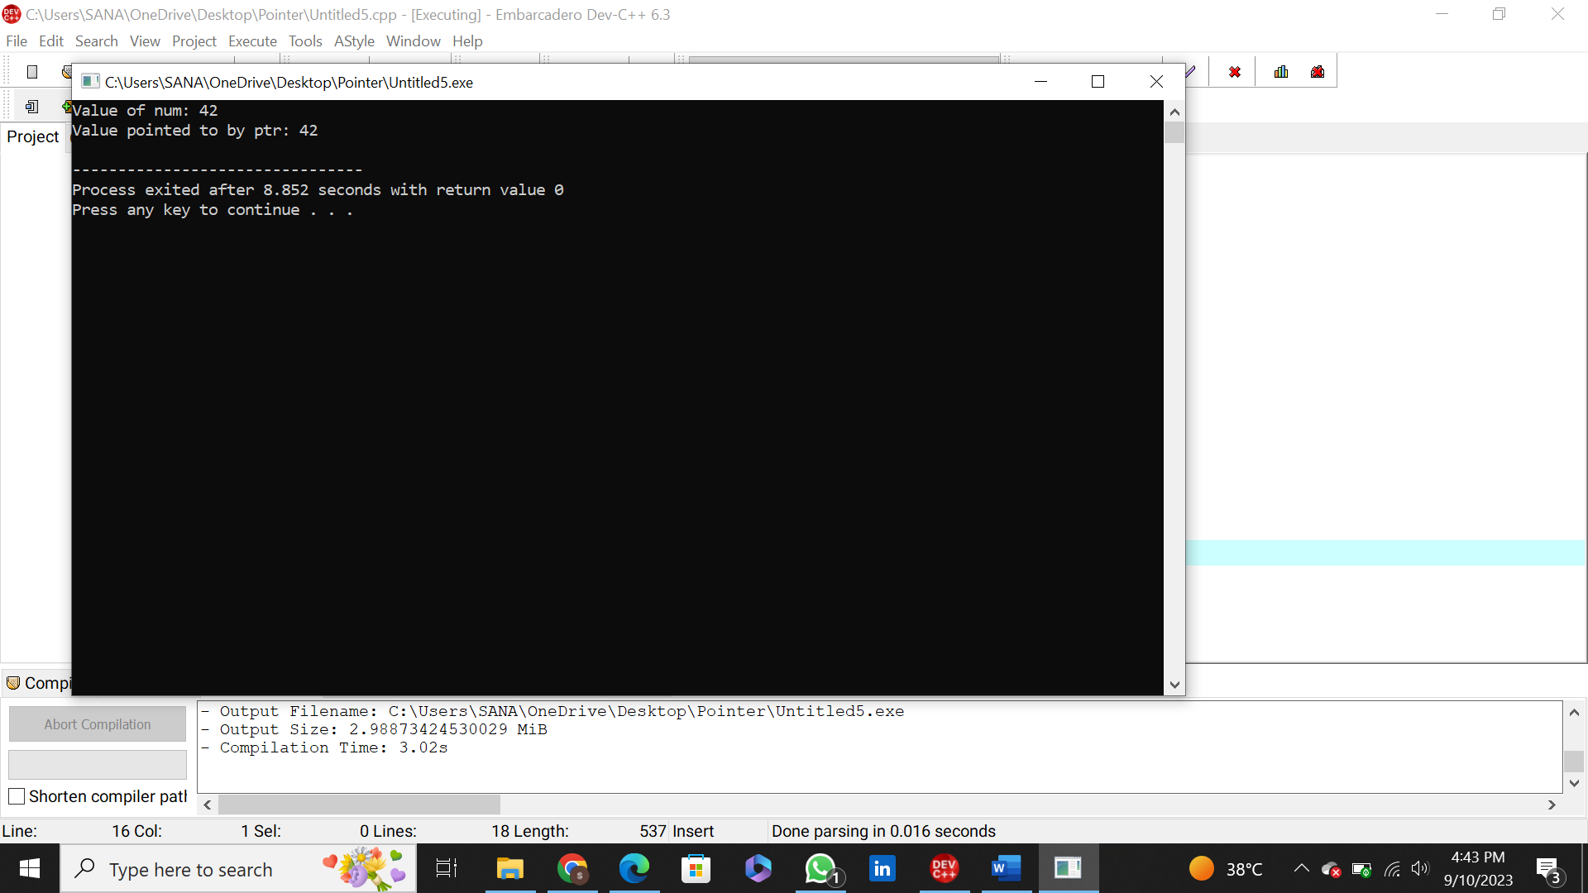

**Problem:13**

#include <iostream>

#include <string>

class Person {

public:

Person(const std::string& name) : name_(name) {}

void introduce() {

std::cout << "Hello, my name is " << name_ << std::endl;

}

private:

std::string name_;

};

int main() {

Person person("Alice");

Person* ptr = &person;

ptr->introduce();

return 0;

}

**Output:**

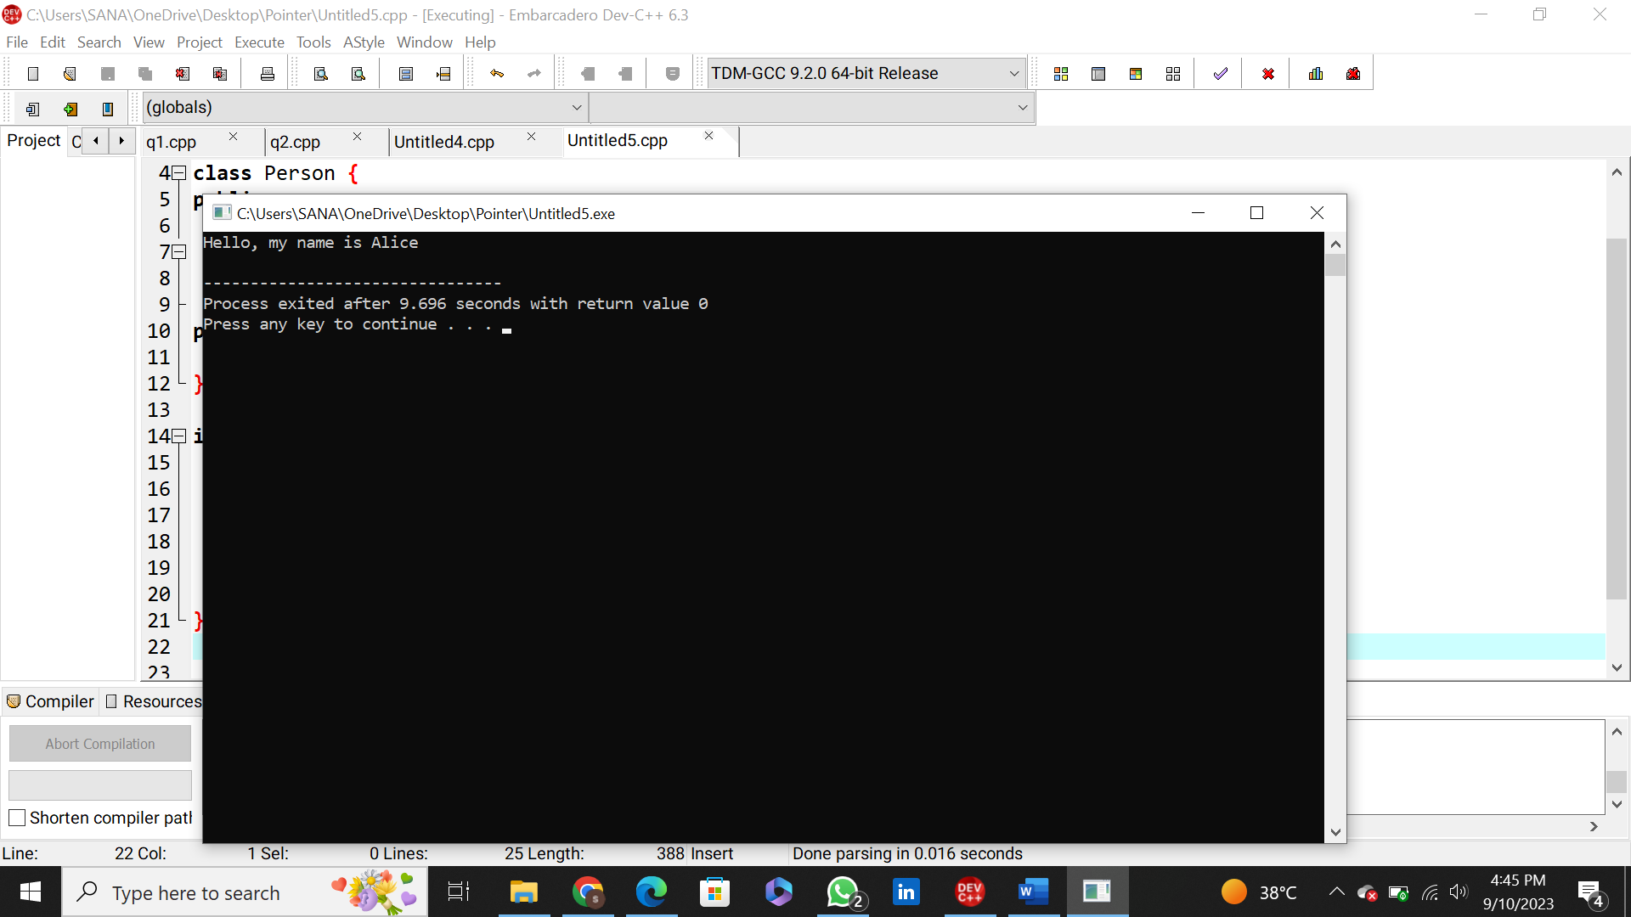

**Problem: 14**

#include <iostream>

class MyClass {

public:

int data = 42;

void printData() {

std::cout << "Data: " << data << std::endl;

}

};

int main() {

MyClass obj;

MyClass* ptr = &obj;

ptr->data = 55;

ptr->printData();

return 0;

}

**Output:**

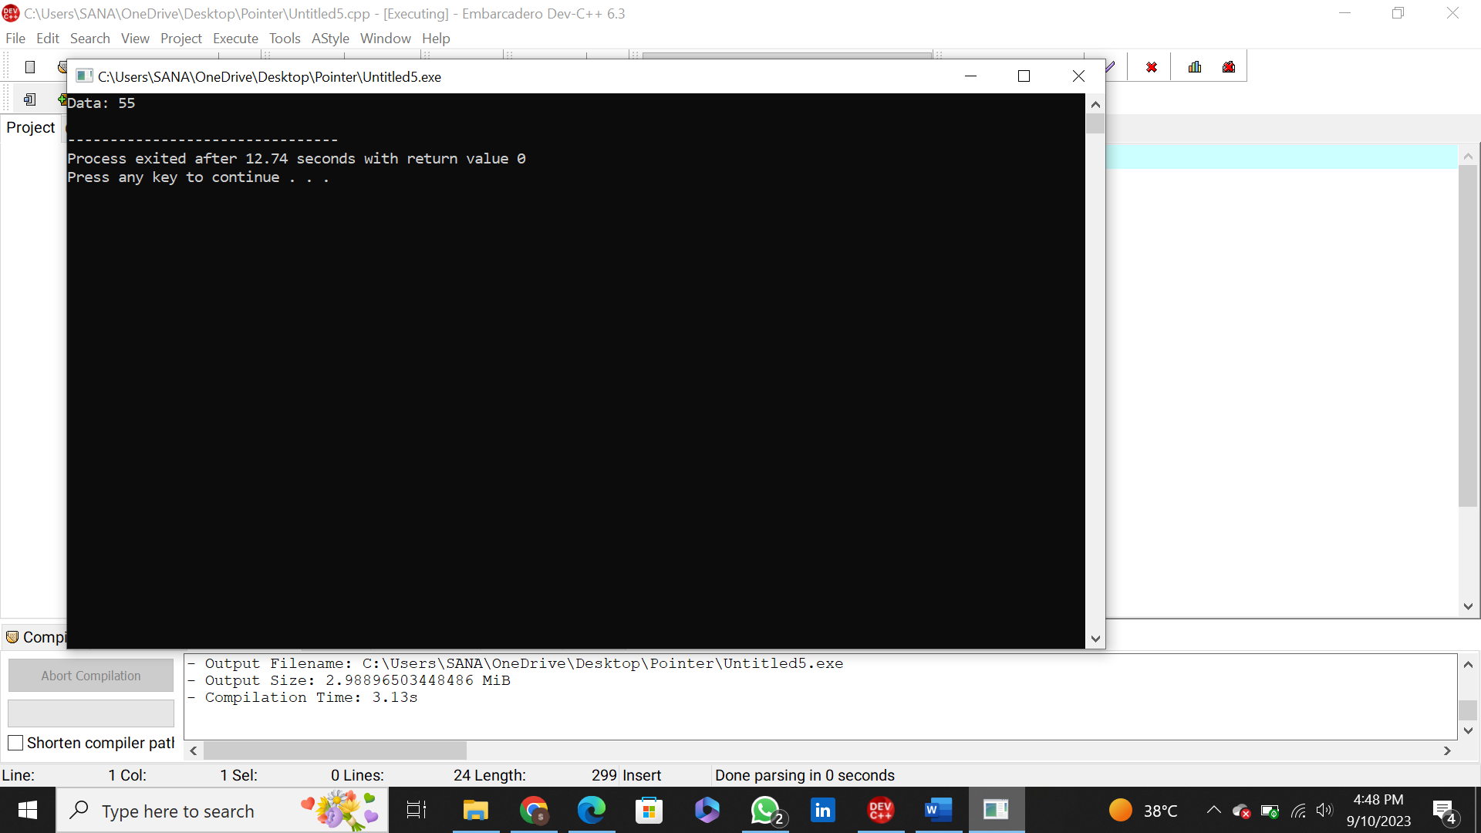

**Problem: 15**

#include <iostream>

class Base {

public:

virtual void show() {

std::cout << "This is the Base class." << std::endl;

}

};

class Derived : public Base {

public:

void show() override {

std::cout << "This is the Derived class." << std::endl;

}

};

int main() {

Base baseObj;

Derived derivedObj;

**Output:**

