**Project Title**

Leader Board Game

**Authors**

Sana’ Hamed 1122162

Haya AboDoha 1120454

**Abstract**

Coffee Runner Game is running on mobile. It has a multiple phases and each phase has multiple levels. This game requires to store data about users such as points ,Bos Name, level,… in web services , those data can’t store in database because the size of application will be increased.

**Proposed Architecture**

My system will consist of **five** *service providers.* The first provider hosts **m** *Web services.* Fig1 shows how the services interact with the clients. Below is a description of each entity in the system:

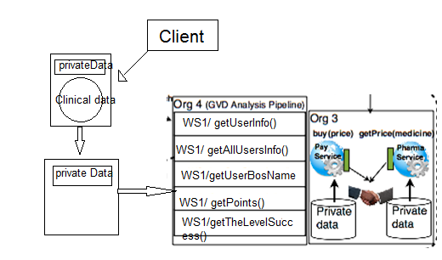

**Private Data : UserName, Passward, BosName, Phase,Level,Points**

**Client**

My client will be a Mobile application that invokes service operations.

**Service Providers**

Service provider 1 will host two services

Service 1: read the data about user from database and show in map.

Service 2: will read data from a (database) data repository, then parse the retrieved data and show all result for all users register on game.

Service3: read who has the BosName

Servise4: read who has most Points.

Service5: read all level finished for each user.

**Enabling Technologies**

**Client**

**Programming language : C#**

**Service provider**

**implementation style (REST/SOAP) : implement with REST style.**

**programming language: Java**

**Web Server : Leader Board.**

**data layer :** database