Linux Basics Assignment
Name: Sana Ali
Date: 28 October 2026
GitHub repository URL: https://github.com/sanaali1307-cell/Linux_Basics_Sana

1. Creating and Renaming Files / Directories
Objective: Create test_dir, make an empty file, and rename it.

Commands used
mkdir test_dir
touch test_dir/example.txt
mv test_dir/example.txt test_dir/renamed_example.txt
ls -l test_dir

Explanation
>>Created a new directory named (test_dir) using – mkdir.
>>Created a new file named (example.txt) inside “test_dir” using – touch.
>>Renamed the file named (example.txt) using – mv.
>>Verified new filename using - ls -l.
Output: The terminal shows renamed_example.txt with a size of 0 bytes.
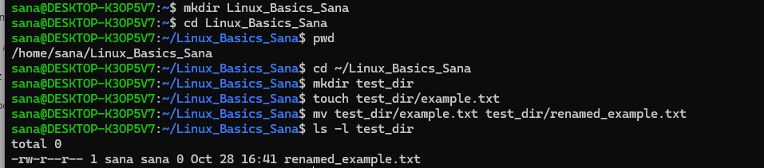

2. Viewing File Contents

Commands used
cat /etc/passwd
head -n 5 /etc/passwd
tail -n 5 /etc/passwd

Explanation
>>To view the contents of the file used – cat.
>>Used to view first five lines – head -n 5.
>> Used to view first five lines – tail -n 5.
Output: The terminal shows the complete list followed by first five lines and last five lines.
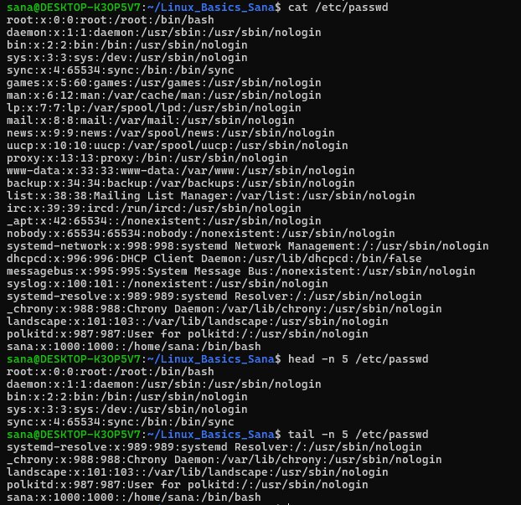

3. Searching for Patterns

Commands used
grep "root" /etc/passwd

Explanation
>>Used to search the word ‘root’ – grep.
Output: root:x:0:0:root:/root:/bin/bash.
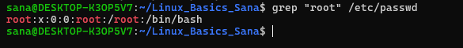

4. Zipping and Unzipping

Commands used
zip -r test_dir.zip test_dir
mkdir unzipped_dir
unzip test_dir.zip -d unzipped_dir
ls -R unzipped_dir

Explanation
>>Used to zip a folder along with all its contents – zip -r.
>>Used to extract the zipped files into a specific folder – unzip -d.
>>Used to view all files and subfolders inside the extracted folder – ls -R.
Output: The extracted unzipped_dir/test_dir/renamed_example.txt appears in the recursive listing.
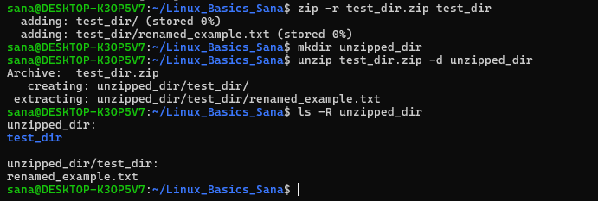

5. Downloading Files

Commands used
(Tried using wget -o sample.txt https://example.com/sample.txt but it did not seemed correct so used below command instead)
wget -O sample.txt https://www.rfc-editor.org/rfc/rfc1149.txt
ls -lh sample.txt
head -n 5 sample.txt
wc -c sample.txt

Explanation
>>Used to download a file from a URL and save it with a specific name – wget -O.
>>Used to check if the downloaded file exists – ls.
>>Used to view the first few lines of the downloaded file – head.
>>Used to check the size of the downloaded file in bytes – wc -c.
Output: Sample.txt downloaded and saved successfully with 3,215 bytes. Its first five lines were blank.
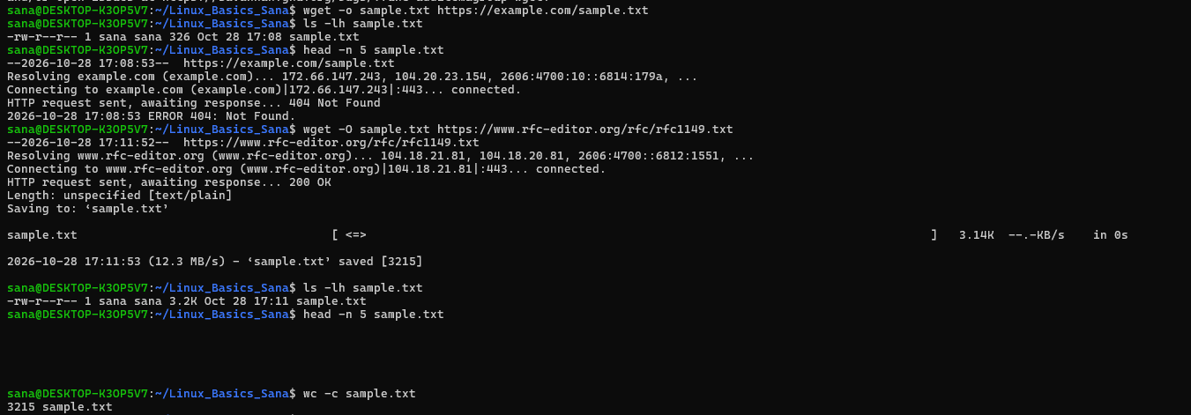

6. Changing Permissions

Commands used
touch secure.txt
ls -l secure.txt
chmod 444 secure.txt
ls -l secure.txt

Explanation
>>Used to give read-only permission to the owner, group, and others – chmod 444.
Output: The permissions changed from -rw-r--r-- to -r--r--r--.
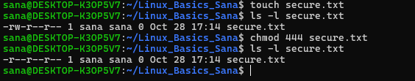

7. Working with Environment Variables

Commands executed
export MY_VAR="Hello, Linux!"
echo "$MY_VAR"
printenv MY_VAR

Explanation
>>Used to set an environment variable – export.
>>Used to display the value of the variable – echo.
>>Used to check if the variable has been exported – printenv.
Output: Both echo and printenv displayed Hello, Linux!.
