Gridbound: Ashes of the Bell

Target GDD and next-production plan — R1
7 September 2026 · Direct Astra session · Documentation only
R1 is a design revision, not an application version or completed feature release. Includes story/world bible, three-mode systems, economies, five-stat hero design, Ultra catalog, profile/save integrity, UI/icon direction, architecture and gated milestones. Read D1–D8 before coding.
Illustrations are original documentation concepts. Mermaid graphs were rendered from editable sources. No reference-game assets are embedded.

Contents
- Gridbound R1 — game direction & target GDD
- Target GDD — Gridbound: Ashes of the Bell
- Riset referensi — arah game R1
- Story bible — Ashes of the Bell
- Mode specification — Story dungeon, Roguelike, Raid
- Economy, crafting & challenge relics
- Lima atribut, unique character kits & advancement
- Ultra skills — target catalog & unlock contract
- Save, Load & mode-profile architecture
- Game UI, skill-tree graph & icon direction
- Technical production blueprint
- Next production R1 — gated execution plan
- Request coverage — R1 design vs existing runtime
- Editable diagrams — R1 target, not implemented
- Validation scope — R1 documentation

Gridbound R1 — game direction & target GDD
Status: DESIGN DRAFT / DOCUMENTATION ONLY. R1 adalah revisi arah desain, bukan versi aplikasi. Ditulis 7 September 2026 berdasarkan source main commit 7aced0b. Merge source sebelumnya terbukti; deployment Hostinger aktual belum diverifikasi. Tidak ada implementasi, perubahan runtime, save, build configuration, commit atau push dalam pekerjaan dokumentasi R1 ini.

Baca berurutan
1. GDD target [GDD-TARGET.md] — game promise, title/menu, batas mode, scope dan keputusan.
2. Riset referensi [RESEARCH.md] — lima game, bukti, yang diadaptasi dan yang ditolak.
3. Story bible [STORY-BIBLE.md] — prologue, world rules, act/chapter, payoff dan original sample script.
4. Mode design [MODE-SYSTEMS.md] — Roguelike 3 hero, Raid 1–6, Story dungeon tanpa shop/upgrade.
5. Economy & crafting [ECONOMY.md] — Gold/material Story, Crystal Challenge, merchant dan anti-duplicate ledger.
6. Character/combat spec [CHARACTERS-COMBAT.md] — STR DEF INT DEX WIS, formulas, unique heroes/classes/skills.
7. Ultra catalog [ULTRA-CATALOG.md] — starter Ultra + signature catalog, unlock, coefficients dan safeguards.
8. UX/skill-tree/icon spec [UX-ART.md] — world map, focused screens, graph routing, spacing, icon language.
9. Save/profile architecture [SAVE-PROFILES.md] — per-mode Load/Save, shared Challenge economy, migration/rollback.
10. Technical blueprint [TECHNICAL-PLAN.md] — proposed module boundaries, command contracts dan test-only Balance Lab.
11. Next production R1 [NEXT-PRODUCTION-R1.md] — dependency milestones, content budget, acceptance/risks.
12. Request traceability [REQUEST-TRACEABILITY.md] — setiap permintaan dipetakan, current vs target.
13. Editable diagrams & design boards [DIAGRAMS.md] — Mermaid + offline HTML/SVG, bukan UI game yang bekerja.
14. Validation record [VALIDATION.md] — pemeriksaan dokumentasi, bukan hasil playtest atau runtime QA.
Full GDD gabungan [GRIDBOUND-R1-FULL-GDD.md] tersedia untuk baca/download satu dokumen; komponen di atas tetap sumber editorial.

Prinsip source of truth
- src/ dan data/database.json: implementasi v0.4.0 yang ada sekarang.
- Gridbound_GDD_GRID_RAID.md: GDD implemented yang digenerate dari runtime. Tidak diganti menjadi wish list R1.
- Paket ini: target baru, dengan semua angka ditandai sebagai seed balance atau content budget, belum diuji di game.
- Production masterplan sebelumnya [../PRODUCTION-MASTERPLAN.md]: process/release baseline. Untuk scope baru, baca R1 milestones [NEXT-PRODUCTION-R1.md]; M0–M7 lama bukan bukti target R1 selesai.
- GUI evidence sebelumnya [../GUI-VERIFIED.md]: bukti lama, tidak menguji title, profile slots, mode-specific economy atau lima atribut karena fitur tersebut belum diimplementasi.

Keputusan default yang masih perlu approval desain
ID | Rekomendasi rancangan | Mengapa
D1 | Crystal Raid + Rogue disimpan pada satu Commander profile; Story terisolasi | Progres lintas-mode sesuai permintaan tanpa menjual Story power
D2 | Crystal bank untuk meta-unlock; Crystal perjalanan untuk shop selama run; bank tidak boleh dibawa masuk | Run tetap menuntut pilihan, tidak bisa membeli kemenangan memakai tabungan Raid
D3 | Story roster 9, aktif 3 pada prologue lalu maksimum 6; bench mendapat catch-up | Selaras Raid 1–6, masih memberi ruang reposisi grid; mengubah baseline 9 hero aktif, jadi perlu konfirmasi
D4 | Rogue tepat 3 recruit custom, job bebas dari 5 basic termasuk duplikat; job upgrade diperoleh di run | Kebebasan build tanpa membawa level/equipment Story
D5 | Rewarded Raid memakai boss/modifier tervalidasi; raw sliders masuk Sandbox tanpa Crystal | Customization tidak menjadi exploit hadiah
D6 | 3 Commander profiles; tiap mode 3 manual slot + 1 auto; satu run aktif per Challenge mode | Ganti profile tetap mudah, ekonomi tidak direwind oleh save lama
D7 | Story utamanya linear dengan pilihan konsekuensi kecil; satu ending utama dan epilogue flags | Cerita runut dan scope penulisan/test terkendali
D8 | Full target: 9 hero unik, 18 advanced + 18 third paths, 32 Ultra definitions; slice jauh lebih kecil | Luas tapi dipecah gate, bukan janji implementasi sekali jalan

User sudah mengarahkan tiga mode, title screen, economy split, stats, skill identity, Ultra unlockable, mode saves dan icon. Detail di D1–D8 adalah interpretasi yang direkomendasikan, bukan persetujuan implementasi.

Non-goals
Tidak ada account login wajib, cloud sync, online leaderboard, multiplayer, monetisasi Crystal, live-ops/FOMO, trade antar-player, procedural AI story, atau downloadable assets dari game referensi. Browser/static Hostinger tetap platform target; restart offline tanpa cache/service worker tidak dijanjikan.

Target GDD — Gridbound: Ashes of the Bell
Working title dipertahankan. Status seluruh target: proposal R1, belum implemented/accepted. Index & keputusan [README.md]. Referensi riset dan batas bukti [RESEARCH.md].

1. Pitch & player fantasy
Bangun party Bellkeeper, percepat aksi dengan tap terukur, baca niat musuh dan tentukan siapa yang dilindungi. Satu sistem combat mendukung kisah authored, run build yang berubah, serta boss lab yang bisa langsung dimainkan—masing-masing punya progression dan resource sendiri.
Rasa yang dicari: membuka sebuah game, bukan dashboard. Musik title, tombol Start yang jelas, world map sebagai rumah Story, brief pendek sebelum berangkat, kemenangan dengan ruang bernapas, dan progression yang dapat ditelusuri. “Premium casual” adalah target pengalaman, bukan klaim harga, polish atau hasil riset pasar.

2. Platform & controls
- Tetap browser desktop/mobile, Phaser + TypeScript + Vite; production static Hostinger, optional Node server.js. Tidak mengganti engine.
- Portrait-first mobile; desktop mengadaptasi komposisi, bukan memperbesar satu kolom panjang.
- Tap sprite → mengurangi cooldown dengan fatigue/cap; drag atau mode pindah → reposition; 2 equipped normal skills/hero; 1 equipped Ultra/hero.
- 5 atribut yang terlihat: STR, DEF, INT, DEX, WIS. Tidak ada level account tersembunyi yang menaikkan semua mode.
- Touch + mouse + keyboard; primary targets minimal 44 CSS px, fokus terlihat, safe areas. Dua sentuhan tidak boleh menjadi dua pembelian/dua Ultra.
- Pause/visibility loss membekukan combat dan timer ancaman; animasi title/motion optional. Background throttling bukan alat skip challenge.

3. First session flow
1. Load lokal → title artwork → PRESS START / TAP TO START, juga bisa Enter/Space. Tidak meminta login. Gesture Start boleh membuka audio sesuai pilihan, tidak memaksa fullscreen.
2. Title transition mengonsumsi pointer/key pemicu hingga release; tidak menekan menu di belakang.
3. Main Menu: Continue, Story Mode, Roguelike, Raid Boss, Profiles, Settings, Credits. Continue menampilkan mode/profile/checkpoint sebelum resume. Disabled Continue menjelaskan belum ada save.
4. Pilih mode → tampilkan Commander aktif dan mode slot. New, Load, Continue, Back selalu jelas; tidak menimpa slot hanya karena memilih New.
5. Story baru → prologue playable → Emberhollow/world map. Rogue baru → party 3 + relic/difficulty → node map. Raid baru → party 1–6 + boss/challenge → arena.
6. Semua mode tersedia dari menu; Story progress tidak wajib untuk mencoba Rogue/Raid. Spoiler boss/story assets disamarkan di Challenge sampai reveal opt-in atau milestone Story pada Commander itu.
7. Settings/credits/profile list adalah halaman sendiri. Tidak semua di bawah title.

4. Mode contract
Story active-party cap seed: 3 pada prologue; 4 setelah Ch02; 5 setelah Ch03; 6 setelah Ch04. Ini batas maksimum, bukan kewajiban membawa party penuh. Roster9 menyediakan pilihan bench, bukan9unit di arena. Cap dan recruitment checkpoint diuji terpisah.
Hal | Story Mode | Roguelike: Sunken Bell | Raid Boss: Echo Crucible
Tujuan | Menyelamatkan kota tanpa mengulang pengorbanannya | Menyelesaikan run dengan build hasil pilihan | Mengalahkan boss/ruleset pilihan
Party | 9 hero authored; aktif 3→6 usulan | Tepat 3 recruit, job bebas | 1–6 echo unit, build dapat diedit
Growth | XP, atribut, talent, unique class, equipment | Run levels, upgrade draft, shop, mastery node | Budget/preset ternormalisasi, unlock pilihan; tidak farming level hero
Resource | Gold + material + supply | Crystal perjalanan saat run; bank Crystal untuk meta | Bank Crystal dari rewarded contracts
Persists | Quest/story flags/hero progress/inventory | Relic library, job/Ultra unlock, bank; build run reset | Presets/bestiary/mastery/bank; encounter state reset
Map | World map region → chapter/dungeon | Branching node map 3 acts | Boss constellation/contract board
Kalah | Checkpoint, tidak permadeath | Run selesai, unbanked run currency hilang | Retry, tidak kehilangan permanent gear
Bisa shopping di run? | Tidak pada Story dungeon | Ya: temporary-only dengan Crystal perjalanan | Sebelum battle saja; unlock alternatif, bukan live power

Tidak saling mengalirkan Gold, material, XP atau stat. Rogue & Raid berbagi ChallengeWallet melalui Commander, tetapi slot run tidak memiliki salinan wallet yang dapat direwind.

5. Story world map & menu
World map menunjukkan satu region fokus dengan node main quest, side quest, material site, dungeon, town. Desktop boleh overview lalu zoom region; mobile memakai tombol region, bukan scrolling canvas tanpa batas.
Node click → panel brief khusus: nama, tujuan, cerita singkat, lawan diketahui, reward/material, recommended level, party, status save. Depart membutuhkan konfirmasi, bukan akibat tap peta.
Game Menu membuka: Party, Quests, Skills, Inventory, Status, Forge, Journal, Save/Load, Settings, Return to Title. Party memuat hero → Overview/Attributes/Gear/Skills/Advancement/Ultra. Skills dari game menu membuka hero terakhir; tidak menggandakan data.
Map mengikuti progression; replay chapter diberi label memory/expedition, tidak mengulang recruitment atau canonical ending. Peta challenge terpisah dari Story canon.

6. Combat identity
Pertahankan grid, intent, Guard/interrupt, cooldown/tap dan reposition dari baseline. Keterbacaan lebih penting dari menggandakan animasi. Lima stats menghasilkan mekanik yang terukur; skill berbasis dua atribut dapat membangun hybrid tanpa satu atribut mendominasi semua tugas.
Setiap action mempunyai source, target, coefficient, damage type, cooldown/charge, cap, status stacking dan icon ID. Primary skills berbeda dari Ultra. Definisi combat [CHARACTERS-COMBAT.md] dan Ultra [ULTRA-CATALOG.md] adalah target, bukan penggantian source otomatis.
Hasil: status terminal → block combat input → death visual bounded (victory) → layar hasil → minimal 1000ms lock setelah tampil → satu action baru setelah gesture lama dilepas. Reward settlement idempotent pada checkpoint/terminal transaction, tidak bergantung klik berulang. Retrying tidak membayar lagi.

7. Progression layers
1. Hero Story: level/allocated attributes/gear/unique talents/job quests/Ultra.
2. Story town: recipes, known material routes, optional dungeons dan journal.
3. Rogue run: 3-unit temporary build, rank/mastery, relics ditemukan, run purse, route choices.
4. Challenge meta: bank Crystal, challenge relic unlock, class/Ultra alternatives, presets. Bukan unlimited stat boost.
5. Raid encounter: frozen config and party, score/first-clear/bestiary mastery; victory receipt satu kali.
6. Commander profile: menampung sub-save tiga mode dan ChallengeWallet, bukan global transfer antar-Commander.

8. Full target & content budget, bukan janji rilis sekaligus
- Title/Main Menu/Profile Hub, Story world map, Rogue route map, Raid board.
- Story: playable prologue + 4 acts/16 chapter + epilogue; baseline 76 encounters dipertahankan sebagai inventory awal, bukan final count setelah authoring pass.
- 9 hero dengan 2 signature normal skills, 2 advanced branches dan third continuation masing-masing; 36 promotion definitions target. Target dibangun bertahap.
- 32 Ultra definitions target: 5 class starters, 18 signatures, 9 capstones; bukan 32 tombol di combat.
- Rogue content target: 3 biomes/acts, 30 upgrades, 12 events, 6 elite contracts, 9 camp recipes, 12 challenge relics; seed values belum tuned.
- Raid initial fully validated bosses 4 lalu 12 base archetypes. 8 authored modifiers awal; recolors bukan boss original tambahan.
- Story farming: 4 region material families + shared iron/cloth; 4 authored challenge dungeons; 12 multi-choice dungeon events target.
- Tidak wajib menambah musuh demi angka sebelum mode-loop lulus.

9. Vertical slice yang harus lulus dulu
Title → one Commander → mode slot → Story prologue dengan 3 hero; satu material dungeon; satu Rogue act dengan 3 hero dan node Shop/Event/Upgrade/Boss; satu Raid boss untuk party 1/3/6; dua challenge relic; save/import/suspend/settle. Hanya 1 advanced branch per hero slice, 5 class starter Ultra + 3 signatures. Scope diperluas setelah bukti loop/ekonomi/UI tidak rusak.

10. Art, sound, monetization boundaries
Forest emerald/brass pixel art dipertahankan. Title art, region maps, icons dan SFX original/local; semua aset berlisensi tercatat. No CDN requirement. Portrait narration bernada hangat/melankolis, tidak voice acting full sebagai gate.
Crystal adalah currency earnable lokal, bukan premium paid currency. Tidak ada ads, gacha, battle pass, IAP, stamina timer. Title premium casual tidak memberi izin monetisasi. UX art dan icon [UX-ART.md].

11. Core risks
Scope membesar menjadi tiga progression system; UI saja tidak cukup. Shared wallet + manual save menciptakan dupe/rewind risks; normalisasi build migration bukan copy/paste gear. Party 1 membutuhkan tank/heal counter tanpa memaksa job tertentu. Formula stats dan banyak Ultra rawan proc loop. Cerita tentang masa depan yang dicuri harus punya aturan agar twist tidak terasa sewenang-wenang.
Semua diturunkan menjadi testable gates di production R1 [NEXT-PRODUCTION-R1.md]. Full production berarti scope disetujui, dites, ada rollback dan remote verification—bukan dokumen panjang saja.

Riset referensi — arah game R1
Riset dokumen publik, bukan hands-on playtest. Diakses 7 September 2026. Halaman store berisi deskripsi penerbit: memadai untuk memahami mekanik yang mereka nyatakan, bukan bukti semua build seimbang, pemain menyukainya, atau game Gridbound akan berhasil.

Ringkasan
Gridbound memerlukan tiga loop yang berbeda, bukan tiga tombol ke progression yang sama. Referensi memberi pola: build berubah sepanjang run, pilihan rute berisiko, telegraph yang dapat dibaca, karakter dengan identitas, dan persiapan ekspedisi. Adaptasi di bawah adalah kesimpulan desain kita, bukan pernyataan penerbit tentang Gridbound.
Referensi | Fakta yang ditemukan | Adaptasi untuk Gridbound (usulan) | Yang tidak diambil
Hades | Escape attempts membuka cerita, Boons mengubah kemampuan, dan Mirror of Night memberi perkembangan permanen.[1] | Upgrade run dipisahkan dari unlock antar-run. Lore kecil kembali ke hub, tetapi kisah utama tidak dikunci di balik grinding Roguelike. | Mythology, dialog, aset, atau asumsi permanent raw-power grind harus menjadi inti semua mode.
Slay the Spire | Rute berubah, pemain memilih jalan aman/berisiko, interaksi relic memengaruhi build; custom mode memiliki run modifiers.[2] | Peta node Roguelike, preview risiko, pilihan upgrade dengan synergy; challenge relic mengubah aturan. | Card combat, daftar kartu/relic, nama event atau layout persis.
Into the Breach | Serangan musuh ditelegrafkan; upgrade senjata/pilot muncul sepanjang tantangan.[3] | Pertahankan intent terlihat pada combat Gridbound; mutator dilarang menghapus semua telegraph. | Mengganti game menjadi turn-based, atau mengklaim UI kita sudah terbaca karena memakai grid.
Octopath Traveler II | Traveler mempunyai asal/motivasi/skill unik; pengembangan jobs/skills dan latent power unik per traveler disebut eksplisit.[4] | Identitas Aldric berbeda dari Bran walau sama-sama Warrior; unique advancement dan Ultra per karakter. | Delapan traveler, dunia Solistia, sistem Break/Boost persis, atau tuntutan HD-2D mahal.
Darkest Dungeon | Merekrut, melatih dan memimpin party ke dungeon, dengan persiapan/pemulihan di town, risiko stress dan permadeath.[5] | Story dungeon memakai party persisten dan pilihan resource sebelum/saat ekspedisi. | Permadeath hero Story, stress spiral, hukuman farming yang bertentangan dengan casual premium.

Sintesis: hal yang cocok dan yang bertentangan
Hades dan Slay the Spire sama-sama menempatkan variasi di dalam percobaan/run, tetapi deskripsi Hades juga menekankan permanent upgrades, sedangkan Slay the Spire menyoroti deck/relic di tiap attempt.[1][2] Keputusan R1: meta Challenge terutama membuka alternatif dan tingkat tantangan; bukan multiplier stat permanen yang wajib digrind.
Darkest Dungeon menjual ekspedisi penuh attrition/stress/permadeath, sementara Gridbound diminta casual, beberapa profile, serta Story yang runut.[5] Keputusan R1: attrition hanya pada ekspedisi; kekalahan Story tidak menghapus karakter, ending atau slot save.
Telegraph eksplisit Into the Breach dan latent power unik Octopath memberi dua arah yang saling melengkapi: informasi musuh jelas, tetapi respons pemain bervariasi.[3][4] Keputusan R1: challenge berarti pola/tujuan berubah, bukan tooltip menghilang atau stat seragam membesar.

Batas riset
- Web search dan web_extract gagal 403 pada backend retrieval. Dilanjutkan dengan direct HTTPS GET terhadap halaman publik Steam; lima halaman mengembalikan HTTP 200 dan bagian About This Game benar-benar dibaca.
- Situs Subset langsung timeout; halaman Steam Into the Breach dipakai sebagai sumber alternatif resmi distribusi.
- Tidak login, tidak mengambil akun privat, tidak mengunduh aset game, tidak membeli game.
- Tidak mengutip angka harga/review/retention sebagai evidence desain; snapshot store dapat berubah.
- Detail ekonomi, jumlah party, formula damage, durasi run dan harga di dokumen R1 adalah rancangan kita. Bukan hasil reverse-engineering game referensi.
- Riset tidak membuktikan pacing, balance, fun, readability, accessibility atau performa. Itu tetap gate prototype dan human playtest.

Keputusan yang lahir dari riset
1. Title → mode → profile → hub/map; setiap mode menjelaskan persist/reset sebelum Start.
2. Story gold/material tidak berhubungan dengan Crystal Challenge.
3. Roguelike mempunyai node, toko, upgrade, event dan boss; bukan endless combat berulang dengan tiga opsi stat saja.
4. Story dungeon mempunyai rute/event/attrition tetapi tidak punya draft upgrade atau shop di dalam.
5. Raid rewarded memakai aturan tervalidasi; parameter bebas masuk Sandbox, tidak mencetak Crystal.
6. Membangun banyak Ultra tanpa identitas/kondisi unlock hanya menambah UI noise; R1 memakai katalog unik dan slot pilihan terbatas.

Evidence singkat
- Hades: “Permanent upgrades mean you don't have to be a god yourself to experience the exciting combat and gripping story.”[1]
- Slay the Spire: “Choose a risky or safe path, face different enemies, choose different cards, discover different relics, and even fight different bosses!”[2]
- Into the Breach: “All enemy attacks are telegraphed in minimalistic, turn-based combat.”[3]
- Octopath II: “Each traveler possesses a unique latent power, which can be used to turn the tide of battle.”[4]
- Darkest Dungeon: “Recruit, train, and lead a team of flawed heroes through twisted forests, forgotten warrens, ruined crypts, and beyond.”[5]
Source IDs, URL dan kutipan didaftarkan serta diperiksa dengan ledger. Ledger lokal paket [research-ledger.json] menyimpan provenance; full halaman riset hanya di ignored artifacts/design-research/, bukan dibundel sebagai aset game.

Sources
[1] https://store.steampowered.com/app/1145360/Hades
[2] https://store.steampowered.com/app/646570/Slay_the_Spire
[3] https://store.steampowered.com/app/590380/Into_the_Breach
[4] https://store.steampowered.com/app/1971650/OCTOPATH_TRAVELER_II
[5] https://store.steampowered.com/app/262060/Darkest_Dungeon

Story bible — Ashes of the Bell
Original narrative proposal R1; mengembangkan cerita source, bukan mengklaim scene baru sudah playable. Spoiler penuh di dokumen ini. English judul pendek boleh dipertahankan, dialog utama Indonesian casual-literary. Tidak menyalin dialog/lore game riset.

1. Janji cerita
Emberhollow selamat karena loncengnya membuang rasa sakit warga ke hutan. Para Bellkeeper memulihkan segel untuk melindungi kota—lalu menemukan bahwa perlindungan itu mengonsumsi nama, ingatan, dan kemungkinan hari esok. Pertanyaan cerita bukan “siapa yang jahat?”, melainkan kapan menjaga seseorang berubah menjadi memilihkan hidupnya?
Aldric mulai sebagai pelindung yang mengejar solusi sempurna. Lyra menanyakan apakah kebaikan yang diciptakan tetap nyata. Sable menyimpan bukti agar persetujuan tidak dapat dihapus. Akhirnya kota belajar perlindungan yang dikerjakan bersama, bukan jaminan ajaib tanpa harga.

2. Dunia yang bisa dipahami sebelum twist

Tempat & kehidupan sehari-hari
- Emberhollow: kota persimpangan kayu/batu; sekolah, klinik, pasar, forge, ferry dan watchtower memberi alasan hidup yang konkret. Scene tidak hanya menjelaskan apocalypse.
- Ashwood / Blackbriar: hutan dan keep yang menyuplai resin, kayu, linen serta jalur pengungsi. Four seals adalah infrastruktur, bukan sekadar collectible.
- Glassmere: sungai/arsip/rumah perawatan; dokumen dan suara bergerak tidak sesuai pemilik. Material glass thread dari struktur, bukan mencuri ingatan manusia.
- Frostward: arsip dan orchard kemungkinan; pemain melihat masa depan yang gagal tanpa setiap hal dapat direwind seenaknya.
- Old Tower: machinery awal dan foundry; bentuk kota lama menjelaskan siapa membangun sistem dan kenapa.

Faksi & kepentingan
Faksi | Yang diinginkan | Konflik manusiawi | Wajah
Bellkeepers | Warga selamat | Terlatih memperbaiki sistem, bukan mempertanyakannya | Aldric/Bran
Ledger Keepers | Nama dan kontrak tetap tercatat | Bukti dapat melukai orang yang ingin lupa | Sable/Nyx
Hearth Cooperative | Obat, jalan, pangan tanpa korban tersembunyi | Butuh tenaga dan waktu, bukan satu boss kill | Mira/Kestrel
Choir custodians | Mengurangi penderitaan melalui mesin | Menganggap izin masa lalu berlaku selamanya | Mayor/Morrow caretaker
Echoes | Diakui sebagai akibat manusia, bukan hama | Ada yang berbahaya; memahami bukan berarti membiarkan menyerang | Lyra/Vharok/Elian

Nama baru Morrow hanya usulan identitas caretaker antagonis pendukung; tidak mengganti twist Old Aldric. Mayor Maren punya keputusan salah dan alasan jelas, bukan pelaku final yang diganti mendadak.

Aturan supernatural (tidak boleh dilanggar demi twist)
1. Bell memindahkan ingatan/kemungkinan, tidak menciptakan matter atau currency dari nol.
2. Resonance dapat meniru suara/tingkah laku yang tersimpan; tidak tahu pilihan baru sebelum dibuat.
3. Setiap loop perlu renewal contract dan mengonsumsi kemungkinan. Warga lupa pernah menyetujuinya; itulah sumber consent problem.
4. Echo bisa menjadi pribadi melalui keputusan barunya. Lyra bukan otomatis “palsu”; Eda tidak wajib menjadi Elian yang diproyeksikan Aldric.
5. Physical ledger, ukiran copper, luka dan benih adalah jejak yang kadang bertahan—tetapi tidak kebal universal. Tunjukkan mekanismenya sebelum menjadi solusi.
6. Mematikan mesin tidak mengembalikan orang, rumah atau waktu yang hilang secara ajaib. Ending menyelesaikan konflik, bukan membatalkan seluruh biaya.
7. Roguelike/Raid memakai Echo rehearsal chamber: tantangan non-kanonis, tidak membuka loop timeline Story lagi setelah ending. Replay campaign diberi label replay/memory; ending tidak dipanen ulang.

3. Prologue playable — A Bell Before Breakfast
Target 8–12 menit *untested*; story cards maksimal 2–4 kalimat per beat, dapat advance/skip dan dibaca ulang di journal. Tidak ada lore wall sebelum pemain mengendalikan hero.
Beat | Scene | Aksi pemain / sistem diajarkan | Informasi cerita / hook
P0.1 | Pagi di sekolah | Press Start; pilih profile; satu optional audio gesture | Seventeen hooks untuk tas, hanya tiga tas terlihat; jangan jelaskan misteri
P0.2 | Latihan halaman | Tap Aldric 3 kali, switch guard skill; telegraph pertama pelan | Melindungi berbeda dari menyerang lebih cepat
P0.3 | Klinik/gerbang | Lyra heal, Rowan pilih lane, party3 | Kenal warga dan pekerjaan mereka sebelum bahaya
P0.4 | Jembatan runtuh | Pilih selamatkan cart obat atau bantu porter; keduanya berhasil dengan biaya berbeda | Agency kecil; choice flag memengaruhi ucapan Mira, tidak hard-lock ending
P0.5 | Serangan Ashfang | Mini-encounter; relocate, Guard; aman dari wipe tutorial pertama | Monster memakai potongan tali bel sekolah
P0.6 | Kembali ke town | Death → lock1s → hasil → first save cue | Sable belum pulang; broken arrow dan ledger tanpa nama
P0.7 | World map unlock | Klik Ashwood → mission brief → party/menu optional → Depart | Tujuan pertama sederhana: temukan scout, bukan “selamatkan seluruh realitas”

Sample script original (P0.4):
Mira: “Cart ini bawa obat. Porter itu juga perlu pulang.”

Aldric: “Kalau aku pegang jembatannya, kalian punya waktu?”

Rowan: “Sedikit. Cukup kalau lo berhenti cari cara yang sempurna.”

Pilihan A — Topang cart: butuh Guard tutorial, obat utuh; porter ditolong Rowan.

Pilihan B — Tarik porter: butuh reposition tutorial; satu peti obat hilang, Mira membuka supply pengganti tanpa menghukum pemain baru.

Lyra, setelah semua sampai: “Bukan tanpa kehilangan. Tapi kita tahu siapa yang belum sampai.”
P0 scene path wajib berakhir di objective yang sama. Tidak ada stat bonus permanen eksklusif yang membuat jawaban moral menjadi optimization puzzle.

4. Empat act / sixteen chapter spine
Chapter IDs existing dipertahankan; tambahan prologue/epilogue punya ID terpisah. Tabel adalah editorial design, bukan janji semua dialog ditulis final.
Ch | Judul / region | Tujuan terlihat | Reveal & seed | Perubahan world map / payoff
1 | Ashwood Trail | Rescue Sable/scouts | Segel pecah, monster mempertahankan label nama | Sable recruit; forge basic; SD01 material route
2 | Sunken Ruins | Temukan Orin/false voice | Echo meniru tetapi tidak memahami pertanyaan baru | Orin recruit; evidence notebook; party cap4; teaser Ultra trial (masih locked)
3 | Blackbriar Keep | Bebaskan Bran/Kestrel | Lonceng kecil non-mesin membantu evakuasi | Recruit; active party cap5; warning bahwa guard bukan possession
4 | Emerald Gate | Selamatkan Nyx/Mira/Vharok | Pemulihan seals membuat kota tenang terlalu cepat | Full roster9; active party cap6; advanced trials; Act I false victory
5 | The Empty Census | Temukan seventeen nama | Kursi sekolah, Elian, tulisan Aldric memberi consent | Glassmere region; ledger flags; meja sekolah payoff P0
6 | The Glass Ferry | Seberangi sungai arsip | Ongkos ingatan, lagu Rowan berpindah ke Echo | Ferry; SD02; kenali monster sebagai ingatan yang dibuang
7 | The Choir Ward | Selamatkan catatan/korban | Lyra adalah rasa bersalah yang diberi tubuh | Lyra companion turning point; heal bukan perintah
8 | The Thirteenth Stroke | Evakuasi saat bell menyerang | Memulihkan seals memperbaiki mesin; pernah ada loop | Matikan city repeater; warga mulai mengingat harga perlindungan
9 | Winter Ledger | Temukan heart/archive | Elian adalah kemungkinan masa depan yang ditukar | Frostward/SD03; sumber repeat/consent terjelaskan
10 | The Unborn Orchard | Ambil benih tanpa merusak jalan | Bukan rewind; memberi kemungkinan tumbuh baru | Third class quest gate; Rowan memilih masa depan orang lain
11 | Nine Funerals | Hadapi echo pilihan menyerah | Prediksi makam bukan kepastian; party sudah berubah | Nine companion beats converging, tidak battle UI 9 hero wajib
12 | The Last Rehearsal | Tolak perfect rescue loop | Old contract tidak bisa menebak pilihan baru | Repeater global putus; capstone trials eligible
13 | A City Without Bells | Jaga pekerjaan warga | Safety mundane: air, rute, klinik | Town map berubah; SD04; goal defend-time bukan HP-only
14 | The Borrowed Crown | Bertemu first Bellkeeper | Old Aldric menyimpan tujuan tetapi membuang alasannya | Serahkan kendali tanpa forced redemption
15 | A Name for Tomorrow | Lindungi benih & pilihan Elian | Ia memilih hidup biasa sebagai Eda | Escort objective, semua peran punya pekerjaan
16 | The Unwritten Dawn | Lepaskan Vharok, padamkan inti | Mesin mempertahankan dirinya; tidak ada perfect undo | Ending → epilogue → optional postgame map, bukan reset canon

Boss tetap harus membayar motif cerita: Vharok dibebaskan, bukan dibantai lalu hidup lagi tanpa alasan. UI battle “Victory / freed” bisa berbeda art death finish yang sekadar membuat enemy leave/fade. Mechanical death sequence berlaku, tetapi teks/FX disesuaikan boss rescue.

5. Foreshadow/payoff ledger
Seed | Ditanam | Reframed | Payoff
Seventeen hooks/chairs | P0 | Ch5 census | Ch13 memorial, tidak orang baru tiba-tiba
Aldric tally scratches | P0 portrait detail | Ch8 loop count | Ch14 old-self contrast
Copper names retain dents | Ch1 Sable | Ch6 ferry manifest | Ch15 nama Eda ditulis sendiri
Lyra tahu obat lama | P0 clinic | Ch7 origin | Epilogue klinik atas pilihannya sendiri
Rowan melody | P0 | Ch6 kehilangan, Ch10 biarkan tumbuh | Lagu baru untuk Eda, bukan restore murah
Small hand bell | Ch3 | Ch8 evacuation | Lunch bell ending
Book cannot model a new answer | Ch2 | Ch9 future records | Ch12 refuse identical contract

6. Character emotional arcs & quests
- Aldric: protector → controller guilt → consent. Companion quest mengembalikan shield milik orang lain; tidak memberi solusi moral dari damage stat.
- Bran: overprepared late arrival → menunggu/ditunggu. Quest memperbaiki bridge tanpa meninggalkan pekerja.
- Sable: thief → witness → public archive. Choices tentang bukti dan privasi warga.
- Rowan: memory keeper → sacrifice → pencipta lagu baru. Tidak semua loss dipulihkan.
- Lyra: doubt authenticity → memilih care → self-authored identity. Companion tidak memakai “buktikan manusia” meter.
- Kestrel: speed → koordinasi → civic signal. Trial Ultra tentang rescue timing.
- Nyx: names/forms → hidup bisa memilih bentuk → respect Eda. Ukiran penting untuk crafting/lore.
- Orin: forecast certainty → tolerate error → guide bukan oracle. Trial menghadapi seeded pattern yang berubah dengan pilihan.
- Mira: penolong kecil → organizer → kota punya kapasitas kolektif. Crafting/supply sebagai ekonomi masuk akal.
Companion beats selesai lewat expedition/trial/lore pilihan, bukan cuma capai level. Existing level-only quest bisa jadi prerequisite, tidak klaim seluruh arc sudah ditulis.

7. Ending & postgame
Ending utama satu: mesin berhenti, Eda memilih namanya, kota membangun perlindungan bersama. Epilogue optional 3 cards berdasarkan flags (sekolah, arsip, cooperative), tidak mengubah hak Eda atau memaksa grinding semua side quests.
Sample final exchange:
Eda: “Kalau aku nggak suka nama itu nanti?”
Aldric: “Kita sediakan papan baru.”
Lyra: “Yang lama nggak perlu dibakar.”
Postgame world map memberi material dungeons, companion remainder dan replay story. Rogue/Raid rehearsals dilabel non-kanonis. Ending receipt hanya sekali per Story slot, tidak first-clear farming lewat manual load.

8. Narrative implementation contract
- SceneDef: sceneId, prerequisite flags, participants (bisa bench portrait), beats, choices, effects allowlist, journal reveal, skipResult, completionId.
- Skip menerapkan outcome default yang terlihat, menandai scene read/skip, tidak memberi pilihan tersembunyi/reward lebih besar.
- Reload sebelum choice memulihkan state; sesudah choice tidak mengganti outcome/RNG. Pilihan Story yang mengubah flags ikut save slot, tidak memengaruhi ChallengeWallet.
- Dialogue fokus: ≤60 kata/card seed; menu Back/log untuk reread. Bukan auto-scroll subtitle yang membuat card tak dapat dibaca.
- English names konsisten, glossary lore in Indonesian; content warning themes memory/loss/grief; tidak gore gratuitous.

9. Acceptance
Pemain baru bisa menjelaskan siapa tiga starter, kenapa pergi ke Ashwood, apa fungsi bell sebelum Ch1. Ch8 reveal didukung minimal dua clues, Ch14 reveal tidak bertentangan timeline. Story finished tanpa memainkan Rogue/Raid, tanpa rare material grind wajib atau membaca codex opsional. Nine hero bios, recruitment IDs, chapter unlock dan dialogue participants divalidasi. Playtest comprehension belum dilakukan.

Mode specification — Story dungeon, Roguelike, Raid
Proposal R1. Semua reward/price/durasi angka awal untuk prototype, belum bukti balance. Ekonomi [ECONOMY.md], saves [SAVE-PROFILES.md].

A. Roguelike — Sunken Bell

A1. Pre-run build
- Pilih tepat 3 slot recruit. Setiap slot nama/avatar optional + salah satu 5 basic jobs; duplikat diizinkan dan tidak didiskon. Semua basic tersedia dari awal.
- Starting stat template/power budget sama untuk seluruh pemain pada ruleset. Pilih satu dari dua normal loadout starter per job, satu starter Ultra, dan formation. Tidak membawa hero level, gear, Gold/material atau talent Story.
- Challenge mastery hanya membuka skill/job alternatives, tidak gratis tambahan point budget. Full advanced class tidak dibawa sejak floor 1: pilih aspiration path, unlock mechanical promotion saat mastery node run.
- Pilih sampai 3 challenge relics dari library unlocked. Nol relic selalu valid. Preview perubahan aturan, risiko, reward eligibility dan incompatibility. Positive rules modifiers masuk Practice bila membuat kontrak reward lebih mudah.
- Start membuat runId, rulesetVersion, seed, configHash, frozen party, route/RNG state, ledger sequence; autosave node start. RNG seed bukan private key.

A2. Bentuk run
Usulan run lengkap: 3 acts. Setiap act memiliki 5 depth dengan 2 node alternatif tiap depth, lalu 1 act boss. Satu path berarti 6 node/act, 18 per run. Start/exit bukan node reward tambahan. Target durasi 20–35 menit adalah hipotesis, ukur human playtest; short-run slice 1 act.
Node wajib per act: sedikitnya 1 shop dan 1 recovery reachable sebelum boss; tidak ada rute wajib resource check tanpa fallback. Jalur mungkin menawarkan:
Node | Pilihan & hasil | Persist
Battle | Preview family/intent; victory Crystal perjalanan + draft 3 upgrade pilih 1 | Run saja
Elite | Optional pressure/objective lebih sulit; reward rare choice | Run saja + mastery receipt jika qualified
Workshop | Upgrade salah satu equipped skill atau replace satu; harga dalam Crystal perjalanan | Run saja
Merchant | Heal, purge downside, skill alternative, temporary relic; stock tersimpan saat entry | Run saja
Event | 2–3 opsi dengan risk/resource/stat preview dan Leave yang layak | State tersimpan sebelum resolve
Camp | Heal satu hero / restore party sedikit / class mastery; pilih satu | Run saja
Challenge | Objective ekstra, timer atau no-potion dengan minimum telegraph | Run reward/risk explicit
Boss | Multi-phase boss; act-clear bank reward tetap + next-act choice | Bank via receipt, build tetap sampai run akhir

Upgrade draft tidak selalu tambah angka: examples “shield berubah ke lane tetangga tetapi durasi lebih pendek”, “second hit hanya pada marked target”, “heal cleanses tetapi cooldown lebih lama”. Tidak memberi upgrade untuk skill/class yang tidak ada kecuali jelas sebagai replace. Reroll dibatasi 1 per draft dan dibayar Crystal perjalanan; autosave sebelum reveal mencegah reroll reload. Class/Ultra content availability berbeda dari equip: run-rank4/9 memberi pilihan advancement, rank6 memberi signature Ultra choice yang eligible, rank10 memberi capstone choice yang eligible. Tiap threshold memiliki satu inter-node milestone prompt di checkpoint berikutnya (fallback bila tidak ada mastery node), bukan node ekstra dengan reward dan bukan guaranteed membeli power dari bank. Pemain selalu boleh keep current build.

A3. Shop & choice examples
Harga seed: heal 12, purge debuff 18, upgrade rank 24, replace skill 20 Crystal perjalanan. Stock ditulis sekali per node; belum ada interest/farming idle. Bank Crystal tidak dapat menutup kekurangan purse.
Event RL-E01: The Unlit Ferry
- Bayar 10 perjalanan → lewati combat berikutnya, tanpa combat reward.
- Bawa lampu → next fight +1 summon wave, menang +18 perjalanan.
- Jalan kaki → tidak ada biaya/reward, next path normal.
RL-E02: Clockmaker's Bench
- Pinjam detik → satu skill cooldown -15% sepanjang run, setiap act boss memiliki extra telegraphed pulse.
- Kembalikan roda → restore 15% HP satu hero, tidak mengubah power.
- Lewati → baseline.
RL-E03: A Name on Copper
- STR/DEF route mengangkat peti → barrier next fight, lose potion.
- INT/WIS route membaca segel → preview dua node tersembunyi, tidak reward.
- DEX route bypass → skip elite; tidak menerima elite mastery.
- Stat check bersifat deterministic: check memakai satu recruit terpilih (STR+DEF pada orang yang sama, tidak menjumlah seluruh party). Bila semua gated opsi gagal, pilihan “Lewati / kembali ke route normal” selalu tersedia tanpa kehilangan slot/node. Threshold ditampilkan; bukan peluang palsu. RNG event jika dipakai menampilkan probabilitas dan state tersimpan.

A4. Death, retry, bank & suspend
Downed hero tetap bagian 3-unit run, bukan rekrut pengganti gratis. Revival di Camp terbatas 1/act dan dibayar/run tradeoff. Party wipe mengakhiri run; purse/temporary upgrades hilang. Bank yang sudah diberikan act boss tidak dicabut. Abandon sama, tidak membayar sisa purse. Final success memberikan reward kontrak tetap, bukan konversi purse.
Suspend di node boundary aman; force-close mid-fight memulihkan snapshot awal encounter yang sudah committed dengan seed sama. Tidak ada shop reroll baru. Manual load lama tidak memulihkan run terminal atau ledger lama; boleh Practice fork tanpa rewards.

B. Raid Boss — Echo Crucible

B1. Build now, fight now
Pilih party 1 sampai 6, job tiap slot, normal skills, Ultra, attributes allocation dan equipment template. Semua 5 basic jobs + serviceable base equipment tersedia; mastery membuka alternatif. Tidak perlu main Story.
Dua tab tegas:
1. Contracts (rewarded): author-validated boss tier, roster size normalized, certified modifier combos.
2. Sandbox: HP/damage/interval/sliders, preview semua skill, unit tetap1–6 dan slot2normal+1Ultra sesuai supported caps, practice spawn; banner NO CRYSTAL / NO MASTERY. Mengubah slider mentah mengubah mode sebelum Start, bukan diam-diam.
Contract customization: boss archetype, allowed variant tier, arena template, phase set, 0–3 challenge modifiers. Config frozen saat Start. Editing pending config tidak mengubah fight atau settlement yang sedang berjalan.

B2. Solo–6 scaling proposal
Enemy HP factor 1 + 0.65*(N-1); per-target damage awal tidak dikali N. Heal/barrier AoE skill budget dinormalisasi terhadap jumlah target. Jumlah simultaneous targets maksimum min(N, configuredTargets). Semua nilai wajib diuji roster 1/2/3/4/5/6 termasuk mono-class.
Solo: satu universal Guard/evade charge dan limited ration tersedia bagi semua jobs, bukan hanya healer. Tidak ada mechanic “dua hero wajib berdiri bersamaan”; multi-position objective memakai sequential pads pada N=1. Unavoidable all-grid harus punya universal counter, cooldown memenuhi worst-case frequency. Floor tick rate/timing minimum sama pada semua party sizes.

B3. Eight initial challenge modifiers
ID | Aturan | Risk points | Incompatibility / safety
RM01 Fractured Armor | Barrier efektif -25% | 1 | Tidak gabung forbidden-shield rule
RM02 Long Night | Potion limit -1, minimum 0 | 1 | Solo rations tetap memiliki minimum 1 untuk baseline eligible
RM03 Echo Pulse | Aftershock telegraphed setelah ritual | 2 | Minimum delay 1.5s; no overlap impossible
RM04 Hunting Choir | Weakest mark menyusul breath | 2 | Target preview, tidak instant
RM05 Restless Brood | Extra minion wave saat phase transition | 1 | Spawn cap dan no target lock obstruction
RM06 Narrow Paths | Satu tile temporary blocked bergilir | 1 | Minimal satu jalur aman; fixed center spawn cap
RM07 Patient Colossus | Boss HP +20%, windup +10% | 0 | Net harder belum terbukti: Practice sampai calibrated
RM08 Last Lantern | Optional secondary lantern objective | 2 | Gagal objective mengurangi bonus, tidak mendadak wipe

Risk points bukan otomatis multiplier. Hanya combos masuk allowlist calibration memperoleh bonus. Sandbox sliders, mutually impossible settings, over-budget gear atau edited imports menonaktifkan ranked-local reward eligibility. Ini bukan anti-cheat server.

B4. Reward & meta shop
Victory mengeluarkan contract receipt. Repeated legal runs boleh farming Crystal dengan effort wajar, tetapi receipt yang sama tidak pernah membayar dua kali. First-clear bonus per boss/tier/config family pada Commander, bukan per manual slot.
Crucible Exchange: unlock boss modifier, cosmetic banners, alternative loadout recipes/Ultra trials. Sunken Archive: unlock challenge relic rule cards, rogue mastery trials, cosmetic maps. Keduanya memakai bank Crystal yang sama dan badge “Shared Challenge Wallet”. Story tidak menerima manfaat stat.

C. Story challenge dungeon — Rootbound Expeditions
Ini bukan mode Rogue dengan shop disembunyikan. Masuk dari world map memakai current Story party, permanent level/gear/skills/Ultra dan supply yang dibeli/disiapkan di town. Party/loadout terkunci saat berangkat; tidak merekrut atau promosi di tengah.
- 1–6 active sesuai roster cap; prologue mulai 3. Dungeon routes 5 room + guardian seed untuk slice/full template.
- Room types: combat, fork, obstacle, lore choice, extraction/guardian. Tidak ada upgrade draft, merchant, workshop atau temporary relic power. Tidak ada latent upgrade UI yang hanya disabled.
- Event effects: resource trade, stat threshold memilih jalan, info/risk, heal dari supply, membuka rute, modifier ancaman berikutnya. Tidak permanent stat reward sampai expedition selesai.
- Material pouch unbanked sampai extraction. Checkpoint safety di designated room memungkinkan bank sebagian dengan aksi Return; memilih Return mengakhiri ekspedisi. Wipe kehilangan pouch yang belum bank, tidak inventory/material/gold lama, XP/hero/quest yang sudah disimpan.
- Gold reward/XP/material diterima saat extraction atau guardian terminal. No Crystal reward; no relic unlock; no story chapter claim ganda.

Dungeon contoh
ID | Region | Material target | Challenge khas
SD01 Charcoal Aqueduct | Ashwood | Ember resin / linen | pilih menahan banjir atau jalan lebih panjang
SD02 The Ledger Vault | Glassmere | Glass thread / ore | door rune dua-stat thresholds dengan alternate combat
SD03 Orchard Beneath Ice | Frostward | Pale sap / frost alloy | escort seed, optional dangerous harvest
SD04 Silent Foundry | Old Tower | Bellsteel / memory cloth | guardian part choice mengubah room akhir

SD-E01 Broken Winch: STR+DEF >=32 (seed) memindahkan puing tanpa fight; DEX>=20 mengambil jalur tali dengan 1 supply; pilih stairway selalu tersedia tetapi combat tambahan. Tidak menciptakan upgrade.
SD-E02 Glass Relief: bayar 1 bandage untuk bantu warga → lore + route intel; ambil ore dari reruntuhan → next fight guardian kuat; lewat → safe/no extra reward. Bukan morality meter palsu.
SD-E03 Last Harvest: pilih ambil 2 material ekstra dan guardian hazard aktif, atau ambil 1 guaranteed dan exit. Preview menjelaskan pouch/risiko hilang sebelum confirm.

D. Mode invariants / acceptance
- Party Rogue tidak bisa Start jika bukan 3; Raid valid N=1..6, di luar itu error friendly; Story obey active cap.
- Story dungeon route generator tidak pernah memilih upgrade/shop payload.
- Wrong-mode currencies dan item ids ditolak, termasuk melalui save import.
- Reload event/shop tidak reset RNG, stock, purchase receipt atau claim eligibility.
- Raid custom enemy configuration tidak mengambil reward rate dari field yang dapat diedit pemain.
- Semua normal jobs punya minimal satu viable counter untuk baseline solo Raid; testing simulations + human, bukan formula saja.
- Return to Title, switch profile, Suspend/Continue dan defeat tidak membuka dupe/softlock.

Economy, crafting & challenge relics
Proposal; semua jumlah adalah seed tuning, bukan economy yang sudah live. Mode definitions [MODE-SYSTEMS.md]. Tidak ada microtransaction, exchange uang, atau currency yang dapat diuangkan.

1. Currency ownership
Resource | Pemilik | Sumber | Sink | Tidak boleh
Gold | Story save slot | chapter, quest, replay, dungeon extraction | equipment purchase, craft fee, supply, respec | ditukar Crystal; membeli relic Challenge
Material | Story save slot inventory | targetable farming/dungeon, quest, dismantle bound gear | recipe, gear upgrade | diterima Rogue/Raid atau dijual ke Crystal
Bank Crystal | Commander ChallengeWallet | eligible Raid receipt; Rogue act/final clear receipt | relic rule unlock, alternative mastery/Ultra trials, cosmetics | transfer antar-Commander; langsung top-up purse run
Crystal perjalanan | satu Rogue run | room win/event/risk | run shop/heal/upgrade/reroll | carry ke run baru, konversi ke Gold, copy dari bank
Supplies | Story slot / carried expedition | Gold/recipe di town | healing, alternate route | auto-refill gratis lewat save reload

Dua scope Crystal tetap tema/currency yang sama, tetapi bukan saldo yang dapat dipindahkan: ikon Crystal isi solid = bank; Crystal outline dengan badge RUN = perjalanan. Setiap shop menyebut sumber saldo, apa yang persist/reset, dan tidak menampilkan saldo salah. Pemisahan ini keputusan rekomendasi D2, perlu approval sebelum coding.

2. Story economy loop
World map menunjukkan lokasi material yang diketahui, guaranteed drop dan risiko bonus. Siklus: pilih recipe → Pin materials → peta menyorot rute → dungeon/extraction → craft preview → confirm. Penggilingan material memberi pilihan, bukan syarat grinding langka untuk story boss mandatory.

Material catalog awal
ID | Material | Region & cara memperoleh | Fungsinya
MAT-IRON | Iron scrap | Jalur biasa/SD01 guaranteed | weapon/armor basic
MAT-LINEN | Field linen | Quest supply/SD01 | healer gear, bandage
MAT-RESIN | Ember resin | Ashwood branches/SD01 | fire/resistance craft
MAT-GLASS | Glass thread | Glassmere/SD02 | focus, precision
MAT-SAP | Pale sap | Frostward/SD03 | restoration
MAT-FROST | Frost alloy | Guardian SD03 | guard/slow resistance
MAT-BELL | Bellsteel | Old Tower/SD04 | late weapon/core
MAT-MEMORY | Memory cloth | SD04 side rescue/quest | signature equipment catalyst

Drop proposal dungeon: guaranteed target 2 per successful extraction, guardian +1, optional hazard +1. RNG cosmetic/bonus boleh ditambah tetapi required recipe tidak bergantung low-probability-only drop. Preview menampilkan pouch yang bisa hilang. Quest materials tidak dapat soft-lock jika dismantled: ada repeatable safe route.

Recipe examples (design IDs, tidak memakai existing IDs secara diam-diam)
Recipe ID | Hasil | Cost seed | Gate | Design purpose
RC-SHIELD | Watchman's Rim | 80 Gold +3 Iron +1 Resin | Ch1 | DEF/WIS barrier hybrid
RC-BOW | Ferry String | 110 Gold +2 Glass +2 Linen | Ch6 | DEX/STR precision
RC-STAFF | Mercy Reed | 100 Gold +2 Sap +2 Linen | Ch9; basic healer gear tetap tersedia sejak Ch1 | WIS/INT healing
RC-COAT | Orchard Coat | 180 Gold +3 Sap +2 Frost | Ch9 | physical survival tanpa tempo
RC-DAGGER | Copper Witness | 170 Gold +2 Bell +2 Glass | Ch13 | DEX utility + reveal
RC-SIGIL | A Name Kept | 200 Gold +2 Memory +1 Bell | companion quest | signature sidegrade, tidak ending requirement

Ferry String baru craftable Ch6 saat SD02 tersedia; Mercy Reed Ch9 saat SD03 terbuka. Recipe boleh muncul grey-preview lebih awal, tidak menjadi quest yang mustahil. Target data-authoring wajib memvalidasi material-route gate <= mandatory requirement gate.
Gear masih memakai Weapon/Armor/Charm. Upgrade +0 → +3 target cap: beda kecil dan satu perk pilih, bukan infinite stat slope. Upgrade preview merinci before/after semua affected stats, skill output examples dan set break. Unique template tidak di-dismantle tanpa warning; owned swap free, craft spends sekali. Respec stat points gratis di town saat tutorial dan setelah rebalance patch; biaya Gold kecil setelah itu optional, jangan memaksa farming untuk memperbaiki salah klik.

Anti-loop
- Dismantle mengembalikan paling banyak sebagian material yang benar-benar dibayar; zero Gold. Quest-granted/free copy memakai provenance refund=0.
- Tidak bisa craft→dismantle menghasilkan lebih dari input. Price/rounding floor satu kali, tidak rekursif set bonus.
- Pertama kali recipe dibuka bukan hadiah berulang dari membuka UI. Inventory full/blocked save membatalkan atomic transaction; tidak potong resource dahulu.
- Item quantity integer bounded; unknown ID, negative cost, NaN/Infinity, wrong-mode item ditolak.

3. Crystal bank reward model
Raid contract seed: reward = floor(Btier * (1 + bonusAllowed) * objectiveFactor).
- Tier base Btier: 12 / 18 / 26 Crystal untuk Bronze / Silver / Gold.
- bonusAllowed = min(0.60, 0.10 * validatedRiskPoints); hanya certified modifier combination. Unknown/unvalidated config → Practice, reward0. Risk points diberi cap sesudah compatibility checks.
- objectiveFactor: 1 untuk victory primary; optional objective success dapat menjadi bonus terpisah yang sudah masuk contract data. Jangan memberi failure payout dari abandon/retry. Prototype default tetap1.
- Reward tidak bertambah berdasarkan party size: HP/targets sudah diskalakan. Solo ditantang tetapi bukan payout eksploit.
- First clear per boss+tier memberi bonus base sekali. Duplicate/import/reload receipt tidak membayar ulang.
- Payout mengacu immutable contract record, bukan boss custom HP, client elapsed seconds, atau nilai reward dari imported save.
Rogue seed: clear act1 +6 bank, act2 +8, act3 +12; clear full run +10. Total base full success 36; wipe act2 setelah act1 mempertahankan6. Challenge relic certified memberi maximum +60% pada masing-masing payout (floor per receipt); tidak ada reward dari sekadar masuk/restart.
Tidak ada purse conversion. Ini menghapus strategi “jangan pernah belanja karena coin akhir jadi meta”. Crystal perjalanan yang tersisa diringkas di result sebagai unspent, lalu reset. Repeated legitimate runs masih boleh memberi Crystal; target effort/reward diuji pada boss termudah serta challenge combo tersulit. Tidak pakai daily cap/streak untuk menutup tuning yang jelek.

Harga meta seed & pacing hypothesis
Purchase | Cost seed | Yang dibuka
Basic challenge relic | 30 | Pilihan aturan tambahan, bukan +stat permanen
Advanced relic | 60 | Aturan gabungan setelah mastery trial
Alternative skill trial access | 24 | Trial unlock; bukan langsung upgrade menang
Ultra specialization trial | 48 | Unlock route yang dibatasi budget
Banner cosmetic | 20 | Tanpa reward multiplier

Contoh aritmetika, bukan measured pacing: tiga Bronze base wins menghasilkan36; satu basic relic30 menyisakan6. Satu Rogue full base run36 juga dapat membeli basic relic dan menyisakan6. Tradeoff unlock vs cosmetic jelas. Tidak ada “bagus” yang dibuktikan oleh angka ini tanpa waktu completion/playtest.

4. Challenge relic library — target 12
Relic library unlock permanen; memasang relic gratis, melepas gratis, hanya sebelum run. Stack maksimum3. Relic ditemukan di run dinamai Run Relic untuk membedakan rule card meta. R1 slice hanya CR01/CR02, full baru setelah calibration.
ID | Nama | Rules change | Seed risk | Guardrail
CR01 | Cracked Bell | Every act boss punya aftershock tambahan | 1 | telegraph tambahan ≥1.5s
CR02 | Narrow Lantern | Satu tile bergilir unavailable per elite | 1 | jalur aman & area party cukup
CR03 | Miser's Prism | Heal shop +25%, camp recovery +10% | 0 | benefit+cost; Practice sampai net-risk measured
CR04 | Restless Root | Extra minion wave tiap elite | 1 | cap minion/sprite/input
CR05 | Glass Bargain | Semua upgrade rare punya downside | 2 | three choices tetap legal
CR06 | Patient Hour | Skill base cooldown +10%, tap cap tetap | 1 | tidak mendorong tapping patologis
CR07 | Open Ledger | Event risiko/stock revealed, shop price +15% | 0 | insight modifier, bukan free reward
CR08 | Hollow Feast | Boss heal reduction debuff pada phase2 | 2 | cleanse/counter universal tersedia
CR09 | Last Watch | Guardian challenge objective tambahan | 2 | not instant fail/safe fallback
CR10 | Ashbound Purse | Start purse0, elite reward +10 | 0 | target baseline start20; higher net reward Practice sampai calibrated
CR11 | Twin Omens | Pattern order remix dengan preview | 1 | no simultaneous impossible patterns
CR12 | Unwritten Path | Dua event slots menjadi elite choice | 2 | mandatory camp/shop preserved

Unlocked tidak berarti equipped. UI menjelaskan rank/risk, change list dan unsupported combo. Relic yang memberi benefit tanpa net higher risk tidak membayar risk bonus. CR02 + crowded-arena modifier wajib generator compatibility validation.

5. Settlement ledger & fairness
Transaction fields target: txnId, ownerCommanderId, mode, runOrAttemptId, checkpointId, type, currencyScope, amount, sourceRuleId, configHash, revision, status. Commit wallet/unlock/receipt dalam satu local transaction. Claim button hanya acknowledgment/UI, bukan sumber kebenaran.
Crash sebelum transaction: retry valid. Crash sesudah commit sebelum dialog: receipt ditemukan, tampilkan hasil tanpa membayar ulang. Purchase transaction menyimpan inventory unlock dan pengurangan wallet atomik. Multi-tab writer lease dan revision compare mencegah overwrite. Save slot load bukan rollback wallet.
Batas jujur: semua ini konsistensi aplikasi offline, bukan tamper-proof economy. Pemilik browser dapat mengedit file/DB, menggandakan profile, atau memulihkan backup lama. Tidak ada kompetisi/leaderboard finansial; jangan mengklaim anti-cheat. Imported full Commander menjadi profile baru/provenance backup, tidak digabung additive ke wallet existing.

6. QA economy gates
- Enumerasi tiap recipe termasuk gates, required routes, dismantle loops, zero paid provenance.
- Simulasi minimum/maximum party, solo baseline job, repeated easiest boss; ukur Crystal per minute, lalu gunakan human playtime untuk menetapkan target—bukan hardcode multiplier dari asumsi.
- Initial Commander bank0 punya Rogue dan Raid playable; tidak wajib farm Story atau membeli relic.
- Ledger duplicate, negative/unknown currency, foreign Commander, old slot, crash points, two tabs, import ulang, quota exceeded harus test.
- Non-zero Rogue purse di ending/abandon tidak pernah masuk bank; only authored receipt. Shop tidak membaca Story Gold.

Lima atribut, unique character kits & advancement
Target design R1, bukan schema/rumus yang sedang dipakai game. Target GDD [GDD-TARGET.md]. Semua coefficient seed; keseimbangan harus diuji setelah combat adapter dibuat. Jangan menggabungkan multiplier level lama dengan formula baru secara otomatis.

1. Atribut & derived values
Stat | Fungsi utama | Fungsi sekunder | Batas anti-dominant-stat
STR | physical power, break/impact | sebagian HP, beberapa DEF hybrid attack | tidak mempercepat semua skill
DEF | physical mitigation, barrier | HP, shield-based offense | tidak menjadi kebal, reflect tidak mengisi charge
INT | magic damage, ritual strength | sebagian heal/control potency | tidak memotong telegraph musuh di bawah minimum
DEX | precision/physical hybrid, cooldown | capped critical chance | dua diminishing curves; crit tidak proc rekursif
WIS | heal, support/ward | magic mitigation, HP | tidak membesarkan semua damage sekaligus

Seed template Challenge level1 (budget60 total, angka bukan hasil balance):
Basic job | STR | DEF | INT | DEX | WIS
Warrior | 18 | 16 | 6 | 12 | 8
Rogue | 10 | 8 | 8 | 24 | 10
Archer | 14 | 10 | 8 | 20 | 8
Healer | 7 | 10 | 13 | 8 | 22
Wizard | 6 | 7 | 22 | 10 | 15

Story hero memakai class template dengan redistribusi ±4 personal tanpa mengubah total. Level Story cap40 tetap sebagai target, tetapi growth baru: 2 auto stat points sesuai job +2 discretionary per level. Total discretionary78 saat level40. All 5 allocations ditampilkan sebelum confirm; respec mengembalikan point budget tepat sekali. Base+growth+gear+buff ditampilkan terpisah. Suggested allocation bisa dipakai, tidak auto-spend tanpa persetujuan.
Rogue max run rank12 proposal; tiap rank-up memberi2auto+2discretionary seperti growth Story, sehingga budget non-gear104 pada rank12. Raid normalized level20 proposal memakai budget non-gear136:60base+38auto+38allocation; preview/reset bebas sebelum attempt. Tidak memakai level hero Story; gear templates membayar budget khusus yang sama untuk semua loadout. Job change tidak memperbanyak total points atau preserve buff dari class lama. Advanced mechanics bukan flat double stats.

Formula reference (deterministik; round hanya di output)
Untuk output nonnegative, round(x) berarti floor(x + 0.5); jangan memakai banker rounding pada satu platform dan half-up pada platform lain. Simpan intermediate dalam precision penuh sebelum cap dan rounding terakhir.
S = base + growth + allocated + gearFlat
S_effective = clamp(S * (1 + sum(statPctBuffs)), 1, 250)
HPmax = 180 + 8*STR + 10*DEF + 4*WIS
rawSkill = basePower + a*STR + b*DEF + c*INT + d*DEX + e*WIS
cooldown = max(1.2, baseCD * (1 - 0.25*DEX/(DEX+50)) * (1 - haste))
0 <= haste <= 0.20
critChance = min(0.20, 0.02 + 0.18*DEX/(DEX+60))
physicalMitigation = min(0.70, targetDEF/(targetDEF+100))
magicMitigation = min(0.60, (0.5*targetWIS)/(0.5*targetWIS+100))
rawHealExample = 10 + 0.85*WIS + 0.35*INT
rawBarrierExample = 12 + 0.65*DEF + 0.45*WIS
Damage pipeline: rawSkill → named additive modifiers (cap +100%) → crit1.4 if eligible → target mitigation → universal Guard factor (0.65 seed) → shield absorption → HP. Final damage half-up once sesuai round(x) di atas; damaging hit minimum1, immunity explicit. Critical per action not per decorative projectile; heals/barriers/DoT tidak crit default. Break window +20% damage masuk named additive cap, bukan separate multiplying chain. DOT applies mitigation sekali saat tick dan bersumber skill budget, tidak on-hit chain.
Area heal/barrier/offense menyebut total budget atau per target. Default budget shared across actual eligible targets, kecuali coefficient explicitly per-target kecil. Mengequip same team aura tidak stack; highest potency refresh capped duration. True damage bukan default balancing shortcut.
Normal cooldown progress dari tap tetap rate-capped dan fatigue; efek “-cooldown” tidak mengulang free cast pada frame sama. Time-control maksimum satu delay trigger/0.5s, total delay suatu intent <=25% base interval; windup yang sedang tampil tidak dipersingkat di bawah1.5s default contract minimum. Endgame raw stats boleh tinggi tetapi derivative cap, threats dan resource counters tetap meaningful.

Worked examples — arithmetic only
Contoh raw physical 18 + 1.6STR + 0.6DEX, target DEF20, tanpa crit/Guard/gear/buff. Tabel dihitung dengan script sesuai formula di atas, bukan DPS test. Heal adalah rawHealExample dan CD sebelum haste. Jangan memakai contoh physical ini sebagai default action semua job: Wizard/Healer memiliki skill coefficients lain.
Template | HP | Contoh physical raw | Setelah DEF20 | Heal contoh | CD dasar6s
Warrior | 516 | 54.0 | 45 | 19 | 5.7097s
Rogue | 380 | 48.4 | 40 | 21 | 5.5135s
Archer | 424 | 52.4 | 44 | 20 | 5.5714s
Healer | 424 | 34.0 | 28 | 33 | 5.7931s
Wizard | 358 | 33.6 | 28 | 30 | 5.7500s

Stat budget non-gear:StoryLv40=216, RogueRank12=104, RaidLv20=136. Ini total points, bukan power-equivalence antar-mode; encounter rulesets dituning terpisah.

2. Baseline vs target identity
Baseline ROSTER berisi Aldric/Bran Warrior; Sable/Nyx Rogue; Rowan/Kestrel Archer; Lyra/Mira Healer; Orin Wizard. Banyak skills/jobs shared by base class. Target: base common pool tetap ada, tetapi tiap named hero punya mechanic, 2 signature normal skills, 2 unique advancement routes, 2 signature Ultras dan1 capstone. Ini rewrite design bertahap, bukan klaim saat ini sudah unik.
Story identity tetap immutable: Aldric tidak diubah jadi Wizard hanya untuk farming optimal. Respec memilih route dalam karakter. Rogue/Raid custom unit memilih job bebas; optional Echo mentor lineage memilih satu named kit sesuai base job. Menambahkan lineage tidak menumpuk passives; satu lineage aktif, signature unlock via Challenge trial independen dari Story. Rogue memulai starter, mastery node membuka owned lineage option di dalam run. Raid dapat memakai unlocked lineage dalam equal build budget.

3. Personal kits — 18 signature normal actions target
Notation: P physical, M magic, H heal, B barrier; N active party count; coefficients action-total. Semua masih memakai 2 equipped normal slots, bukan semua skill menjadi tombol baru.
Hero / resource | Signature 1 (seed) | Signature 2 (seed) | Weakness / role difference
Aldric · Oath max3 dari protected ally hits | Keep the Line: B 16+.7DEF+.3WIS, shared lane, CD6; Oath+1 jika barrier benar-benar menyerap | Promise Cut: P 10+.7STR+.4DEF, CD5; spend Oath3 untuk break+20 | defensive counter, bukan fastest damage
Bran · Bastion max3 saat guard first impact | Spare Shield: B 12+.9DEF, ally lowest barrier, CD6.5; tidak overwrite shield lebih besar | Grounded Return: P 12+.45STR+.65DEF, CD6; +one taunt window3s | menahan/redistribute, lemah menghadapi magic tanpa WIS
Sable · Evidence max3 dari marking different intent families | Expose Receipt: P 8+.65DEX+.25INT, CD5; mark+10% damage4s, highest-only | Borrowed Opening: P 10+.7DEX+.25STR, CD4.5; spend3 Evidence untuk cleanse1 enemy buff | utility/debuff, tidak unlimited Gold steal
Rowan · Quarry satu enemy | Thread the Branch: P 12+.75DEX+.35STR, CD5, +break versus Quarry | Shelter Arrow: B 10+.45DEX+.5WIS, CD6; protect one ally in targeted lane | precision dengan support opportunity cost
Lyra · Mercy max3 dari effective heal, sekali/cast | Name the Wound: H 12+.9WIS+.3INT, CD5.5; weakest ally; spend3 Mercy cleanse1 | Living Chorus: H 10+.65WIS+.25INT dibagi3 tick party-total, CD8 | heal/cleanse, tidak damage aura universal
Kestrel · Cadence max3 dari planned relocation, per2s | Signal Step: B 10+.6DEX+.25WIS, CD5.5; one ally move penalty -0.3s next move | Crosswind Volley: P 12+.65DEX+.35STR, CD5; total split minions; spend3 cadence mark lane | mobility support, cap mencegah drag-spam
Nyx · Inscription max2 pada target berbeda | Copper Rune: M 10+.55INT+.55DEX, CD6; delayed hit after1s | Namekeeper's Knot: B 12+.5WIS+.4DEX, CD6.5; bind one debuff expiry extension only once | hybrid setup, burst perlu waktu
Orin · Forecast max2 dari interrupt successful | Uncertain Star: M 14+.95INT+.2WIS, CD7; choose lane before cast | Margin of Error: M 8+.6INT+.4WIS, CD8; interrupt interruptible ritual, cooldown if failed | control/burst, low HP, no perfect future dodge
Mira · Supply max3 first effective heals on different allies | Field Dressing: H 10+.7WIS+.3DEF, CD5.5; overheal tidak supply | Safe Passage: B 12+.6WIS+.4DEF, CD7; shared lane, spend3 Supply remove1 temporary blocked tile at safe phase | sustain/logistics, tidak menambah inventory supply permanen

Resource reset encounter kecuali mode contract explicitly permits carry; cannot gain from Ultra/reflect/duplicate proc. Resource gain icon hanya feedback, tidak extra sixth attribute.

4. Unique advancement — 18 routes +18 third continuations
Story advanced gate proposal: Lv8 + Ch4 clear + hero trial. Third: Lv20 + Ch10 clear + parent trial; companion capstone Ultra later Ch12+. Trials tersedia setelah hero direkrut dan tidak memerlukan Rogue/Raid. Dua routes mutually exclusive per hero; respec di town, learned alternate route tidak bertumpuk.
Rogue equivalent gate: run rank4/9 + mastery nodes; jika tidak menemui mastery pilihan, node act transition menawarkan fallback. Raid: mastery trial + normalized build budget; menu preview prerequisite jelas.
Hero | Advanced A → third A | Advanced B → third B | Branch mechanical choice
Aldric | Oathguard → Dawnbastion | Bell Duelist → Covenant Breaker | lane protection/Oath spending vs break-pressure/mark
Bran | Stonebearer → Last Rampart | Gate Marshal → Open Gate | personal absorb distribution vs party reposition window
Sable | Ledger Knife → Truthbinder | Night Broker → Unbought Shadow | expose/buff cleanse vs evasion/choice info, no economy multiplication
Rowan | Trail Warden → Greenwood Sentinel | Stringseer → Far-Horizon | Quarry+shelter vs charged weakpoint hits
Lyra | Mercy Cantor → Living Hymn | Echo Shepherd → Self-Named Saint | heal cadence vs cleanse/anti-echo control
Kestrel | Wind Courier → Skyrelay | Alarm Ranger → Stormcaller | movement windows vs precise mark/interrupt chains
Nyx | Runecarver → Namewright | Veil Artisan → Unmasked | hybrid delayed inscriptions vs defensive mirage, no untargetable loop
Orin | Star Scribe → Unwritten Sage | Rift Auditor → Horizon Keeper | forecast burst vs phase/rule-safe control
Mira | Hearth Medic → Common Dawn | Pathmaker → Refuge Architect | sustained recovery vs supply-efficient guard/route support

Each advanced adds1 signature normal action; third upgrades/replaces that action, does not add another equipped slot. Full design budget: 18 personal normals +18 advanced actions +18 third replacements =54 personal action records, plus existing shared pool for reuse. Exact normal-action coefficients for the 36 promotion actions are not authored yet; class names/mechanics above are directional, production milestone R7 owns full executable spec (R3 authors the slice subset). Jangan memasukkan dummy skills dan menghitungnya implemented.

5. Talent graph & specialization depth
Per hero template target26 nodes: 4 foundation, 6 hero-identity nodes, 6 routeA nodes, 6 routeB nodes, 4 Ultra/trial nodes. Only selected branch spent path active. Full library 9*26=234 positions, reuse node mechanics allowed but signature labels/effects character-specific. This is content budget, not new runtime count; baseline50 definitions unchanged.
Point budget intentionally tidak cukup untuk semua route sekaligus. AND prerequisites explicit; OR unlock uses typed anyOf, bukan ditarik dua arrows seolah AND. Levels/quest/point/gold conditions shown in node detail; unlocking skill ≠ automatically equip. Graph layout rules [UX-ART.md] are acceptance-critical.

6. Balance strategy & debug scene specification
Future Balance Lab local/test-only harness (not implemented): 5 equal-budget templates; each enemy intent can be forced, damage/heal/absorb/charge breakdown; visible coefficient source; seed replay; pause/single-step; dump report with mode/config. Build a 1/3/6 party matrix plus mono-job parties. Test same stat redistribution vs primary+secondary builds; no claim stat combinations are balanced before measurement.
Regression gates: zero/infinite stats rejected, respec refund once, class swap budget conserved, double-aura/cast/reflect loop forbidden, DPS vs survivability tradeoff, solo universal counter, UI damage preview matches simulation rounding, baseline legacy level multiplier removed in new ruleset only. Legacy ruleset can still load safely until user approves migration.

Ultra skills — target catalog & unlock contract
32 definitions usulan; belum ada di runtime. Source baseline simulation.ts memiliki satu shared ultimate() / Ninefold Dawn; UPGRADES berisi tiga upgrade lama dan bukan tiga Ultra berbeda. R1 menggantikan kebingungan itu dengan label serta catalog eksplisit. Jangan mengubah legacy save saat dokumentasi saja.

1. Input & activation contract
- Setiap hero memasang satu Ultra dari pilihan yang di-unlock, di luar 2 normal skills. Combat punya satu button Ultra berukuran nyaman → memilih caster/target → Confirm; bukan32 tombol sekaligus.
- Shared Resonance 0–100, start encounter0; tidak diisi dari idle tap, overheal, reflect, self-damage atau Ultra. Normal effective action memberi4 max sekali/hero/detik; successful Guard/interrupt memberi5; total seluruh sumber cap5/detik/team. Angka seed, perlu tempo testing.
- Semua Ultra biaya100, global lock6s, maksimum1 pemakaian per hero per encounter. Basic skill/equipment tidak bisa menghapus cap. Mengganti equipped Ultra di tengah combat dilarang. Stage baru adalah encounter baru hanya jika StageDef mengatakan demikian; wave spawning bukan reset cap.
- Cancel target picker tidak mengonsumsi charge. Confirm atomik: mode battle/status valid, caster alive, equipped/unlocked, target legal, charge dan per-encounter cap dicek lagi. Gesture membuka menu tidak bisa sekaligus Confirm.
- Tidak semua harus damage. Offensive Ultra biasanya single-target budget; area/shared defensive budget tidak linear meledak mengikuti N. Revive di bawah ini eksplisit limited, tidak standar semua heal.
- Animation0.4–0.9s, reduced-motion fade0.12s; tidak memakai white-screen flash. Simulation pause? Tidak pada cast; telegraph tetap readable dan damage/event timing eksplisit. Target picker boleh pause single-player dan replay state; picker tidak mengurangi enemy timer tanpa cost.
- Ultra tidak mengisi Ultra, tidak memicu on-cast Echo recursion, tidak menggandakan drop/Crystal. No invulnerability chain/perma interrupt.

2. Unlock semantics
Gate | Story | Roguelike | Raid
Starter | Tersedia saat basic job direkrut; prologue tutorial memakai one starter | Semua 5 tersedia saat build | Semua 5 tersedia saat build
Signature A/B | Hero Lv12 + relevant advanced branch/trial; branch B sama gate tanpa wajib punya A | Challenge lineage trial unlocked; run rank6/mastery node baru menawarkan equipped upgrade | Challenge lineage trial selesai + corresponding build route
Capstone C | Hero Lv28 + Ch12 clear + companion decision/trial | Lineage capstone trial unlocked + run rank10 final-act mastery node | Advanced challenge trial, budget/cap sama; tidak wajib main Story

Progress memisahkan content availability dan current equip eligibility. Membeli akses trial dengan Crystal tidak instant unlock. Trials punya deterministic objective yang dapat diulang, tanpa stamina/daily gating. No Story→Challenge raw-power transfer.
Notation: STR/DEF/INT/DEX/WIS milik caster. Semua formula action-total, sebelum common damage pipeline. B barrier total dibagi eligible allies; H heal total, dibagi sesuai target rule; durations/percent adalah seed. Biasa M magic, P physical. Semua status tunduk stacking/delay cap di combat [CHARACTERS-COMBAT.md].

3. Lima class starters
ID | Job / nama | Efek seed | Kondisi/counterweight | Icon concept
U-WAR | Warrior — Hold the Horizon | B 40+1.2DEF+.5STR, shared party; Guard window+2s | tidak heal, damage tetap bisa menembus setelah barrier habis | shield + horizon
U-ROG | Rogue — Open Secret | P 36+1.2DEX+.4INT; mark+10%6s | single target, same-type mark tidak stack | dagger + open eye
U-ARC | Archer — Guiding Comet | P 40+DEX+.7STR, split lane target | tidak auto-hit semua lane | bow + comet
U-HEA | Healer — Dawn Chorus | H 32+1.1WIS+.6INT, lowest-HP weighted | no revive, no overheal barrier default | bell + rising line
U-WIZ | Wizard — Falling Constellation | M 44+1.3INT+.3WIS, one target; splashes memakai budget yang sama | delayed1s, no infinite stagger | three stars + descending arc

4. Sembilan hero: dua signature dan satu capstone
ID | Hero / nama | Gate | Efek seed | Batas / identity | Icon concept
U-ALD-A | Aldric — A Promise Kept | A | B 44+1.3DEF+.4WIS, lane terancam; satu guaranteed intercept nonlethal hit | intercept hanya sekali, damage tidak hilang menjadi heal | shield + knot
U-ALD-B | Aldric — Break the Covenant | B | P 40+.9STR+.7DEF, boss break+25 | memakan semua Oath, no shield | cracked sword + seal
U-ALD-C | Aldric — No One Owes Tomorrow | C | B 60+DEF+.8WIS, party; satu ally fatal hit dilindungi hingga1HP selama4s | satu proc total, bukan revive party | dawn + open hands
U-BRA-A | Bran — The Spare Rampart | A | B 48+1.5DEF, shared two lowest-barrier allies | tidak damage, max2 target | twin shields
U-BRA-B | Bran — Make a Way | B | P 30+.5STR+DEF; hapus satu tile hazard dan buka safe corridor3s | hazard boss wajib non-removable hanya ditunda capped | gate + footprint
U-BRA-C | Bran — We Waited for You | C | H 24+.6WIS+.8DEF pada satu downed ally sebagai revive HP cap25% | revive hanya jika corpse eligible, once/team/encounter; no dead target refunds exploit | lantern + return arrow
U-SAB-A | Sable — Read the Fine Print | A | P 34+DEX+.5INT; hapus satu removable boss buff | boss immutable trait tidak dihapus | ledger + blade
U-SAB-B | Sable — No Debt to Shadows | B | P 42+1.1DEX+.5STR; caster evasion satu marked strike4s | no team invulnerability | broken chain + dagger
U-SAB-C | Sable — The Record Stands | C | P 40+DEX+.6INT; expose+15%6s dan reveal phase intent queue2 | expose highest-only, tidak mengubah RNG/reward | copper page + eye
U-ROW-A | Rowan — Path Through Ash | A | P 42+1.2DEX+.4WIS, Quarry; satu ally cleanse root | single-target, no Quarry = no bonus | branch + arrowhead
U-ROW-B | Rowan — Beyond the Last Branch | B | P 48+.9DEX+.9STR, one target delayed1.2s | strongest burst, tidak interrupt | longbow + horizon
U-ROW-C | Rowan — A Song Newly Made | C | P 28+.7DEX+.4STR dan H 20+.7WIS shared party | budgets terpisah kecil, tidak pure damage/heal terbaik | arrow + music leaf
U-LYR-A | Lyra — Mercy Has a Name | A | H 44+1.3WIS+.4INT, chosen ally; cleanse2 normal debuffs | no revive, cleanse immunity fixed | named bandage + small light
U-LYR-B | Lyra — I Choose to Stay | B | B 38+.9WIS+.7INT shared; anti-Echo damage taken -10%4s | species tag validated, no stacking mitigation beyond cap | hand + echo ring
U-LYR-C | Lyra — A Life of Her Own | C | H 48+1.4WIS+.5INT party-total over4s; first1 overheal portion35% becomes B | effect tidak meregenerasi resource/charge | sprout + heart
U-KES-A | Kestrel — Signal in the Gale | A | B 32+.9DEX+.5WIS; next voluntary move semua allies tanpa move penalty | satu move per hero, bukan haste permanen | flag + wind
U-KES-B | Kestrel — Thunder Between Bells | B | P 38+DEX+.6STR; interrupt1 eligible ritual | ritual yang kebal tetap damage tanpa stunlock | bell + lightning
U-KES-C | Kestrel — Every Road Returns | C | P 24+.6DEX+.3STR, B 30+.6DEX+.5WIS; party safe reposition preview | tidak memindah hero tanpa confirm, no unavoidable unsafe auto move | crossroads + bell
U-NYX-A | Nyx — Name Carved in Copper | A | M 40+.8INT+.8DEX; inscribed target takes delayed burst1s | one pending mark, no duplicate | chisel + nameplate
U-NYX-B | Nyx — The Unmasked Door | B | B 36+.7DEX+.8WIS; one marked target redirect ke highest barrier ally | cannot redirect onto downed/invalid slot | mask + open door
U-NYX-C | Nyx — Be Who You Become | C | M 30+.7INT+.5DEX, H 24+.6WIS; remove1 ally debuff | no stat copying/permanent job mutation | unfinished face + star
U-ORI-A | Orin — The Unwritten Star | A | M 50+1.5INT+.3WIS, next phase weakness if visible | no hidden weakness spoilers | quill + star
U-ORI-B | Orin — Margin for Tomorrow | B | M 28+.8INT+.5WIS; delay next intent by min1.5s or25% interval | active telegraph not erased, total delay cap | hour arc + quill
U-ORI-C | Orin — Close the Book | C | M 44+INT+WIS, burst boss; cleanse1 party fear | no rewind/revive/reset timers | closed book + sunrise
U-MIR-A | Mira — The Work of Many Hands | A | H 36+WIS+.6DEF, lowest-weighted party | tidak generate permanent supply/material | three hands + bandage
U-MIR-B | Mira — Shelter We Build | B | B 44+DEF+.7WIS, shared party; hazard damage -10%4s | total mitigation cap, no field permanent | roof + path
U-MIR-C | Mira — A Morning for Everyone | C | H 36+WIS+.5INT, B 24+.6DEF+.4WIS | split budget, no unlimited sustain loop | sun + town roof

Setiap baris sudah memiliki concept motif; final icon asset dan manifest belum dibuat. Tidak memakai generic sparkle untuk menutupi icon yang belum authored.

5. Availability/progression schedule
Slice:5 starters +3 signatures (Aldric A, Rowan A, Lyra A). Story act1 memberi tutorial starter dan preview locked signatures; trials/signatures available act2. Capstones menjadi rewards act3/companion payoff, bukan collectible otomatis dari membeli Gold.
Full target32 bukan rollout satu patch. Add one Ultra: formula/test/telegraph interaction/icon/localization/keyboard control → review → content manifest. Satu class jangan dikunci tanpa Ultra viable sampai postgame.

6. Acceptance matrix
- Catalog IDs unik; all heroIDs/classes exist; gates reachable dari mode sendiri; no icon reuse yang membuat skill berbeda tak dapat dibedakan.
- UI shows cost100, equipped slot, locked requirement, caster, target, damage/heal preview, caps. Disabled menjelaskan alasan.
- Charge generator cap invariant pada N1/N3/N6, proc-heavy build, overheal spam, same-time multi-touch, held keyboard, pause/resume.
- Revive once/team, no-target cancellation, boss phase change mid-confirm, dead caster, death terminal race, repeated confirm, save reload tested.
- Semua attack/defense formulas berbeda secara role; efek yang memperkenalkan mechanic baru wajib simulation test. Katalog bukan bukti implementasi atau fun.

Save, Load & mode-profile architecture
R1 proposal, bukan schema yang sudah digunakan. Current source menyimpan satu Profile v3 di gridbound.v3 dan membaca backup v2/v1. R1 tidak boleh sekadar memasukkan bank Crystal ke setiap snapshot lalu berharap reload tidak menggandakan hadiah.

1. Apa yang pemain lihat
Title → Profiles menampilkan hingga 3 Commander profiles (seed UI limit; bukan account online). Setiap card memiliki nama/avatar, last played, mode terakhir, Story chapter dan Challenge bank Crystal. New/Rename/Export/Delete sebagai aksi jelas; Delete memerlukan preview data terdampak + hold/confirm bukan double-click cepat.
Di setiap Commander:
- Story: 3 manual slots +1 rolling autosave; Load preview chapter, active party, Gold/material, playtime, saved build/ruleset.
- Roguelike: 3 manual checkpoint bookmarks +1 rolling autosave; satu active reward-eligible run. Load preview runId short, act/node, party3, Run Crystal, eligible/finished/Practice status.
- Raid: 3 manual loadout/attempt slots +1 auto; satu active attempt. Load preview party1–6, boss/config, ruleset, reward eligibility.
- Shared bank/relic library tampil di kedua mode Challenge, dengan label Shared on this Commander. Bukan account-wide lintas Commander dan tidak terhubung Story slots.
Switch Commander saat run aktif menawarkan Save & Suspend, Abandon, Cancel. Tidak menghapus run hanya karena membuka menu. Switch mode boleh setelah suspension committed. Jika storage blocked, tampilkan mode session-only + export option; jangan pura-pura autosave berhasil.

2. Storage boundary
Target pilihan teknologi: IndexedDB transaction untuk multi-record atomicity, bukan banyak localStorage keys tanpa transaction. localStorage v3 tetap read-only migration source. Ini keputusan teknis usulan yang harus spike dengan Safari/private/quota behavior sebelum acceptance.
SaveDatabase (draft schema4; ruleset R1 terpisah)
CommanderManifest [commanderId, activeMode, activeSlotIds, revision]
Settings [audio, reducedMotion, textScale] — global device preference optional
StorySlot [commanderId, slotId, storyState, inventory, checkpoint, rulesetId]
RogueCheckpoint [commanderId, slotId, runId, seed, rngState, node, party, purse]
RaidSlot [commanderId, slotId, attemptId, normalizedBuild, frozenContract]
ChallengeWallet [commanderId, bankCrystal, unlockIds, mastery, revision]
RunLedger [commanderId, runId/attemptId, checkpointSeq, status, configHash]
Transactions [txnId unique, commanderId, sourceId, amount, receipt, revision]
Recovery [lastGoodSnapshot, migrationSourceDigest, schema/content versions]
Schema version mendeskripsikan format; rulesetId formula/game balance; contentVersion dictionary IDs. Semuanya harus ada dalam header import. Profile name tidak dipakai sebagai key/file path dan selalu escaped di UI.

3. Saving protocol
1. Freeze relevant gameplay state pada safe boundary. Validate mode, IDs, quantities, slot count, PRNG state, relationships dan size limits.
2. Acquire writer lease for Commander + compare expected revision (lease alone not enough).
3. Within one DB transaction write checkpoint, ledger status, wallet delta/receipt if any, and manifest revision.
4. Commit result → baru tampilkan Saved timestamp dan stable checkpoint. Jika gagal, original lastGood tetap ada, state dirty warning, retry/export.
5. Broadcast revision to other tabs. Tab stale masuk read-only/refresh prompt; jangan last-writer silently overwrite.
Frame-by-frame autosave tidak perlu. Checkpoints: sebelum reveal event/shop/draft, setelah pilihan/pembelian, node terminal, safe camp, mode switch. Victory settlement idempotent jika render dialog membuka/menutup berkali-kali. Settlement terjadi dari outcome event, tidak menunggu claim/Continue click. Result dapat tampil setelah death readiness dengan status Saving; navigation tetap terkunci hingga save receipt committed dan one-second visible lock selesai. Save gagal menjaga pending outcome untuk Retry/export.

Reload behavior
- Story: manual save boleh rewind Story state, karena tidak memberi bank/reward Challenge atau global first-clear gift. Kemajuan tiap slot independen; player memilih snapshot jelas.
- Rogue: snapshot sebelum node memakai seed/RNG yang sama. RunLedger progression monotonic. Load snapshot lebih tua dari ledger yang telah settled tidak mengurangi seq/undo wallet; tawarkan view build / fork Practice no-reward / continue latest. Tidak ada branch snapshot yang menggandakan runId eligible.
- Raid: old loadout bisa dipakai untuk attempt baru dengan ID baru; old completed attempt dapat replay Practice, receipt lama tetap spent.
- Crash mid-combat: restore encounter-start snapshot dengan seed/config sama, HP dan supplies dari encounter start; tidak restore reward yang sudah terminal sebagai unclaimed. If terminal transaction committed, return to results/checkpoint, not refight for another receipt.
- Tidak ada exact mid-frame combat save di R1. UI harus mengatakan “resumes from encounter start”, bukan berpura-pura screenshot frame resume.

4. Import/export
Whole Commander export: manifest + all owned mode slots + wallet/ledger + version metadata, optional settings; user-download JSON. Mode-only export hanya state/build tanpa additive wallet. Max uncompressed10MiB proposal, bounded arrays/strings/numbers, reject unknown executable payload/URLs; JSON hanya data.
Import flow: pick file → parse bounded → validate complete envelope → migration preview → list counts/progress/currencies → destination New Commander atau explicit replace with pre-import backup → confirm → transaction → readback revision → success. Never merge Crystal balances atau first-clear lists dengan penjumlahan.
Mode-only Rogue import dari Commander berbeda: bisa mengimpor build preset atau Practice snapshot; tidak memberi rewards dan tidak menghapus unlocks wallet tujuan. Raid preset import menjalani normal budget validator. Unknown/future version protected; show needs compatible app; no drop unknown fields then overwrite source.
Checksum hanya corruption detection, bukan signature anti-cheat. Pemilik local files dapat mengubah data; single-player offline tidak menyatakan fairness online. Full backup restore di browser baru bisa mengembalikan progression lama, tetapi tidak dapat dijumlahkan ke Commander lama lewat UI.

5. Migration v3 → target
1. Detect v3 secara lengkap dengan validator yang ada; corrupted/incomplete/future data tidak otomatis fresh-save.
2. Prompt Create R1 copy; simpan v3 byte-identical + export reminder. Tidak migrate diam-diam saat halaman terbuka.
3. Create Commander default dengan Story slot copy. Gold/material mapping: existing Gold tetap Story; existing gear inventory valid tetap menjadi legacy-owned recipe/template item, no free dismantle payout. Old raids/endless metrics jadi legacy statistics, bukan bank Crystal.
4. Named hero IDs, XP, chapter/quest flags, formation (9 slots) dipertahankan. Five-stat growth baru dihitung dari level/class baseline + refund allocated budget; preview memperlihatkan sebelum/sesudah. Old talents/jobs disimpan mapping manifest; unknown paths tidak dibuang—migration blocked atau tetap Classic.
5. Usulan Story active cap6: original roster9 tetap, tiga terakhir masuk bench; pemain memilih first active6 dalam preview. Tidak menghapus equipment/XP hero cadangan. Keputusan ini perlu user approval.
6. Generic old advanced jobs tidak dipetakan ke unique hero path dengan nama asumsi. Mapping table authored per hero/job, skill slots revalidated, semua investasi yang invalid dikembalikan sesuai historical paid provenance, tidak menghasilkan loop refund.
7. Store migrationId + source digest dalam target; repeat import same source mengarah ke copy/replace jelas, bukan reward baru. Target fresh ChallengeWallet0; basic jobs playable.
8. Commit R1 copy; opening Classic version membaca v3 lama, tidak menulis schema baru.
Schema rollback ≠ app rollback. Deploy asset lama tidak boleh mencoba menormalisasi save R1. Legacy save tetap tersedia; bila user lanjut banyak di R1, returning Classic mengorbankan progress R1 yang belum compatible dan harus dijelaskan. Release drill wajib memakai backup nyata fixture, bukan production user data.

6. Required states & UX
Slots: empty, valid, incompatible-version, corrupted/protected, active-checkpoint, terminal-replay, dirty-unsaved. Cloud sync tidak ada di scope; jangan menampilkan status seolah cloud sedang tersedia.
Load/cancel tidak mutate active profile. Dialog warning tidak auto-close; Enter dari file picker tidak confirm overwrite. Focus dikembalikan ke slot button. Save status local time boleh ditampilkan jika waktu sistem tersedia, tetapi transaction order memakai integer revision bukan jam wall-clock.

7. Acceptance fixtures
- Zero saves, full slots, rename/delete current, blocked storage, quota, Safari private, two tabs editing, power-loss before/after commit.
- v1/v2/v3 valid, v3 incomplete, schema4 unknown fields, future version, empty arrays, wrong hero/job ID, NaN/Infinity/negative resources, overlength name, HTML/script-looking name, huge import.
- Same receipt twice, same event before/after reveal, old node bookmark, wallet unlock purchase crash, retry after victory render crash, foreign Commander mode import.
- Full export→fresh origin import exact semantic round-trip; restore backup replaces instead of sums wallet; current backup preserved.
- Switching mode cannot heal/refill an active Rogue run or change frozen Raid config.
- Automated validator tests + browser interactions + physical device storage checks needed. Tidak ada yang lulus hanya karena schema di dokumen lengkap.

Game UI, skill-tree graph & icon direction
Design specification R1; boards/SVG di paket ini adalah dokumentasi, bukan layar game baru yang bisa dimainkan. Mode definitions [MODE-SYSTEMS.md].

1. Information architecture — bukan dashboard
Screen | Primary decision | Content yang boleh terlihat | Dipisahkan ke halaman lain
Press Start | Memulai interaksi | Logo, key art, profile hint, Start, versi kecil | Stats, gear, semua mode descriptions
Main Menu | Continue / pilih mode | Continue card, 3 mode cards, profile/settings/credits | Party detail, story journal, shop inventory
Profiles / mode slots | Load / New / Export | Slot preview, save state, mode, parent Commander | Seluruh world map
Story world map | Pilih destinasi | Region fokus, nodes, party miniature, Game Menu | Inventory/quest list penuh
Mission brief | Depart atau prepare | Threat/reward/supply/party summary | Full skill tree
Rogue build | Tiga hero/job + challenge rules | Three slots, branch aspiration, relic cards | Shop stock yang belum ditemui
Rogue route map | Pilih node berikut | Reachable paths, type icons, danger, purse | Semua upgrade detail sekaligus
Raid build | Party/boss/challenge/preset | Stepper Party → Boss → Rules → Review | Raw Sandbox slider dalam rewarded mode
Combat arena | Read threat, tap/move/skill | Arena, compact status, selected hero, actions | Roster9 biography / inventory
Hero detail | Satu hero dan satu subtab | Attributes / Gear / Skills / Advance / Ultra | Semua subtabs stacked
Results | Baca outcome lalu pilih | Short totals, level/unlock highlights, Continue | Expandable breakdown terpisah

Game Menu bisa overlay sheet/tombol, tetapi destination berupa full focused screen. Back selalu ke konteks asal (map node/run node/raid draft), bukan reset selection. Tidak ada modal bertumpuk di atas modal.

2. Screen flows
Story: World Map → Game Menu → Party → Aldric → Attributes / Gear / Skills / Advancement / Ultra → Back to Party → Back to Map. Quest pin deep-links ke relevant map region. Inventory item → preview → equip/craft confirmation, tidak transaksi pada select.
Rogue: Menu → Profile → New Run / Continue → Build3 → Relic rules → Route map → Encounter/Event/Shop/Draft → Next node → Act result → Final/Defeat → Archive. Leave shop selalu tersedia tanpa beli. Nilai temporary ditandai RUN.
Raid: Menu → Profile → Build1–6 → Boss → Challenge → Final config/reward preview → Start → Result → Edit/Retry/Map. Config summary mudah dibandingkan; Sandbox banner ditampilkan dari awal sampai receipt.

3. Layout & spacing tokens (proposal)
- Base spacing scale:4/8/12/16/24/32 CSS px. Body card padding16 desktop,12 mobile; touch controls min44×44. Hit target boleh lebih besar dari icon tanpa bertabrakan.
- Text blocks line-height1.45–1.6; body14–16px default, mobile tidak diperkecil menjadi10px demi nol scroll. Body uses local readable font; pixel heading short, bukan semua paragraf pixel.
- Major sections separated24px desktop/16px mobile; text boxes tidak menempel border. Long item names wrap dua baris, bukan overflow di belakang icon.
- Page header compact (title/back/profile/currency mode). Footer primary action fixed hanya jika safe-area + content padding menjamin tidak menutupi teks.
- Default pages target satu viewport, boleh sedikit scroll pada360×740. Target budget:0 horizontal, ≤120px overflow default390×844, ≤160px default360×740; bukan keadaan v0.4 yang sudah lulus. Detail expanded/200% text scaling boleh scroll lebih panjang, tetapi konten tetap bisa dicapai.
- Tidak memakai overflow:hidden global untuk “membuktikan” nol scroll. min-height:0 dan scroll regional untuk dialog detail boleh jika fokus/scroll affordance jelas.
- Bounded lists: quest/story log1–3 entries/page sesuai content, inventory6–8 compact cards dengan detail terpisah, main chapter per region. Pagination state/filters ikut Back restoration.
- Mobile combat: Arena / Hero / Log tabs; arena tetap primary, Hero detail dedicated page/sheet dengan Back jelas. On Hero/Log single-player combat pause secara eksplisit, bukan fighting tak terlihat di belakang. Panel raid config tidak dapat dibuka untuk mutate saat fighting.

4. Skill tree — semantics dulu, arrows kemudian

Graph data
Each node: nodeId, heroId/classId, branchId, rank, kind, prerequisites typed allOf/anyOf, exclusivityGroup, content unlock, cost, level/trial gates, iconId. Tidak menebak prerequisite dari urutan array/nama file.
- Top-to-bottom invariant: root rank0 di atas, descendants lebih bawah. Mobile tidak membalik arah hanya karena1-column; rank rows tetap masuk akal.
- DAG validated: unique IDs, all targets exist, no cycles; rank(child)>rank(parent), no self-edge. Edge meaning allOf=AND, anyOf=OR group. Promotion prerequisite dari branch lain tampil ghost-linked dan label, bukan hilang.
- Group branch view: Foundations / Personal / Path A / Path B / Ultra. View hanya5–8 nodes sekaligus; overview graph bisa zoom/pan, tidak memaksa membaca26 cards pada phone sekaligus.
- Locked branch visible preview; learn terpisah dari inspect. Locked bukan disabled inaccessible text. Inspect opens selected-node detail panel yang menunjukkan *seluruh* unmet gates.
- Branch keystone mutually-exclusive diberi connector/bar bracket bertanda choose one. Arrow tidak dipakai untuk berarti exclusion.

Geometry & arrow routing
1. Measure node boxes setelah local fonts ready; gunakan ResizeObserver/layout scheduler untuk resize/text scale. Layout data coordinates terpisah DOM screen coords.
2. Node min footprint96×56 mobile proposal dengan hit44px; desktop132×64. Row gap minimum32px, column gap minimum24px. Card internal gap8px. Mobile width360 content328: dua96px nodes +24 gap muat, bukan tiga cards kecil paksa.
3. Draw orthogonal cubic/rounded paths dari bottom-center parent ke top-center child, edges layer di belakang opaque card. Stem12px dan arrowhead10px berakhir 6px sebelum border; bukan masuk text.
4. Multi-parent: route shared trunk/junction di gutter, per-parent branch visible. AND junction solid dot/“ALL”; OR hollow diamond/“ANY”. Jumlah endpoint harus sesuai data, tidak satu ornamental arrow di heading.
5. Edges tidak menembus node lain. Crossing yang tak dapat dielakkan memakai bridge/offset dan highlight selected ancestry. Cross-branch prerequisite pakai labelled ghost node + jump link; semua dependency masih dapat ditemukan keyboard.
6. Selected, learned, available, locked dibedakan shape/icon/text/dash; warna bukan satu-satunya channel. Selected ancestry high contrast; unselected masih terbaca.
7. Text detail berada di luar graph, bukan membuat satu node meluas tanpa rerouting. Short node label tetap terbaca; long names detail on inspect.

Graph tests (future runtime)
Fixtures: diamond AND, OR group, shared prerequisite, cross branch, exclusive A/B, long localized names,26-node hero, collapsed group, narrow viewport,200% text scale. Assert every required edge, endpoint offset within tolerance, arrow direction positive rank, no segment/card intersection, buttons not overlapped, keyboard select and learn confirmation. DOM test + screenshot inspection; screenshot alone tidak membuktikan prerequisite benar.

5. Equipment, skills & stats preview
Select item hanya membuka preview; tidak memotong wallet atau mengubah loadout. Preview memuat:
- icon/name/slot/rarity, Story Gold+materials atau Challenge context, requirement dan owned/equipped status;
- full description, five stat delta, derived HP/CD/skill examples, set bonus aktif→nonaktif;
- cost breakdown per material/currency dengan after balance; missing material → Pin route;
- Confirm Buy & Equip / Craft / Equip owned sesuai action, serta Cancel/Back;
- schema changed / not enough funds / wrong hero / active expedition → reason, no partial purchase.
Atribut: base+growth+allocated+gear ditampilkan; preview allocation before commit. Skills: icon, cooldown, formula sederhana “INT+WIS”, effect, unlock source. Advanced menu memisahkan inspect, learn dan equip. Ultra slot shows progress requirement, bukan spam32 cards di combat.

6. Icon art system — original/local
Bukan menyalin icon Hades/Octopath. Buat silhouette pada32×32 grid, primary safe area26×26, scale2×/3× tanpa blur. Silhouette beda ketika grayscale. Foreground brass/ivory, accent class-specific; minimal contrast3:1 non-text,4.5:1 body labels (verify rendered palette, bukan klaim otomatis).
Layer | Makna | Contoh
Main silhouette | Action family | blade physical, starburst magic, bandage heal, shield barrier, broken ring interrupt
Secondary motif | Hero identity | Aldric knot, Bran gate, Sable ledger, Rowan leaf, Lyra bell, Kestrel pennant, Nyx chisel, Orin quill, Mira roof
Small corner badge | Variant/target | lane chevron, shared dots, delayed clock; not more than1 badge
Border/frame | Slot category | normal square, Ultra double-outline, challenge relic angled corners
Lock/progress | Availability overlay | padlock + text in detail, tidak menghapus silhouette

Icon IDs stable (icon.skill.aldric.promise-cut, icon.ultra.aldric.promise, icon.node.shop). Tooltips bukan satu-satunya label mobile; aria-label text ada, icon decorative alt kosong jika text label sama. No emoji sebagai final art fallback.
Asset budget target: common UI/action family12 prototypes sekarang di design sheet; full kit art18 signature normals +18 advanced +18 third variants +32 Ultras; reuse motif boleh, exact actions tidak identical. Same ID reuse semantic pada multiple screens desirable. Placeholder must say placeholder in manifest; no fake production asset count.
Offline concept icon sheet [art/icon-concepts.svg] adalah 12 original SVG study symbols, bukan final pixel assets atau implementation. Nama dan outline membantu art direction. Future deliverables: .aseprite/editable vector masters, PNG32/64 atlas, icon manifest, source/license ledger, per-icon acceptance checklist. Tidak mengubah src/art/public dalam task ini.

7. Motion, audio, accessibility
- Title idle scene subtle leaves/bell glow, no aggressive flashing. Press Start consumes first input; audio respects mute, no volume jump.
- Victory enemy death780ms existing target normal /120ms reduced as starting reference; rescued boss use escape/release animation not corpse logic. Outcome membuat settlement intent satu kali. Death animation dan local save transaction boleh berjalan paralel; results menunggu death readiness, menampilkan Saving jika receipt belum committed. Navigasi result aktif hanya setelah kedua syarat:1000ms sesudah visible dan receipt commit sukses, plus fresh pointer/key release. Save gagal menampilkan Retry save/Export dengan data masih utuh, bukan Continue yang membuang reward. Screen reader live region announces outcome then ready, not repeatedly each frame.
- Reduced motion stops shakes/drifts/rapid particles; all mechanics still visible. Colorblind mode combines shapes/text. Keyboard: Escape backs one layer after locked transition, Tab stable focus, arrows graph navigation optional.
- Pause on background; fullscreen optional explicit user click, no browser permission prompt on boot.
- Human QA reading speed, thumb zones, skills names, hearing/screen reader, text zoom and physical low-end Android/iOS remain necessary.

8. Design-board acceptance
Presentation boards [art/design-boards.html] memperlihatkan target IA/economy/tree, bukan screenshot hasil game. Bisa dibuka offline tanpa fonts/CDN atau login. SVG layout harus XML valid, tidak merujuk aset remote, arrows visibly stop before card boxes. Visual review artifact tidak sama dengan final GUI QA.

Technical production blueprint
Proposed module boundaries and debug tooling, not files already implemented. Phaser/TypeScript/Vite remain the stack. No Godot migration, server game backend, new package install, or config change is authorized by this document.

1. Proposed component tree
src/ (future implementation paths; do not assume they exist)
app/
navigation.ts Title / Menu / Profiles / Mode hub / Overlay stack
input-boundary.ts Gesture consumption, focus, result/Ultra locks
mode-session.ts ModeID, active Commander, slot and run identity
persistence/
schema.ts Versioned envelope / bounded validators
database.ts IndexedDB atomic transactions and recovery
migration-v3.ts Copy-only migration with preview/mapping report
checkpoint.ts Save/Load without wallet rewind
economy/
story-inventory.ts Gold/material ownership and craft provenance
challenge-wallet.ts Bank Crystal / meta unlocks
run-purse.ts Run Crystal, no bank top-up/conversion
settlement.ts Immutable receipts / duplicate rejection
modes/
story/ Scene flags, world map, material dungeon allowlist
rogue/ Build3, seeded route, event/draft/stock state
raid/ Build1–6, certified config vs Sandbox
combat/
rulesets/ Legacy vs R1 adapters
stats.ts Five-stat derived values and common effect pipeline
actions.ts Signature / Ultra effects and caps
battle.ts Deterministic state transitions and threats
presentation/
pages/ Focused DOM pages and selected-item panels
tree-layout.ts DAG rank + AND/OR + collision-free connector geometry
icon-manifest.ts Stable semantic icon IDs to local atlases
BattleScene.ts Phaser presentation; not wallet authority
dev/
balance-lab.ts Test-only scene/data explorer, absent from production
The real project currently organizes systems in src/game, src/ui and src/render. New directories above are a boundary proposal, not an instruction to move all files at once. Introduce adapters around current systems, prove behavior, then reorganize only when useful. Preserve IDs; don't rename arrays and silently break save mappings.

2. Authority boundaries
- ModeSession selects a typed ruleset/context, never a loose bag of optional flags where Story and Raid fields mix.
- Combat calculates outcome, not wallet rewards. ResultPresenter displays terminal snapshot, not recomputes eligibility from current UI sliders.
- Settlement resolves rule IDs from trusted authored definitions, validates owner/run/attempt/config/revision, and commits once with checkpoint.
- Renderer death animation exposes readiness, cannot itself credit currency. Game logic terminal state suppresses combat gestures; presenter waits for animation then full1s lock and fresh gesture.
- UI inspect has no authority to purchase. Confirm dispatches an explicit command; authority validator rechecks cost, slot, ownership, phase, and revision.
- StoryDungeonGenerator and RogueRouteGenerator have different node-kind types/allowlists. Not the same generator with hidden store icon.
- Save bookmark refers to a run ledger sequence; it cannot embed authoritative wallet copy. User-owned backup still can restore a full Commander, never additive merge.

3. State transition contracts
Command | Preconditions | Writes | Failure / cancellation
StartStory | Valid Story slot, no blocking modal | Mode state + safe checkpoint | No overwrite if empty slot not confirmed
StartRogue | 3valid units, relic combo supported | Frozen run config + node seed + ledger | Show invalid slot/rule; no wallet spend
StartRaid | 1–6units, normalized budget | AttemptId + configHash + eligibility | Invalid raw modifiers move to Sandbox confirmation
ChooseEvent | Active event revealed, choice legal | RNG outcome/effects/checkpoint once | Reload shows existing outcome; no extra roll
PurchaseRunItem | Run active, stock exists, purse enough | Purse decrement + run item + receipt atomic | No partial write if checkpoint fails
UnlockRelic | Commander bank enough, no duplicate ownership | Bank decrement + unlock + receipt atomic | Duplicate is no-op with explanation
CraftStoryGear | Story in town, materials/Gold valid | Inventory/payment/provenance atomic | Preview missing materials, keep selection
SettleTerminal | Unseen terminal ID + frozen rules | Mode rewards + ledger + checkpoint | Already committed → read result, no new credit
SwitchProfile | Safe checkpoint or explicit abandon | Active manifest only after successful suspend | Storage failure keeps old active session

4. Debug-room blueprint
Future Balance Lab is a dedicated local route/scene behind development/test build guard. It must not be bundled in release, not inspect normal user's saves and not grant real currency. Suggested panels: Spawn, Build, Stats, Timing, Intents, Events, Ledger Sandbox, Hit Geometry, Graph Fixtures. Debug state uses separate namespace/browser profile.
Controls: seed input; N1/3/6 quick presets; basic/lineage selection; set bounded stats; select signature/Ultra; force enemy intent/phase; pause/0.25×/single-step; render hit rectangles; toggle reduced motion; show damage/heal/absorb/charge components; simulate commit failure; export a sanitized deterministic report. Timers, sim state and presentation state shown separately.
Required seed scenarios:
1. Solo Wizard vs unavoidable ritual with universal counter.
2. Six support units, healing cap and shared Resonance rate.
3. Three duplicate Rogues, no proc/economy loop.
4. Multi-parent talent graph with long label and phone width.
5. Victory → scene reset while death wait unresolved → stale presenter rejected.
6. Wallet transaction before/after crash; no duplicate claim.
7. Story dungeon event with insufficient supply and guaranteed alternate path.
A debug command bossHp=0 proves UI terminal transitions only. Separate full-input policy combat establishes reachability, and humans establish readability/fun. Reports explicitly identify forced state.

5. Runtime-content manifests
Every authored record needs stable ID, version, mode scope, display/localization key, art/icon ID, mechanics data and availability gates. Cross-reference validator checks hero/job/action/material/relic/event/scene IDs; all texture variants count separately from base silhouettes.
Build manifest records appVersion, sourceCommit, rulesetVersion, contentVersion, saveSchema, local asset hash list. UI shows friendly version in Settings/bug export. Do not include platform tokens, local path usernames or complete save data in automatic reports. No remote telemetry by default.

6. Performance and release boundaries
No heavy build/framework migration required for docs target. Future design profile page changes cannot create hundreds of hidden DOM nodes or Phaser textures per frame. Render one branch/page, cache icons, virtualize where real measurements justify it, coalesce ResizeObserver work and avoid resize loops. Small screens get dedicated pages, not tiny text.
Offline once loaded and local storage are current principles; cold offline boot requires separate caching/PWA decision (out of scope until approved). Static files remain dist; optional Node entry is hosting-only, not authoritative anti-cheat service. Hostinger remote verification and save rollback remain independent gates.

Next production R1 — gated execution plan
Documentation only; semua milestone OPEN/NOT STARTED. Scope baru mengubah core gameplay/data, bukan cosmetic patch. Checklist M0–M7 lama dan 84 tests lama tidak berarti R1 diterapkan. GDD [GDD-TARGET.md], current implemented evidence [../GUI-VERIFIED.md], release operations baseline [../production/RELEASE-OPERATIONS.md].

1. Definition of done
R1 production-ready hanya jika: scope approved; profile/save/economy aman; tiga mode punya playable complete loop; Story runut; UI touch/mouse/keyboard wajib (gamepad di luar scope); semua referenced content real bukan placeholder; bounded layout/readability; balance/human/device gates; clean checkout CI; safe migrate/rollback; user approves deployment; remote URL benar-benar diuji.
Dokumen dibuat dan matematika diperiksa bukan pengganti prototype/human evidence. Tidak ada commit/deploy oleh pekerjaan R1 docs ini. Prior approval push versi lama tidak otomatis mengizinkan implementasi/release R1.
Technical blueprint dan proposed module tree [TECHNICAL-PLAN.md] mendefinisikan authority boundaries dan debug-room yang harus dibangun pada milestone foundation/combat. File paths di blueprint belum dibuat.

2. Work ownership & method
- Operator/coding: Astra langsung di sesi utama; tanpa subagent kecuali user mengubah instruksi.
- User: product scope, art/story approval, budget/timeline, physical playtest/production authorization.
- Workflow: inspect → RED contract tests → implementation minimal → GREEN → refactor → isolated browser → targeted review → evidence update. One milestone outcome/session, docs handoff di repo.
- Dokumen boleh diriset bounded melalui sumber publik; public broad market research terpisah. No private-account access required.
- Source branch baru setelah implementation approved; remote changes main dan auto-deploy memiliki approval boundary sendiri. Jangan mengutak-atik deployed save dari test browser.

3. Milestones, dependencies, exit evidence
Milestone | Depends | Implement nanti | Evidence wajib sebelum lanjut
R0 · Design lock | User review | Putuskan D1–D8, scope slice, naming Crystal, party6 Story, content budget | Decision record signed/dated by user; requirement traceability; unresolved list
R1 · Save/economy foundation | R0 | IndexedDB spike, mode typed model, Commander slots, receipts, ruleset ids, migration dry-run | Crash/quota/multi-tab/import/duplicate fixtures; v3 untouched; rejected wrong-mode state; rollback drill
R2 · Game shell | R1 | Press Start, title/main menu, mode/profile slots, world map shell, Back/focus, optional audio | Fresh/returning player flows at360/390/tablet/desktop, no tap-through, no giant stacked page; slots test
R3 · Combat and character slice | R1,R2 | Five stats adapter, role1/3/6, 2normal+1Ultra slots, 3 named identities, starter5+signature3, valid graph and icons | Formula oracle/rounding caps; no proc loop; baseline solo viable; graph edge geometry; key/touch tests
R4 · Story slice & material dungeon | R2,R3 | Prologue +Ch1,3starter heroes, world map, quest/forge/material routes, SD01 and choice events | Comprehension playtest, no mandatory grind, dungeon no shop/draft, extraction transaction, replay no duplication
R5 · Rogue slice | R1,R3 | Exactly3 job build, one-act seeded branching map, shop/event/draft/camp/boss, CR01/02 | New/abandon/suspend/clear; no wallet top-up or purse convert; generation reachability; varied viable builds
R6 · Raid slice & shared shop | R1,R3,R5 | One boss N1–6, certified modifiers vs Sandbox, repeatable rewards, shared bank exchange | All N and5basic jobs counterable; random free sliders reward0; receipt duplicates/reloads rejected
R7 · Full content production | R4,R5,R6 | Four-act story pass, full catalog targets, regions/dungeons, challenge library, icons/audio | Every ID/reference real; skip/reload/flags; all Ultra mechanics; all recipes/gates; no fake placeholder counts
R8 · Balance/device/accessibility | R7 | Tuning not scope expansion, layout polish, help text, optimization | Active/idle and solo/party balance, human sessions, Safari/Firefox/mobile,200% text, low-end sustained test
R9 · Release candidate | R8 | Clean install/build, versioned manifests, save/rollback/backup UX, legal/source ledger, release notes | CI same commit; generated docs match; build artifacts/hash; red issues none at release severity; user approval
R10 · Deploy & observe | R9 + explicit approval | Hostinger same plan configuration, correct branch/commit, backup first, deployment verification | Live URL/version/build/asset loading/save smoke; rollback method exercised; short observation window agreed

No automatic calendar promises. Effort buckets S/M/L/XL estimate relative complexity only; staffing and measured throughput required before calendar. R1/save XL, R3/combat XL, R7 content XL are critical scope costs. Slices must prove feasibility before authoring hundreds of detailed nodes.

4. Ticket seed backlog (future work)
ID | Priority | Requirement / ticket | Definition of done
FND-01 | P0 | ModeID and currency scope domains | Wrong Gold/Crystal/material calls type/runtime reject; no old global modifier leak
FND-02 | P0 | Wallet+receipt+checkpoint atomic commit | Crash before/after each write and duplicate settle converge
FND-03 | P0 | V3 to R1 copy migration | Legacy preserved; gear/job/level mapping preview, no silent lost point/hero
FND-04 | P0 | Load old Rogue bookmark | Can't rewind Challenge bank; Practice replay explicit
UX-01 | P0 | Title, profile and Continue flow | One pointer gesture cannot skip two screens; correct audio/focus
UX-02 | P0 | Focused mode maps/menus | No horizontal overflow; short phone page budgets measured not hidden
UX-03 | P0 | Skill DAG geometry renderer | AND/OR/exclusive fixtures, arrow endpoint offset, no node intersections
UX-04 | P0 | Preview transaction shared component | Inspect zero writes, confirm current price/hero/mode revalidation, cancel stable
CB-01 | P0 | Five-stat formulas and equal budgets | Numeric oracle, point conservation, no old power multiplier double count
CB-02 | P0 | Starter/identity/Ultra adapter | Actual effects/assertions, charge cap, no perma invulnerability/proc/revive loops
ST-01 | P0 | Prologue and world rules onboarding | New player comprehension, skips preserve state, objective clear
ST-02 | P1 | Material route/craft/extraction | Deterministic supply fallback; no recipe softlock; inventory provenance
RG-01 | P0 | 3-unit run builder/map generator | Exactly3, duplicate jobs legal, reachable shop/camp, deterministic choices
RG-02 | P1 | Upgrade/shop/events with stock | Repeat load no reroll, options legal, Leave always safe, run-only scope
RD-01 | P0 | Solo–6 boss validation | All party sizes legal, universal counter, scaling UI accurate
RD-02 | P0 | Certified contracts vs Sandbox | Config frozen, unsupported combos reward0, first clear once
CT-01 | P1 | Promotion action authorship | All36 advancement actions/replacements get coefficients, IDs, icons, tests
CT-02 | P1 | 32 Ultra catalog finalization | Actual effect/gate/icon/test per ID; no placeholder success
CT-03 | P1 | Story act and companion editorial pass | Foreshadow ledger consistent, gate/cast IDs validated, no Rogue mandatory
QA-01 | P0 | Cross-mode save/currency hostile fixtures | Imports, two tabs, dupes, wrong-mode fields, quota, rollback
QA-02 | P0 | Human/device playtest | Reference device named, evidence file, observed pain points, no fabricated certification
REL-01 | P0 | Release manifest/runbook update | Source SHA/build schema/ruleset/artifact hash; approved deployment scope

P0 menunjukkan risiko atau dependency, bukan semua wajib dilaksanakan bersamaan. Staging order mengikuti milestone.

5. Content budgets / production pipelines
Content | Slice budget | Full target | Pipeline / gate
Story | Prologue +Ch1 +3hero beats | Prologue +16chapters +epilogue,9companion arcs | beat map → original script → flag graph → skip/reload → playtest
Active Story party | 3 | 6 active of9 roster usulan | migration preview → formation test
Unique advancement | 1 route for each3starter | 18advanced +18third | mechanic spec → simulation → signature art → UI
Ultra | 5starters +3signatures | 32definitions | formulas → effects test → icon/readability → gate
Hero talent graph | 3hero templates | 26nodes per9hero,234positions | semantic DAG → geometry → purchase → save
Rogue | 1act6nodes,6upgrade definitions,3events | 3acts18traversed nodes,30upgrades,12events | seeded generator → reachability → economy runs
Challenge relic | 2 | 12 | incompatibility table → reward calibration
Raid | 1boss,3modifiers | 4validated first, then12archetypes,8initialmodifiers | N1–6 matrix → per-class counter → receipt
Story dungeon | SD01,3events | 4dungeons,12events | material/gate → route/choice → extraction
Icons | 12original motif studies | Action-specific normal/advancement/Ultra/UI manifest | original master → atlas → license ledger →32px readability

Full target catalog is scope ceiling pending R0 approval, not promise all in initial release. Tutorial effectiveness precedes extra bosses. Existing32/48variant record distinctions must remain honest.

6. Verification plan

Baseline commands (already exist, not executed for R1 docs)
npm ci
npm test
npm run database
npm run docs
npm run build
npm run balance
npm run test:browser # dev server matching GRIDBOUND_URL needed
npm run test:webapp
npm run test:production
npm run package:hostinger
npm run test:hostinger
git diff --check
CI currently lacks target tests because target does not exist. Future suites must be authored; do not document nonexistent npm run test:profiles-r1 as runnable now.

Required new coverage
- Table-driven save domain validators per mode, transaction/invariant/property tests, deterministic seeds and replay ledger.
- Every Ultra/counter/recipe/action mechanic; max cap, cooldown rounding, party size, advancement transitions.
- Browser: Press Start, continued gesture guard, profiles, long names, load/cancel, menus/back, world map, gear preview, graph keyboard, death/Ultra/input locks.
- Generator fixtures no invalid node route, no forced purchase,3-upgrade choices legal, Story dungeon no upgrade/shop node.
- Economy numeric simulation plus human completion time—not store-page metrics as tuning evidence.
- Safari/Firefox/Chrome, physical Android/iPhone, short-phone landscape, text scaling, focus/contrast/soundless/reduced motion.
- Production root/subdir Node/static, fresh origin import/backup; no gameplay backend assumed.

7. Risk register
Risk | Detection | Mitigation / stop rule
Crystal save rewind | Old run+wallet fixture | atomic ledger, mode bookmarks not wallet clones; stop R1 if cannot prove
Infinite economy from cheap Raid | highest Crystal/min run policy | calibrated contract payout; no arbitrary raw stat sliders rewarded
Rogue feels endless with cosmetic nodes | playtest build variety/choice recall | distinct event/shop/camp economy, at least2viable draft paths
Story dungeon secretly Roguelike clone | generated room type audit | separate allowlist excludes shop/upgrade/relic
Nine heroes huge UI / party6 unpopular | prototype feel + migration preview | approve cap before content work; never delete benched progress
32Ultras exceed QA/art capacity | content ledger incomplete | slice8first; cut optional capstones rather than ship dummy
Five stats one dominant build | coefficient/cap sweeps + humans | equal budget and capped DEX/WIS effects; no exponential stacking
Story twist undermines agency | comprehension retell | world rules and foreshadow; linear main ending not erased by replay
Browser storage loss/migration | quota/future/incomplete fixtures | export/import preview, protected backup, no cloud-sync promise
Diagrams mistaken for implementation | doc/package labels | target watermark, source baseline links, no run tests claimed

8. Release/rollback handoff
Keep static architecture; no service install or new public endpoint in R1 plan by default. Potential future data layer entirely local. Hostinger build config remains root./npm run build/dist, optionalnpm start; verify exact hPanel at release, never infer from repo alone.
At approved release capture commitSHA, app version, schema/ruleset/content manifest, CI URL, ZIP checksum, known issues, backup/export instructions, deployed origin and read-back. Rollback assets does not downgrade saves; R1 supports protected legacy source copy. Do not promote main automatically because tests pass if migration/human/layout gates fail. Baseline operations [../production/RELEASE-OPERATIONS.md].

9. Handoff for next session
Read package index, D1–D8, latest source Git state, R1 content data, and current implemented GDD first. Ask only choices that materially change execution. Start with R0 approvals then R1 storage/economy spike, not drafting32icons and coding Story/Rogue/Raid all at once. Keep work direct Astra without subagent. No implementation has started under this document.

Request coverage — R1 design vs existing runtime
Semua request target di bawah sudah dibahas dalam dokumentasi, bukan otomatis diimplementasikan. Baseline diperiksa pada main commit7aced0b, package0.4.0. Exact count current diambil dari data/database.json/source; target tidak mengganti export implemented.
Req | Permintaan user | Current implemented baseline | R1 target & dokumentasi | Verification setelah implementasi
Q01 | Press Start/title/menu utama | Boot ke town; belum full game shell | GDD §3 [GDD-TARGET.md], UX [UX-ART.md] | First gesture consumed, audio opt-in, Continue/New/focus
Q02 | Story / Roguelike / Raid pilihan terpisah | adventure/endless/raid memakai banyak profile progression yang sama | Mode matrix [GDD-TARGET.md], modes [MODE-SYSTEMS.md] | Currency/build ownership tiap mode
Q03 | Cerita bagus/runut/prologue/world building | 4acts16chapter,76encounter,9hero bios sudah ada; prologue belum yang dirancang | Story bible [STORY-BIBLE.md] | Prologue comprehension, foreshadow/payoff, skip/save/flags
Q04 | Rogue build3 & job bebas | Endless memakai Story roster/loadout | Rogue A1 [MODE-SYSTEMS.md] | Exactly3,5basic jobs+duplicates, no Story stat carry
Q05 | Rogue upgrade/shop/challenge/multiple choice | 12boons, floor progression; belum node-shop-event lengkap | Rogue A2–A4 [MODE-SYSTEMS.md] | Seeded reachable map, legal drafts, stock no reroll reload
Q06 | Raid langsung build1–6, custom enemy/challenge | Raid enemy variants selectable, party progression shared; belum free normalized builder | Raid B [MODE-SYSTEMS.md] | All N tested, all jobs counters, frozen config
Q07 | Crystal dari Raid, relic menambah tantangan Rogue | Belum Crystal bank/per-mode separation | Economy §§1/3/4 [ECONOMY.md] | Receipt once, installable rules, no free stat inflation
Q08 | Rogue juga Crystal, shop khusus Raid/Rogue | Belum implemented | Currency ownership [ECONOMY.md], profile wallet [SAVE-PROFILES.md] | Run vs bank labels, no deposit/convert loophole
Q09 | Story pure Gold+material/equipment/farming loop | 42gear/6sets, Gold; material crafting belum ada | Story economy [ECONOMY.md], dungeon [MODE-SYSTEMS.md] | Recipe sources, extraction, no low-drop mandatory blocker
Q10 | Story dungeon seperti Rogue tanpa upgrade/shop, ada pilihan | Belum distinct dungeon room system | Rootbound Expeditions [MODE-SYSTEMS.md] | Node allowlist no upgrade/shop/relic, permanent party
Q11 | World map, menu Party/Quest/Skills/Inventory/Status | Town sections/pagination; belum map shell target | UI flow [UX-ART.md] | Navigation/back/selection persisted, no page pile
Q12 | Gear/skill/atribut karakter,5stats | Individual level/XP, gear/skills; belum STR DEF INT DEX WIS | Combat [CHARACTERS-COMBAT.md] | Points conserved, preview formula equals output
Q13 | Skills/advance class unik tiap hero, multi-stat scaling | 5bases,10advanced+10third shared,40skills;50talent definitions | Unique hero kits/routes [CHARACTERS-COMBAT.md] | 18+18 routes authored later, all effect tests, hybrid viability
Q14 | Banyak Ultra, unlockable by progress | Satu shared Ninefold Dawn Ultimate;3legacy upgrades bukan3Ultra | Ultra catalog [ULTRA-CATALOG.md] | 32proposed IDs/gates, equip1hero, cap/proc safeguards
Q15 | Load/Save Profile setiap mode, ganti profile | Single local v3 + backup JSON export; no multi-slot UI | Saves/profiles [SAVE-PROFILES.md] | New/load/cancel/switch/suspend, transactions/import/rollback
Q16 | Skill tree direction benar, margin/padding antar text box | SVG prerequisite map ada; visual polish belum full accepted | Graph geometry [UX-ART.md], board [art/skill-tree.svg] | AND/OR/branch/gutter/endpoint tests & physical readability
Q17 | Skill icons | Existing procedural/common art; no target unique asset manifest | Icon system [UX-ART.md], 12concept studies [art/icon-concepts.svg] | Original masters, all icon IDs, grayscale/contrast/touch labels
Q18 | Dokumentasi dulu, riset sebelum GDD/next production | Historical production plan sebelum request ini | Research [RESEARCH.md], R1 milestone plan [NEXT-PRODUCTION-R1.md] | Source ledger verified; no runtime files changed

Open design decisions
D1–D8 di index [README.md] masih rekomendasi. Yang paling penting untuk approval: Story active cap6 dari roster9; bank/run Crystal tidak saling transfer; rewarded Raid vs Sandbox; mode slots memakai Commander wallet bukan rewind wallet; full content budget32Ultra/36promotion actions dibagi milestone.

Hal yang sengaja tidak diklaim selesai
- UI game baru, Three-mode split, Crystal,5stats, material crafting, new story scenes, slot save, new combat mechanics/icon atlas.
- 32 final Ultra sprites atau seluruh54personal normal actions final spec; di sini hanya signature18normals,32Ultra seed catalog,36promotion directions.
- Real fun/balance/pacing, player retention, low-end FPS, physical-device compatibility, final production approval.
- Remote deploy/live Hostinger status atau source commit untuk docs R1. Approval main versi lalu tidak sama dengan approval R1.
Dokumentasi lengkap untuk mengambil keputusan dan memulai prototype ≠ semua content siap produksi tanpa authoring/test lagi.

Editable diagrams — R1 target, not implemented
Package index [README.md]. Mermaid source can be edited in any compatible tool. Offline SVG/HTML boards are separate renderable design studies. No external game assets.

Title Navigation
Source [diagrams/title-navigation.mmd]
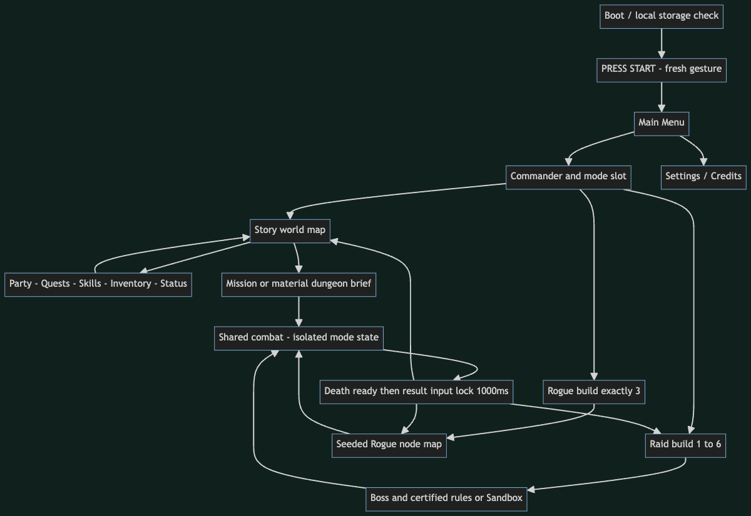

Mode Economy
Source [diagrams/mode-economy.mmd]
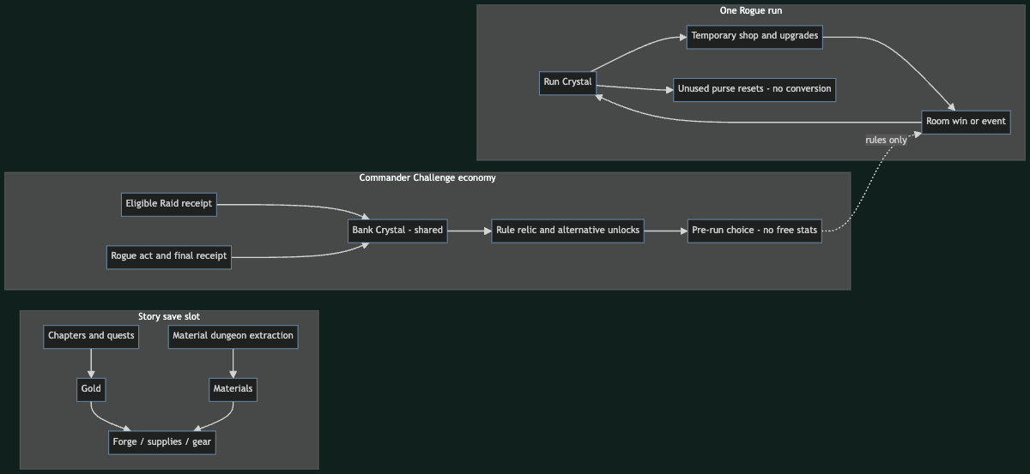

Rogue Loop
Source [diagrams/rogue-loop.mmd]
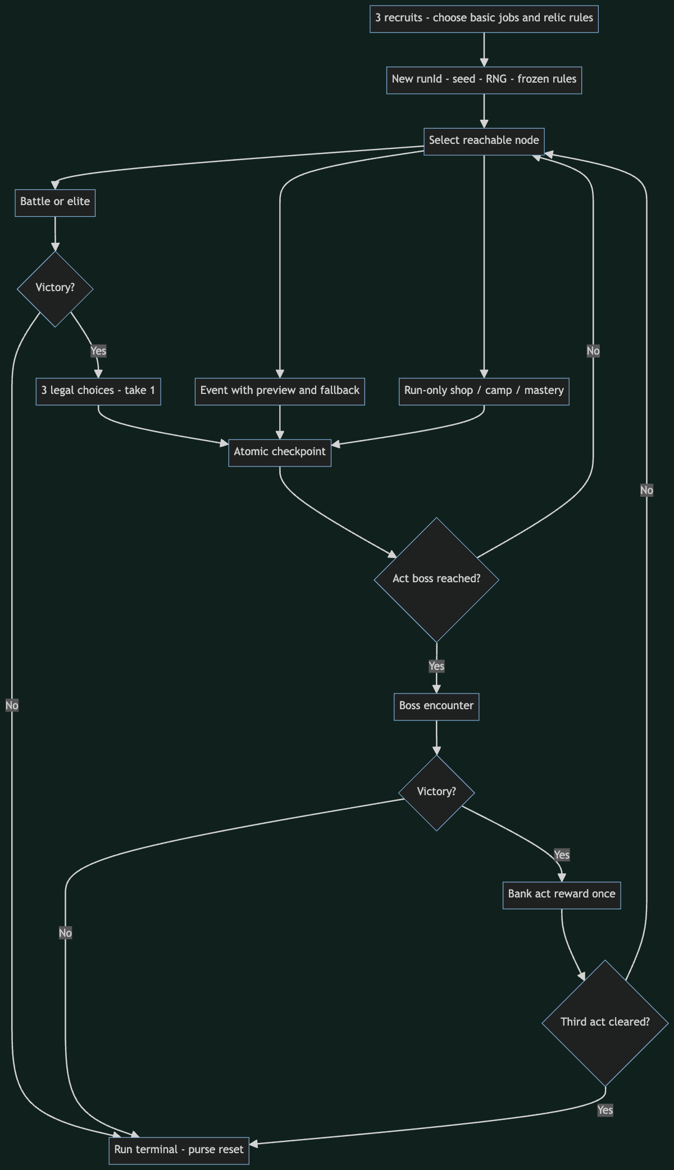

Story Journey
Source [diagrams/story-journey.mmd]
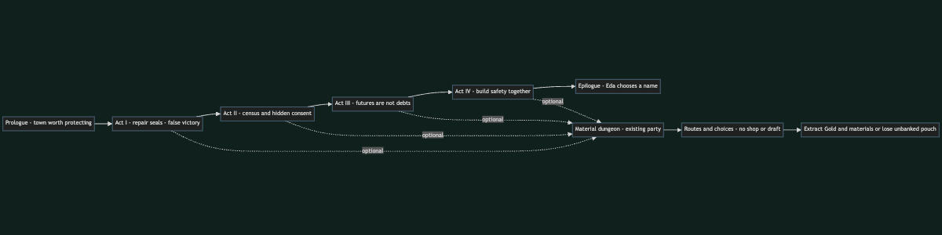

Raid Contract
Source [diagrams/raid-contract.mmd]
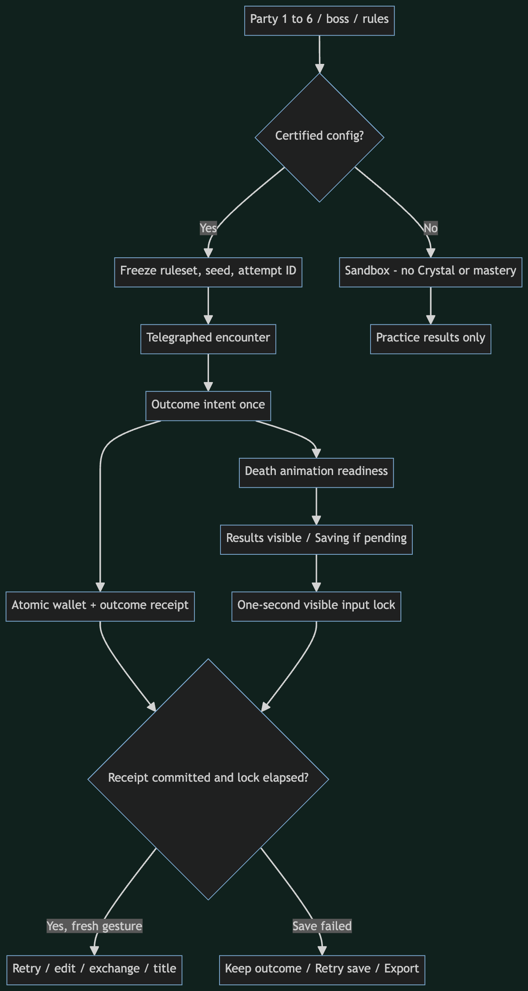

Save Settlement
Source [diagrams/save-settlement.mmd]
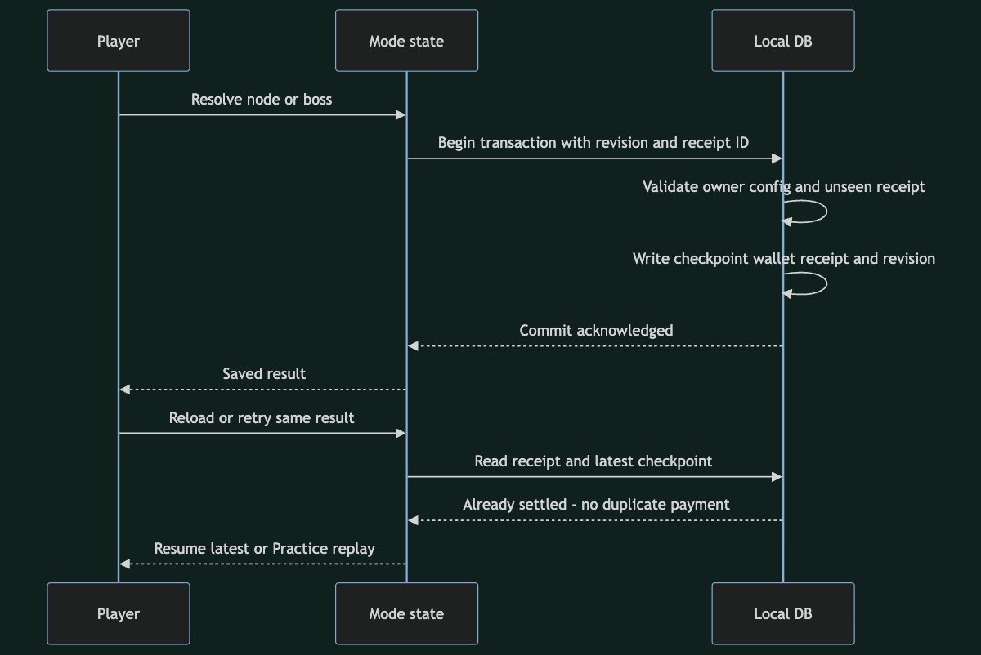

Production Gates
Source [diagrams/production-gates.mmd]
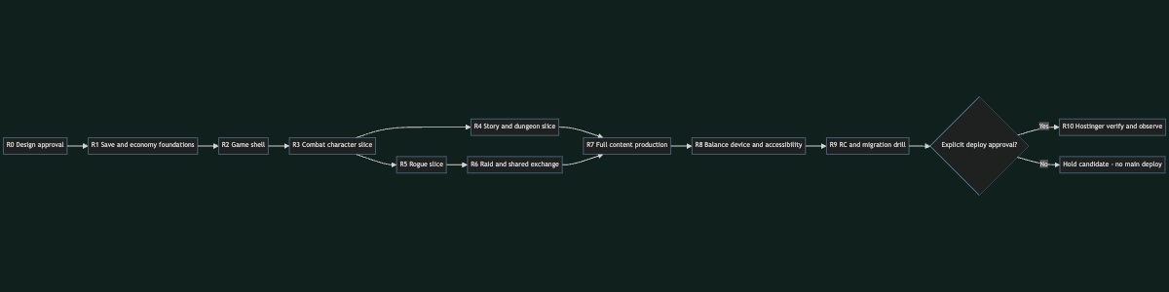

Skill Dependencies
Source [diagrams/skill-dependencies.mmd]
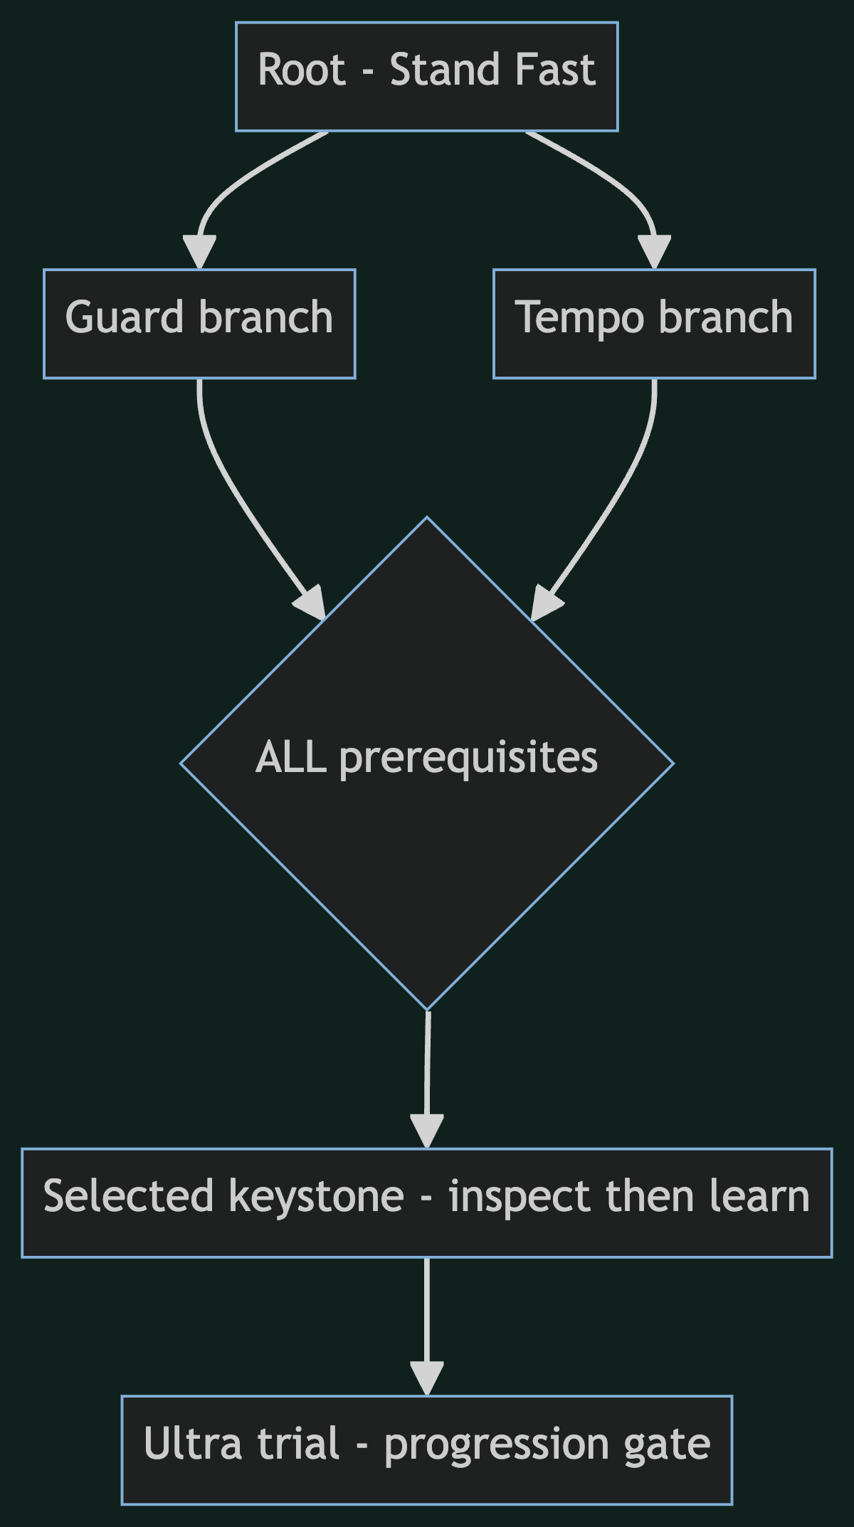

Offline design boards
- Three-mode navigation [art/mode-navigation.svg]
- Economy boundaries [art/economy-boundaries.svg]
- Prerequisite tree geometry [art/skill-tree.svg]
- 12 original icon studies [art/icon-concepts.svg]
- All boards as one HTML document [art/design-boards.html]
These are static documentation artifacts; no game controls or current gameplay screenshots are implied. Mermaid syntax/render validation status is reported in VALIDATION [VALIDATION.md].

Validation scope — R1 documentation
Dokumentasi only. Angka tuning dan catalog dalam paket ini belum diuji sebagai gameplay. Ini bukan laporan QA dari game baru, approval release, atau pernyataan live Hostinger update.

Pemeriksaan yang dikerjakan
- Audit source baseline 7aced0b: v0.4 RPG/GUI yang ada dipisahkan dari usulan title/three-mode/economy/profile redesign. src/, data/, package/config, implemented GDD dan save pengguna tidak diubah.
- Lima sumber publik penerbit di Steam berhasil dibaca. Referensi + petikan disimpan dalam ledger; citation checker dijalankan. Search/extract service403 dan subset site timeout dicatat; tidak ada claimed hands-on playtest.
- Delapan source Mermaid telah benar-benar diparse dan dirender memakai renderer sementara di folder artifact, bukan hanya dihitung code fence-nya. File .mmd masuk paket; library renderer tidak menjadi dependency game.
- Empat SVG design boards original dan viewer HTML offline dites di isolated headless Chrome pada1440px dan390px. Navigation anchors, local-only resources, label bounds di SVG, dan no page-wide horizontal overflow diperiksa.
- Review gambar mendeteksi diagram mobile memerlukan pan affordance; ditambahkan instruksi swipe per board dan Back to index. Diagram lebar bisa dipan di viewer dokumen; itu bukan rancangan untuk membuat game scroll horizontal.
- ID katalog, jumlah chapter/hero/Ultra/relic/modifier, total stat budget, aritmetika reward/rounding, links lokal, code fences dan SVG structure diperiksa dengan validator dokumentasi. Hasil mesin final dilampirkan di evidence/doc-validation.json pada arsip.
- Full Markdown gabungan diekspor dari komponen sumber; DOCX merupakan convenience export dengan heading/tabel/diagram. Paket diperiksa ZIP integrity dan isi dokumen dibaca kembali. Word pagination final tidak disertifikasi tanpa Word/LibreOffice rendering.
- Git scope diperiksa agar hanya README/dokumentasi baru/handoff pointers berubah; tidak ada commit/push/deploy dalam task R1 ini.

Ringkasan hasil validasi akhir
Pemeriksaan terakhir lulus untuk16file Markdown (termasuk GDD gabungan),8source Mermaid,4boardSVG,32Ultra seed records,12challenge relics,8Raid modifiers,8material,6recipe,9hero/18advanced/18third directions,7prologue beats dan16chapter. Matriks mencakup18request; decision log8default; milestone R0–R10. Ini hitungan dokumen/record rancangan, bukan implemented content baru.
Worked examples dihitung dari stat template aktual yang tertulis dan pipeline mitigation/cap/rounding yang sama; seluruh template basic berjumlah60points. Consistency checks tidak menggantikan simulator/human balancing.

Koreksi konsistensi saat authoring
- Story cap party:3prologue,4setelahCh02,5setelahCh03,6setelahCh04; roster9 tetap, tidak diam-diam berubah antara GDD dan chapter plan.
- Trial teaser Ch02 dibedakan dari actual signature Ultra gate setelah advancement/progress. Main plot tidak mewajibkan Challenge currency.
- Recipe Glass/Sap/Bell dipasang setelah dungeon region yang menyediakan material terbuka; basic support gear tersedia lebih awal.
- Rounding damage memakai satu definisi half-up untuk nonnegative output; economy payout memakai floor sesuai rule-nya. Tidak mencampur formula prototype yang sudah diganti.
- Ultra starter5 + signature18 + capstone9 =32; 12challenge relics dan8Raid modifiers punya draft record, sedangkan36promotion actions masih memerlukan final coefficients/effect specs pada R3/R7.
- Target content budget tidak sama dengan authored examples: contoh event Rogue3 dan dungeon3; full budget masing-masing12 baru future authoring.

Belum diuji / bukan deliverable implementasi
- Tidak ada title baru, material farming, shop/events Rogue, Raid normalized builder, Commander saves,5stats atau Ultra catalog yang dijalankan di game.
- Tidak ada klaim balance/fun/pacing/production quality dari formula, screenshots dokumen atau referensi store.
- Physical device, final pixel/icon atlas, migration behavior, browser game QA, world-map usability dan accessibility runtime memerlukan implementation gate berikutnya.
- Diagram skill tree ilustratif tidak menggantikan semantic/layout tests pada runtime. Icon12motif adalah concept SVG, bukan32Ultra art final.
- D1–D8 masih keputusan usulan; user review diperlukan sebelum implementasi.
Untuk urutan eksekusi baca R0–R10 [NEXT-PRODUCTION-R1.md]. Jangan menandai milestone DONE karena dokumen ini ada.

Original concept boards

Mode Navigation
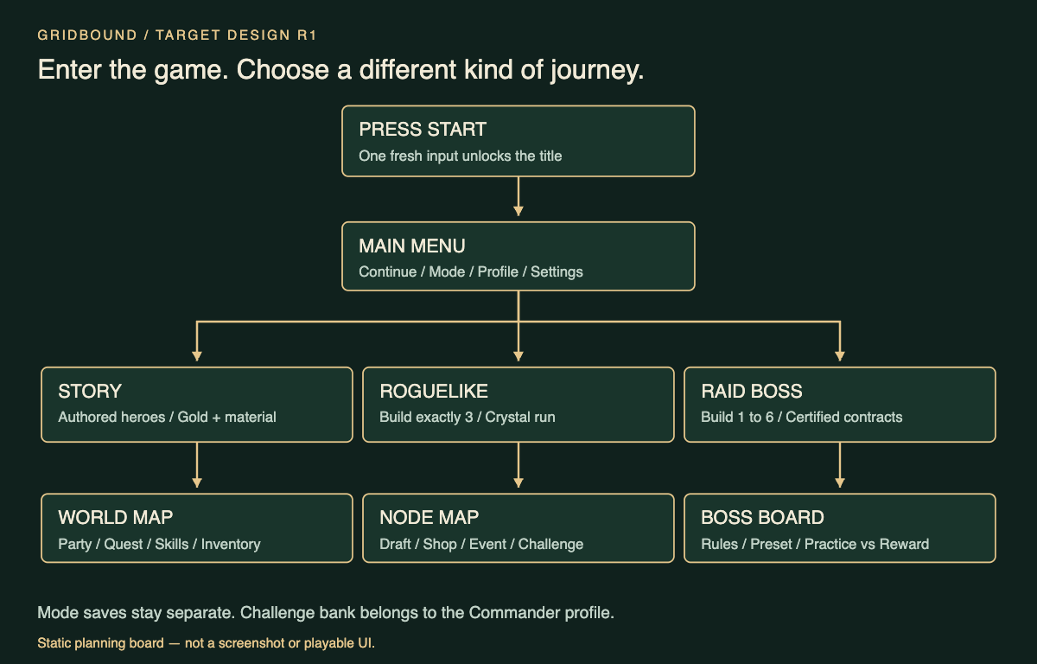

Economy Boundaries
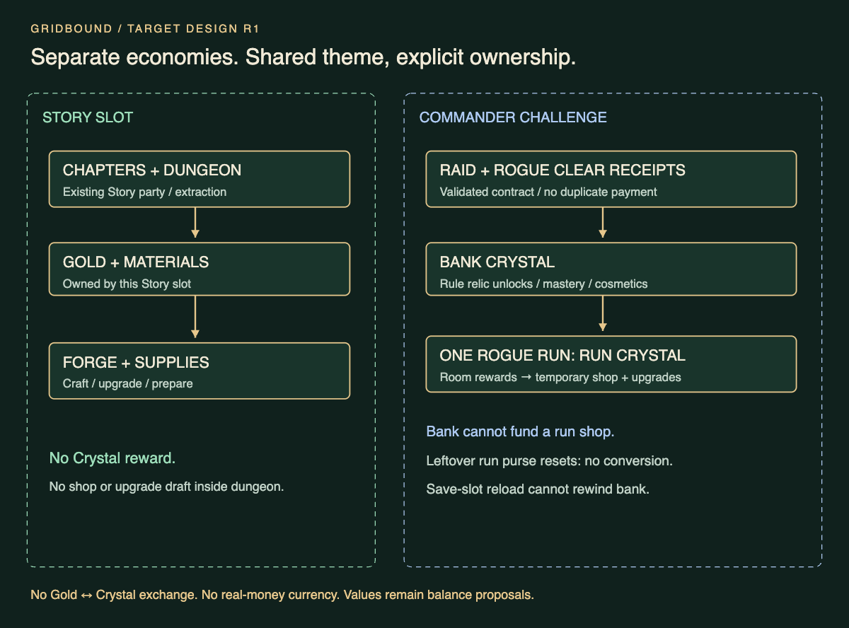

Skill Tree
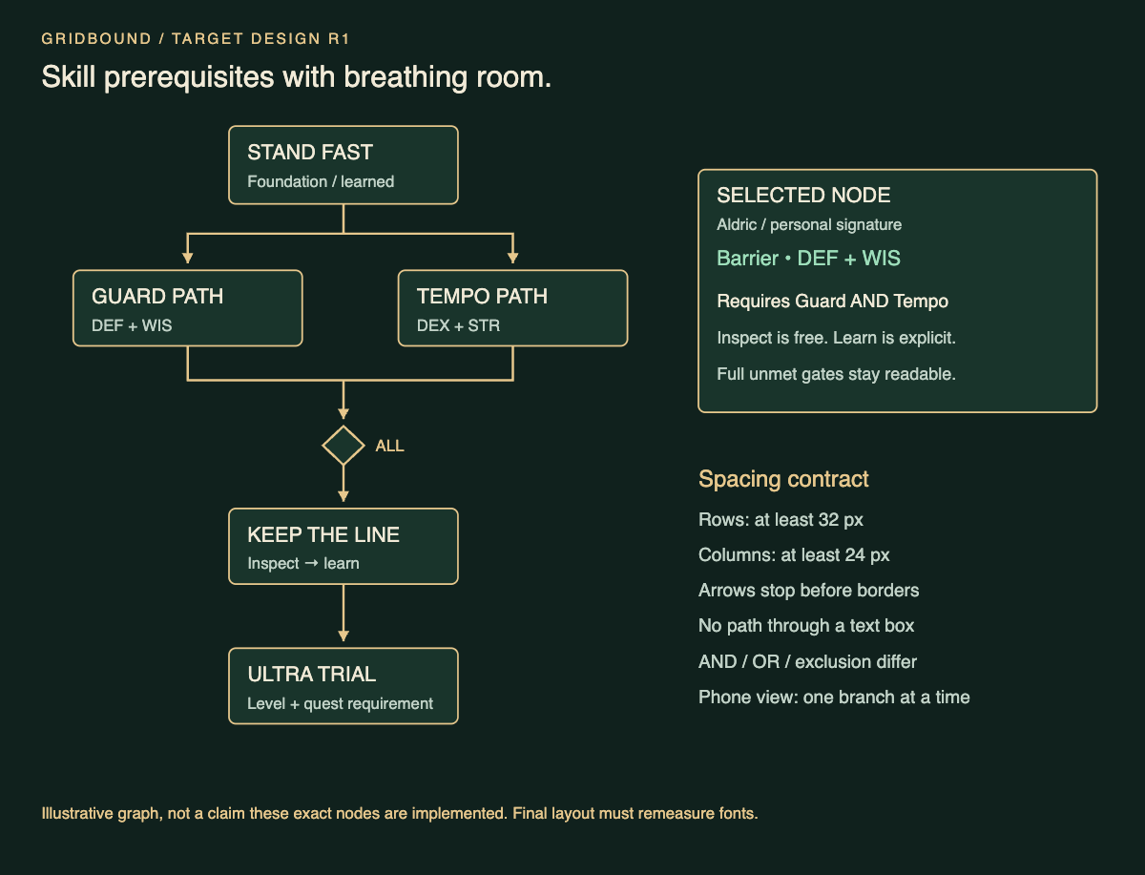

Icon Concepts
