**ASSIGNMENT -2**

Name: Nandini Sanagala

E-Mail: [sanagalanandini2002@gmail.com](mailto:sanagalanandini2002@gmail.com)

Mobile: 9121829379

Reg NO: 20NN1A12B7

College: Vignan’s Nirula Institute Of Technology And Science For Women

1.APP.JS

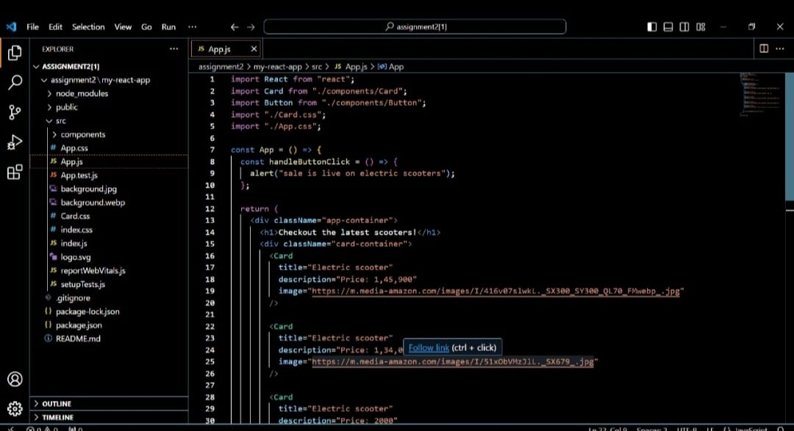

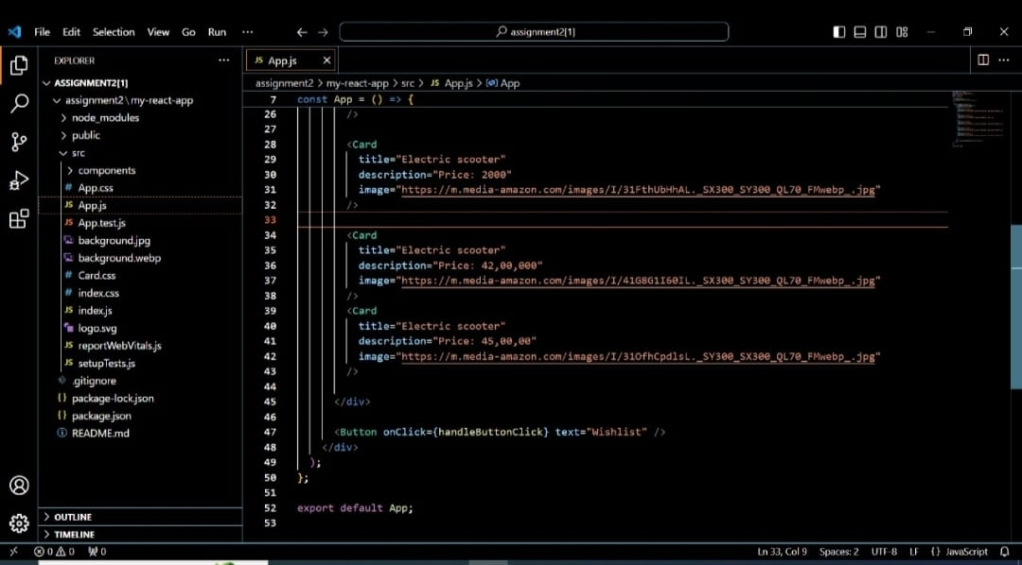

2.APP.CSS

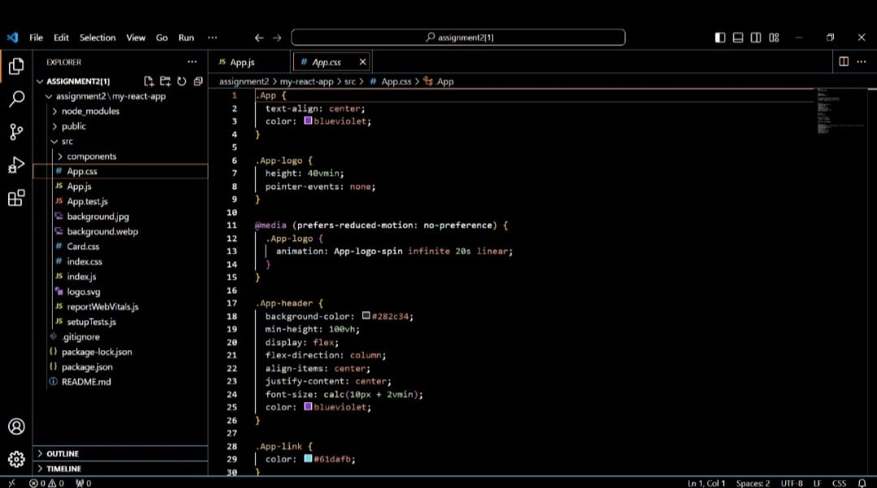

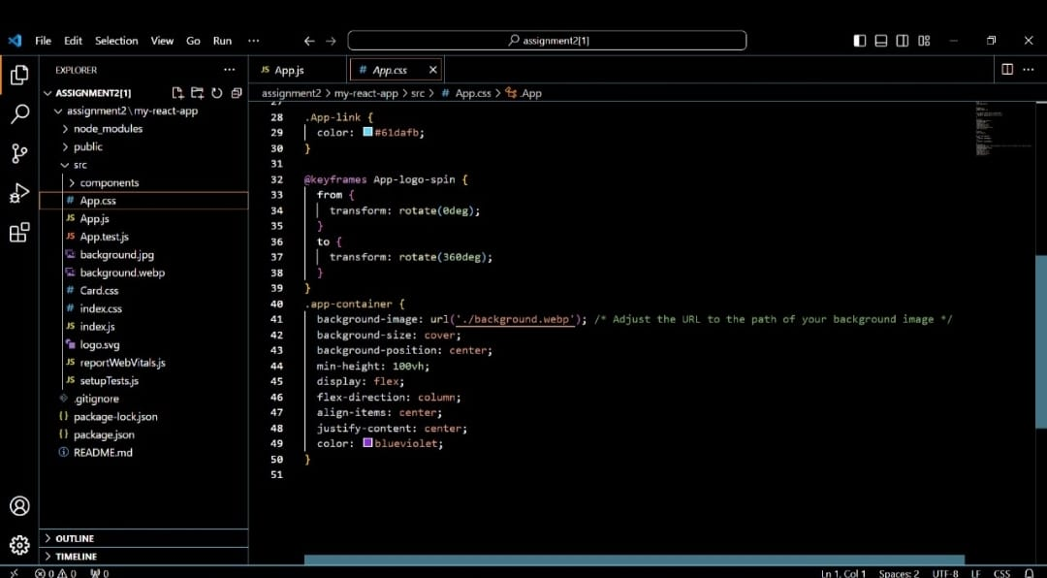

3.INDEX.JS

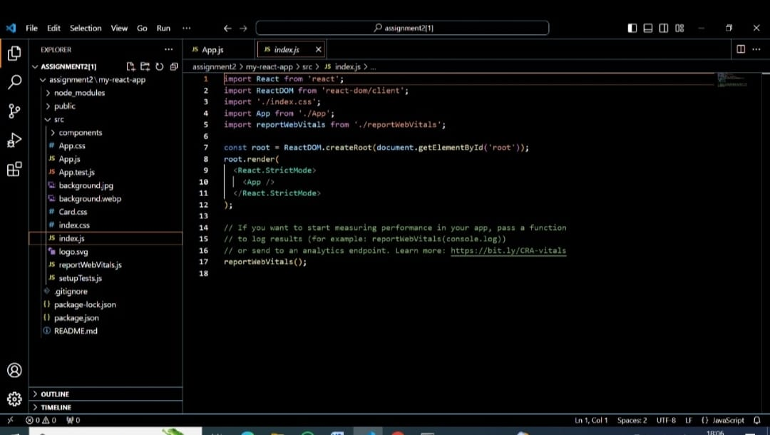

4.CARD.JS

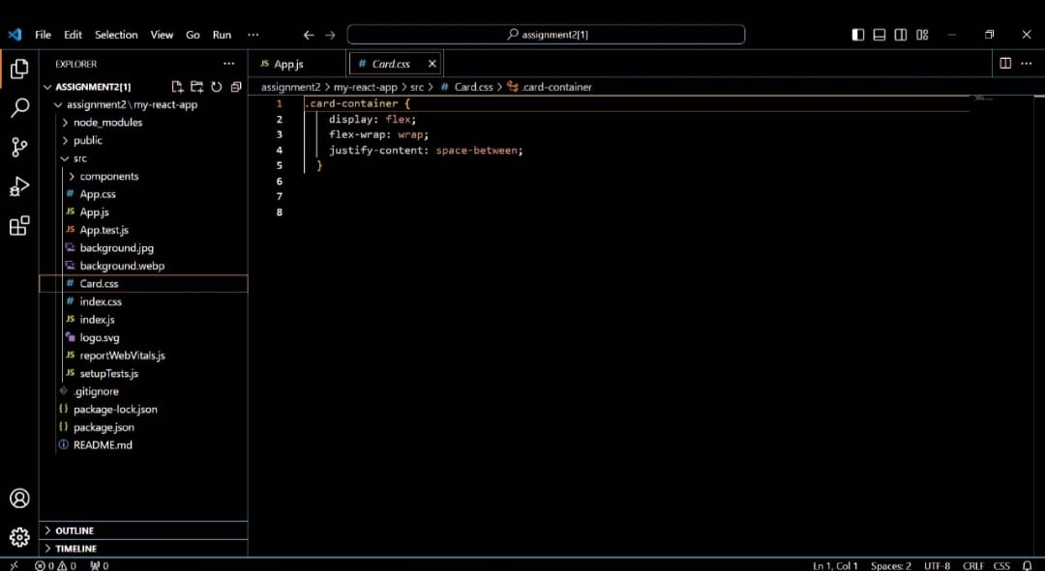

5.OUTPUT

