Meal Delivery App Concept | Internship Task 2

1. App Concept
- App name: QuickPlate
- Type: Meal delivery mobile app
- Problem: Busy people struggle to find and order healthy meals quickly because of long menus and confusing checkouts.
- Goal: Let a user order a meal in under 2 minutes.

2. User Personas

Persona 1: Ayesha, 24, University Student
- Goal: Order cheap meals quickly between classes.
- Needs: Deals and discounts, fast reordering, low delivery fees.
- Frustrations: Hidden charges, slow checkout, too many steps.
- Tech comfort: High (uses her phone for everything).

Persona 2: Hamza, 35, Office Professional
- Goal: Get a healthy lunch delivered at work.
- Needs: Diet filters, scheduled delivery, live order tracking.
- Frustrations: Late deliveries, unclear menus, no healthy options.
- Tech comfort: Medium.

3. User Flows

Main flow: Ordering a meal
Login → Home → Restaurant Menu → Item Detail → Cart → Checkout → Order Tracking → Rate Order
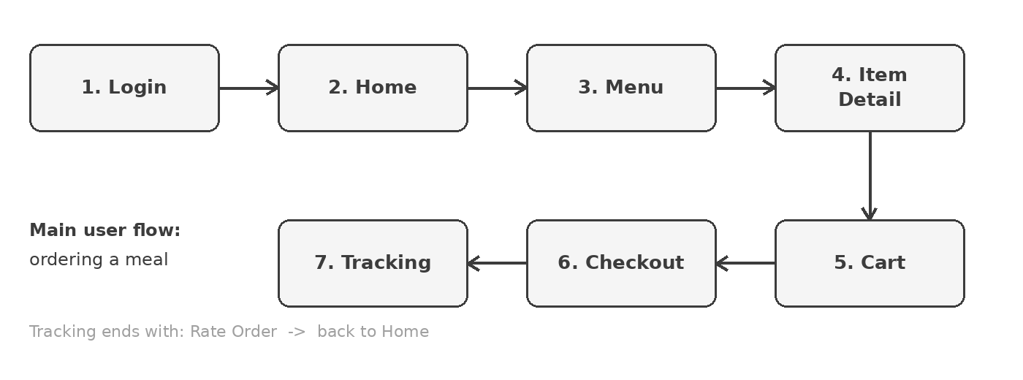

Secondary flow: Finding a meal with filters
Home → Search → Filter (diet, price) → Restaurant Menu → Cart

4. User Journey Map (Ayesha ordering lunch)
Stage | Action | Feeling | Pain point / Opportunity
Discover | Opens app, browses Home | Hungry, hopeful | Too many options. Show popular meals first.
Choose | Opens menu, picks an item | Curious | Unclear prices. Show price clearly.
Order | Adds to cart, checks out | Impatient | Slow checkout. Keep it to 3 taps.
Wait | Tracks the order | Anxious | No updates. Show live progress.
Receive | Gets food, rates order | Satisfied | Make reordering one tap.

5. Screen List and Navigation
Screen | Main elements | Navigates to
1. Login / Sign up | Logo, email/phone field, password field, Login button, 'Sign up' link, Google login button | Home
2. Home | Location bar, search bar, category chips, popular meals list, bottom menu (Home, Orders, Profile) | Restaurant Menu, Search, Profile
3. Restaurant Menu | Back arrow, banner image, rating and delivery time, menu items with [+] button, View Cart button | Item Detail, Cart
4. Item Detail | Large image, name, description, price, quantity selector, Add to Cart button | Cart
5. Cart | List of items, promo code field, subtotal, delivery fee, total, Checkout button | Checkout
6. Checkout | Delivery address, payment method, order summary, Place Order button | Order Tracking
7. Order Tracking | Map area, progress steps (Preparing, Picked up, On the way, Delivered), rider info with call button | Home, Rate Order

6. Low-Fidelity Wireframes
Wireframe screens for the main flow, designed in Figma. Boxes marked IMAGE or MAP are placeholders. Layout and navigation matter here, not final visual style.
1. Login  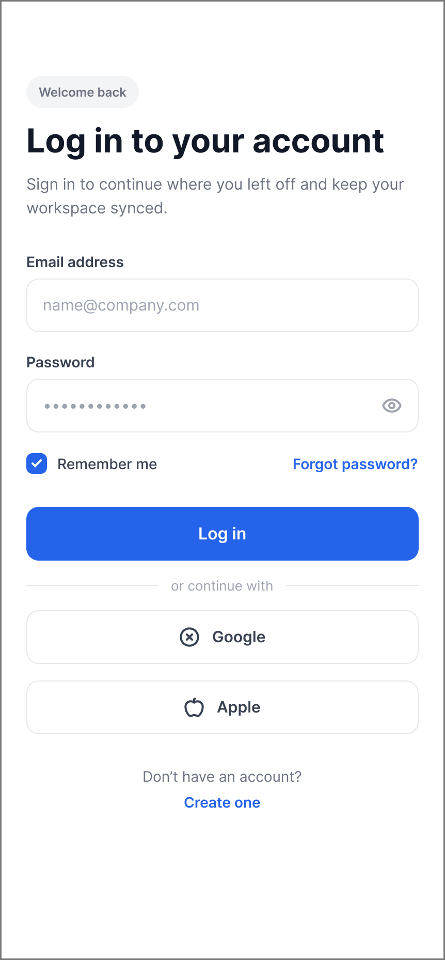 | 2. Home  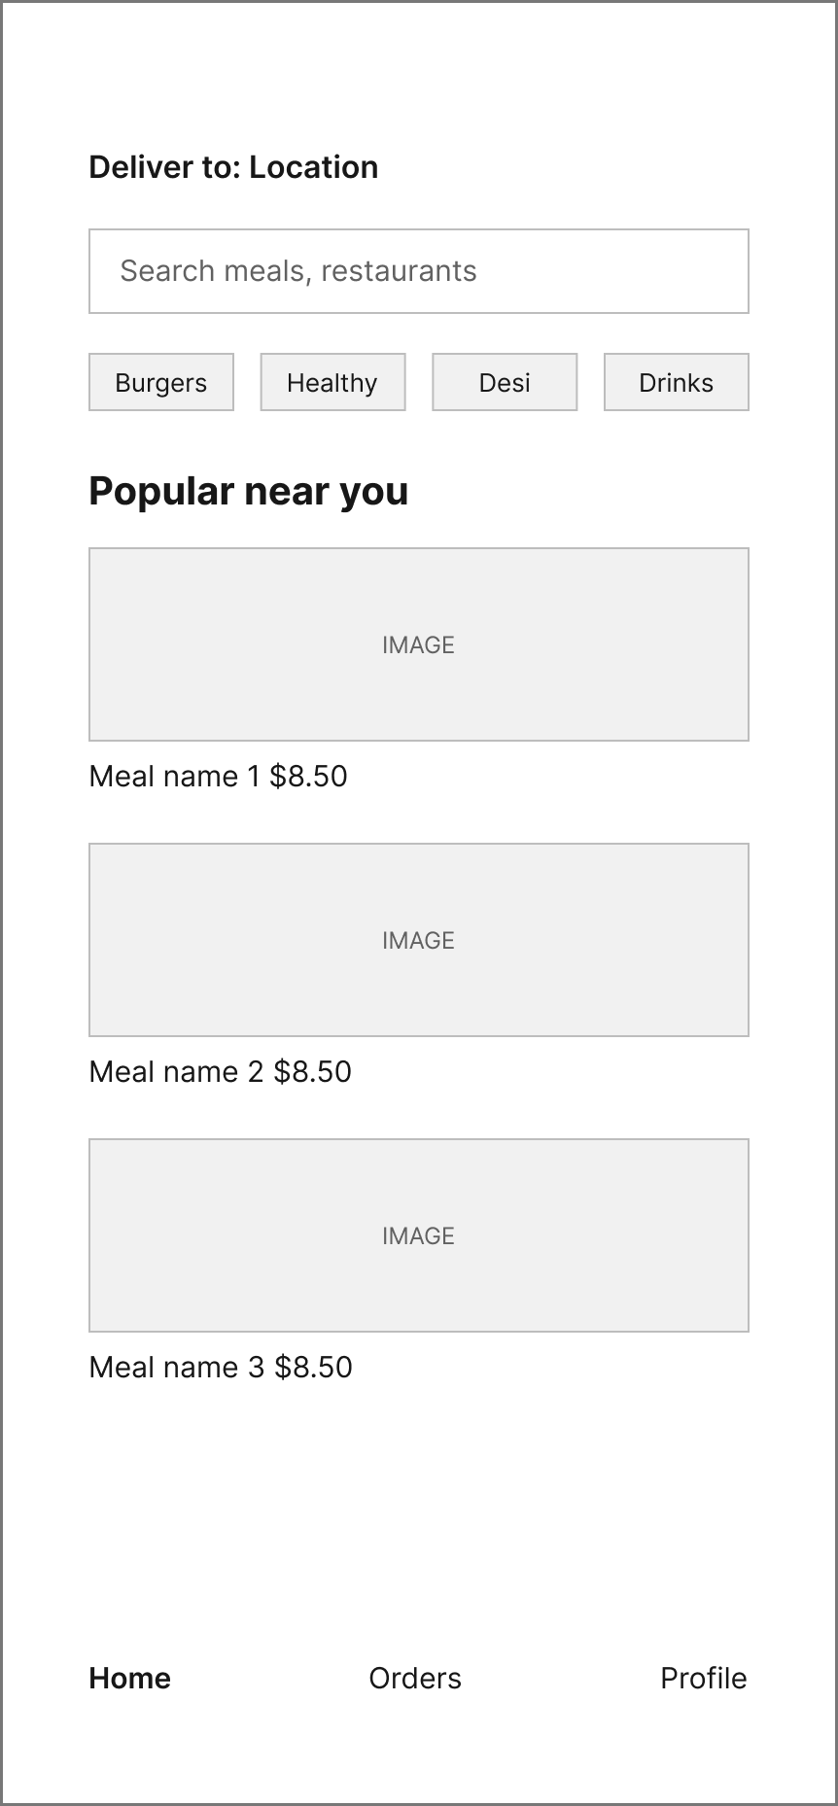 | 3. Restaurant Menu  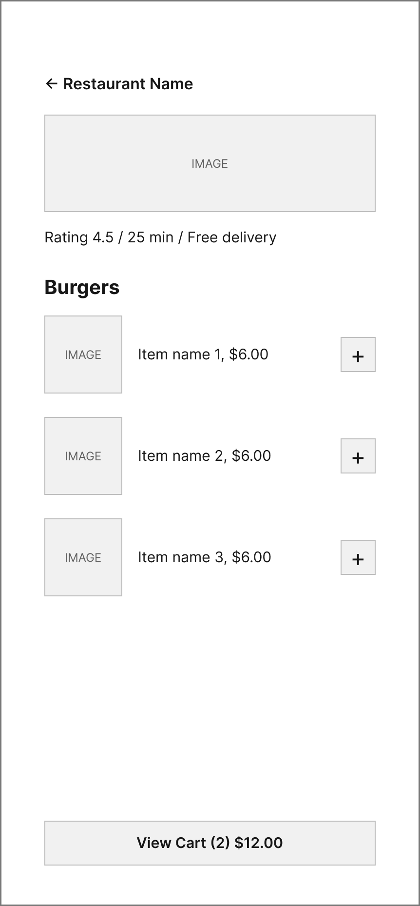
4. Item Detail  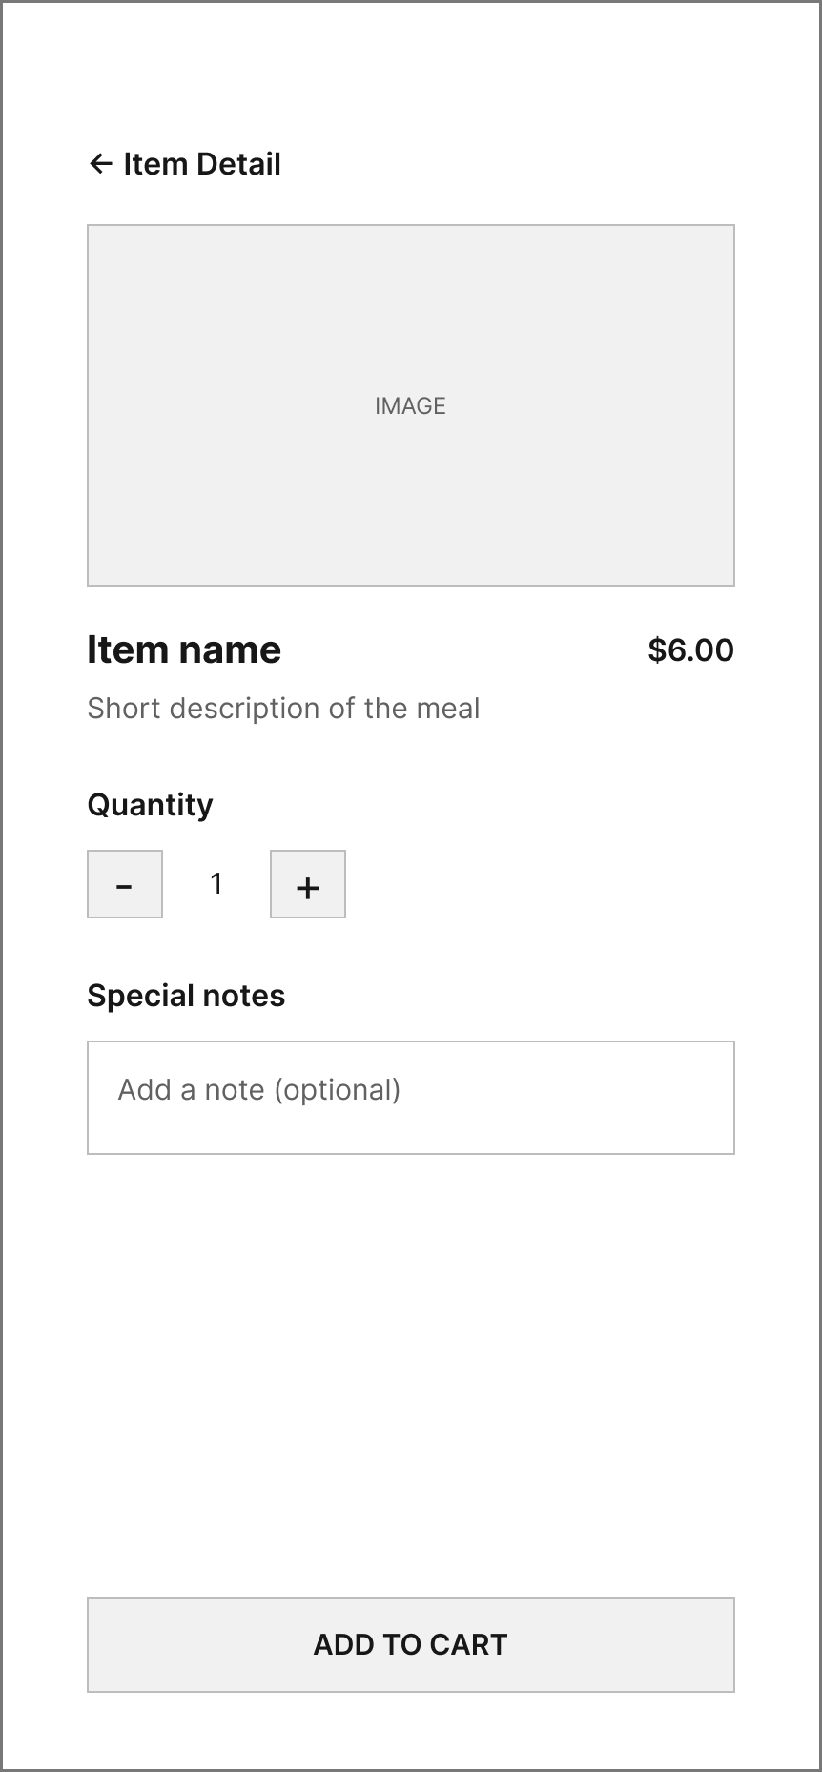 | 5. Cart  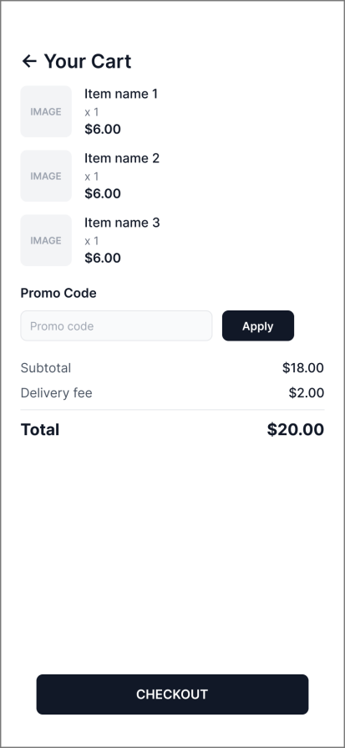 | 6. Checkout  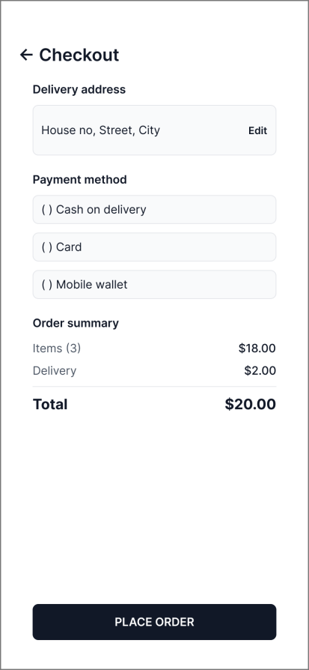
7. Order Tracking
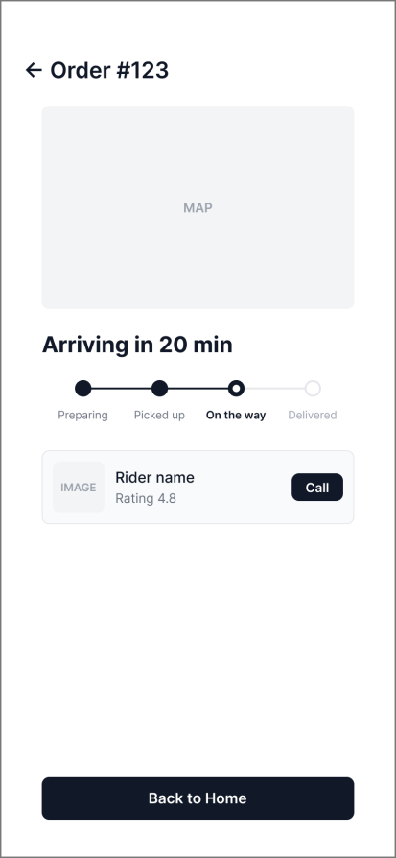

7. Wireframe Notes for Figma
Wireframes are built in Figma using simple boxes and placeholder text. No final images or branding.
- Frame size: iPhone 14 Plus (428 x 926).
- IMAGE / MAP boxes: placeholders for photos and maps.
- Rectangles: buttons, fields and search bars.
- Frame naming: 01 Login, 02 Home, 03 Menu, 04 Item, 05 Cart, 06 Checkout, 07 Tracking.
- Prototype: Figma Prototype arrows connect buttons to the next screen to show the navigation path.

Figma link
All 7 screens with prototype arrows: https://www.figma.com/design/Qkdiqvis10elXrxhxZ7fHw/QuickPlate-Wireframes?node-id=0-1&t=VlVzoucYnn4zpoVI-1

