Reconnaissance Report
Analyst: San
Date: June 05, 2026
Assigned target: scanme.nmap.org (parent domain: nmap.org)

1. Target information
- Target hostname: scanme.nmap.org
- Parent domain: nmap.org
- Target IP address: 45.33.32.156
- Authoritative DNS servers: ns1.linode.com, ns2.linode.com, ns3.linode.com, ns4.linode.com, ns5.linode.com
- Operator authorization notice: The scanme.nmap.org host is intentionally provided for public Nmap testing and educational scanning.

2. Kali network identity
- Kali IP address: 10.10.10.134
- Interface: eth0
- Subnet: 10.10.10.0/24

3. Connectivity results
- Target reached: Yes
- Packets transmitted: 4
- Packets received: 4
- Packet loss: 0%
- Average round-trip time: 253.375 ms

4. Website findings
- Project / site display name: NMAP.ORG
- Page types observed on nmap.org: Homepage, Download, Docs, security scanning notice,Reference
- Visible technologies: Apache web server, SSL/TLS, JavaScript
- Authorization notice summary: The site explicitly authorizes limited testing and scanning for educational and verification purposes.
- Other public-facing information: Public DNS records, hosting provider details, registrar information, and email infrastructure are visible.

5. Whois findings (for nmap.org)
- Registrar: Dynadot Inc
- Name servers: ns1.linode.com, ns2.linode.com, ns3.linode.com, ns4.linode.com, ns5.linode.com
- Creation date: 1999-01-18
- Updated date: 2026-04-10
- Expiration date: 2029-01-18
- Other relevant fields: DNSSEC unsigned, domain status clientTransferProhibited

6. DNS findings
- Default resolver: 192.168.200.2
- A record: 50.116.1.184
- MX records: ASPMX.L.GOOGLE.COM, ALT1.ASPMX.L.GOOGLE.COM, ALT2.ASPMX.L.GOOGLE.COM, ASPMX2.GOOGLEMAIL.COM, ASPMX3.GOOGLEMAIL.COM
- NS records: ns1.linode.com, ns2.linode.com, ns3.linode.com, ns4.linode.com, ns5.linode.com
- CNAME record: No CNAME returned for www.nmap.org
- SOA record: ns1.linode.com hostmaster.nmap.com 2021000018 14400 14400 1209600 3600
- Notes on differences: nslookup was used interactively with type changes, while dig returned detailed sections including authority and query timing.

7. Search reconnaissance findings
- Query 1: site:example.com intitle:"About us" revealed indexed About pages and organization details.
- Query 2: site:example.com filetype:pdf attempted to locate exposed PDF documents.
- Query 3: site:example.com "Contact us" revealed publicly accessible contact pages.
- Query 4: site:example.com -reddit filtered out Reddit references to focus on direct site content.

8. OSINT lookup findings (for nmap.org)
- Hosting provider: Linode
- Server technology: Apache
- First-seen date: May 2000
- Related hostnames: ns1.linode.com through ns5.linode.com
- Other technologies: CentOS, SSL/TLS, JavaScript

9. Public data awareness observations
- Category 1 — Personal Information
Names, emails, and phone numbers can help attackers create phishing or impersonation attacks.
Reduction strategy: Limit public contact details and provide phishing-awareness training.
- Category 2 — Employment Information
Job titles, departments, and manager names help attackers perform social engineering and pretexting attacks.
Reduction strategy: Avoid publishing detailed organizational structures publicly.
- Category 3 — Project Information
Project names and operational details can make phishing emails appear legitimate.
Reduction strategy: Keep sensitive project details internal and avoid exposing codenames publicly.
- Category 4 — Infrastructure Information
DNS records, IP addresses, and server technologies help attackers map systems and identify targets.
Reduction strategy: Minimize exposed technical details and regularly patch systems.
- Category 5 — Online Presence
Public websites, documents, and social media profiles may reveal sensitive business information.
Reduction strategy: Regularly review public content and remove unnecessary exposed data.

10. Key risks
- Risk 1: Public infrastructure information can aid attackers in reconnaissance and phishing campaigns.
- Risk 2: DNSSEC is unsigned, which may increase susceptibility to DNS spoofing-related attacks.
- Risk 3: Publicly indexed files and contact pages may expose operational or administrative information.

11. Recommended next steps
- Next step 1: Continue vulnerability management and regular patching of exposed services.
- Next step 2: Perform periodic third-party risk and hosting provider reviews.
- Next step 3: Escalate unusual reconnaissance indicators or suspicious scanning activity for further analysis.

12. Evidence list
- target_info.txt
- target_whois.txt
- target_dns.txt
- task01_ip.png
- task02_ping.png
- task03_homepage.png
- task03_scanme_notice.png
- task04_whois.png
- task05_nslookup.png
- task06_nslookup_auth.png
- task06_nslookup_auth2.png
- task07_dig.png
- task08_search1.png
- task08_search2.png
- task08_search3.png
- task08_search4.png
- task09_osint.png
- task09_osint2.png
- task11_evidence.png
- recon_report.docx

Screenshots / Evidence
task01_ip.png
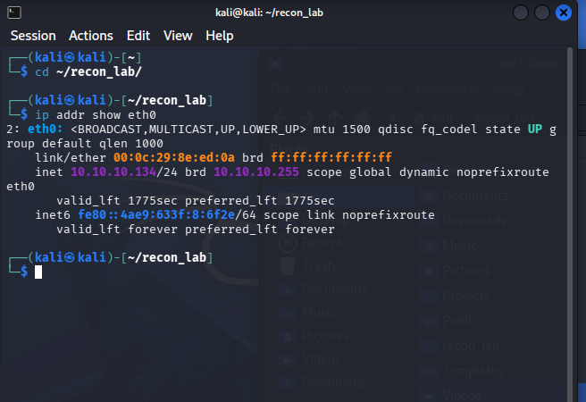
task02_ping.png
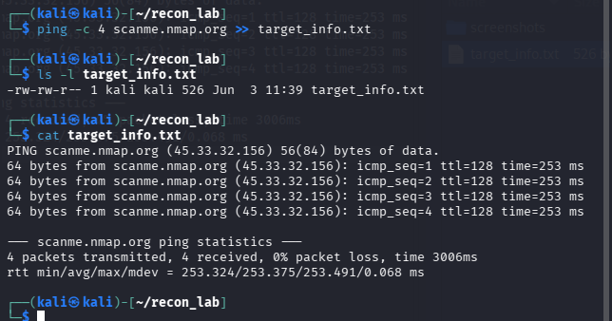
task03_homepage.png
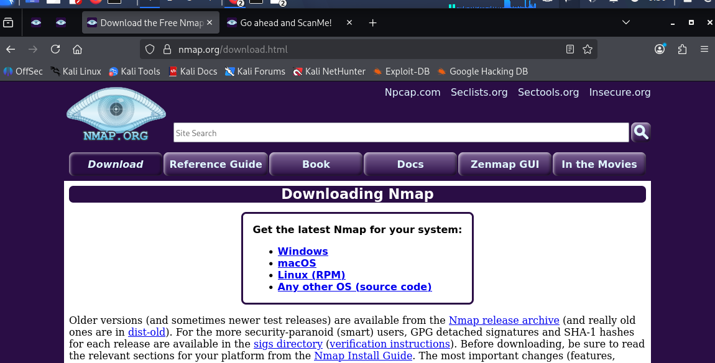
task03_scanme_notice.png
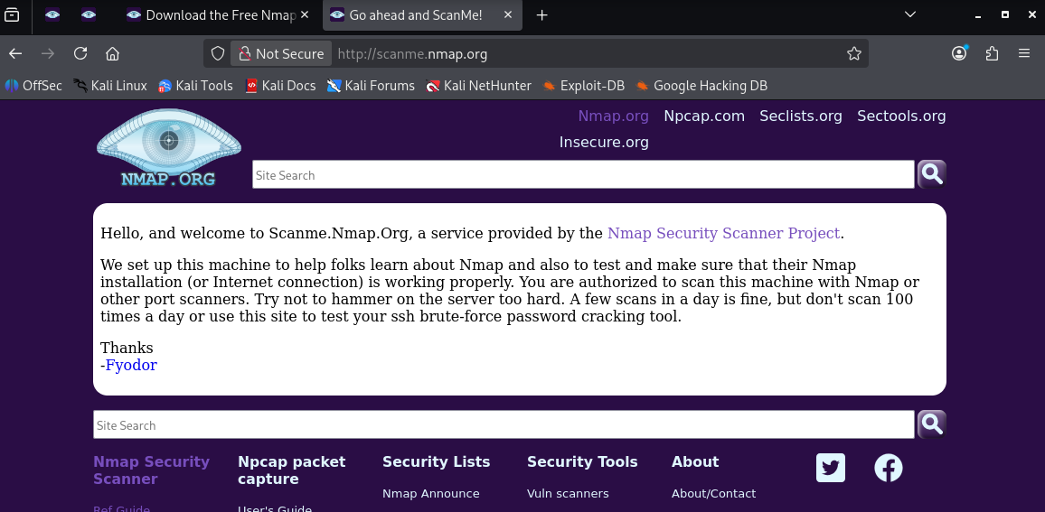
task04_whois.png
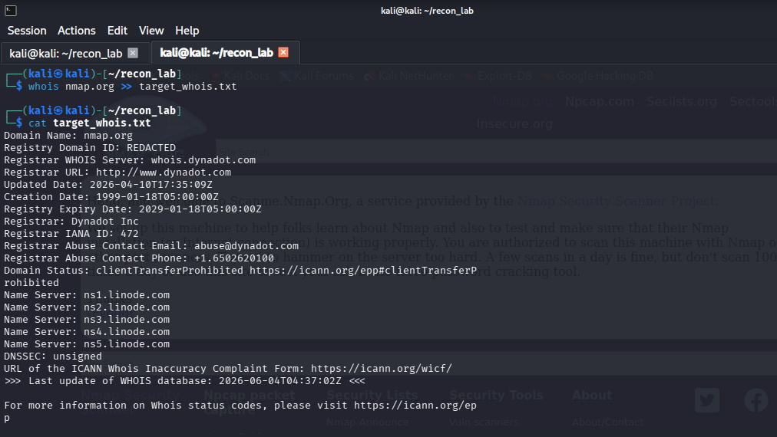
task05_nslookup.png
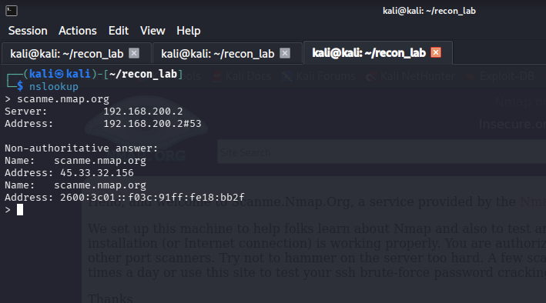
task06_nslookup_auth.png
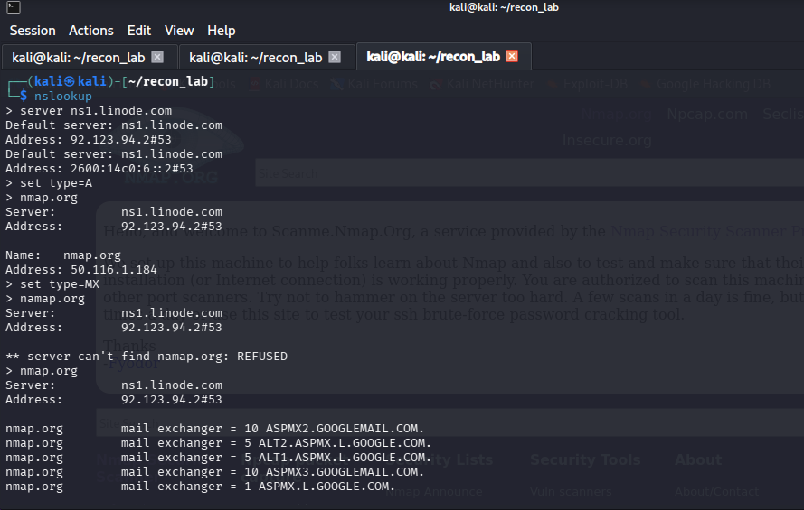
task06_nslookup_auth2.png
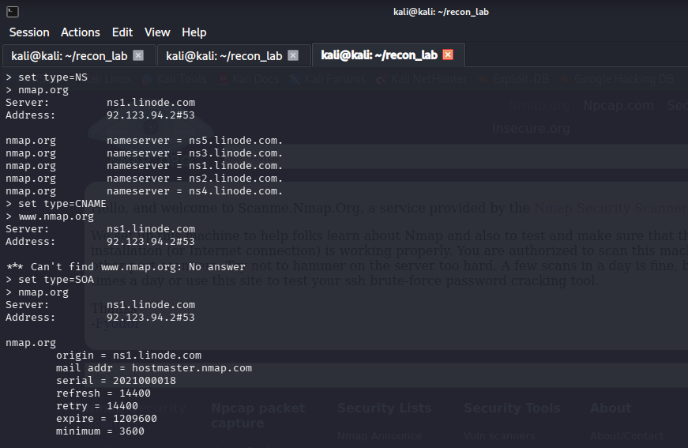
task07_dig.png
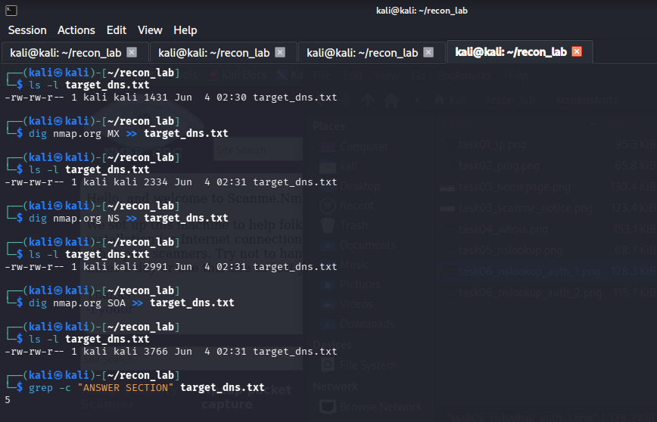
task08_search1.png
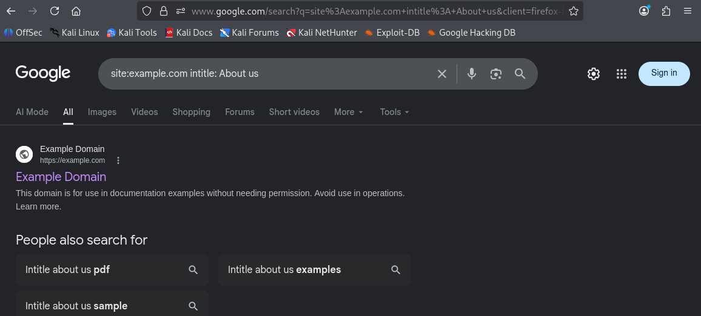
task08_search2.png
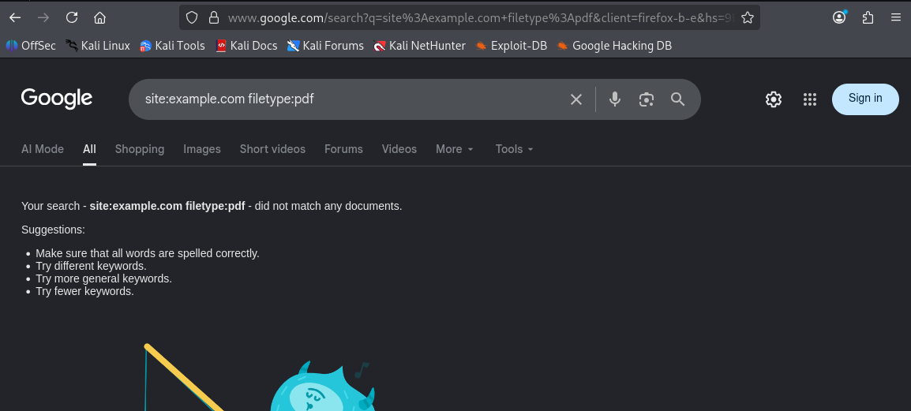
task08_search3.png
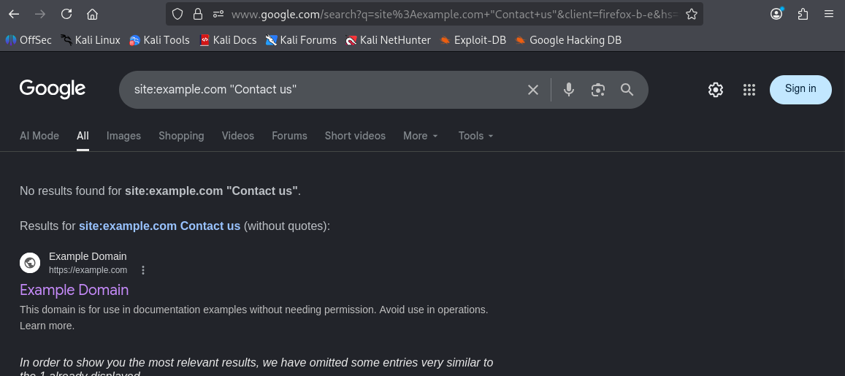
task08_search4.png
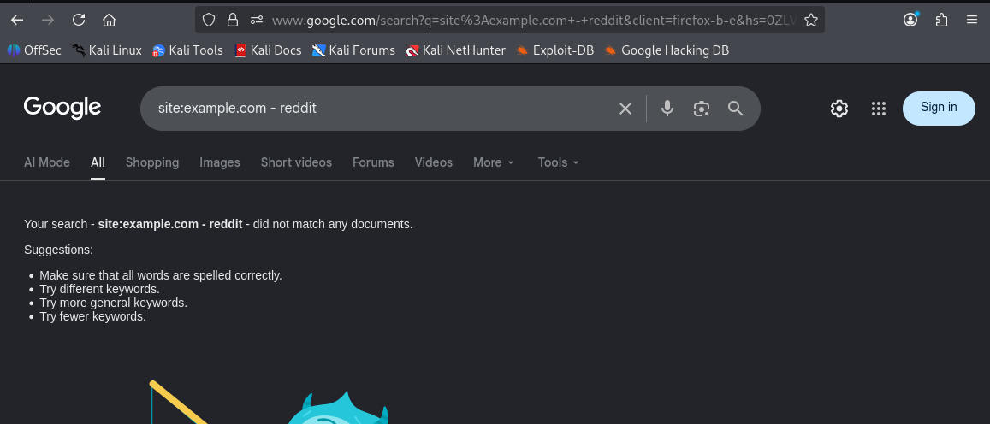
task09_osint.png
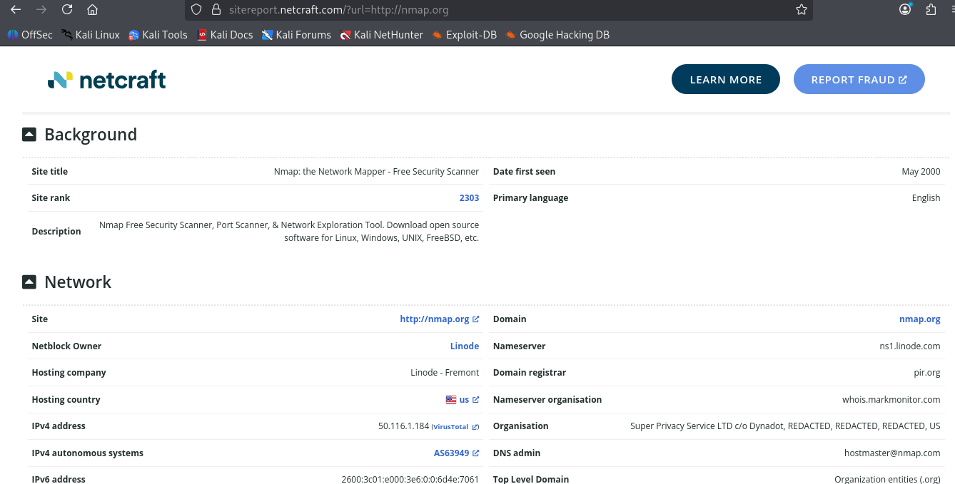
task09_osint2.png
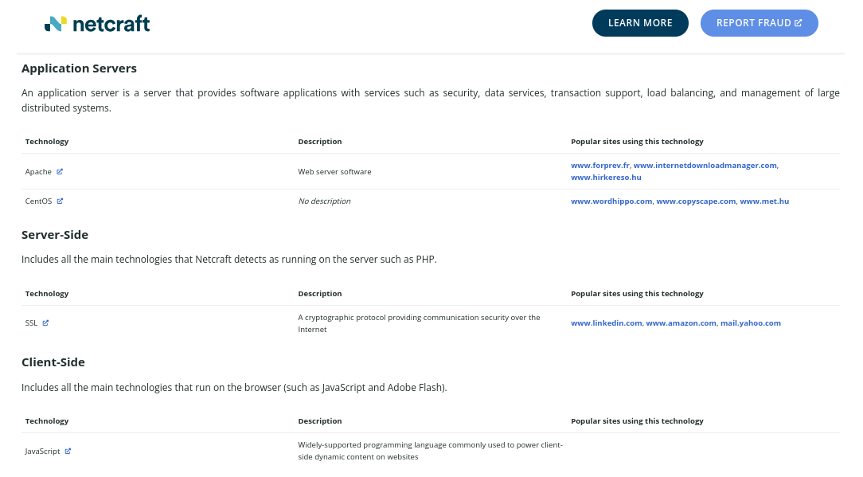
task11_evidence.png
