**DATA ANALYSIS**

Topic : IPL Data Frame

Q1. Import necessary libraries

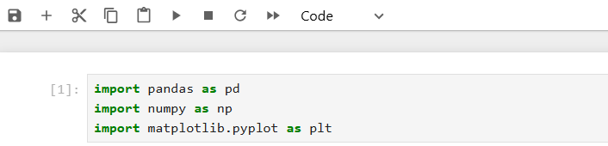

Q2. Load the dataset

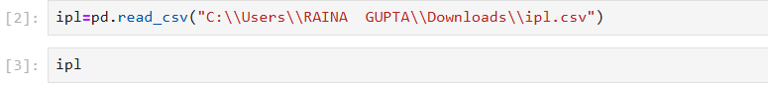

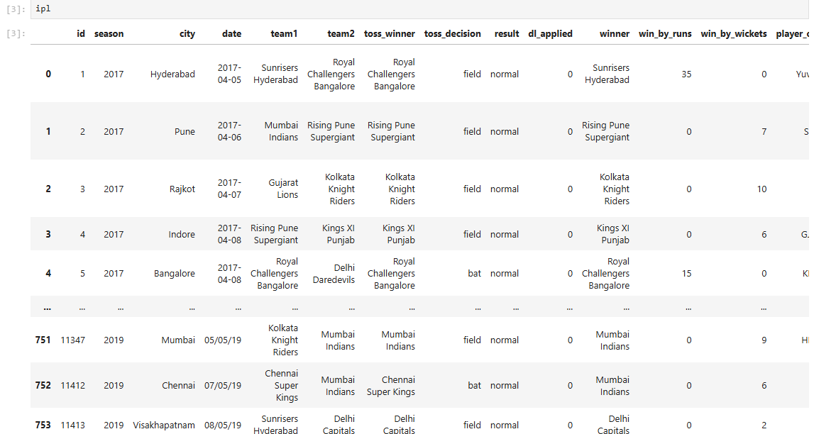

Q3. Display first few rows

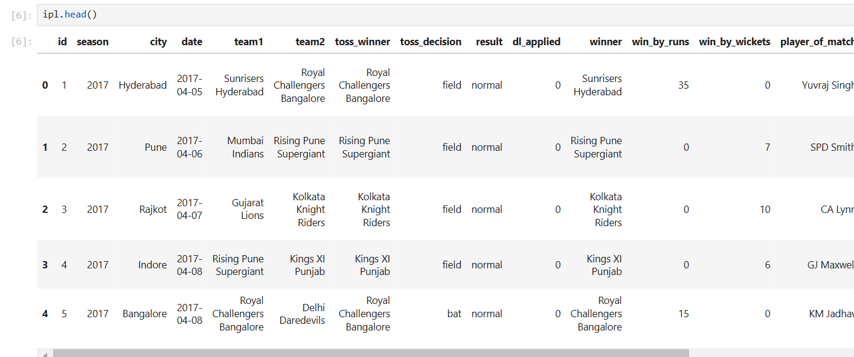

Q4. isplay last few rows

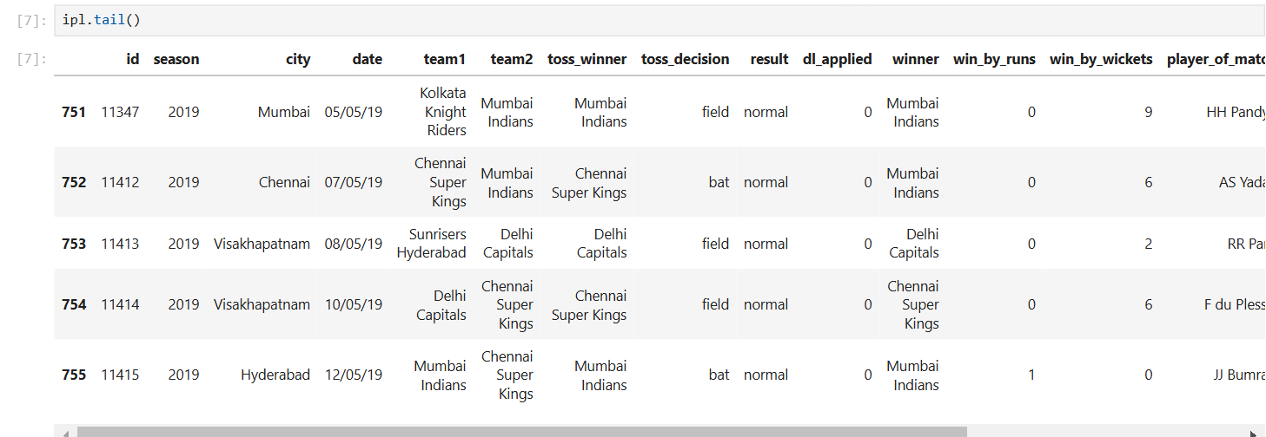

Q5. Check dataset shape

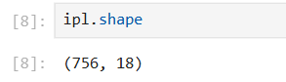

Q6. Check column names

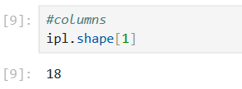

Q7. Check rows names

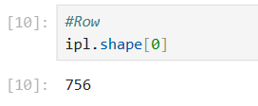

Q8. Check Data Type

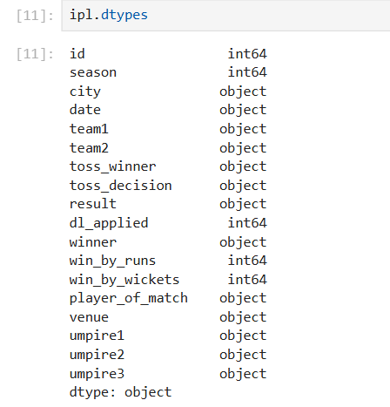

Q9. Summary statistics

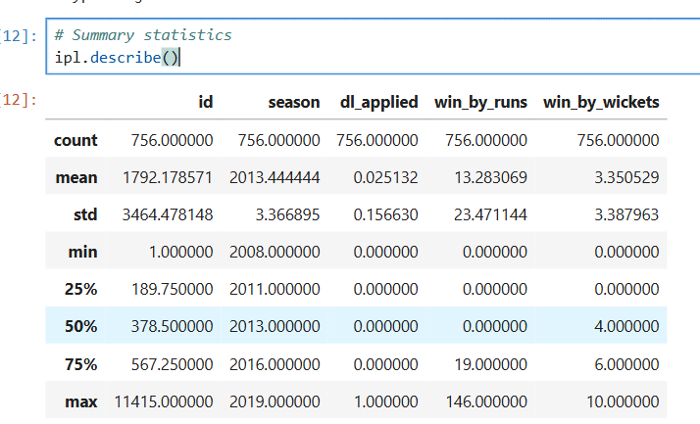

Q10. check if there are any missing values in data frame

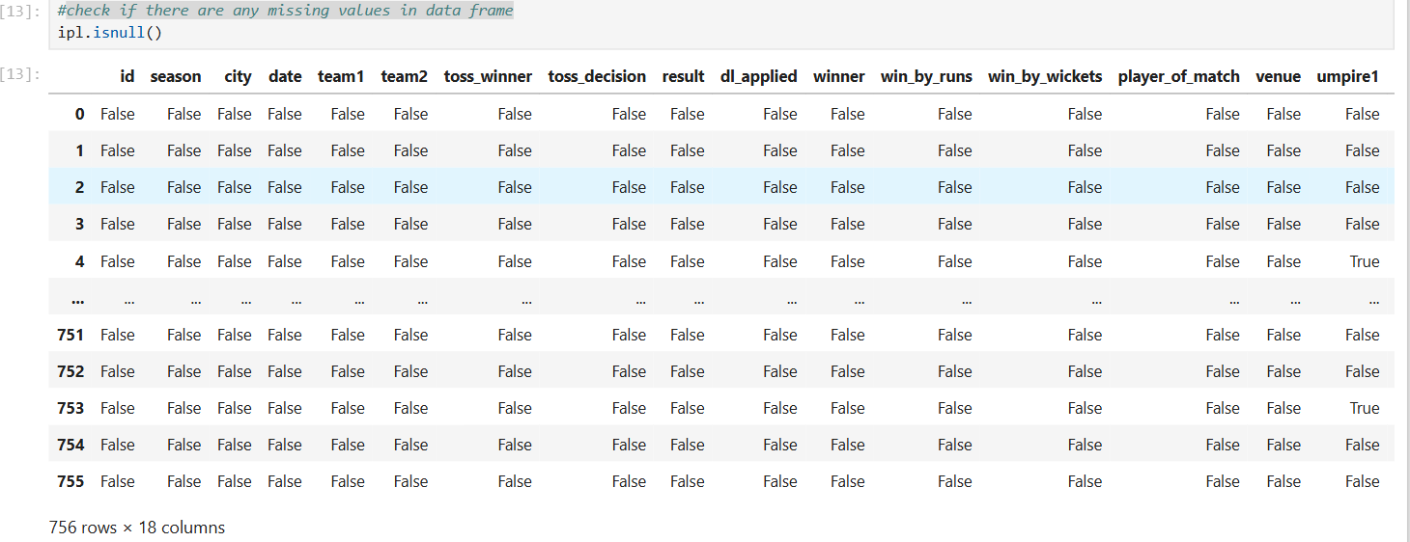

Q11. count the number of missing values in the dataset

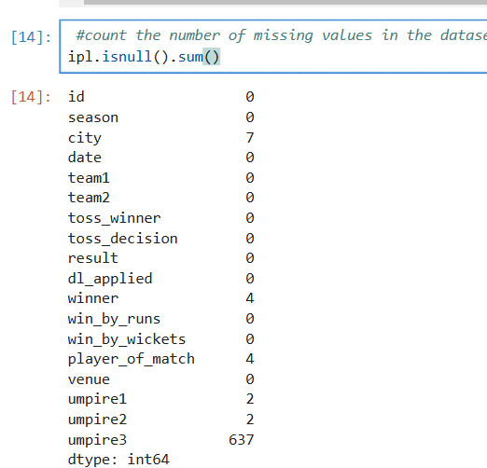

Q12. How to get toss winners for rows 0 and 5

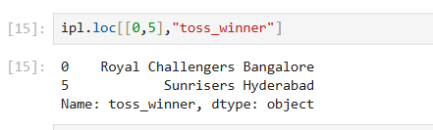

Q13. Find all matches where a specific team won the toss

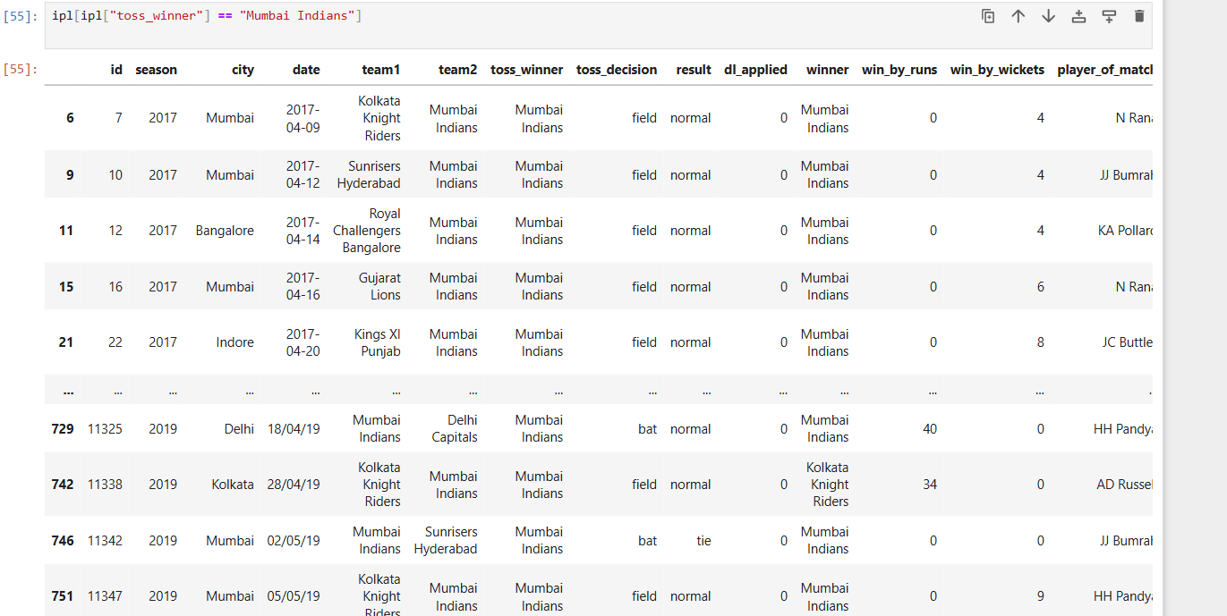

Q14. Count unique seasons

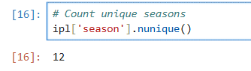

Q15. List all seasons

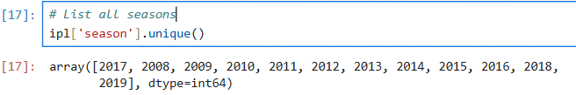

Q16. select twwo columns from index no2 and end on index no20 and skip at 2

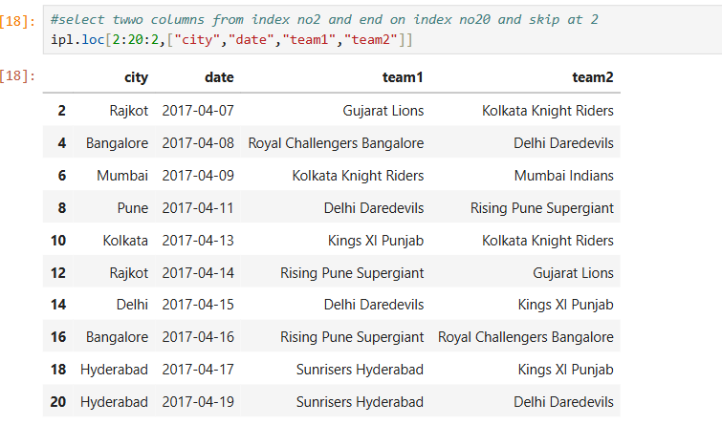

Q17. Find all matches played in a specific season

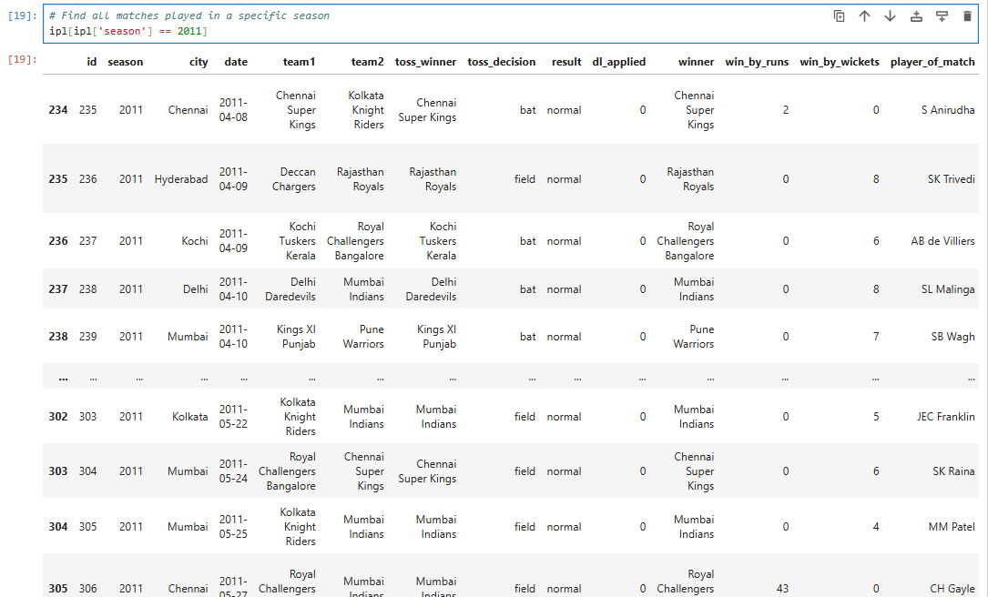

Q18. Count matches played by each team

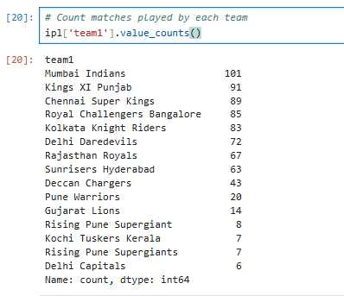

Q19. How to count match wins by each team in Pandas

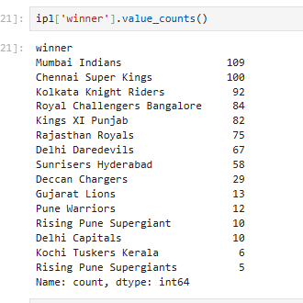

Q20. How to get the top 10 teams with the most wins in an IPL dataset using Pandas

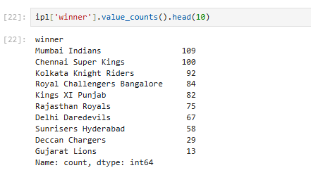

Q21. How to count matches where the toss winner also won the game

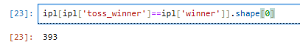

Q22. Find the most common toss decision

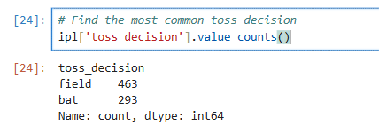

Q23. Find how many matches were won by batting first vs chasing

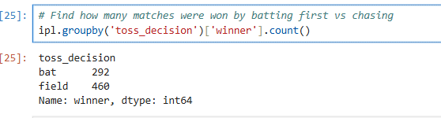

Q24. Find the most common venues for matches

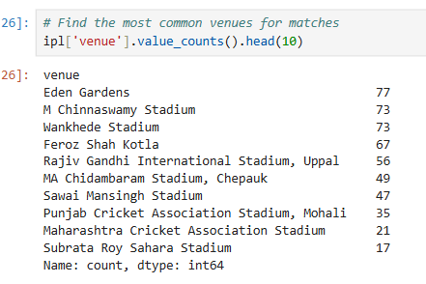

Q25. Matches won by the highest margin (runs)

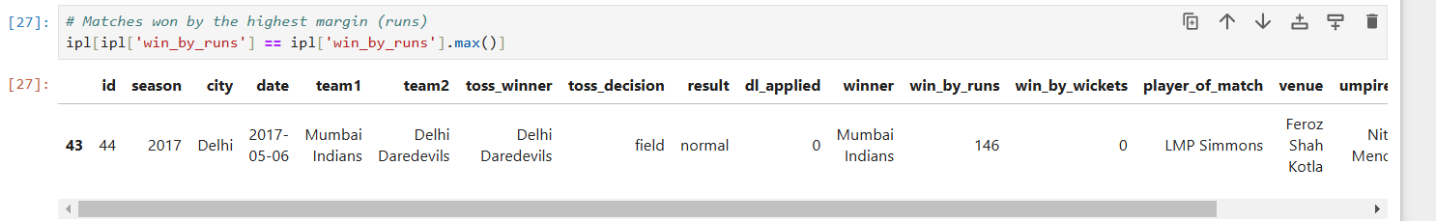

Q26. Find the teams that won by 10 wickets the most

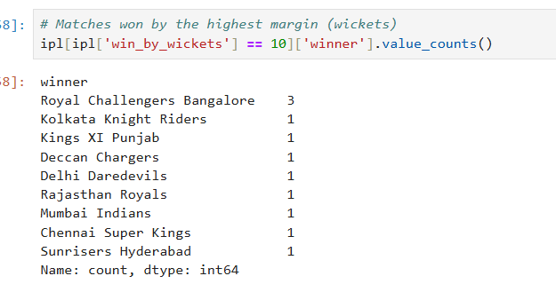

Q27. Matches that were tied

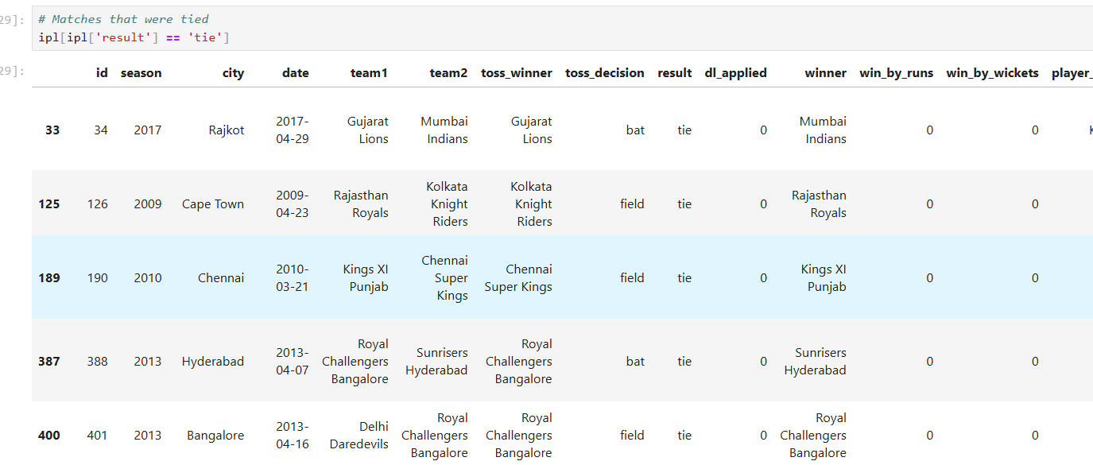

Q28. Check if there are any matches where win_by_wickets is 1

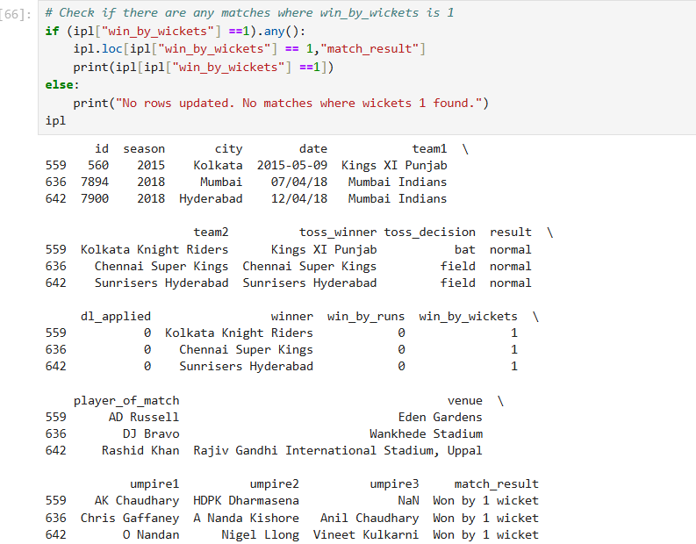

Q29. How to find and sort umpire pairings by the number of matches officiated

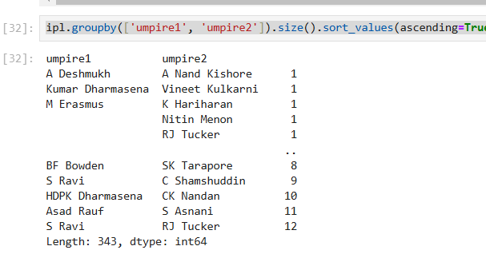

Q30. Find matches where Duckworth-Lewis (DL) method was applied and check the toss decision

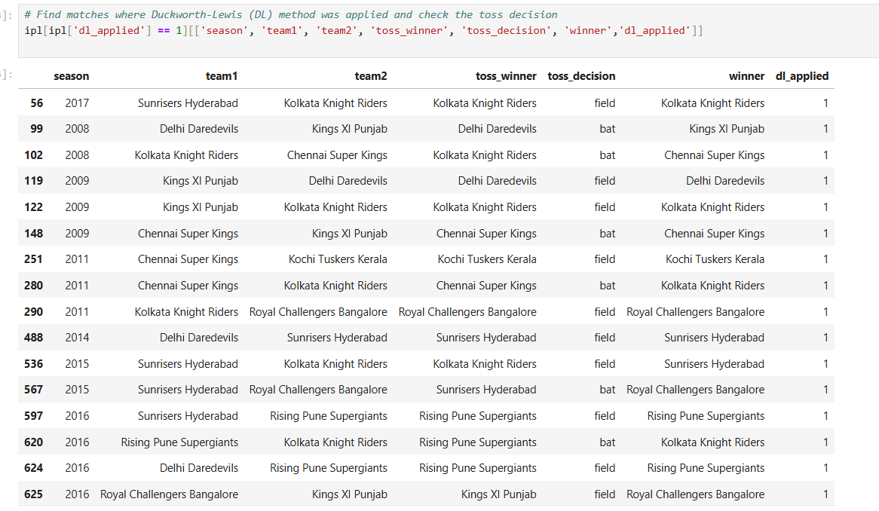

Q31. How to get match wins per team per season

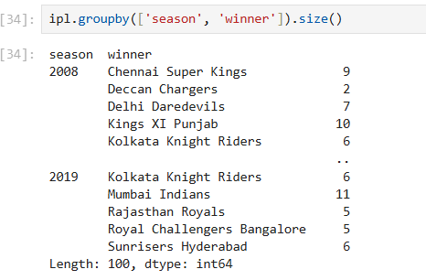

Q32. Convert columns to NumPy arrays

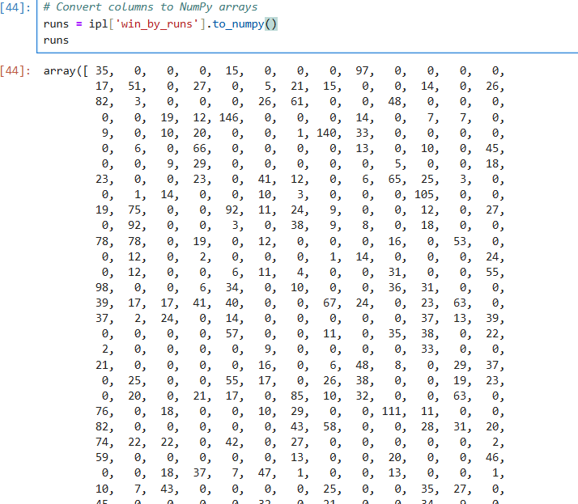

Q33. Median wickets in winning matches

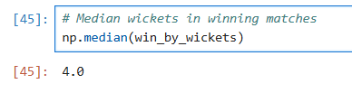

Q34. Maximum and minimum victory margins by runs

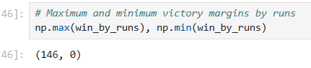

# Q35. **Find matches where teams won by more than 120 runs**

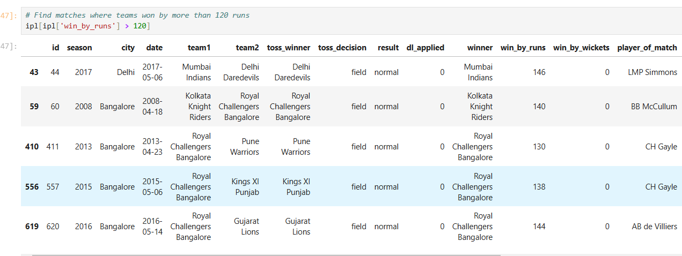

Q36. Find matches where teams won by exactly 2 wickets

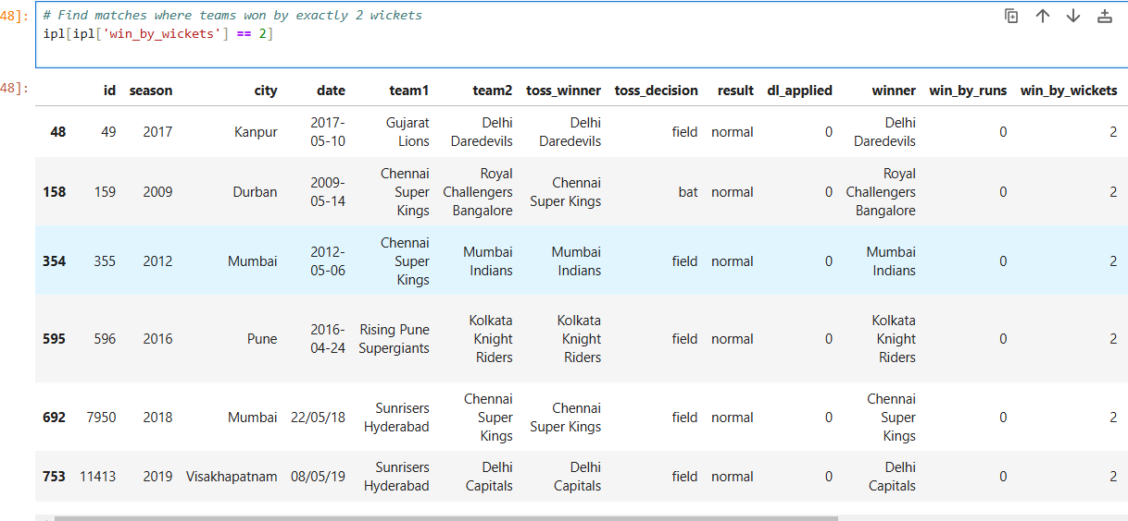

Q37. Standard deviation of victory margins by runs

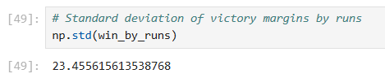

Q38. Count matches where teams won by exactly 1 wicket

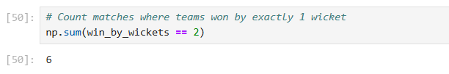

Q39. How to filter matches where 'dl_applied' is in the winner column

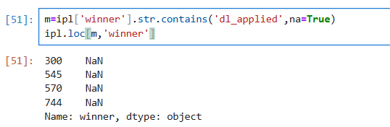

Q40. Count the number of matches won by each team

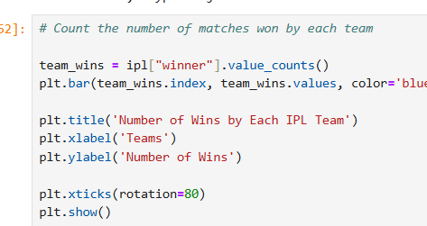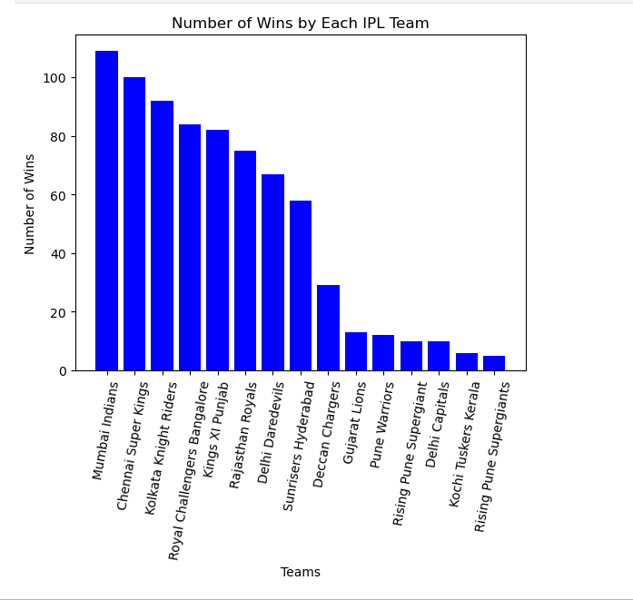

Q41. toss_decisions in pie chart. 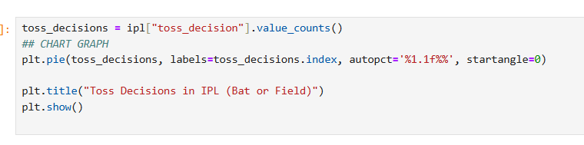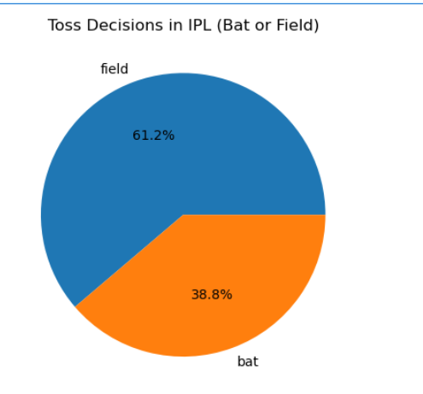

Q42. Histogram to reprsent win_by_wickets

