BMISystem User Manual

**Version <1.0>**

**2015719243**

**Cem ŞANAL**

**09/01/2017**

**CONTENT**

1. FACILITY INFORMATION 2

2. VERSION TRACKING 2

3. SOFTWARE INSTALLATION 2

4. FUNCTIONAL USES/OPERATIONAL CAPABILITIES 2

1. Step by Step Guide of the Basic Capabilities 3

1. User Registration 3

2. User Login 4

3. Food Search from USDA Food Database 4

Step 2: Examine your fetched foods 5

4. Add Food 5

5. Users Food Showcase 6

6. Add Activity 6

7. Users Activity Showcase 6

# FACILITY INFORMATION

BMISystem project is supported from Boğaziçi University. The project is the term project of graduate program class which is named as “Software Development Practice” under the supervision of Suzan Üsküdarlı.

# VERSION TRACKING

All developments and changes could be traced from GitHub. (<https://github.com/sanal-cem/Fall2016Swe573_Cem_Sanal>)

**Wiki** section is for tracing general improvements and further documentation.

# SOFTWARE INSTALLATION

No installation required.

# FUNCTIONAL USES/OPERATIONAL CAPABILITIES

Design and development of a web system that suggest different foods and activities to overcome people’s health issues such as being overweight using BMI calculation.

Body Mass Index (BMI) is simply a guideline to track weight issues. It is a measurement of body fat based on weight. BMI calculation for females and males would differ. BMI is the amount of fat content in the body as related to height and weight. This is a way of measuring the fat content and muscle mass so that the person knows whether they are healthy or whether they can be prone to health problems like cardiovascular diseases, diabetes, or even certain types of cancer.

## Step by Step Guide of the Basic Capabilities

### User Registration

**Step 1:** Enter your registration information.

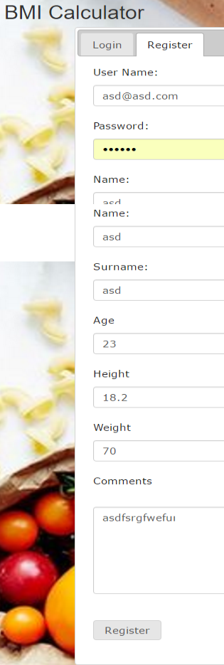

**Step 2:** Press and move to Login page.

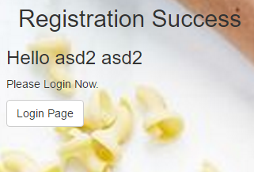

### User Login

**Step 1:** Enter Your information.

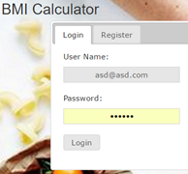

**Step 2:** Choose a task

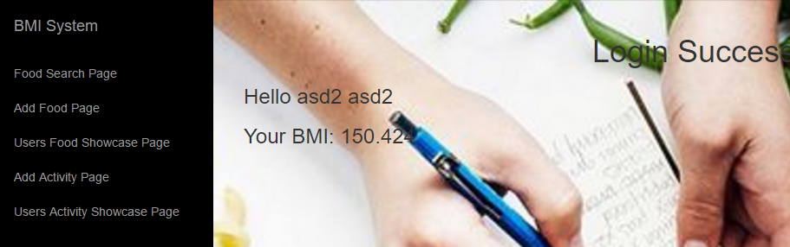

### Food Search from USDA Food Database

**Step 1:** Write a food name

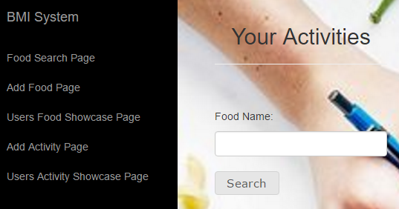

### Step 2: Examine your fetched foods

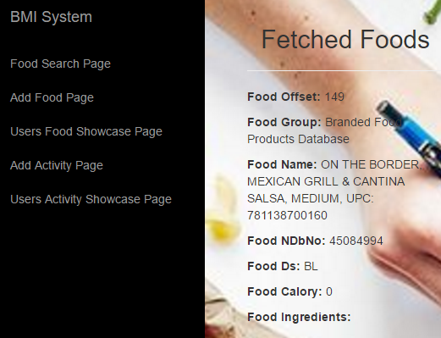

### Add Food

**Step 1:** Enter your food information

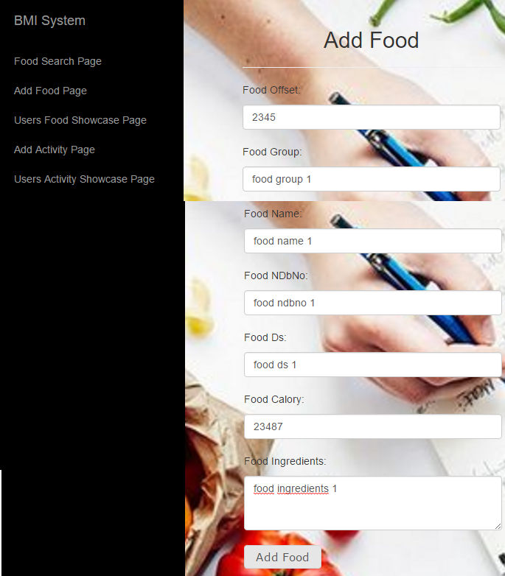

**Step 2:** You will see only a success message and your food name.

### Users Food Showcase

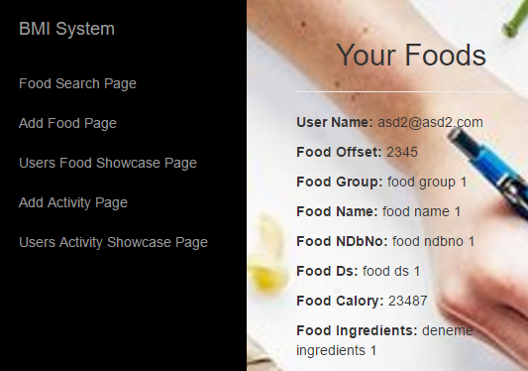

### Add Activity

Steps are exactly the same as steps of Add Food page. However, an activity date should be chosen from the date picker.

### Users Activity Showcase

