BLUESTOCK DATA ANALYTICS INTERNSHIP

EXPLORATORY DATA ANALYSIS (EDA) REPORT

MUTUAL FUND ANALYTICS PROJECT

Prepared By:
S. Bhavana
Internship:
BlueStock Data Analytics Internship
Project:
Mutual Fund Analytics
Report Type:
Exploratory Data Analysis (EDA) Report
Submission Date:
02 August 2026

1. Objective
The objective of this project is to analyze mutual fund data using Python, SQL, and Power BI. The project focuses on cleaning the data, performing exploratory data analysis (EDA), writing SQL queries, and creating an interactive dashboard to gain meaningful business insights.

2. Datasets Used
Three datasets were used in this project.
2.1 NAV History
This dataset contains the historical Net Asset Value (NAV) of different mutual fund schemes over time.
2.2 Investor Transactions
This dataset contains investor details, transaction type, investment amount, payment mode, KYC status, age group, gender, state, and city.
2.3 Scheme Performance
This dataset contains information about mutual fund schemes, including returns, AUM (Assets Under Management), expense ratio, risk grade, and ratings.

3. Data Cleaning Process
The following data cleaning steps were performed using Python:
- Removed duplicate records.
- Checked for missing values.
- Converted date columns to DateTime format.
- Sorted the data for better analysis.
- Validated NAV values.
- Validated transaction amounts.
- Verified KYC status.
- Standardized transaction type names.
- Saved the cleaned datasets into the Processed folder.

4. Exploratory Data Analysis (EDA)
The cleaned datasets were analyzed to understand investor behavior and mutual fund performance.
The following analyses were performed:
- Dataset information
- Data types
- Descriptive statistics
- Missing value analysis
- Transaction type analysis
- Payment mode analysis
- KYC status analysis
- State-wise transaction analysis
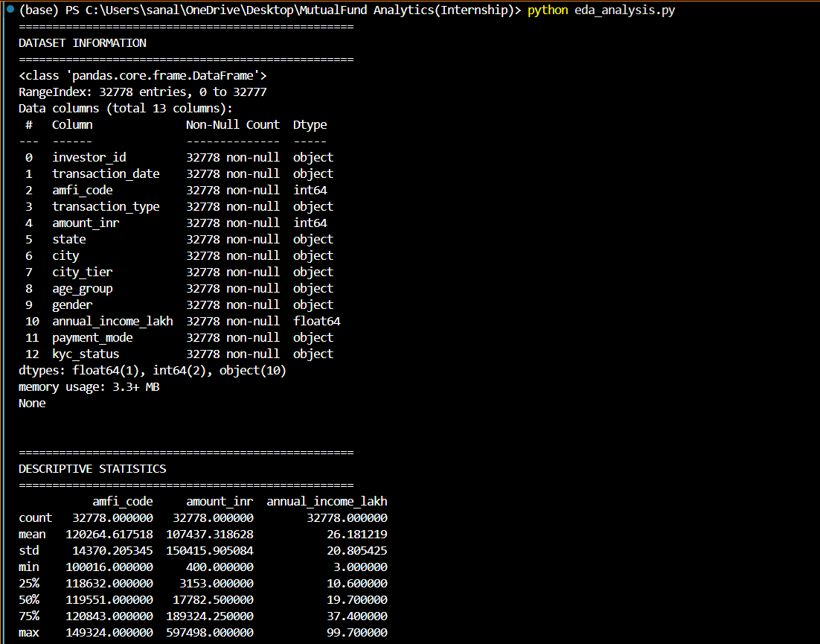
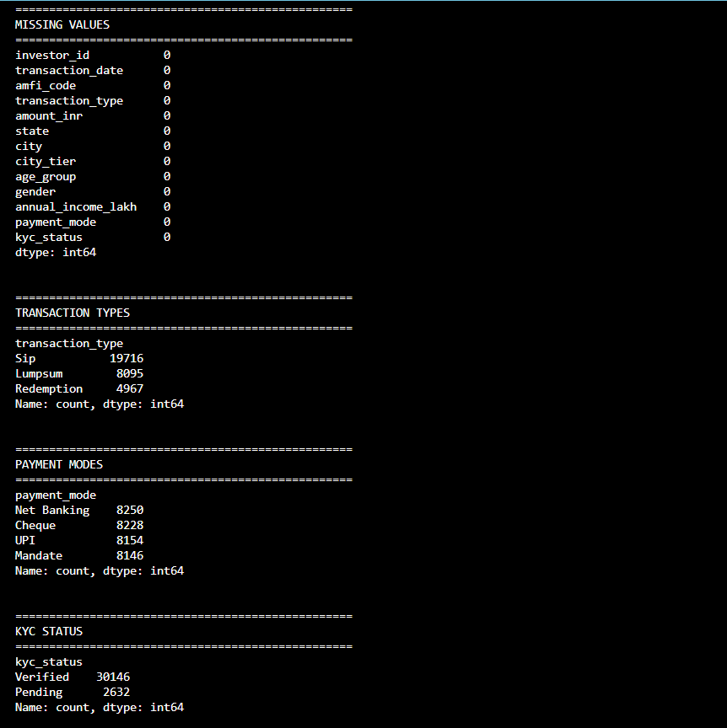
5. Key Findings
The analysis provided the following insights:
- Total Transactions: 32,778
- Total NAV Records: 46,000
- Total Mutual Fund Schemes: 40
- SIP is the most common transaction type.
- Most investors have completed KYC verification.
- Net Banking, UPI, Cheque, and Mandate are commonly used payment modes.
- Punjab recorded the highest number of investor transactions in the dataset.
6. SQL Analysis
SQLite was used to create the project database. SQL queries were executed to analyze the data.
The following analyses were completed:
- Total number of transactions
- Total investment amount
- Average investment amount
- Transaction type analysis
- Investment by transaction type
- Top 10 schemes by AUM
- Average expense ratio
- Highest 1-year return
- Risk grade distribution
- NAV statistics
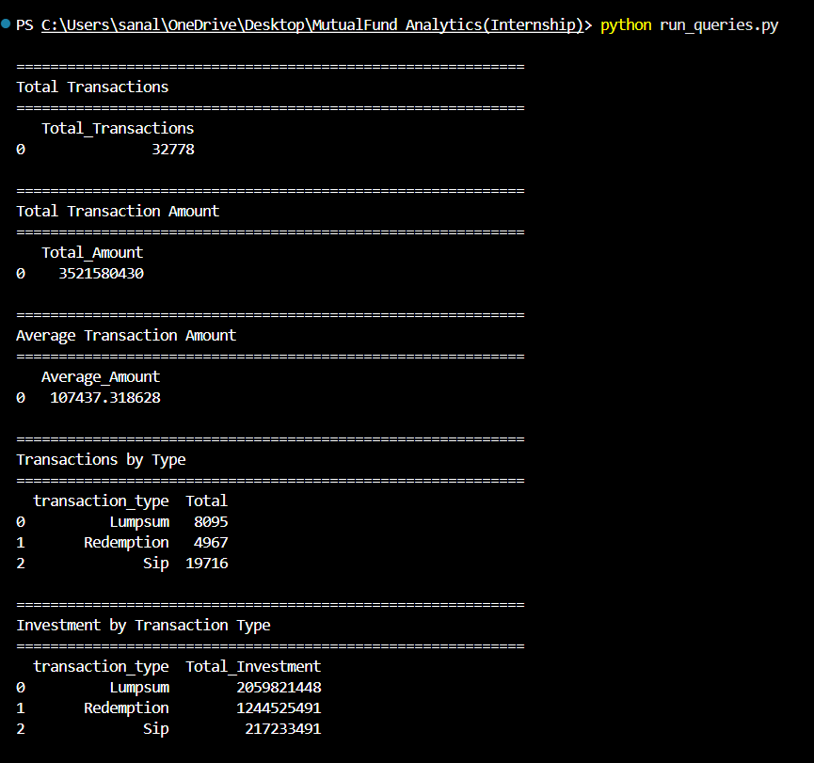
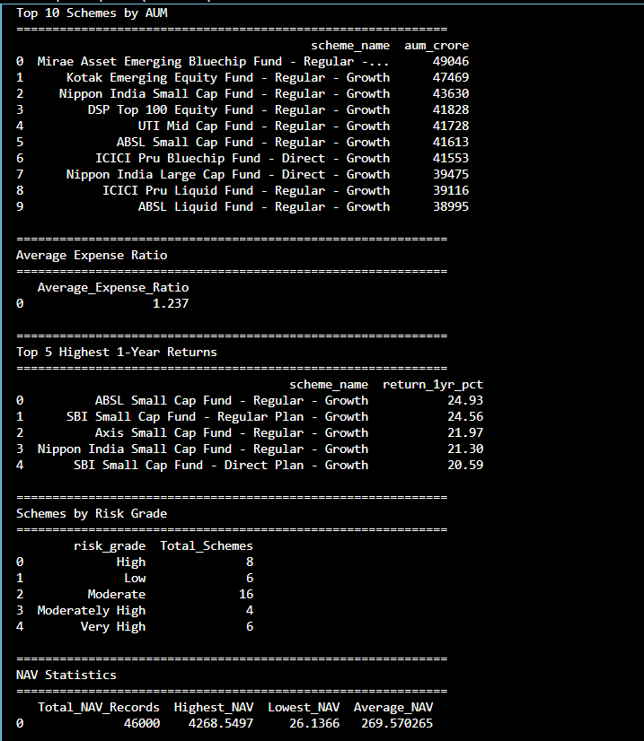
7. Power BI Dashboard
An interactive dashboard was developed in Power BI to visualize business insights.
The dashboard includes:
KPI Cards
- Total Transactions
- Total Investment
- Average Investment
- Total Schemes
- Average Expense Ratio
Charts
- Transaction Type Distribution
- Payment Mode Analysis
- KYC Status Distribution
- Top 10 States by Investment
- Risk Grade Distribution
- Expense Ratio by Fund House
- NAV Trend
Interactive Filters (Slicers)
- Transaction Type
- State
- Payment Mode
- KYC Status

8. Tools & Technologies Used
- Python
- Pandas
- NumPy
- SQLite
- SQL
- Microsoft Power BI
- Microsoft Excel
- Visual Studio Code
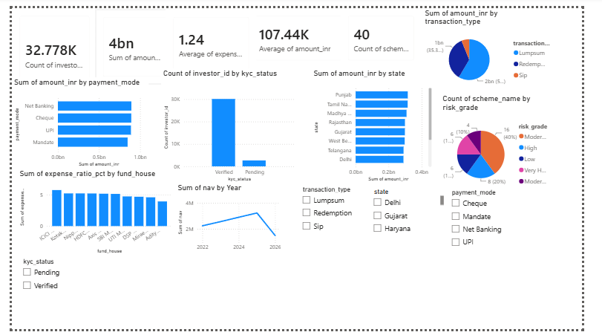

9. Conclusion
This project successfully demonstrated the complete data analytics workflow. The datasets were cleaned using Python, stored in a SQLite database, analyzed using SQL, and visualized through an interactive Power BI dashboard. The analysis helped identify investment patterns, transaction trends, and mutual fund performance, providing meaningful insights for decision-making.

