Case Study Module4: Microservices Security

Problem statement

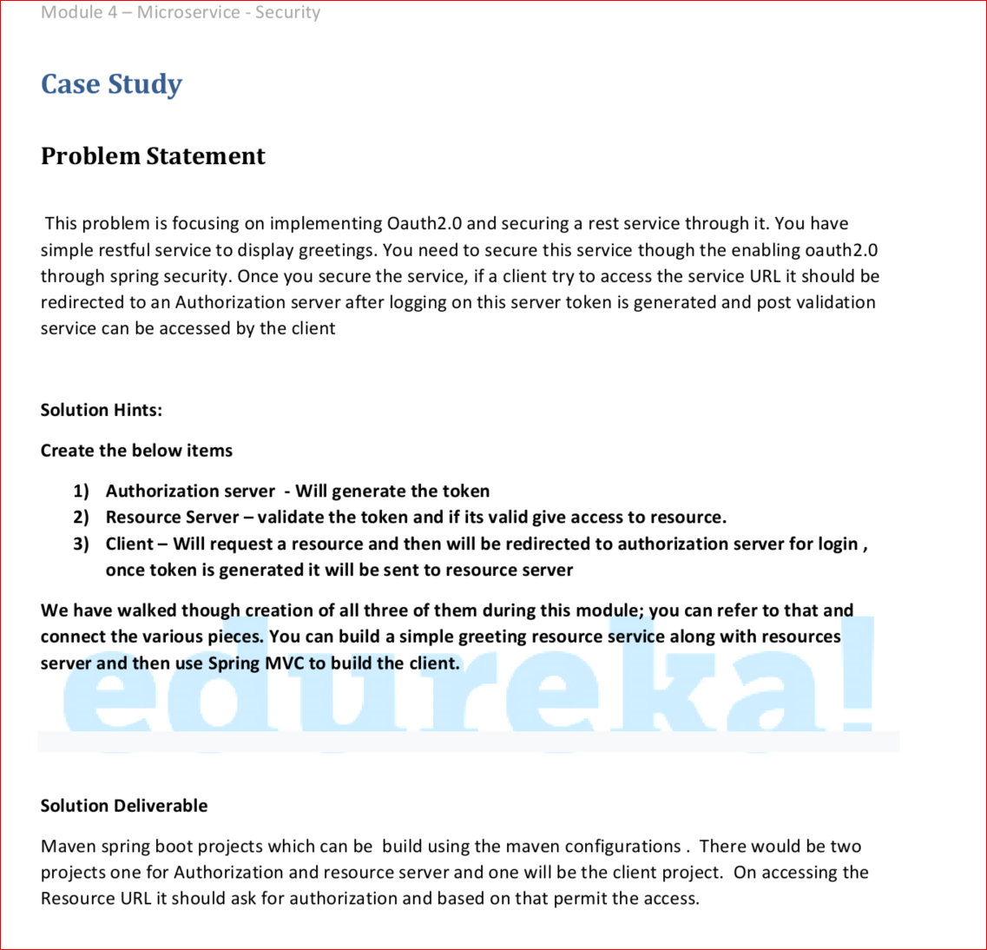

Solution

Create endpoint for greetings

<http://localhost:8090/greetings>

by default direct access is denied as shown in the below screen

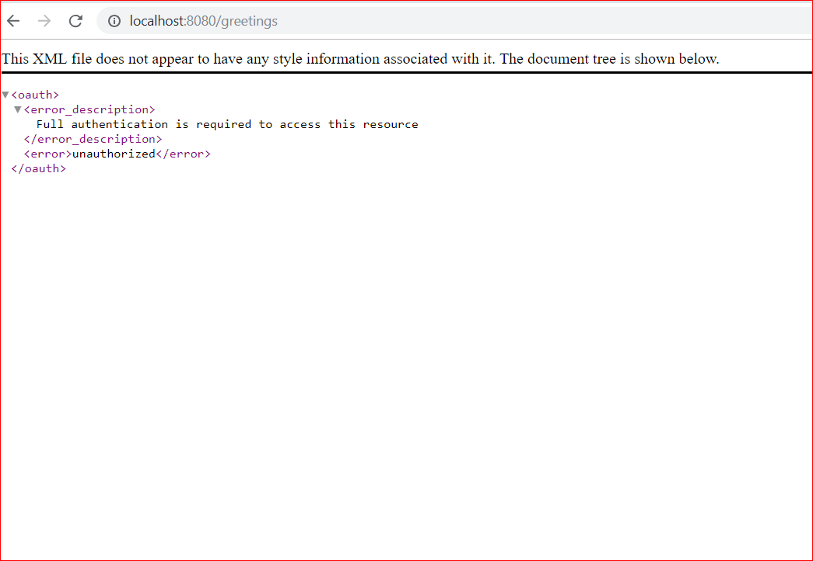

Create a client as shown in below screen, client will ask for the resource

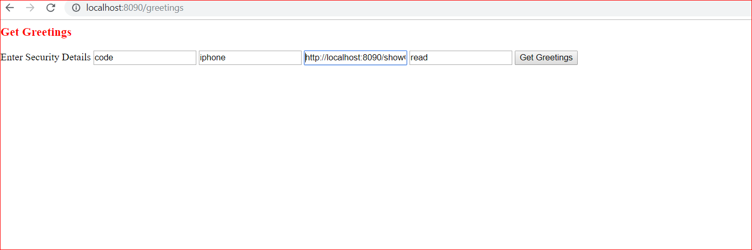

Request will go to the resource server, which will ask for the credentials as shown below

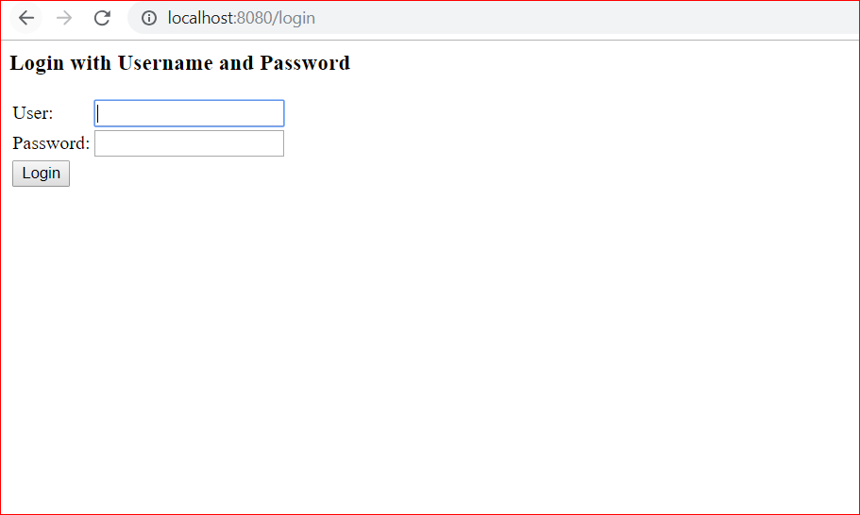

On successful login it will ask for approval

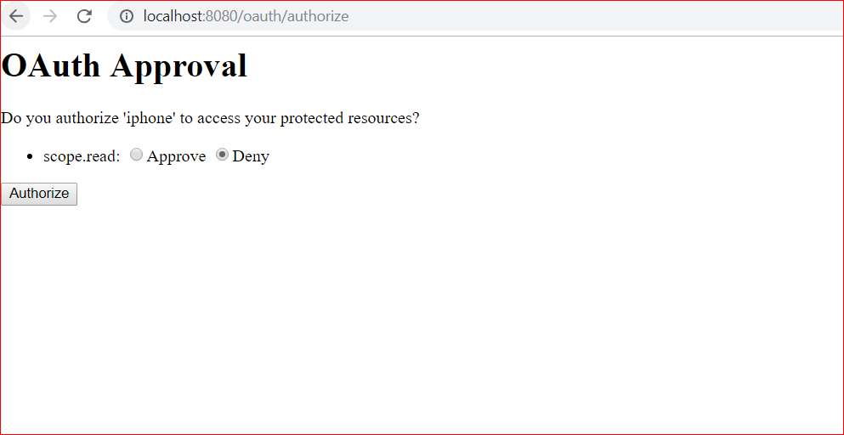

Once approved client is able to get the access to the resource as shown below.

