Case Study

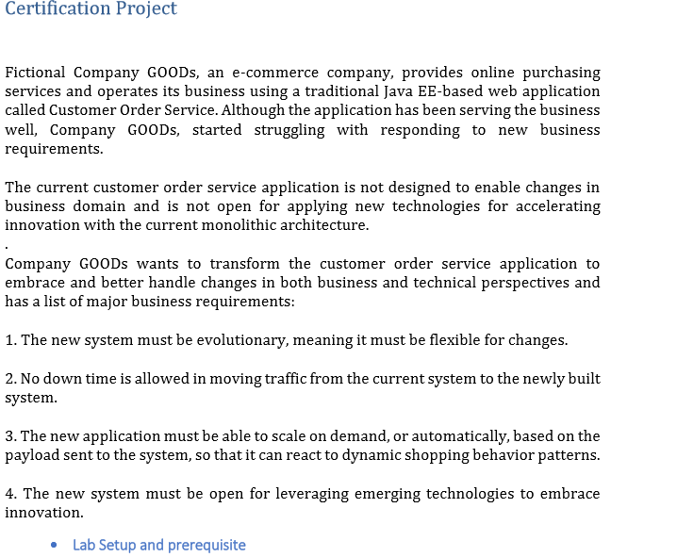

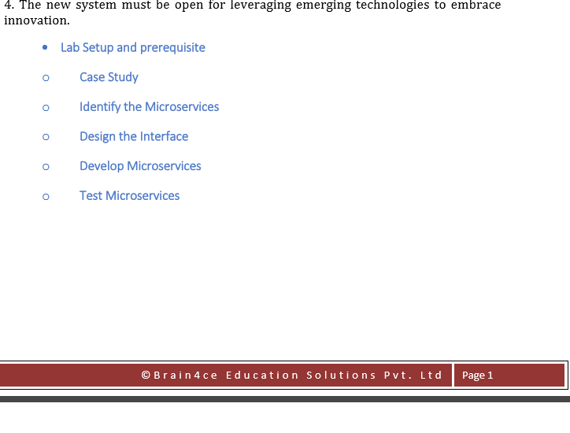

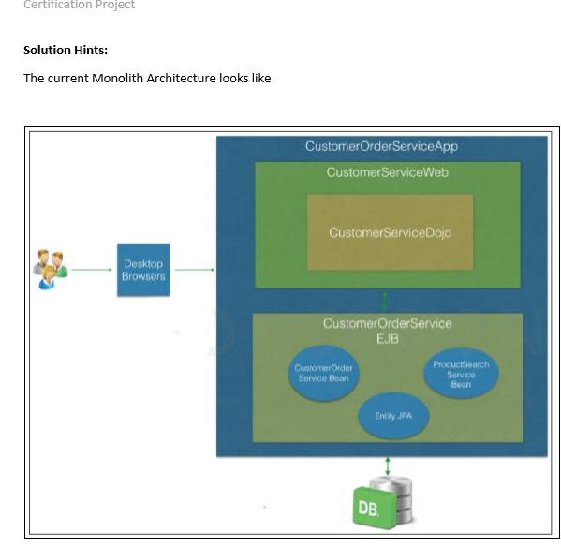



Solution:

Below architecture depicts our solution. Here inter process communication is shown between order service and product service via zuul gateway, service discovery, rest-template and feign,ribbon.

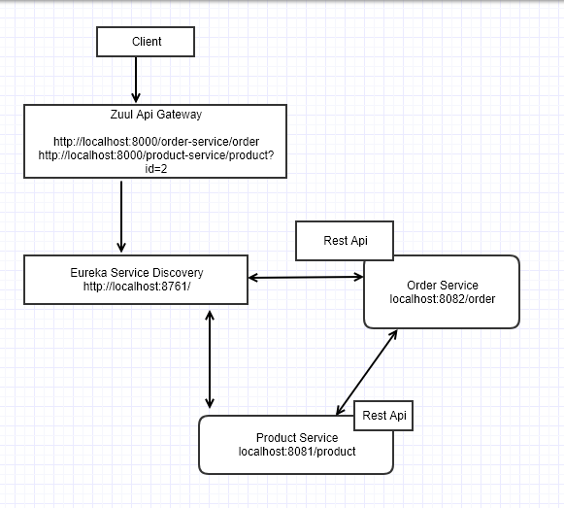

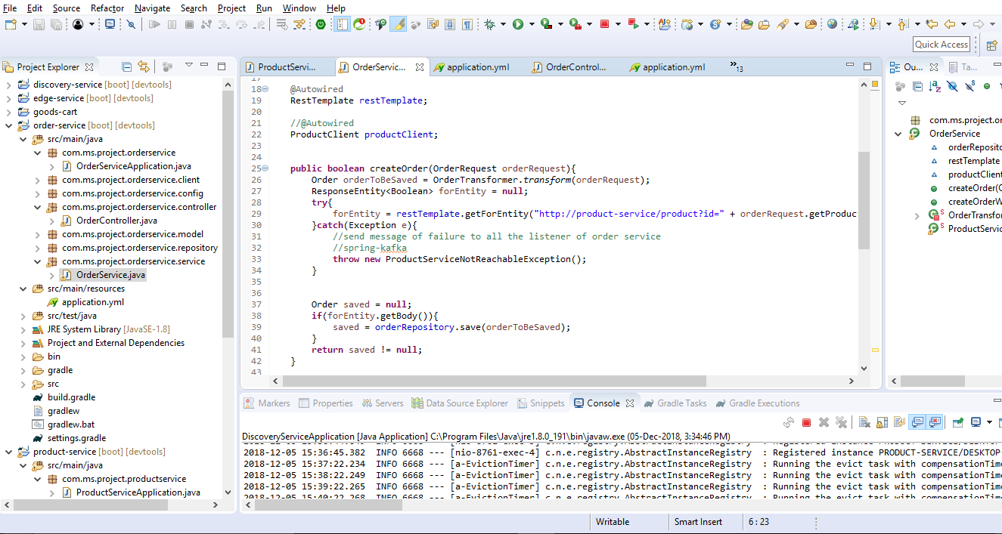

For creating order order-service communicates with product-service if product exists, if yes it creates order.

Here are four tasks we are going to provide the solution

1. Break the monolithic
2. Identify the applications that could exist independently and converted into micro-services
3. Identify the right inter-service communication
4. Build one of the services using spring boot
5. Break the monolithic

Below design depicts the monolithic break down for goods purchasing business, however as per the above Given design we need to focus on Order Service and Product Service

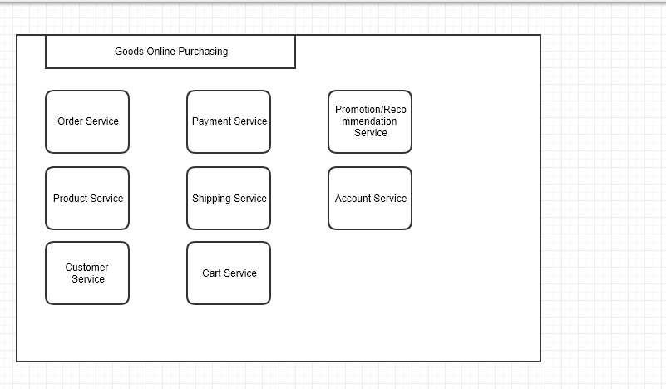

1. Identify the applications that could exist independently and converted into micro-services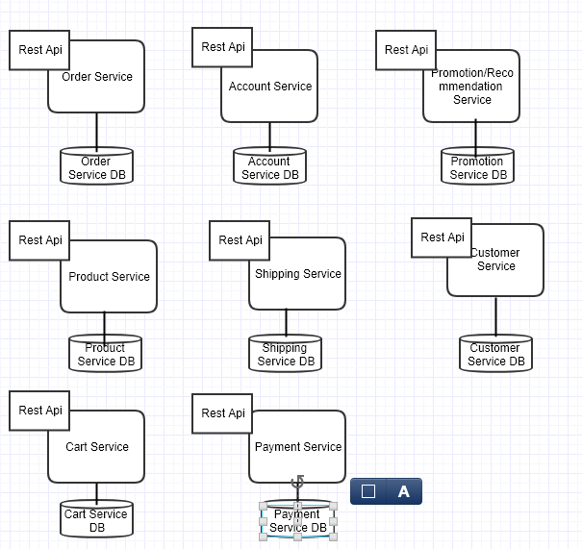
2. Identify the right inter-service communication

We can us Zuul Proxy as API gateway, eureka discovery service, rest-template, feign and ribbon for inter-process communication

1. Build one of the services using spring boot

Here we have created order-service and product-service, also there are additional services to support inter-process communication, below is the description for each

1. goods-cart -> root project which includes subprojects
2. product-service -> Creates product
3. order-service -> communicate with product-service if product exists it creates order
4. discovery-service -> to register all the services and used for discovery.
5. edge-service -> service for API gateway via Zuul proxy

Post request to create product

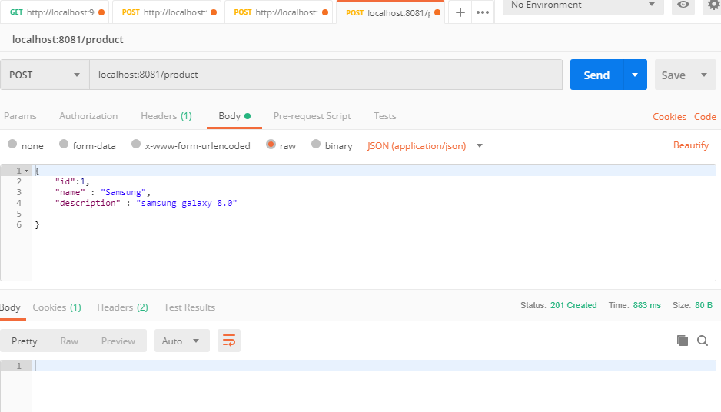

Got to h2-console and confirm if product created

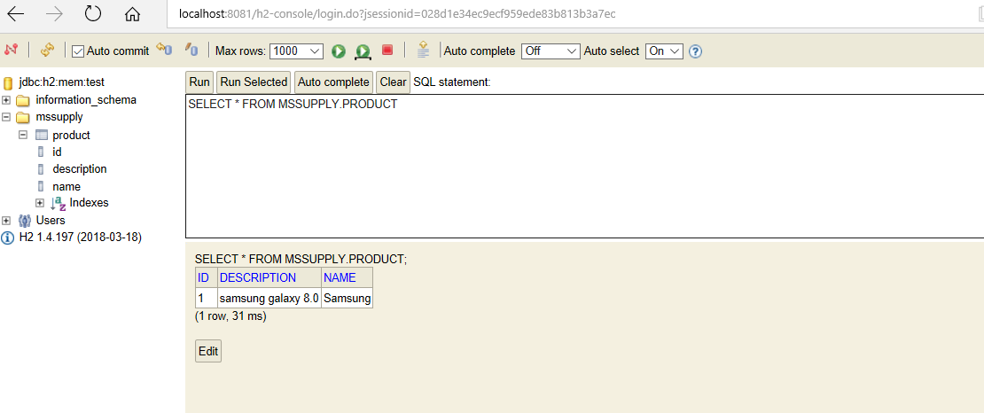

Get request to get the product

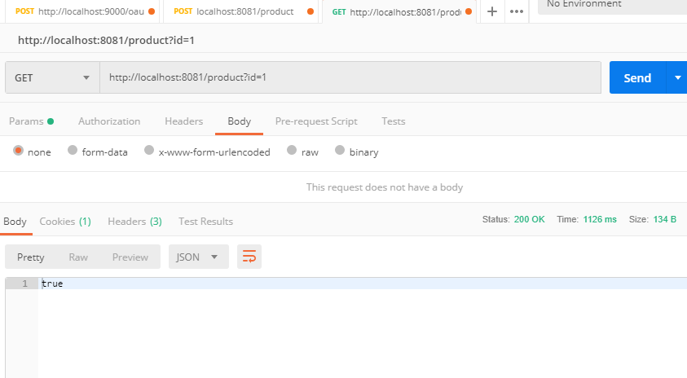

Discovery Service:

localhost:8761

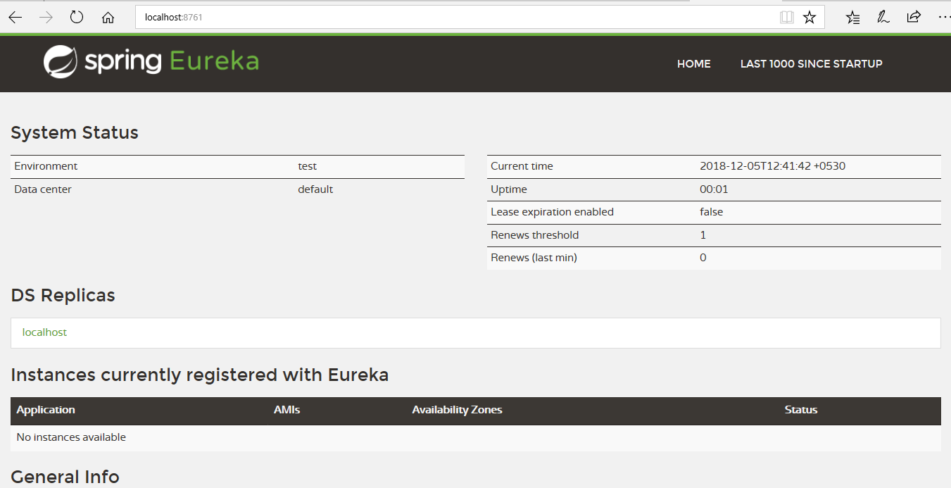

Add product service instances

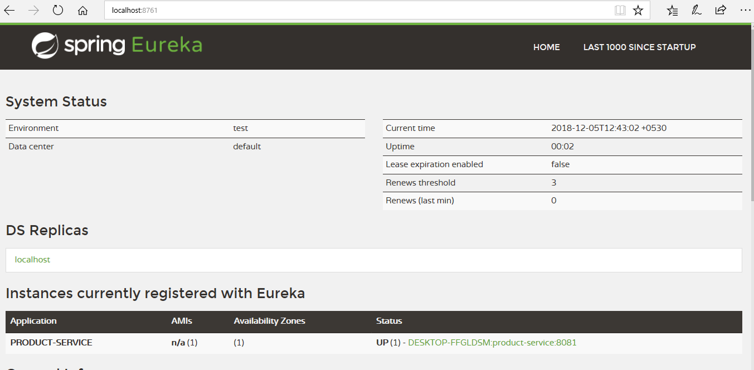

Add order service instance

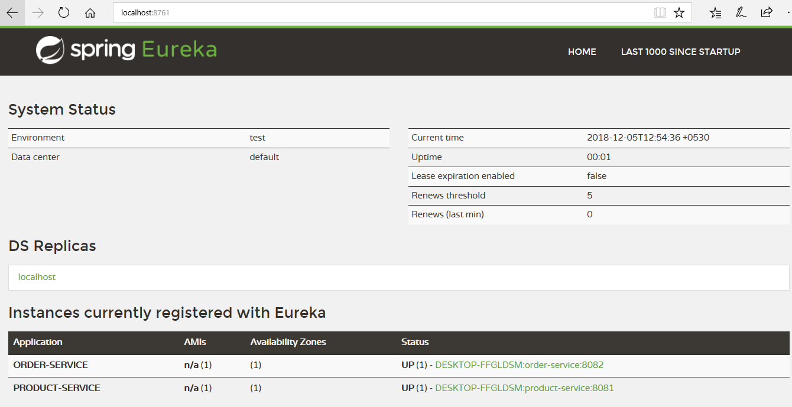

Create Order using rest-template to show inter-service call

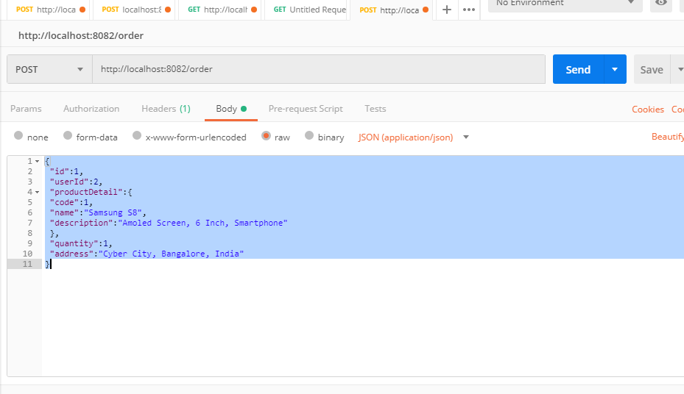

Create Zuul Proxy and register with Eureka

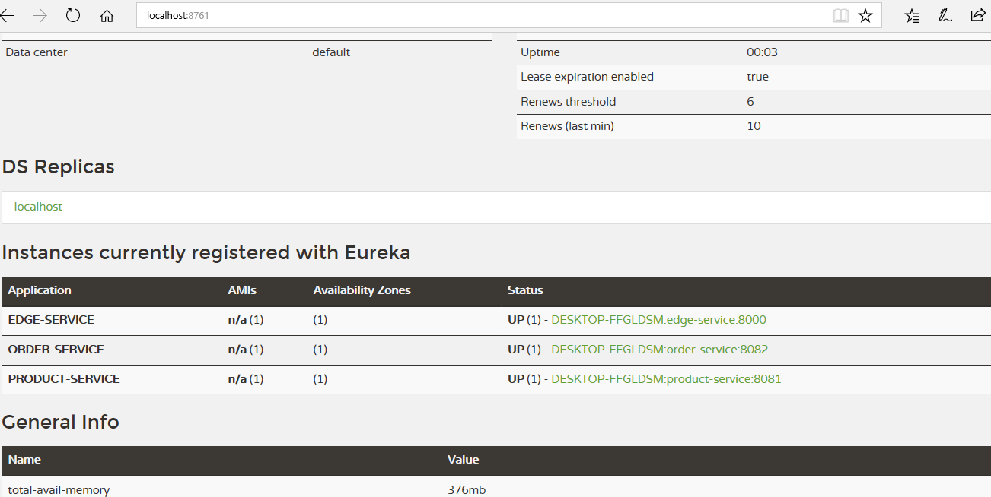

Restart the server

Create Product

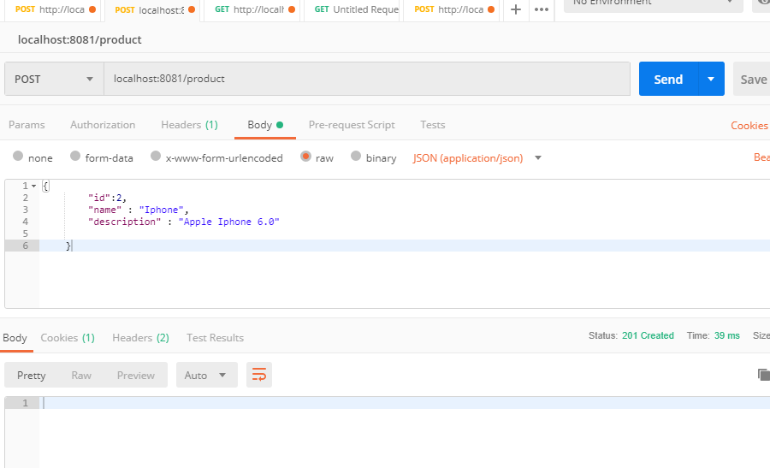

H2-console for product

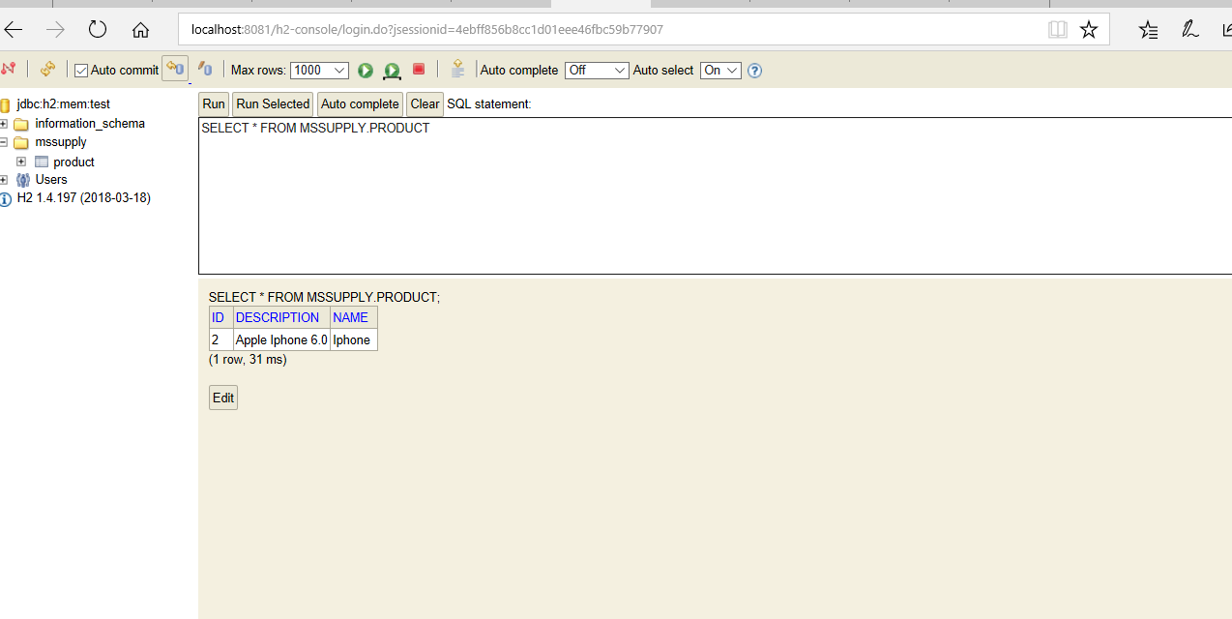

Use Zuul proxy to get the product

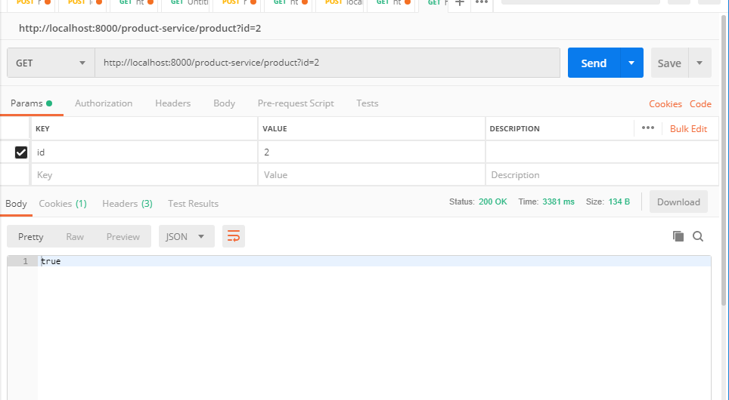

Use Zuul proxy to create the order

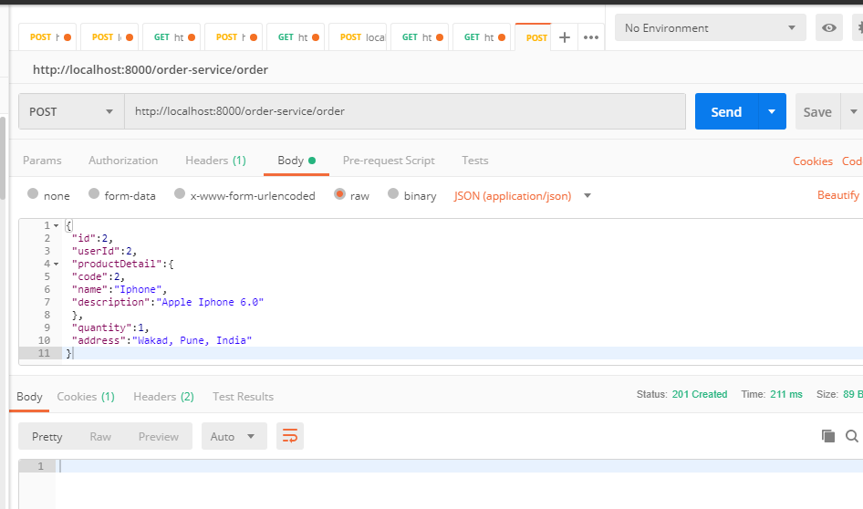

H2-consoles

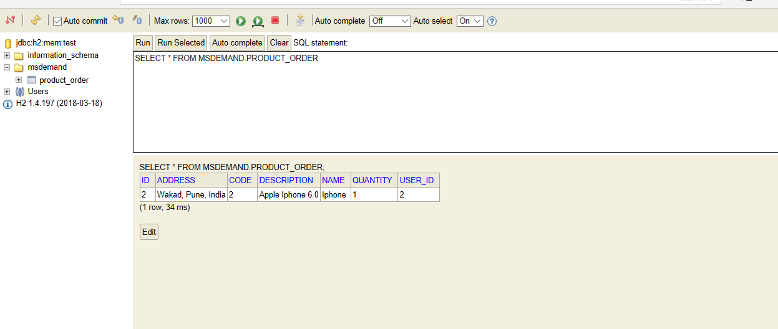

Thanks