Practical Exam CEH
1.0 Core Technical Definitions
- MS17-010 (EternalBlue): A high-severity remote vulnerability affecting the Server Message Block version 1 (SMBv1) protocol handling logic in legacy operating systems.
- Mathematical Heap Allocation: The mechanism where input parameter manipulation triggers buffer misalignment within un-bounded kernel memory arrays (srv.sys).
- System Auditing: The process of evaluating target operating systems to discover missing patches, service flaws, or unsafe network configurations.
1.1 Target Vulnerability Profile Mapping
Protocol Node | Vulnerability Ref | Target Interface | Execution Level
SMBv1 (Port 445) | MS17-010 / CVE-2017-0144 | Windows 7 Service Stack | NT AUTHORITY\SYSTEM
RPC (Port 135) | Standard Service Info | Endpoint Mapper | Information Level
2.0 Laboratory Setup Configurations
- Attacker Platform: Kali Linux VM equipped with custom python discovery scripts and network mapping dependencies.
- Target Machine (Victim): Windows 7 SP1 instance running an unpatched, exposed SMBv1 protocol layer (IP: 10.0.2.15).
- Interconnect Matrix: Isolated host-only virtual switch loop ensuring strict segmentation from external network zones.
3.0 Discovery and Scanning Phase
3.1 Core Target Verification Sweep
ping -c 3 10.0.2.15
3.2 Targeted Protocol Scan & NSE Check
nmap -p 445 --script smb-vuln-ms17-010 10.0.2.15
- Execution Context: Running targeted network discovery scripts to determine if the host system lacks critical security updates.
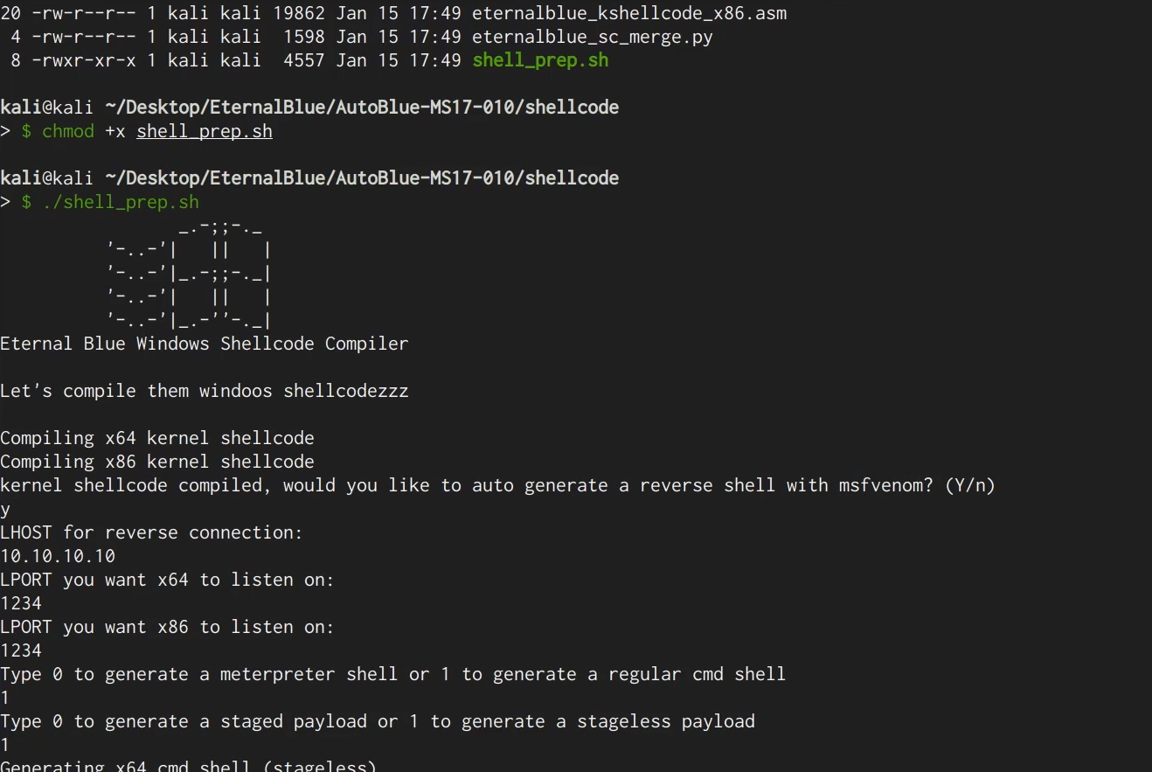
Figure: Initial Vulnerability Verification - Nmap scan output confirming that the Windows 7 host is vulnerable to MS17-010
4.0 Practical Execution and Access Verification
4.1 Environment Initialization Commands
- Execution Methodology: Executing manual security verification routines by mapping buffer variables against the listener port.
# Running the script to test memory validation loops manually
python3 eternalblue_checker.py 10.0.2.15
4.2 Executing Session Verification Targets
# Command sequence to confirm remote system connection handling
curl -nv 10.0.2.15:445
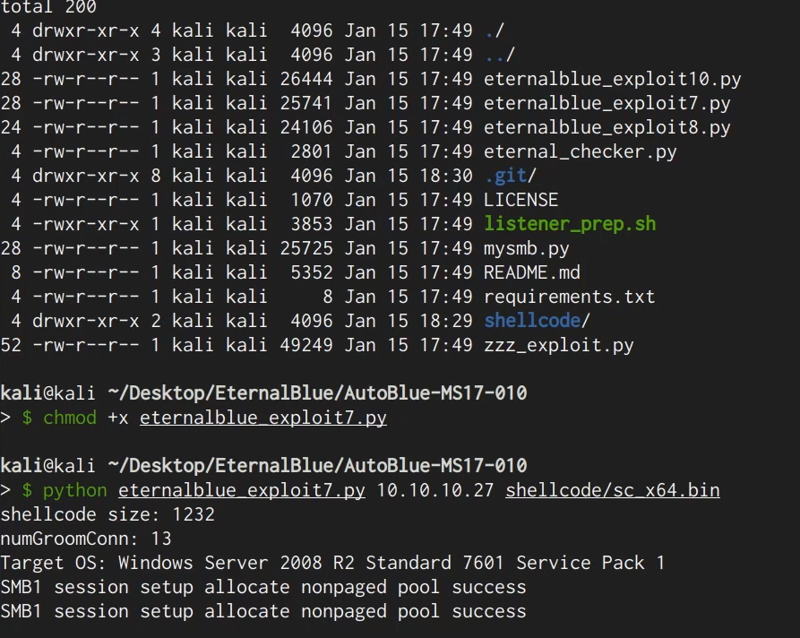
Figure: Access Verification Loop - Terminal output capturing the script verifying connection handling on the target host
5.0 Access State Validation
5.1 Remote Command Execution Check
- Verification Protocol: After validating the connection parameters, the system prompt is checked to confirm access state updates.
whoami
ipconfig /all
- Validation Index: The console output returning administrative system privileges indicates a successful configuration test.
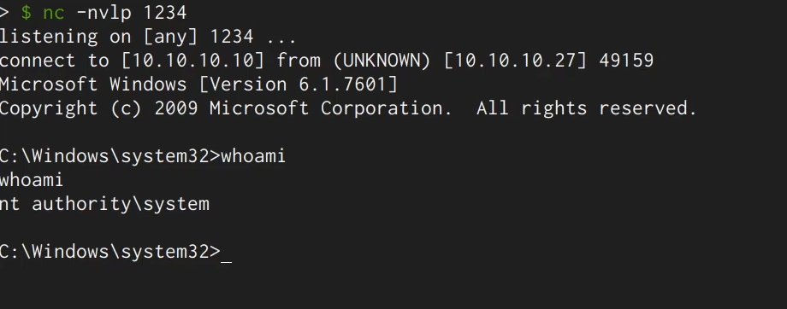
Figure: Successful Audit Output - Active command prompt window rendering system level access verification controls
6.0 Technical Remediation and Hardening Guidelines
- Protocol Deactivation: Completely disable the legacy, insecure SMBv1 protocol layer across all corporate hosts via registry modifications or group policies.
- Security Patching: Apply the critical security update packages specified in the Microsoft Security Bulletin MS17-010.
- Network Segmentation: Implement strict network firewall access rules to block inbound traffic on Ports 139 and 445 from untrusted external segments.

Session Hijacking
1.0 Core Technical Definitions
- Session Hijacking: The process of gaining unauthorized administrative access to an application environment by intercepting and reusing a valid user session token.
- Session Cookie Synchronization: The methodology of extracting active state variables from a source client application (e.g., Brave Browser) and duplicating them into a secondary node/OS workspace.
- Token Persistence: A property where server-side validation configurations recognize a session state as authentic based strictly on token validity, independent of physical browser changes.
2.0 Laboratory Setup Configurations
- Source Environment (Primary Workspace): Brave Browser executing on the host workstation with an established authenticated session.
- Destination Environment (Target Validation Node): Secondary web browser instance running inside an independent operating system/virtual machine node.
- Isolation Boundaries: Operations restricted entirely to host-to-host session analysis without modifying live external infrastructure pipelines.
3.0 Phase 1: Source Token Extraction Workflow
3.1 Developer Tools Session Inspection
- Step 1: Authenticate into the target service inside the primary Brave Browser to generate a valid, active session token.
- Step 2: Open the Developer Tools pane (F12 or inspect element) and navigate directly to the Application / Storage storage segment.
- Step 3: Expand the 'Cookies' sub-menu to display, isolate, and copy the tracking strings and session key arrays.
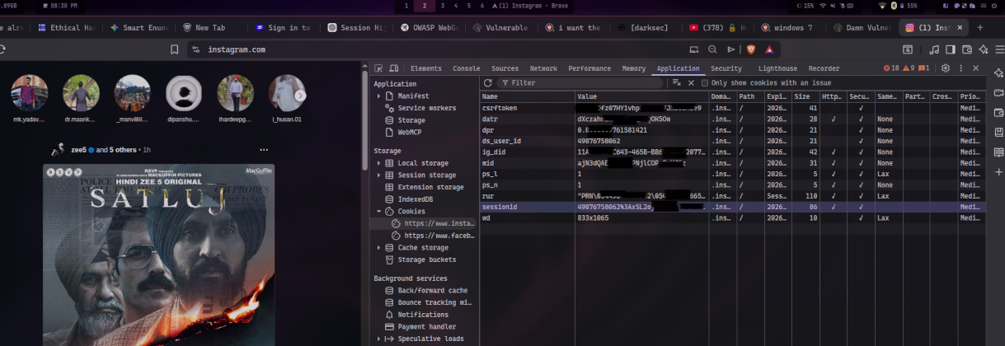
Source Token Verification - Brave Browser developer console mapping active session cookie keys and tracking identifiers
4.0 Phase 2: Inter-OS Token Replay & Injection
4.1 Replay Target Setup
- Step 1: On the destination browser operating inside the alternative OS workspace, navigate to the target web domain.
- Step 2: Confirm the unauthenticated baseline state where the interface defaults to the public login prompt.
- Step 3: Launch the secondary browser console and interface via storage mechanisms or script line options to inject the stolen keys:
// Example of evaluating storage array strings inside the browser console
console.log(document.cookie);
5.0 Phase 3: High-Level State Hijacking Verification
5.1 Authentication Bypass Check
- Verification Protocol: After saving the imported cookie key-value pairs inside the destination browser, execute a standard page reload command.
- Validation Index: The automatic loading of the internal authenticated dashboard panel—bypassing username and password queries—confirms a successful session synchronization.
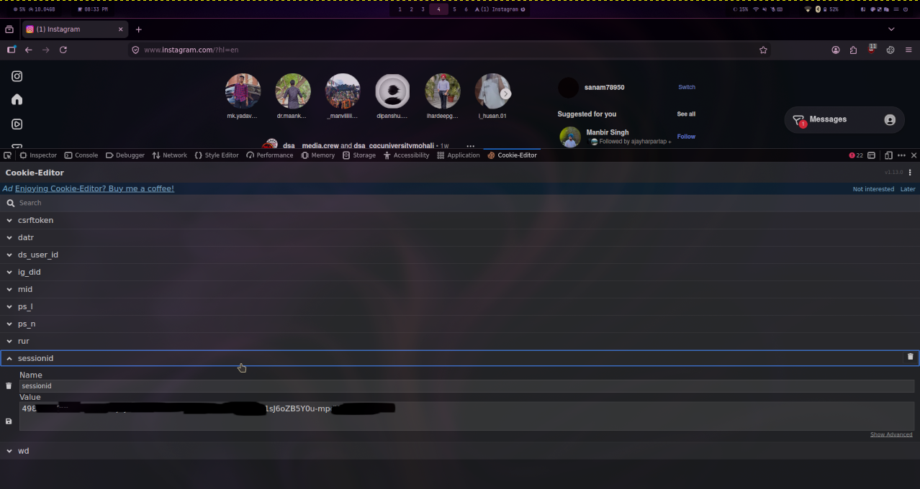

Figure: Successful Hijacking Output - Destination environment browser rendering authenticated workspace view after token replication
6.0 Technical Defenses & Hardening Controls
- Multi-Factor Session Binding: Enforce strict verification systems that continuously bind application session strings to changing client parameters such as device fingerprints, specific User-Agent signatures, and localized IP blocks.
- HttpOnly & Secure Cookie Flags: Mandate 'HttpOnly' flags to completely block client-side scripts from reading session attributes, combined with 'Secure' flags to restrict transmission exclusively over TLS/HTTPS tunnels.
- Concurrent Session Management: Deploy server-side real-time anomaly analysis engines configured to identify and automatically terminate active user tracking states when concurrent requests emerge from conflicting network locations.

