System Hacking & Vulnerability Assessment Report
1.0 Core Technical Definitions
- System Hacking: The process of identifying weaknesses in a target system configuration, analyzing network services, and assessing potential deployment issues.
- Metasploitable 2: An intentionally unhardened Linux virtual machine designed for educational training, configuration auditing, and security assessment practice.
- Vulnerability Verification: The process of checking if an identified service misconfiguration or older software version allows unauthorized administrative access.
1.1 Common Target Port Vulnerability Mappings
Target Port | Service Type | Common Assessment Profile
21 | FTP | Misconfigured daemon or older server version checks.
23 | Telnet | Unencrypted cleartext credential sniffing verification.
1524 | Ingreslock | Misconfigured bind shell listener mapping.
2.0 System Assessment Methodology
- Information Gathering: Using scanning tools to map open communication ports, active banners, and specific operating system signatures.
- Vulnerability Identification: Cross-referencing discovered service version strings against public deployment documentation and common misconfiguration lists.
- Post-Assessment Steps: Verifying system access levels and evaluating methods to properly patch or secure the identified exposures.
3.0 Laboratory Infrastructure Design
- Host Machine: Windows 11 Local Architecture hosting a VirtualBox hypervisor interface.
- Target Machine (Victim): Metasploitable 2 Linux instance deployed inside an isolated host-only network adapter loop.
- Attacker Machine: Kali Linux operating system localized within the same host-only network adapter segment.
- Isolation Control: The entire subnet remains completely disconnected from the live internet to ensure safe automation execution.
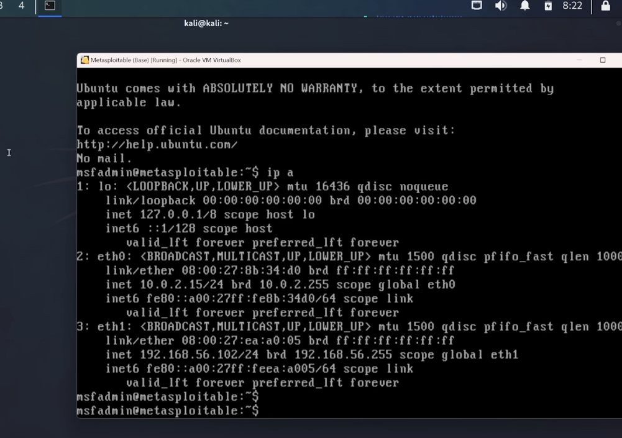
Figure: Laboratory Target Infrastructure - Metasploitable 2 Boot Screen showing Active Terminal and Local Network Details
4.0 Target Discovery and Port Mapping
4.1 Initial Live Target Discovery Sweep
ping -c 3 192.168.56.101
4.2 Comprehensive Service and Version Mapping Scan
nmap -sV -p- 192.168.56.101
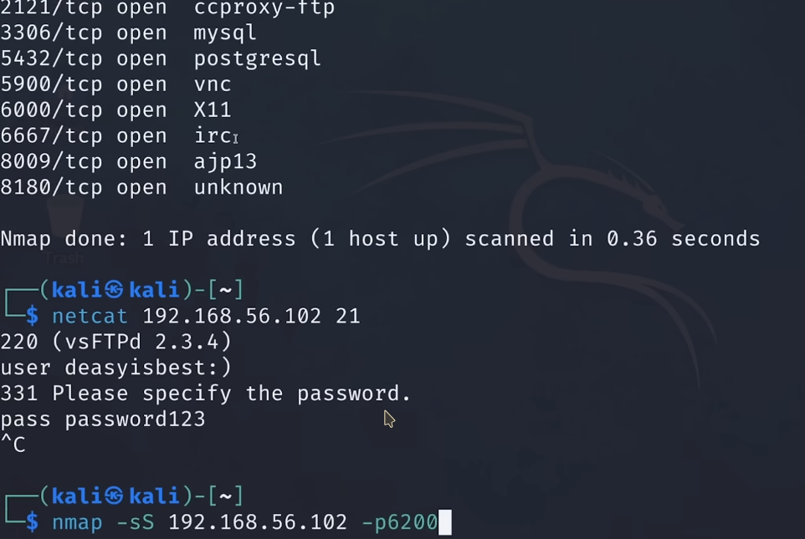
Figure: Nmap Active Service Discovery Output - Terminal screen showing open ports (21, 23, 1524) and software version text strings
5.0 System Auditing and Verification Steps
5.1 Verifying Cleartext Service Exposures (Port 23)
telnet 192.168.56.101 23
- Assessment Context: Verifying if default credentials or plain text communication is allowed over standard terminal services.
5.2 Verifying Open Port Listeners (Port 1524)
nc -nv 192.168.56.101 1524
- Assessment Context: Checking for misconfigured background services that expose system access command prompts without proper verification loops.
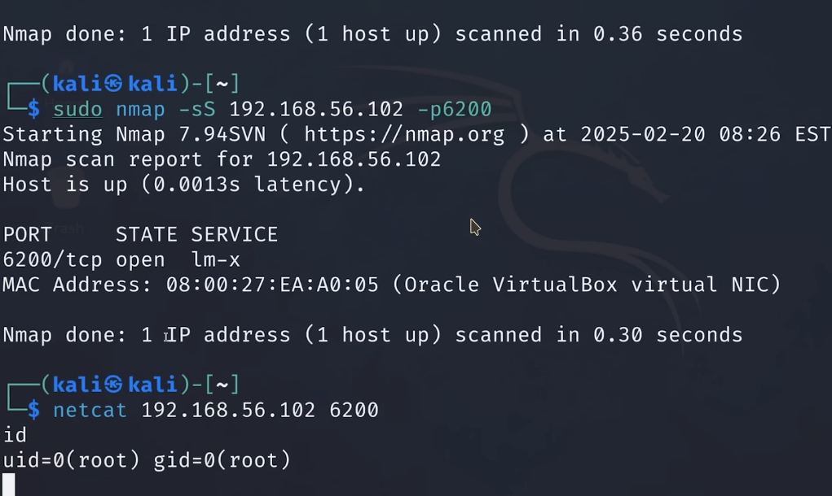
Figure: Kali Linux Terminal Results - Access validation screen showing active root shell commands like whoami and id
6.0 Technical Remediation and Hardening Guidelines
- Service Deactivation: Disable insecure or obsolete communication protocols (such as unencrypted Telnet or non-essential shell listeners).
- Access Control Policies: Implement strict host-based firewall configurations to restrict access to management interfaces to trusted network paths only.
- Credential Management: Enforce complex password rules and completely remove default or blank authentication paths across all system users.

