1. SELECT * FROM EMP;

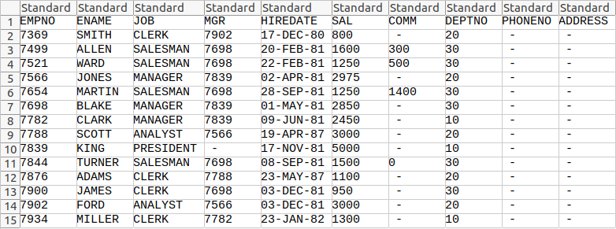

1. SELECT DEPTNO, DNAME FROM DEPT;

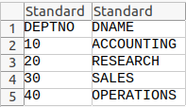

1. SELECT EMPNO, ENAME, DEPTNO FROM EMP WHERE DEPTNO = 20;

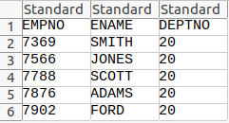

1. SELECT * FROM EMP ORDER BY DEPTNO DESC;

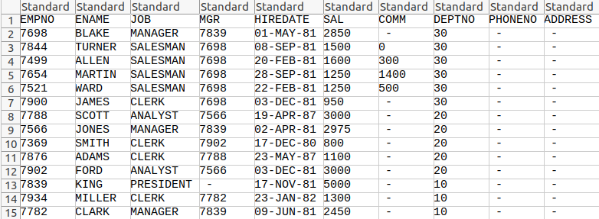

1. SELECT UNIQUE JOB FROM EMP;

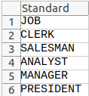

1. SELECT ENAME, SAL*12+NVL(COMM,0) AS ANNUAL_SALARY, DEPTNO FROM EMP WHERE JOB = 'CLERK' AND DEPTNO = 20;

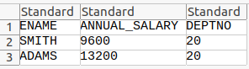

1. SELECT ENAME, HIREDATE FROM EMP WHERE ENAME LIKE 'S%' OR ENAME LIKE '_J%';

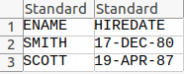

1. SELECT ENAME, HIREDATE, SAL FROM EMP WHERE JOB <> 'MANAGER';

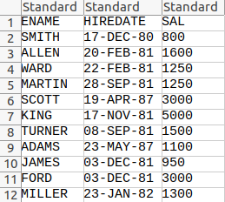

1. SELECT INITCAP(ENAME) AS ENAME, LENGTH(ENAME) AS LENGTH FROM EMP;

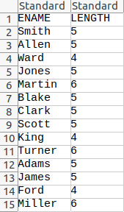

1. SELECT ENAME FROM EMP WHERE SAL >= 4000 AND SAL <= 6000;

