**MANAS PRATIM BISWAS**

**IT-A1-025 DBMS ASSIGNMENT 2**

1. SELECT ENAME, MGR, TO_CHAR(HIREDATE,'DDSPTH MONTH YYYY')

AS DATE_HIRED FROM EMP

WHERE JOB = 'CLERK' OR DEPTNO = 20;

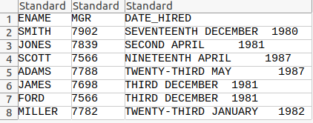

1. SELECT ENAME, SAL AS OLD_SALARY, ROUND(1.25*SAL) AS NEW_SALARY FROM EMP;

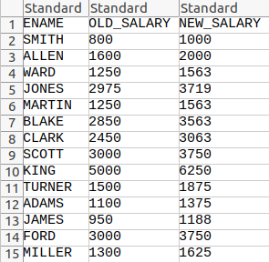

1. SELECT RPAD(ENAME,30), LPAD(SAL,30) FROM EMP;

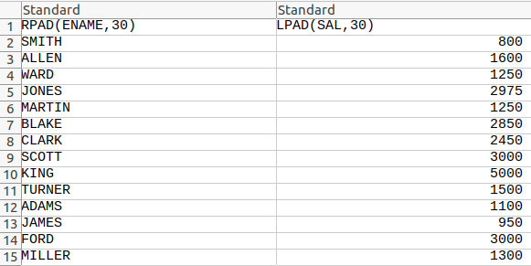

1. SELECT CONCAT(CONCAT(INITCAP(ENAME),'('),CONCAT(INITCAP(JOB),')')) AS "ROLE OF THE EMPLOYEE" FROM EMP;

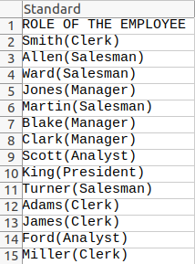

1. SELECT * FROM EMP WHERE JOB = 'CLERK';

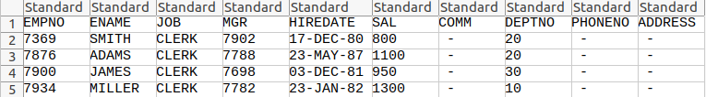

1. SELECT ENAME, HIREDATE AS HIRE_DATE,

ADD_MONTHS(HIREDATE,12)

AS SALARY_REVIEW_DATE

FROM EMP ORDER BY SALARY_REVIEW_DATE ASC;

**ALTERNATE APPROACH :**

SELECT ENAME, HIREDATE AS HIRE_DATE,

(HIREDATE+365) AS SALARY_REVIEW_DATE

FROM EMP ORDER BY SALARY_REVIEW_DATE ASC;

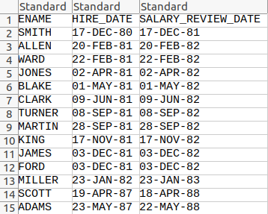

1. SELECT * FROM EMP

WHERE SAL IN (

SELECT MAX(SAL) FROM EMP

GROUP BY JOB)

ORDER BY SAL DESC;

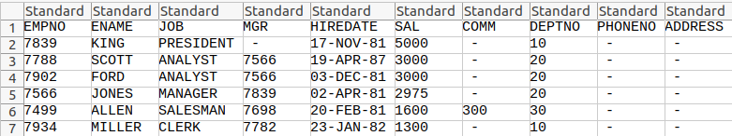

1. SELECT * FROM EMP E

WHERE HIREDATE IN(SELECT MAX(HIREDATE)

FROM EMP WHERE E.DEPTNO = DEPTNO)

ORDER BY DEPTNO;

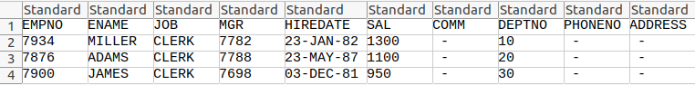

1. SELECT D.DNAME, COUNT(E.EMPNO)

FROM EMP E, DEPT D WHERE

E.DEPTNO = D.DEPTNO

GROUP BY D.DEPTNO, D.DNAME

ORDER BY D.DEPTNO;

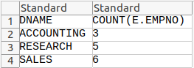

1. SELECT E.EMPNO, E.ENAME, E.SAL, S.GRADE

FROM EMP E, SALGRADE S

WHERE E.SAL IN(SELECT MAX(SAL)

FROM EMP GROUP BY DEPTNO) AND

E.SAL BETWEEN S.LOSAL AND S.HISAL

ORDER BY E.DEPTNO;

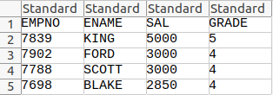

1. SELECT TO_CHAR(HIREDATE, 'YYYY') AS YEAR,

COUNT(EMPNO) AS NO_OF_EMPLOYEES

FROM EMP GROUP BY TO_CHAR(HIREDATE, 'YYYY')

HAVING COUNT(EMPNO)=(SELECT MAX(COUNT(EMPNO))

FROM EMP

GROUP BY TO_CHAR(HIREDATE, 'YYYY'));



1. SELECT EMPNO, ENAME, JOB, MGR, HIREDATE,

SAL, COMM, DEPTNO, PHONENO, ADDRESS

FROM(SELECT EMPNO, ENAME,JOB, MGR, HIREDATE,

SAL, COMM, DEPTNO, PHONENO, ADDRESS, ROWNUM RN

FROM EMP)

WHERE MOD(RN,2)=1;

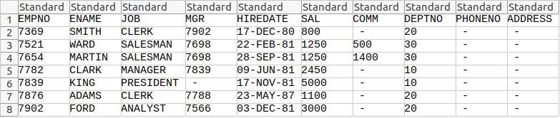

1. SELECT EMPNO,ENAME, SAL+NVL(COMM,0) AS TOTAL_SALARY FROM EMP;

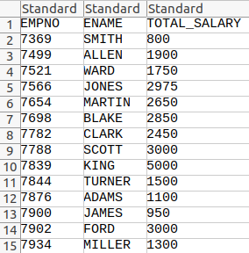

1. SELECT DISTINCT D.DNAME AS DEPARTMENT,

E.JOB AS AVAILABLE_JOBS FROM EMP E,

DEPT D WHERE D.DEPTNO = E.DEPTNO

ORDER BY DNAME;

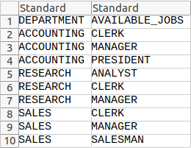

1. SELECT DISTINCT D.DNAME AS DEPARTMENT,

E.* FROM EMP E, DEPT D

WHERE D.DEPTNO = E.DEPTNO;

