*Cal xml*

*<?*xml version="1.0" encoding="utf-8"*?>*<androidx.constraintlayout.widget.ConstraintLayout  
 xmlns:android="http://schemas.android.com/apk/res/android"  
 xmlns:tools="http://schemas.android.com/tools"  
 xmlns:app="http://schemas.android.com/apk/res-auto"  
 android:layout_width="match_parent"  
 android:layout_height="match_parent"  
 tools:context=".MainActivity">  
  
 <LinearLayout  
 android:layout_width="409dp"  
 android:layout_height="729dp"  
 android:orientation="vertical"  
 tools:layout_editor_absoluteX="1dp"  
 tools:layout_editor_absoluteY="1dp">  
  
 <EditText  
 android:id="@+id/n1"  
 android:layout_width="match_parent"  
 android:layout_height="102dp"  
 android:ems="10"  
 android:inputType="textPersonName"  
 android:hint="first number"  
 android:textSize="25sp"/>  
  
 <EditText  
 android:id="@+id/n2"  
 android:layout_width="match_parent"  
 android:layout_height="96dp"  
 android:ems="10"  
 android:inputType="textPersonName"  
 android:hint="second name"  
 android:textSize="25sp"/>  
  
 <EditText  
 android:id="@+id/ans"  
 android:layout_width="match_parent"  
 android:layout_height="66dp"  
 android:ems="10"  
 android:inputType="textPersonName"  
 android:hint="answer"  
 android:textSize="25sp"/>  
  
 <Button  
 android:id="@+id/button2"  
 android:layout_width="match_parent"  
 android:layout_height="105dp"  
 android:onClick="click"  
 android:text="Button" />  
  
 <LinearLayout  
 android:layout_width="match_parent"  
 android:layout_height="match_parent"  
 android:orientation="horizontal">  
  
 <Button  
 android:id="@+id/add"  
 android:layout_width="72dp"  
 android:layout_height="wrap_content"  
 android:layout_weight="1"  
 android:text="add" />  
  
 <Button  
 android:id="@+id/sub"  
 android:layout_width="wrap_content"  
 android:layout_height="wrap_content"  
 android:layout_weight="1"  
 android:text="sub" />  
  
 <Button  
 android:id="@+id/mul"  
 android:layout_width="wrap_content"  
 android:layout_height="wrap_content"  
 android:layout_weight="1"  
 android:text="mul" />  
  
 <Button  
 android:id="@+id/div"  
 android:layout_width="wrap_content"  
 android:layout_height="wrap_content"  
 android:layout_weight="1"  
 android:text="div" />  
 </LinearLayout>  
  
 </LinearLayout>  
</androidx.constraintlayout.widget.ConstraintLayout>

Java

package com.example.add;  
  
import androidx.appcompat.app.AppCompatActivity;  
import android.os.Bundle;  
import android.view.View;  
import android.widget.Button;  
import android.widget.EditText;  
  
public class MainActivity extends AppCompatActivity {  
 EditText n1,n2,ans;  
 Button button2,sub,mul,div,add;  
  
 @Override  
 protected void onCreate(Bundle savedInstanceState) {  
 super.onCreate(savedInstanceState);  
 setContentView(R.layout.*activity_main*);  
  
 n1=findViewById(R.id.*n1*);  
 n2=findViewById(R.id.*n2*);  
 button2=findViewById(R.id.*button2*);  
 ans=findViewById(R.id.*ans*);  
 sub=findViewById(R.id.*sub*);  
 mul=findViewById(R.id.*mul*);  
 div=findViewById(R.id.*div*);  
  
  
 }  
  
 public void add(View view) {  
 int num1=Integer.*parseInt*(n1.getText().toString());  
 int num2=Integer.*parseInt*(n2.getText().toString());  
 int sum =num1+num2;  
  
 ans.setText(sum+"");  
 }  
 public void sub(View view) {  
 int num1=Integer.*parseInt*(n1.getText().toString());  
 int num2=Integer.*parseInt*(n2.getText().toString());  
 int sum =num1-num2;  
  
 ans.setText(sum+"");  
 }  
 public void mul(View view) {  
 int num1=Integer.*parseInt*(n1.getText().toString());  
 int num2=Integer.*parseInt*(n2.getText().toString());  
 int sum =num1*num2;  
  
 ans.setText(sum+"");  
 }  
 public void div(View view) {  
 int num1=Integer.*parseInt*(n1.getText().toString());  
 int num2=Integer.*parseInt*(n2.getText().toString());  
 int sum =num1/num2;  
  
 ans.setText(sum+"");  
 }  
  
  
 public void click(View view) {  
 }  
}

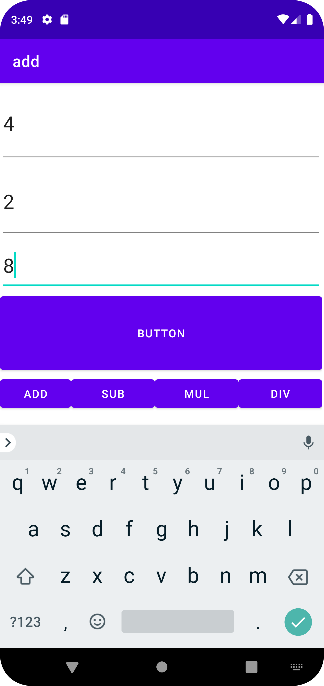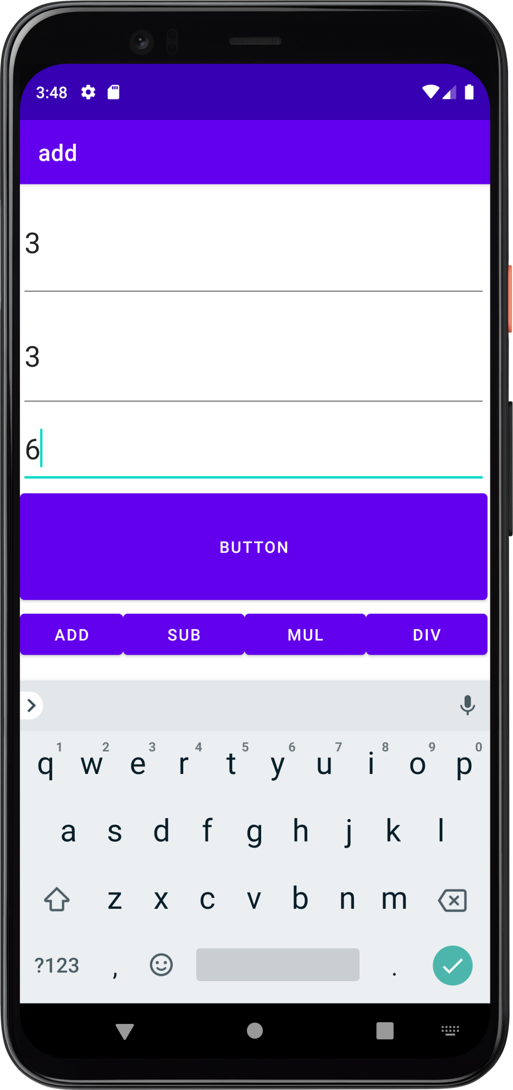

Activity

Xml

*<?*xml version="1.0" encoding="utf-8"*?>*<androidx.constraintlayout.widget.ConstraintLayout xmlns:android="http://schemas.android.com/apk/res/android"  
 xmlns:app="http://schemas.android.com/apk/res-auto"  
 xmlns:tools="http://schemas.android.com/tools"  
 android:layout_width="match_parent"  
 android:layout_height="match_parent"  
 tools:context=".MainActivity">  
  
 <TextView  
 android:layout_width="wrap_content"  
 android:layout_height="wrap_content"  
 android:text="Hello World!"  
 app:layout_constraintBottom_toBottomOf="parent"  
 app:layout_constraintEnd_toEndOf="parent"  
 app:layout_constraintStart_toStartOf="parent"  
 app:layout_constraintTop_toTopOf="parent" />  
  
</androidx.constraintlayout.widget.ConstraintLayout>

Java

package com.example.prgm2;  
  
import androidx.appcompat.app.AppCompatActivity;  
  
import android.os.Bundle;  
import android.widget.Toast;  
  
public class MainActivity extends AppCompatActivity {  
  
 @Override  
 protected void onCreate(Bundle savedInstanceState) {  
 super.onCreate(savedInstanceState);  
 setContentView(R.layout.*activity_main*);  
 Toast.*makeText*(this,"onCreate",Toast.*LENGTH_LONG*).show();  
 }  
 @Override  
 protected void onStart(){  
 super.onStart();  
 Toast.*makeText*(this,"onStart",Toast.*LENGTH_LONG*).show();  
  
 }  
 @Override  
 protected void onResume() {  
 super.onResume();  
 Toast.*makeText*(this, "onResume", Toast.*LENGTH_LONG*).show();  
 }  
 @Override  
 protected void onStop() {  
 super.onStop();  
 Toast.*makeText*(this, "onstop", Toast.*LENGTH_LONG*).show();  
 }  
 @Override  
 protected void onRestart() {  
 super.onRestart();  
 Toast.*makeText*(this, "onRestart", Toast.*LENGTH_LONG*).show();  
 }  
 @Override  
 protected void onDestroy() {  
 super.onDestroy();  
 Toast.*makeText*(this, "onDestroy", Toast.*LENGTH_LONG*).show();  
 }  
 @Override  
 protected void onPause() {  
 super.onPause();  
 Toast.*makeText*(this, "onPuase", Toast.*LENGTH_LONG*).show();  
 }  
}

sssss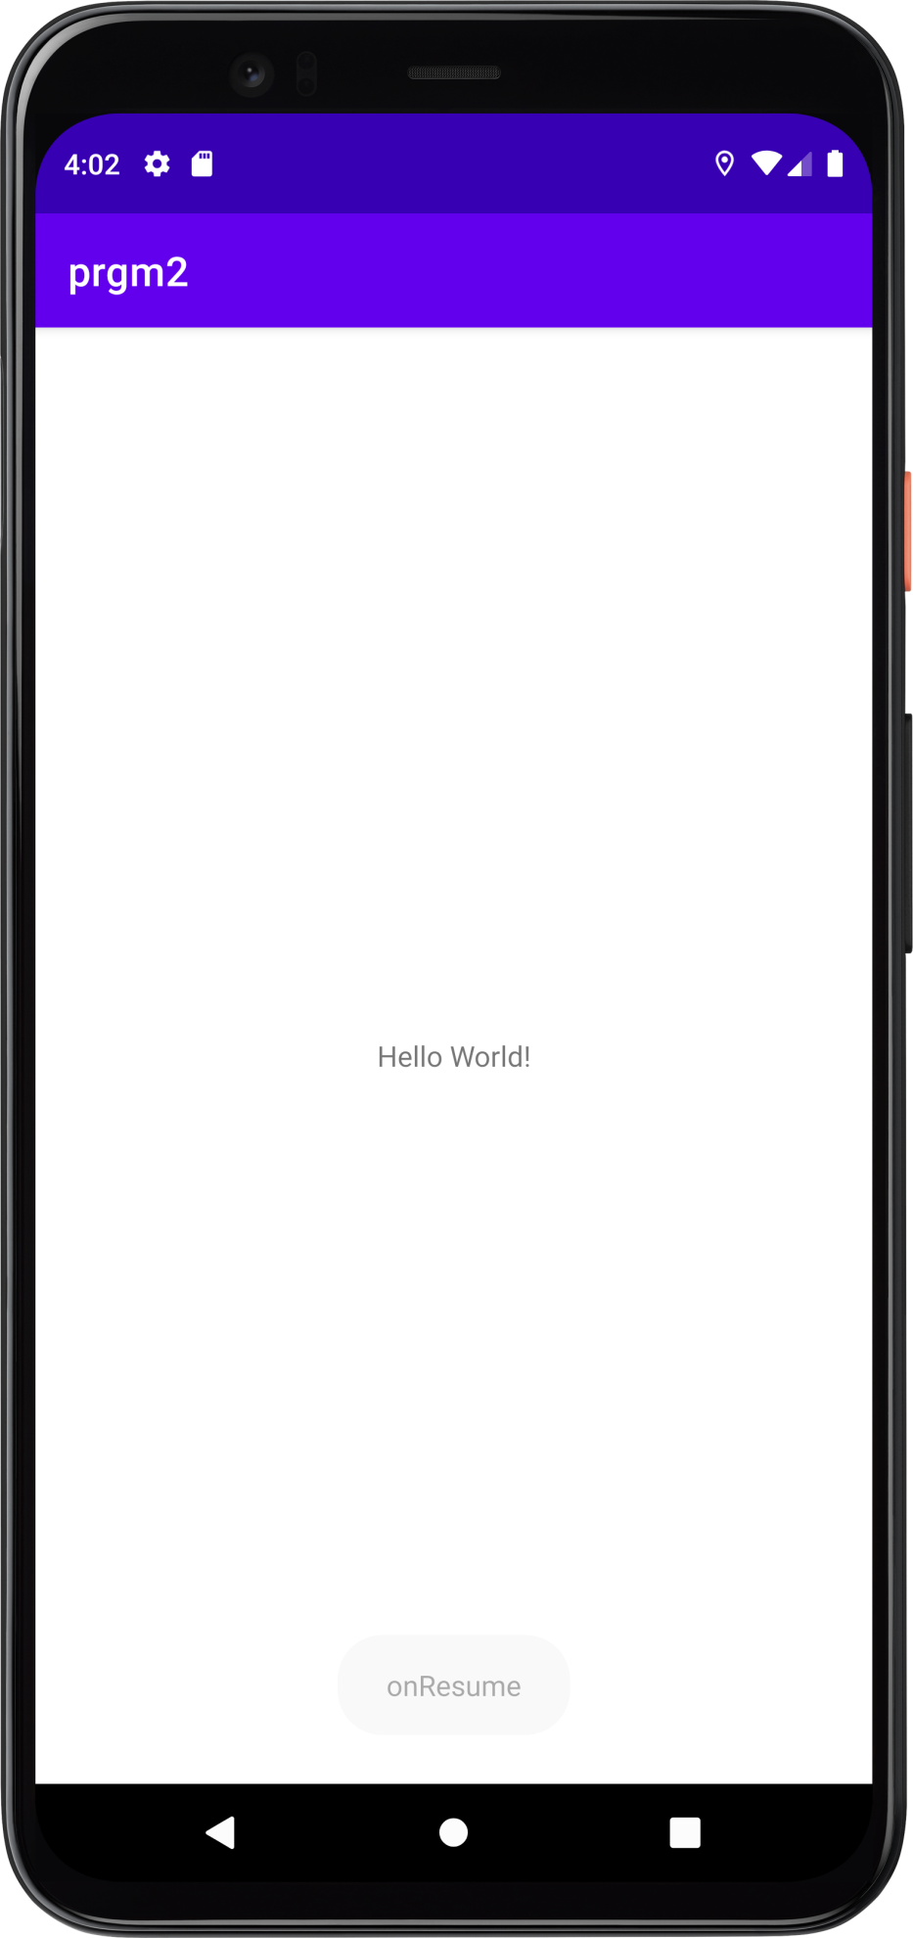

toggle

xml

*<?*xml version="1.0" encoding="utf-8"*?>*<FrameLayout xmlns:android="http://schemas.android.com/apk/res/android"  
 xmlns:app="http://schemas.android.com/apk/res-auto"  
 xmlns:tools="http://schemas.android.com/tools"  
 android:layout_width="match_parent"  
 android:layout_height="match_parent"  
 tools:context=".MainActivity">  
  
 <ImageView  
 android:id="@+id/img1"  
 android:layout_width="212dp"  
 android:layout_height="240dp"  
 app:srcCompat="@android:drawable/arrow_down_float" />  
  
 <ImageView  
 android:id="@+id/img2"  
 android:layout_width="256dp"  
 android:layout_height="match_parent"  
 app:srcCompat="@android:drawable/btn_star_big_on" />  
</FrameLayout>

Java

package com.example.toggle;  
  
import androidx.appcompat.app.AppCompatActivity;  
  
import android.os.Bundle;  
import android.view.View;  
import android.widget.ImageView;  
  
public class MainActivity extends AppCompatActivity implements View.OnClickListener {  
 ImageView img1,img2;  
  
  
 @Override  
 protected void onCreate(Bundle savedInstanceState) {  
 super.onCreate(savedInstanceState);  
 setContentView(R.layout.*activity_main*);  
 img1=(ImageView) findViewById(R.id.*img1*);  
 img2=(ImageView) findViewById(R.id.*img2*);  
 img1.setOnClickListener(this);  
 img2.setOnClickListener(this);  
  
  
  
 }  
  
 @Override  
 public void onClick(View view) {  
 if(view == img1){  
 img1.setVisibility(View.*GONE*);  
 img2.setVisibility(View.*VISIBLE*);  
  
 }else {  
 img2.setVisibility(View.*GONE*);  
 img1.setVisibility(View.*VISIBLE*);  
 }  
  
 }  
}

output of toggle

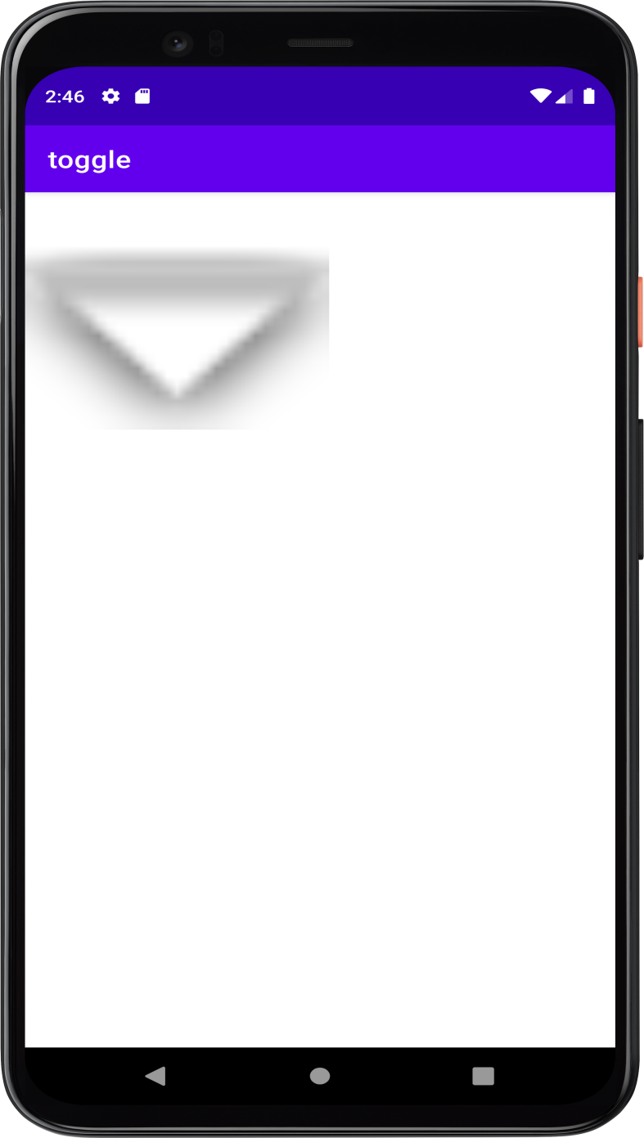

}

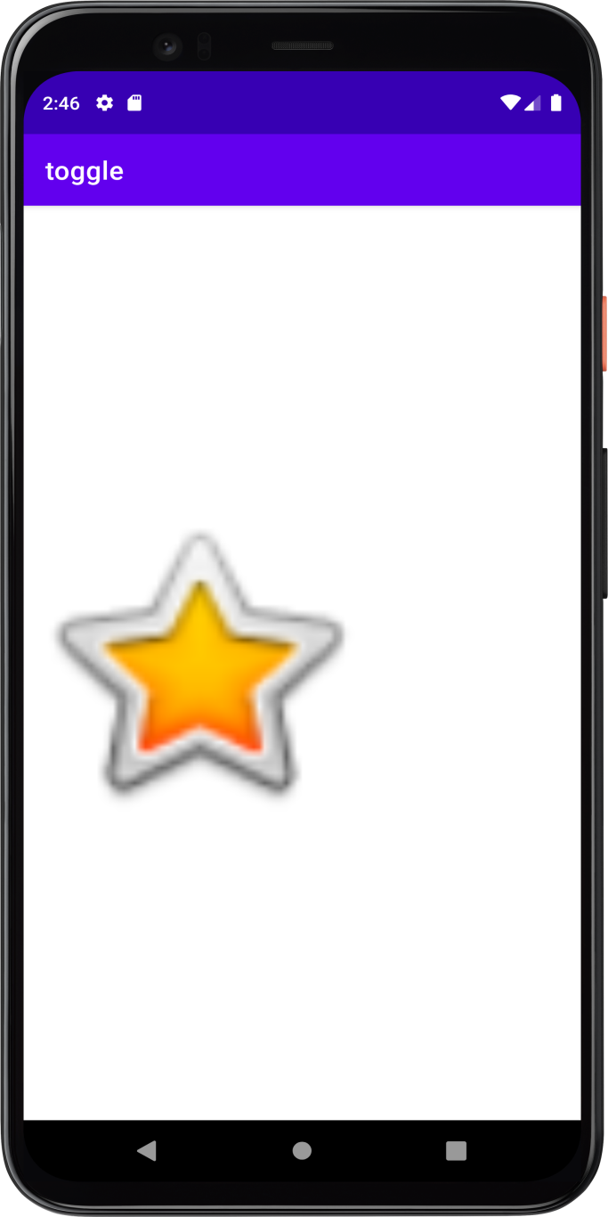

Face book

Xml

*<?*xml version="1.0" encoding="utf-8"*?>*<RelativeLayout xmlns:android="http://schemas.android.com/apk/res/android"  
 xmlns:app="http://schemas.android.com/apk/res-auto"  
 xmlns:tools="http://schemas.android.com/tools"  
 android:layout_width="match_parent"  
 android:layout_height="match_parent"  
 android:background="#4295f5"  
 tools:context=".MainActivity">  
  
 <ImageView  
 android:id="@+id/imageView"  
 android:layout_width="match_parent"  
 android:layout_height="207dp"  
 app:srcCompat="@drawable/fb" />  
  
 <EditText  
 android:id="@+id/edit"  
 android:layout_width="match_parent"  
 android:layout_height="wrap_content"  
 android:layout_below="@+id/imageView"  
 android:layout_marginTop="0dp"  
 android:textColorHint="@color/white"  
 android:ems="10"  
 android:inputType="textPersonName"  
 android:hint="username or email" />  
  
 <EditText  
 android:id="@+id/ed"  
 android:layout_width="match_parent"  
 android:layout_height="35dp"  
 android:layout_below="@+id/edit"  
 android:layout_marginTop="10dp"  
 android:ems="10"  
 android:textColorHint="@color/white"  
 android:inputType="textPersonName"  
 android:hint="password" />  
  
 <Button  
 android:id="@+id/button2"  
 android:layout_width="match_parent"  
 android:layout_height="wrap_content"  
 android:layout_below="@id/ed"  
 android:layout_marginTop="0dp"  
 android:text="LOG IN" />  
  
</RelativeLayout>

Java

package com.example.facebook;  
  
import androidx.appcompat.app.AppCompatActivity;  
  
import android.os.Bundle;  
  
public class MainActivity extends AppCompatActivity {  
  
 @Override  
 protected void onCreate(Bundle savedInstanceState) {  
 super.onCreate(savedInstanceState);  
 setContentView(R.layout.*activity_main*);  
 }  
}

output

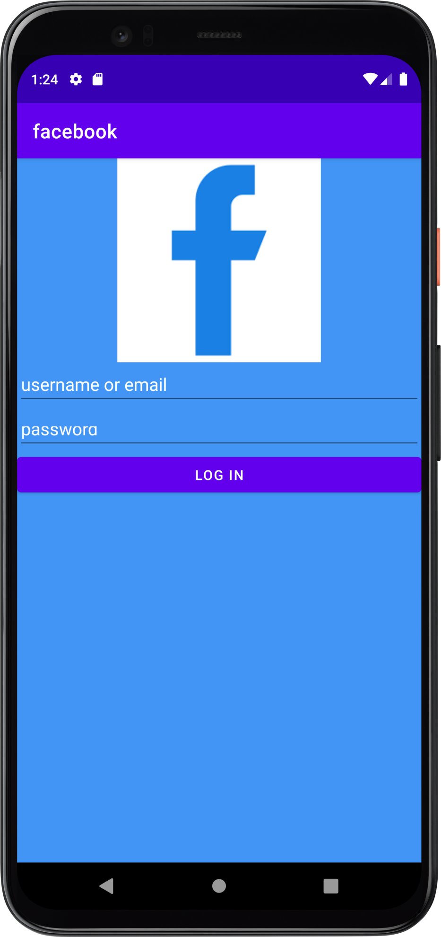

Co5

Xml

*<?*xml version="1.0" encoding="utf-8"*?>*<LinearLayout xmlns:android="http://schemas.android.com/apk/res/android"  
 xmlns:app="http://schemas.android.com/apk/res-auto"  
 xmlns:tools="http://schemas.android.com/tools"  
 android:layout_width="match_parent"  
 android:layout_height="match_parent"  
 tools:context=".MainActivity">  
  
 <LinearLayout  
 android:layout_width="match_parent"  
 android:layout_height="match_parent"  
 android:orientation="vertical">  
  
 <EditText  
 android:id="@+id/name"  
 android:layout_width="match_parent"  
 android:layout_height="59dp"  
 android:ems="10"  
 android:inputType="textPersonName"  
 android:hint="name" />  
  
 <EditText  
 android:id="@+id/sub"  
 android:layout_width="match_parent"  
 android:layout_height="wrap_content"  
 android:ems="10"  
 android:inputType="textPersonName"  
 android:hint="subject" />  
  
 <EditText  
 android:id="@+id/mark"  
 android:layout_width="match_parent"  
 android:layout_height="wrap_content"  
 android:ems="10"  
 android:inputType="textPersonName"  
 android:hint="mark" />  
  
 <Button  
 android:id="@+id/insert"  
 android:layout_width="match_parent"  
 android:layout_height="wrap_content"  
 android:text="INSERT" />  
  
 <Button  
 android:id="@+id/select"  
 android:layout_width="match_parent"  
 android:layout_height="wrap_content"  
 android:text="SELECT" />  
  
 <Button  
 android:id="@+id/update"  
 android:layout_width="match_parent"  
 android:layout_height="wrap_content"  
 android:text="UPDATE" />  
  
 <Button  
 android:id="@+id/delete"  
 android:layout_width="match_parent"  
 android:layout_height="wrap_content"  
 android:text="DELETE" />  
  
 <Button  
 android:id="@+id/clear"  
 android:layout_width="match_parent"  
 android:layout_height="wrap_content"  
 android:text="CLEAR" />  
 </LinearLayout>  
</LinearLayout>

Java

package com.example.co5_1;  
  
import androidx.appcompat.app.AlertDialog;  
import androidx.appcompat.app.AppCompatActivity;  
  
import android.database.Cursor;  
import android.database.sqlite.SQLiteDatabase;  
import android.net.Uri;  
import android.os.Bundle;  
import android.view.View;  
import android.widget.Button;  
import android.widget.EditText;  
import android.widget.Toast;  
  
 public class MainActivity extends AppCompatActivity {  
 EditText name,sub,mark;  
 Button insert,select,update,delete,clear;  
 SQLiteDatabase data;  
 AlertDialog.Builder builder;  
 @Override  
 protected void onCreate(Bundle savedInstanceState) {  
 super.onCreate(savedInstanceState);  
 setContentView(R.layout.*activity_main*);  
 name = findViewById(R.id.*name*);  
 sub = findViewById(R.id.*sub*);  
 mark = findViewById(R.id.*mark*);  
 insert = findViewById(R.id.*insert*);  
 select = findViewById(R.id.*select*);  
 update = findViewById(R.id.*update*);  
 delete = findViewById(R.id.*delete*);  
 clear = findViewById(R.id.*clear*);  
 builder = new AlertDialog.Builder(this);  
  
 try {  
 data = openOrCreateDatabase("studentdb", *MODE_PRIVATE*, null);  
 data.execSQL("create table stud(id integer primary key,subject Text, mark Integer)");  
 Toast.*makeText*(this, "successfully created", Toast.*LENGTH_SHORT*).show();  
 } catch (Exception e) {  
  
 }  
  
 insert.setOnClickListener(new View.OnClickListener() {  
 @Override  
 public void onClick(View view) {  
  
 try {  
 data.execSQL("insert into stud values(" + name.getText().toString() + ",'" + sub.getText().toString() + "'," + mark.getText().toString() + ")");  
 Toast.*makeText*(MainActivity.this, "successfully inserted", Toast.*LENGTH_SHORT*).show();  
  
 } catch (Exception e) {  
 Toast.*makeText*(MainActivity.this, "error in inserting", Toast.*LENGTH_SHORT*).show();  
 }  
  
 }  
 });  
 clear.callOnClick();  
 select.setOnClickListener(new View.OnClickListener() {  
 @Override  
 public void onClick(View view) {  
 Cursor c = data.rawQuery("select * from stud", null);  
 if (c.getCount() == 0) {  
 Toast.*makeText*(MainActivity.this, "no such records", Toast.*LENGTH_SHORT*).show();  
 } else {  
 StringBuffer b = new StringBuffer();  
 while (c.moveToNext()) {  
 b.append("id:" + c.getString(0) + "\n");  
 b.append("subject:" + c.getString(1) + "\n");  
 b.append("mark:" + c.getString(2) + "\n");  
 }  
 Toast.*makeText*(getApplicationContext(), b.toString(), Toast.*LENGTH_SHORT*).show();  
 builder.setMessage(b.toString());  
 AlertDialog alert = builder.create();  
 alert.setTitle("student details");  
 alert.show();  
 }  
 }  
 });  
 update.setOnClickListener(new View.OnClickListener() {  
 @Override  
 public void onClick(View view) {  
  
 data.execSQL("update stud set mark=" +mark.getText().toString()+",sub='"+sub.getText().toString()+"' where "+name.getText().toString()+"");  
 Toast.*makeText*(getApplicationContext(), "updated....", Toast.*LENGTH_SHORT*).show();  
 }  
 });  
 delete.setOnClickListener(new View.OnClickListener() {  
 @Override  
 public void onClick(View view) {  
 data.execSQL("delete from stud where mark=" +mark.getText().toString());  
 Toast.*makeText*(getApplicationContext(), "Item Deleted", Toast.*LENGTH_SHORT*).show();  
 }  
 });  
  
 clear.setOnClickListener(new View.OnClickListener() {  
 @Override  
 public void onClick(View view) {  
 name.setText("");  
 sub.setText("");  
 mark.setText("");  
  
 }  
 });  
 clear.callOnClick();  
  
 }  
 }

output

