**Breaking News App:**

1. What goal will your website be designed to achieve?

* This is a simple news app with a variety of categories and topics. Also adding weather data on site. Users can view the latest news across different places, different topics like sports, entertainment, worldwide news, politics, finance, covid-data, etc.

 2. What kind of users will visit your site? In other words, what is the demographic of your users?

* In general all the users can visit the site. Users who wants to check the latest and trending news

3. What data do you plan on using? You may have not picked your actual API yet, which is fine, just outline what kind of data you would like it to contain.

* I am using news api-[https://newsapi.org/](https://newsapi.org/v2/top-headlines?country=us&apiKey=)
* For weather data api-<http://api.openweathermap.org>
* Also adding covid data with api: <https://covid-19-statistics.p.rapidapi.com>

4.  What kinds of issues might you run into with your API?

* Using just a simple and free api, for news I am getting data of title, image, content, date created at, etc.

5. What does schema design look like?

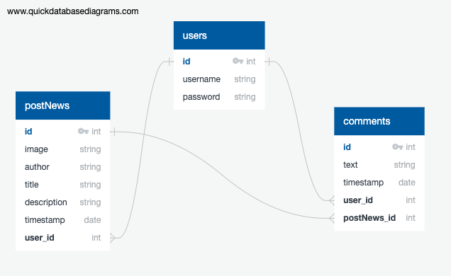

6. Is there any sensitive information you need to secure?

* Each user can create an account or can check in as a guest. To sign up, users need to add name, username and password.

7. What functionality will your app include?

* Simple app, navbar at the top with sign up and login button. Also users can login as guests if they don't want to sign up. App will be using javascript, axios, flask, python, sqlalchemy database, api, bootstrap, etc.

8. What features make your site more than CRUD? Do you have any stretch goals?

* Adding with signup/login/logout features with adding comments, like and share button for news content.