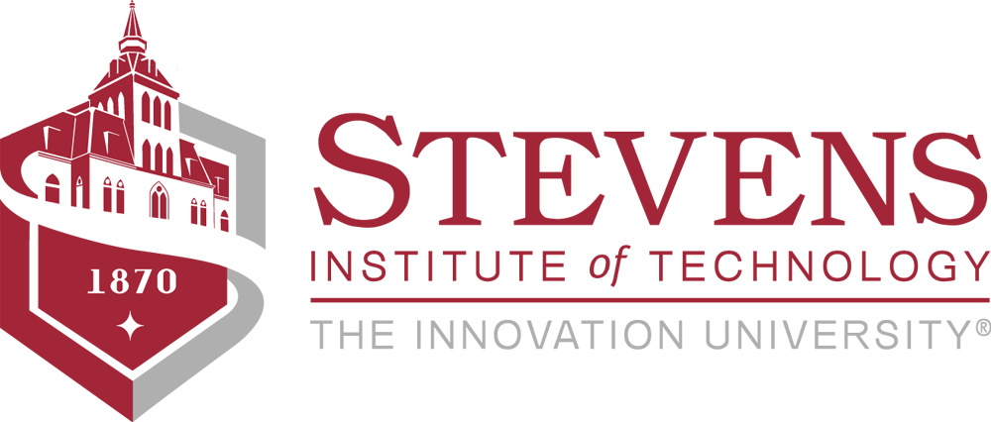

**CS501 Introduction to Java Programming**

Charles V. Schaefer, Jr. School of Engineering & Science

Fall 2019

Meeting Times: None – all on line using Canvas

Classroom Location: None

Instructor: M Peter Jurkat

Contact Info: None on campus; [pjurkat@stevens.edu](mailto:pjurkat@stevens.edu), 505-603-9412 (cell)

Office Hours: None on campus; Mail and/or video conferences within Canvas. I live in New Mexico and teach on line only. We can converse starting by email within Canvas, then proceed to telephone calls and video conferences as the need arises. Questions and comments related to assignments can be put into the Assignment response pages.

Course Web Address: None

Prerequisite(s): None

Co-requisite(s): None

Cross-listed with: SOC501

**COURSE DESCRIPTION**

##### This course offers an introduction to the Java programming language for those students who have little or no background in programming. It includes basic programming constructs as well as creating programs for simple input-output to graphical user interfaces, numerical calculations, and text manipulations typical for physical and social sciences.

**LEARNING OBJECTIVES**

**After successful completion of this course, students will be able to…**

* Become proficient in the creation and execution of Java programs using either a text editor and command line prompts or the use of a Java Integrated Development Environment (IDE) such as Eclipse. This to include the use of pop-up windows for communication with users.
* Expand these programs to include selection statements (all the forms of if..., if .... else ..., etc.) and program controls (for, while, etc., loops and case).
* Understand the basics of object-oriented programming and create Java classes and test classes, objects, methods, and exception handling in multiple files.
* Develop proficiency in the use of arrays.
* Develop proficiency in the use of text, Strings, and input from files.
* Become proficient in the basics of graphical user interfaces and components (such as text boxes, buttons, etc.).
* Develop an independent project based on material in the advanced chapters of the text (such as applets and web pages, graphics, chat, and/or database access) or an application of the students own choosing (e.g., computer games).

**FORMAT AND STRUCTURE**

This course is taken entirely on line using Canvas. Students are expected to read material on this site and indicated chapters of the text, and write programs in response to end of chapter exercises. These programs are to be submitted using the Canvas Assignment pages. Your instructor will compile, run, comment, and score the assignment, and possibly return them for revision. Seven required assignments are to be done as well as a final project of the student’s or group of student’s choosing.

**COURSE MATERIALS**

**Textbook(s):** Y. Daniel Liang (2018) *Introduction to Java Programming and Data Structures Comprehensive Edition*, 11th Edition, Pearson, ISBN 978-0-13-467094-2

**Other Readings and Materials:**  Included for reading and downloading from this Canvas web site.

Instead of the 11th edition you can use the 10th. Assignments for both editions are shown. No earlier editions are to be used.

**COURSE REQUIREMENTS**

|  |  |  |  |  |  |  |  |  |  |  |  |  |  |  |  |  |  |  |
| --- | --- | --- | --- | --- | --- | --- | --- | --- | --- | --- | --- | --- | --- | --- | --- | --- | --- | --- |
| |  |  | | --- | --- | | Weeks (approx.) | Topics | | 1-2 | Java program structures, rudimentary input and output, computations | | 3-4 | Logic operators, testing | | 5-6 | Iteration, sorting | | 7-9 | Java classes, parameters, methods, constructors, built-in classes part of Java Development Kit (JDK), exception handling | | 10 | String processing, elementary parsing, streaming I/O | | 11 | Points, lines, polygon images, hidden/overlap test  Class hierarchies | | 12 | Graphical user interfaces, screen layouts | | 14+ in Exam period | Student selected and designed project | |

**Attendance** No face to face meeting are planned. Video conferences can be scheduled as announced by the instructor and/or requested by a student or groups of students.

**Participation** Required for assignment submissions. Participation in discussion forums is optional.

**Homework** Seven programming assignments.

**Quizzes** None

**Project(s)** One final project chosen by an individual student or group of students with approval by the instructor. Must be submitted as a group project even when the group has only one member.

**Exams** None

**GRADING PROCEDURES**

Your grade will depend on responses to the eight assignments, both on how many you do and how well you do them. Each assignment will be scored as a percent according to the following rules:

1. If each response is submitted on or before the due date, and is substantially correct and acceptable the first time it is submitted, it will be eligible for the full 100% score. If not, it will be returned for re-submission with comments.
2. Up to four resubmissions will be allowed unless an acceptable submission is received earlier. The fourth resubmission will be scored regardless and that score will be the one recorded.
3. All submissions and resubmission must be made within three weeks of the due date. After that the assignment will be scored on what was awarded on the latest submission. Do not abuse this privilege, particularly near the end of the semester.
4. Successfully completing the first 5 assignments can earn a grade up to a C, completing the first 7 can earn a grade up to a B, and completing the first 7 and a project can earn a grade up to an A.

**ACADEMIC INTEGRITY**

*Please Note:*

* Students in undergraduate courses (100-400 level) about bound to the Honor System.
  + - If you teach a strictly undergraduate course, you should include the **Undergraduate Honor System** portiononly.
* Students in graduate courses (600 level) are bound to the Graduate Student Code of Academic Integrity.
  + - If you teach a graduate course, you should include only the **Graduate Student Code of Academic Integrity** portion only.
* Graduate students in 500-level courses are bound to the Graduate Student Code of Academic Integrity, while undergraduate students in those courses have special provisions that have been agreed upon by the Dean of Graduate Academics and the Honor Board.
  + - If you teach a 500-level course, be sure to include both the **Undergraduate Honor System** and the **Special Provisions for Undergraduate Students in 500-level Courses** portions.

**Undergraduate Honor System**

Enrollment into the undergraduate class of Stevens Institute of Technology signifies a student's commitment to the Honor System. Accordingly, the provisions of the Stevens Honor System apply to all undergraduate students in coursework and Honor Board proceedings. It is the responsibility of each student to become acquainted with and to uphold the ideals set forth in the [Honor System Constitution](http://web.stevens.edu/honor/documents/constitution.pdf). More information about the Honor System including the constitution, bylaws, investigative procedures, and the penalty matrix can be found online at <http://web.stevens.edu/honor/>

The following pledge shall be written in full and signed by every student on all submitted work (including, but not limited to, homework, projects, lab reports, code, quizzes and exams) that is assigned by the course instructor. No work shall be graded unless the pledge is written in full and signed.

“*I pledge my honor that I have abided by the Stevens Honor System*.”

Reporting Honor System Violations

Students who believe a violation of the Honor System has been committed should report it within ten business days of the suspected violation. Students have the option to remain anonymous and can report violations online at [www.stevens.edu/honor](http://www.stevens.edu/honor).

**Graduate Student Code of Academic Integrity**

*All Stevens graduate students promise to be fully truthful and avoid dishonesty, fraud, misrepresentation, and deceit of any type in relation to their academic work. A student’s submission of work for academic credit indicates that the work is the student's own. All outside assistance must be acknowledged. Any student who violates this code or who knowingly assists another student in violating this code shall be subject to discipline.*

All graduate students are bound to the Graduate Student Code of Academic Integrity by enrollment in graduate coursework at Stevens. It is the responsibility of each graduate student to understand and adhere to the Graduate Student Code of Academic Integrity. More information including types of violations, the process for handling perceived violations, and types of sanctions can be found at [www.stevens.edu/provost/graduate-academics](http://www.stevens.edu/provost/graduate-academics).

**Special Provisions for Undergraduate Students in 500-level Courses**

The general provisions of the Stevens Honor System do not apply fully to graduate courses, 500 level or otherwise. Any student who wishes to report an undergraduate for a violation in a 500-level course shall submit the report to the Honor Board following the protocol for undergraduate courses, and an investigation will be conducted following the same process for an appeal on false accusation described in Section 8.04 of the Bylaws of the Honor System. Any student who wishes to report a graduate student may submit the report to the Dean of Graduate Academics or to the Honor Board, who will refer the report to the Dean. The Honor Board Chairman will give the Dean of Graduate Academics weekly updates on the progress of any casework relating to 500-level courses. For more information about the scope, penalties, and procedures pertaining to undergraduate students in 500-level courses, see Section 9 of the [Bylaws of the Honor System](http://web.stevens.edu/honor/documents/Bylaws%20of%20the%20Honor%20System%20of%20Stevens%20Institute%20of%20Technology.pdf) document, located on the Honor Board website.

**LEARNING ACCOMODATIONS**

Stevens Institute of Technology provides appropriate accommodations to students with documented disabilities. Student Counseling and Disability Services works with undergraduate and graduate students with learning disabilities, attention deficit-hyperactivity disorders, physical disabilities, sensory impairments, and psychiatric disorders in order to help students achieve their academic and personal potential. They facilitate equal access to the educational programs and opportunities offered at Stevens and coordinate reasonable accommodations for eligible students. These services are designed to encourage independence and self-advocacy with support from SCDS staff.  The SCDS staff will facilitate the provision of accommodations on a case-by-case basis. These academic accommodations are provided at no cost to the student.

***Disability Services Confidentiality Policy***

Student Disability Files are kept separate from academic files and are stored in a secure location within the office of Student Counseling, Psychological & Disability Services. The Family Educational Rights Privacy Act (FERPA, 20 U.S.C. 1232g; 34CFR, Part 99) regulates disclosure of disability documentation and records maintained by Stevens Disability Services. According to this act, prior written consent by the student is required before our Disability Services office may release disability documentation or records to anyone. An exception is made in unusual circumstances, such as the case of health and safety emergencies.

For more information about Disability Services and the process to receive accommodations, visit <https://www.stevens.edu/sit/counseling/disability-services>. If you have any questions please contact:

Lauren Poleyeff, Psy.M., LCSW - Disability Services Coordinator and Staff Clinician in Student Counseling and Disability Services at Stevens Institute of Technology at [lpoleyef@stevens.edu](mailto:lpoleyef@stevens.edu) or by phone **(201) 216-8728.**

**INCLUSIVITY STATEMENT**

Stevens Institute of Technology believes that diversity and inclusiveness are essential to excellence in education and innovation. Our community represents a rich variety of backgrounds, experiences, demographics and perspectives and Stevens is committed to fostering a learning environment where every individual is respected and engaged. To facilitate a dynamic and inclusive educational experience, we ask all members of the community to:

* be open to the perspectives of others
* appreciate the uniqueness their colleagues
* take advantage of the opportunity to learn from each other
* exchange experiences, values and beliefs
* communicate in a respectful manner
* be aware of individuals who are marginalized and involve them
* keep confidential discussions private

**TENTATIVE COURSE SCHEDULE**

* Topics and actual exercises are listed in the Canvas web site.