**Homework 1.1**

Jerry and Susan have a joint bank account.

Jerry goes to the bank 20% of the days.

Susan goes there 30% of the days.

Together they are at the bank 8% of the days.

1. Susan was at the bank last Monday. What’s the probability that Jerry was there too?
2. Last Friday, Susan wasn’t at the bank. What’s the probability that Jerry was there?
3. Last Wednesday at least one of them was at the bank. What is the probability that both of them were there?

**Answer**

Venn Diagram of the scenario:

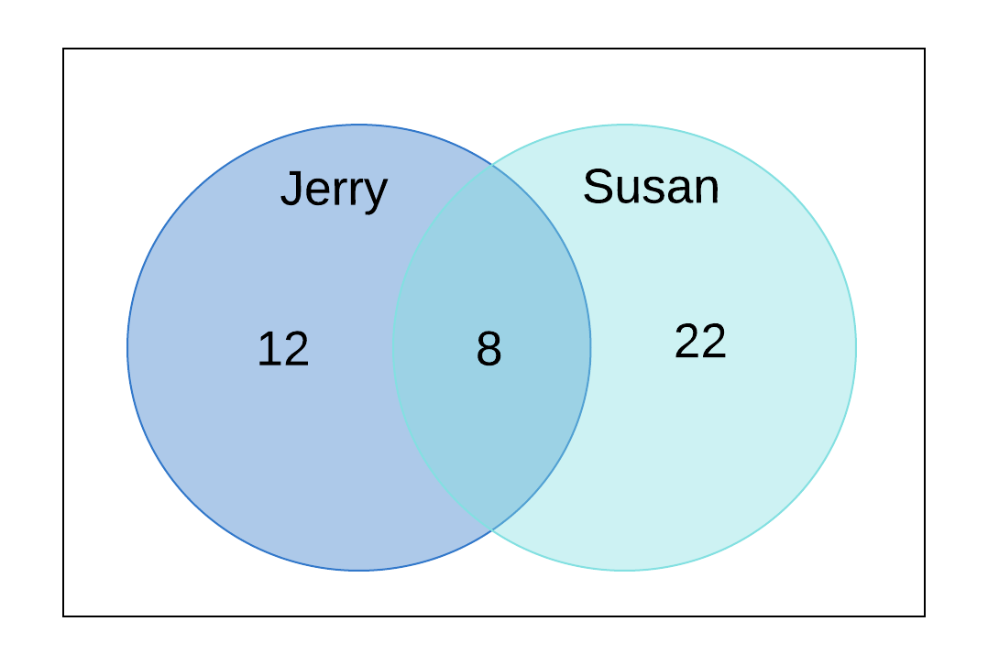

**Ans 1:** P(Jerry was at bank on last Monday | Susan was at bank on last Monday) = **8/30 = 0.2667 = 26.67%**

**Ans 2:** P(Jerry was at bankon last Friday | Susan was not at bank on last Friday) = **21/70 = 0.1714 = 17.14%**

**Ans 3:** P(Both of them at bank | At least one of them at bank on last Wednesday) = **8/(12+22) = 8/42 = 0.1905 = 19.05%**

**Homework 1.2**

Harold and Sharon are studying for a test.

Harold’s chances of getting a “B” are 80%. Sharon’s chances of getting a “B” are 90%.

The probability of at least one of them getting a “B” is 91%.

1. What is the probability that only Harold gets a “B”?
2. What is the probability that only Sharon gets a “B”?
3. What is the probability that both won’t get a “B”?

**Answer**

P(Harold) = 80%

P(Sharon) = 90%

P(Harold ∪ Sharon) = 91%

Now,

P(Harold ∪ Sharon) = P(Harold) + P(Sharon) - P(Harold ∩ Sharon)

P(Harold ∩ Sharon) = P(Harold) + P(Sharon) - P(Harold ∪ Sharon) = 80 + 90 –91 = 79%

Venn Diagram of the scenario:

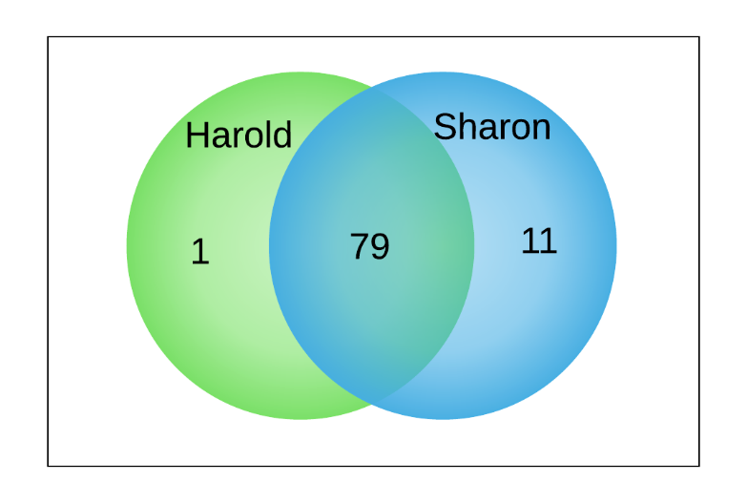

**Ans 1:** P(Only Harold gets a “B”) = P(Harold) – P(Harold ∩ Sharon ) = 80 – 79 = 1%

**Ans 2:** P(Only Sharon gets a “B”) = P(Sharon) - P(Harold ∩ Sharon ) = 90 – 79 = 11%

**Ans 3:** P(Both of them won’t get a “B”) = 100 - P(Harold ∩ Sharon ) = 100 – 91 = 9%

**Homework 1.3**

Jerry and Susan have a joint bank account. Jerry goes to the bank 20% of the days. Susan goes there 30% of the days.  
Together they are at the bank 8% of the days.

Are the events “Jerry is at the bank” and “Susan is at the bank” independent?

**Answer**

**No,** the events P(Jerry is at bank & Susan is at bank) != P(Jerry is at bank) * P(Susan is at bank)

* **8% != 20% * 30%**
* **8% != 6%**

**Homework 1.4**

You roll 2 dice.

1. Are the events “the sum is 6” and “the second die shows 5” independent?
2. Are the events “the sum is 7” and “the first die shows 5” independent?

**Answer**

**Ans 1: No**, the events “the sum is 6” and “the second die shows 5**” are not independent.** Because it doesn’t follow the rule: Events A and B are independent if

P(A and B) =P(A) *P(B)

Here, P(A)=5/36, P(B)=1/6 and P(A and B)=1/36 , which violates this rule.

**Ans 2: Yes**, the events “the sum is 7” and “the first die shows 5” are independent

Because, P(A)=1/6, P(B)=1/6 and P(A and B)=1/36

Here, P(A and B) =P(A) *P(B) is satisfied.

**Homework 1.5**

An oil company is considering drilling in either TX, AK and NJ. The company may operate in only one state. There is 60% chance the company will choose TX and 10% chance – NJ.

There is 30% chance of finding oil in TX, 20% - in AK, and 10% - in NJ.

1. What’s the probability of finding oil?
2. The company decided to drill and found oil. What is the probability that they drilled in TX?

**Answer**

Probability of drilling & finding oil in **Texas** = 0.3 * 0.6 = 0.18

Probability of drilling & finding oil in **Auckland** = 0.2 * 0.3 = 0.06

Probability of drilling & finding oil in **New Jersey** = 0.1 * 0.1 = 0.01

**Ans 1:** P(Finding oil) = P(drilling & finding oil in TX + drilling & finding oil in AK + drilling & finding oil in NJ) = 0.18 + 0.06 + 0.01 = 0.25 = **25%**

**Ans 2:** P(Drilled in TX & found oil | drilled & found oil) = 0.18/0.25 = 0.72 = **72%**

**Homework 1.6**

The following slide shows the survival status of individual passengers on the Titanic. Use this information to answer the following questions

1. What is the probability that a passenger did not survive?
2. What is the probability that a passenger was staying in the first class?
3. Given that a passenger survived, what is the probability that the passenger was staying in the first class?
4. Are survival and staying in the first class independent?
5. Given that a passenger survived, what is the probability that the passenger was staying in the first class and the passenger was a child?
6. Given that a passenger survived, what is the probability that the passenger was an adult?
7. Given that a passenger survived, are age and staying in the first class independent?

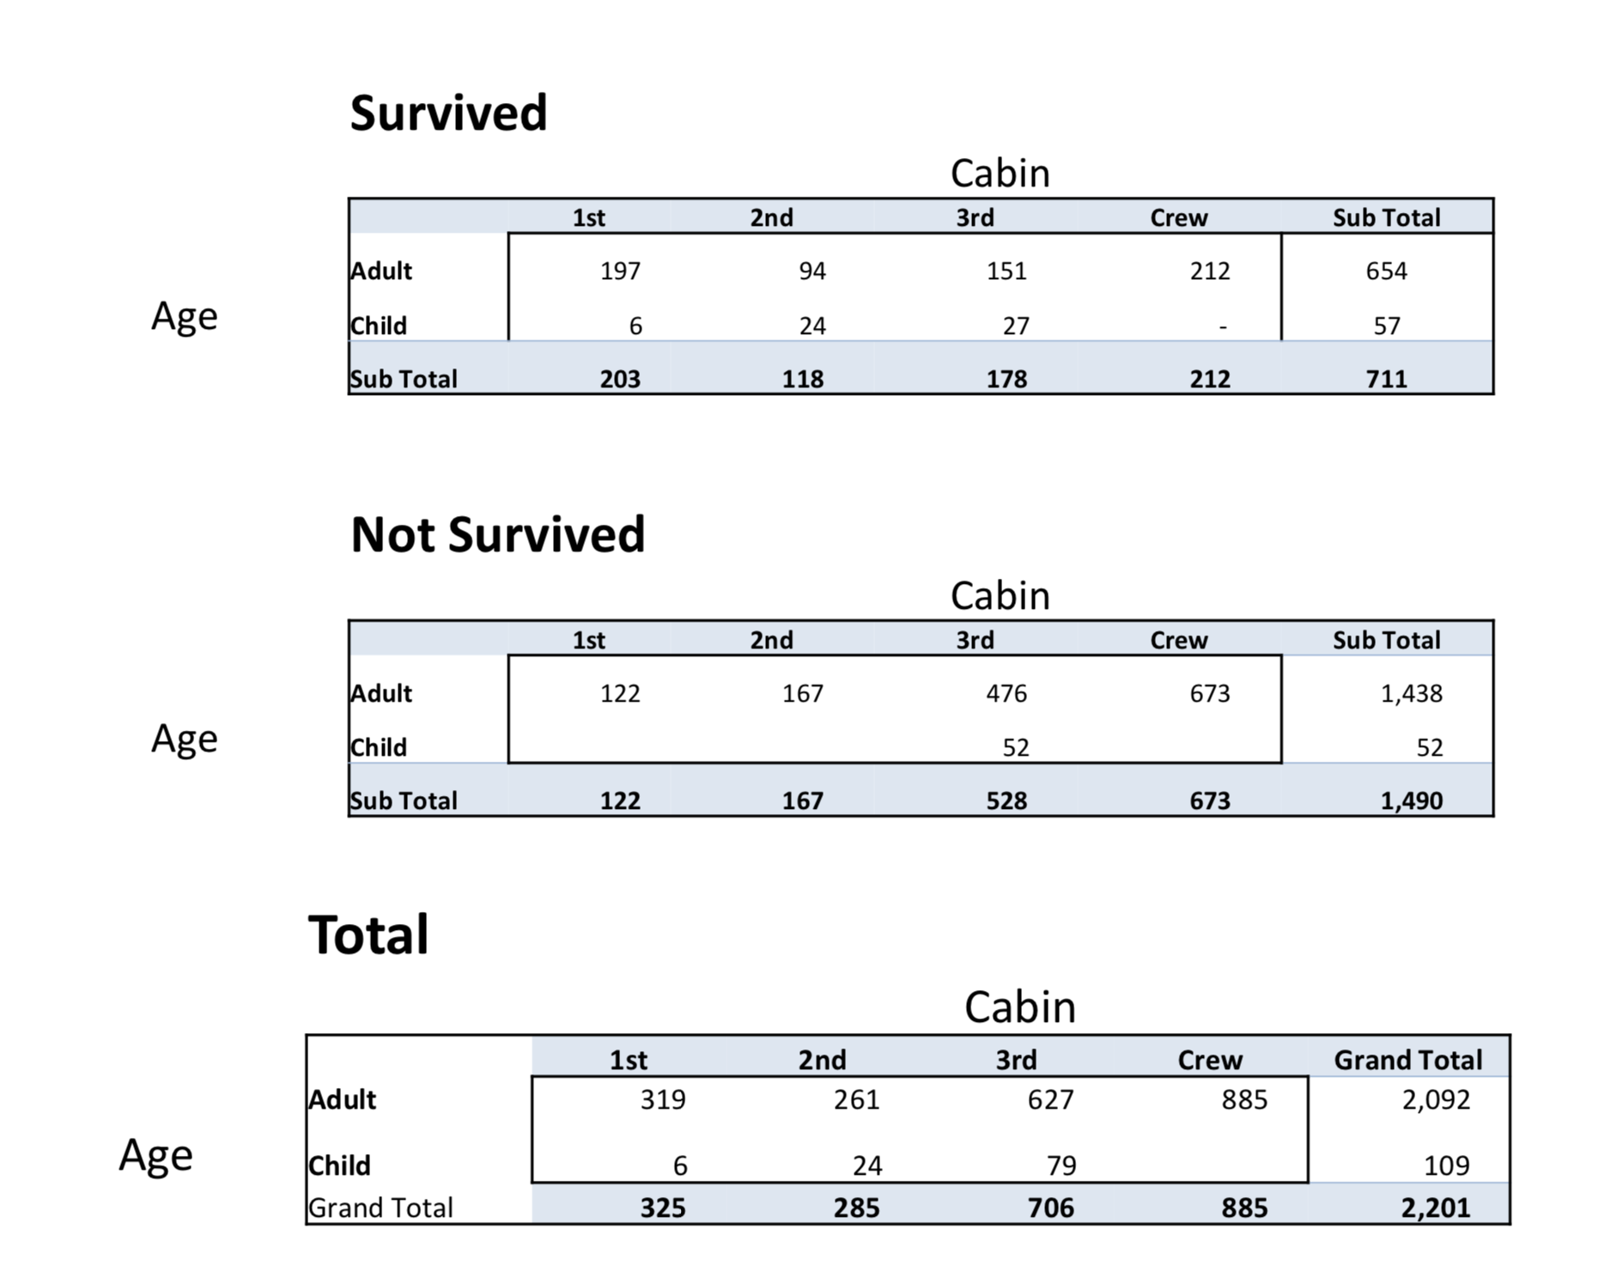

**Answer**

**Ans 1:** P(not survived) = (1490 - 673) / (2201 – 885) = 0.62 = **62%**

**Ans 2:** P(person in 1st class) = 325 / (2201 – 885) = 0.246 = **24.60%**

**Ans 3:** P(Survived and staying in 1st class) = 203 / (711 – 212) = 0.406 = **40.60%**

**Ans 4:** P(Total people survived) = 711 / 2011 = 0.323

P(Total people staying in first class) = 325 / 2201 = 0.147

P(Total People survived) ∩ P(Total people staying in first class)) = 203 / 2201 = 0.092

Above statement doesn’t satisfy the equation P (A ∩ B) = P(A) * P(B)

**So these events are not independent.**

**Ans 5:** P(Passenger survived in first class and was a child) = 6 / 499 = 0.012 = **1.20%**

**Ans 6:** Passenger survived and was an adult = 654 – 212 = 442

P(Passenger survived and was an adult) = 442 / 499 = 0.8857 = **88.57%**

**Ans 7:**

P(Adult survived) ∪ P(Child Survived) = 711

P(Adult survived) ∪ P(Child Survived) = 1

P(First class survived) = 203 / 711

P((Adult survived) ∪ P(Child Survived)) ∩ P(First class survived) = 203 / 711

Above statement satisfies the equation P (A ∩ B) = P(A) P(B)

**So, these events are independent.**