**SQL Exercise 1**

---------------------------------------------------------------

**1.** Create the table SEMP with the following structure:-

EMPNO CHAR(4)

EMPNAME CHAR(20)

BASIC FLOAT(9,2)

DEPTNO CHAR(2)

DEPTHEAD CHAR(4)

**Answer –**

**create table SEMP (**

**EMPNO CHAR(4),**

**EMPNAME CHAR(20),**

**BASIC FLOAT(9,2),**

**DEPTNO CHAR(2),**

**DEPTHEAD CHAR(4)**

**);**

**2.** Create the table SDEPT with the following structure:-

DEPTNO CHAR(2)

DEPTNAME CHAR(15)

**Answer –**

**CREATE TABLE SDEPT(**

**DEPTNO CHAR(2),**

**DEPTNAME CHAR(15)**

**);**

**3.** Insert into the SDEPT table the following values:-

10, Development

20, Training

**Answer –**

**insert into sdept**

**values ('10',' Development '), ('20', 'Training ');**

**4.** Insert into the SEMP table the following values:-

0001, SUNIL, 6000, 10

0002, HIREN, 8000, 20

0003, ALI, 4000, 10, 0001

0004, GEORGE, 6000, 0002

**Answer –**

insert into SEMP (EMPNO,EMPNAME,BASIC,DEPTNO)

values ('0001', 'Sunil', 6000.00, '10'),

('0002', 'Hiren', 8000.00, '20');

insert into SEMP (EMPNO,EMPNAME,BASIC,DEPTNO,depthead)

values ('0003', 'ALI', 4000.00, '10', '0001' );

insert into SEMP (EMPNO,EMPNAME,BASIC,depthead)

values ('0004', 'GEORGE', 6000.00, '0002' );

**-------------------------------------------------------------------------------------------------------------**

Create S, P, J, SPJ tables as specified below and insert a few rows in each table:-

SUPPLIER

(S#, Sname, Status, City)

- S

PARTS

(P#, Pname, Color, Weight, City)

- P

PROJECTS

(J#, Jname, City)

- J

SUPPLIER-PARTS-PROJECT

(S#, P#, J#, Qty)

- SPJ

Sample data for S# column:- ‘S1’, ‘S2’, ‘S3’, etc.

Sample data for P# column:- ‘P1’, ‘P2’, ‘P3’, etc.

Sample data for J# column:- ‘J1’, ‘J2’, ‘J3’, etc.

Sample data for Status column:- 10, 20, 30, etc.

**Answer –**

create table s (

`s#` char (10),

sname varchar (15),

status int (4),

city varchar (15)

);

insert into s (`S#`,sname,Status,City)

values('S1','BOB',10,'London'),

('S2','OGGY',20,'paris'),

('S3','NOBITA',30,'Athens'),

('S4','DANI',40,'London');

create table p (

`p#` char (10),

pname varchar (15),

colour varchar (15),

weight int (4),

city varchar (15)

);

insert into P(`P#`,Pname,colour,Weight,City)

values('P1','tony','red',12,'London'),

('P2','cap','yellow',14,'Paris'),

('P3','banner','blue',13,'London');

create table j (

`j#` char (4),

jname varchar (15),

city varchar(15)

);

insert into J(`J#`,Jname,City)

values('J1','home','London'),

('J2','office','Athens'),

('J3','shop','paris');

create table spj (

qty int (10),

`s#` char (10),

`p#` char (10),

`j#` char (4)

);

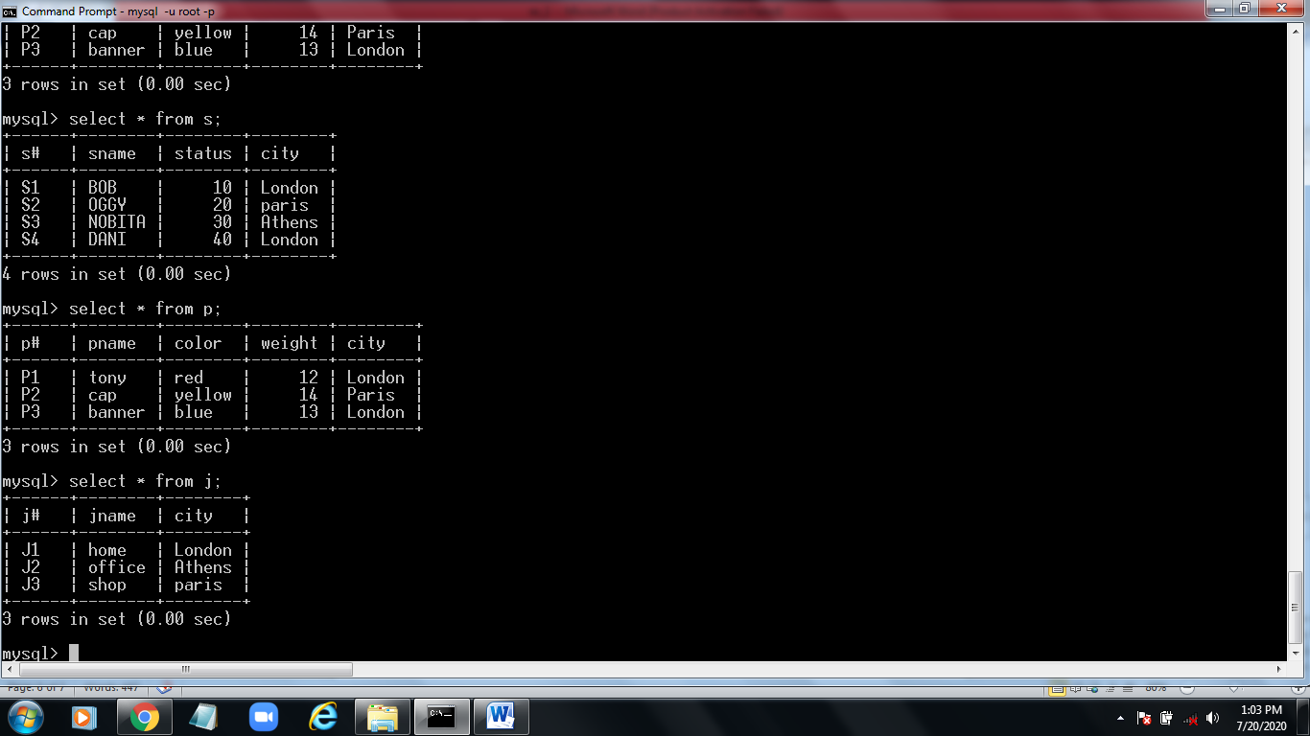

**Write the SELECT queries to do the following:-**

**5.** Display all the data from the S table.

**select * from s;**

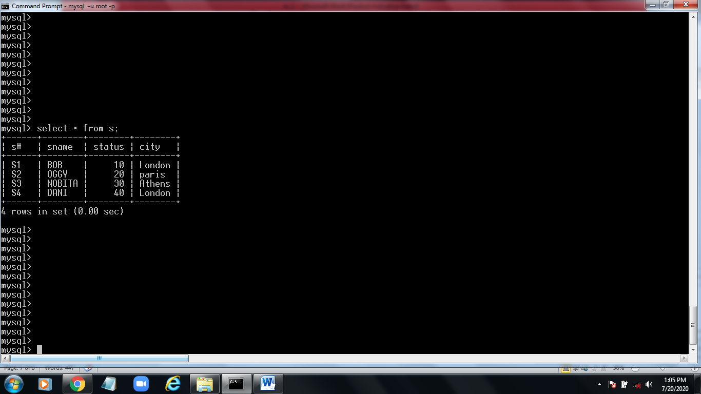

**6.** Display only the S# and SNAME fields from the S table.

**select `s#`,sname from s;**

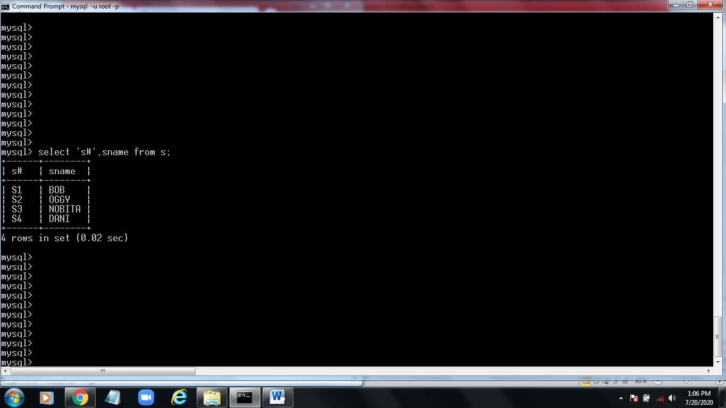

**7.** Display the PNAME and COLOR from the P table for the CITY=”London”.

**select pname,colour from p where city='london';**

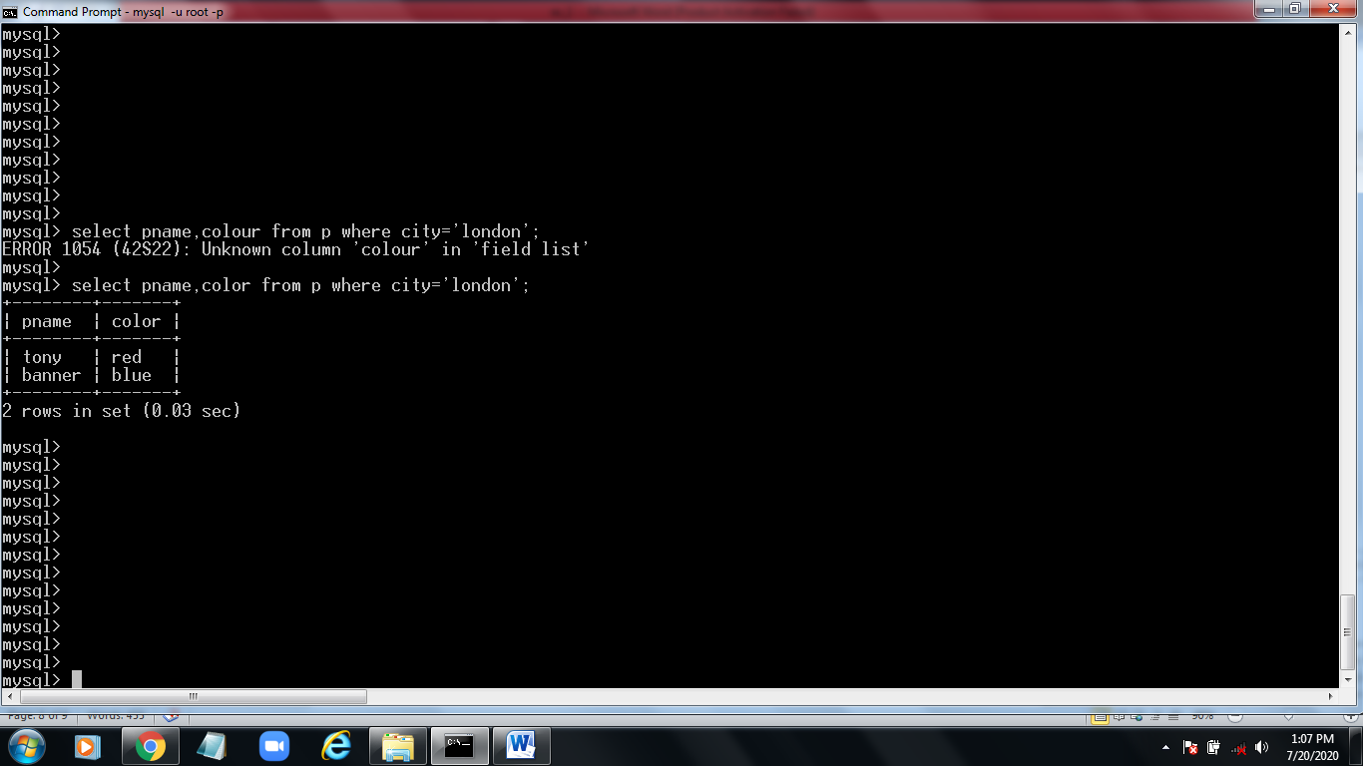

**8.** Display all the Suppliers from London.

**select * from s where city='london';**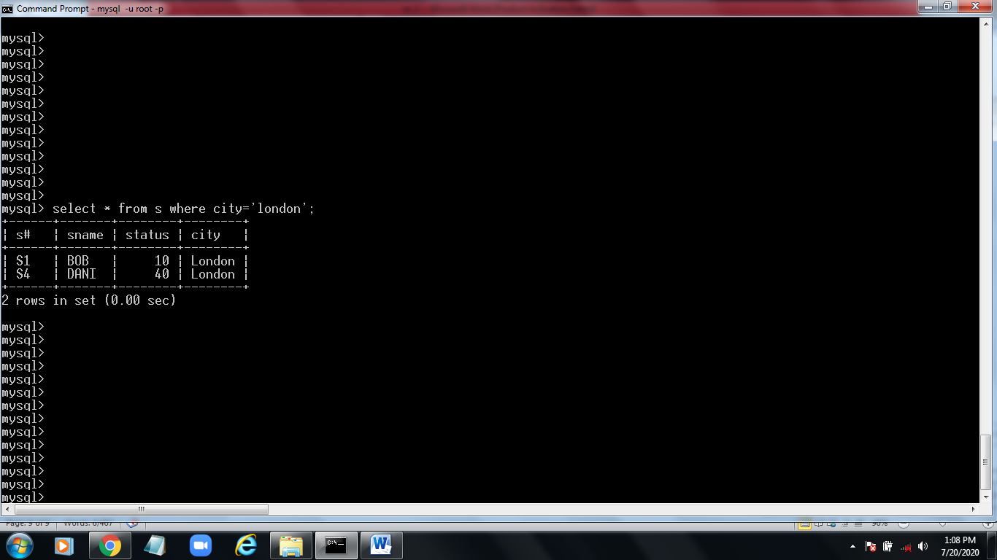

**9.** Display all the Suppliers from Paris or Athens.

**select * from s where city in ('athens','paris');**

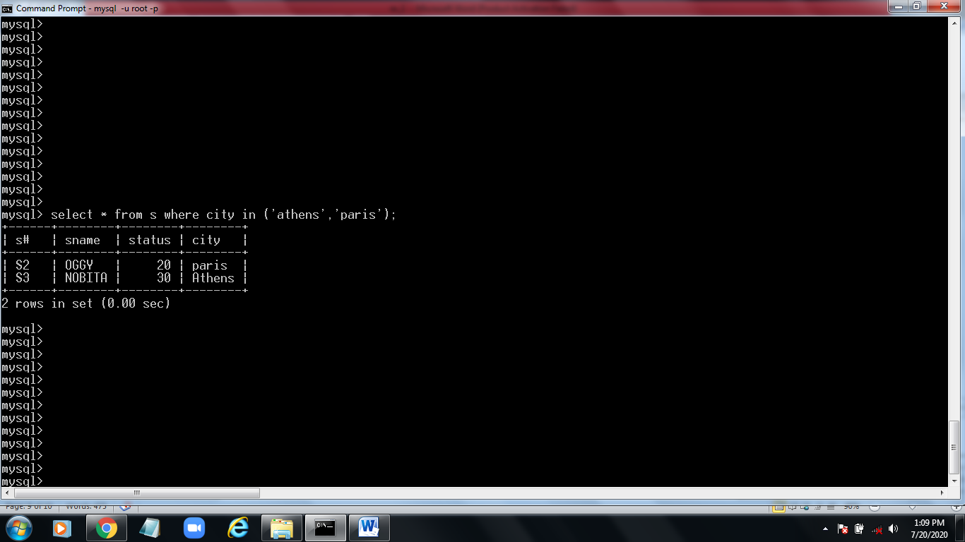

**10.** Display all the Projects in Athens.

**select * from s where city ='athens';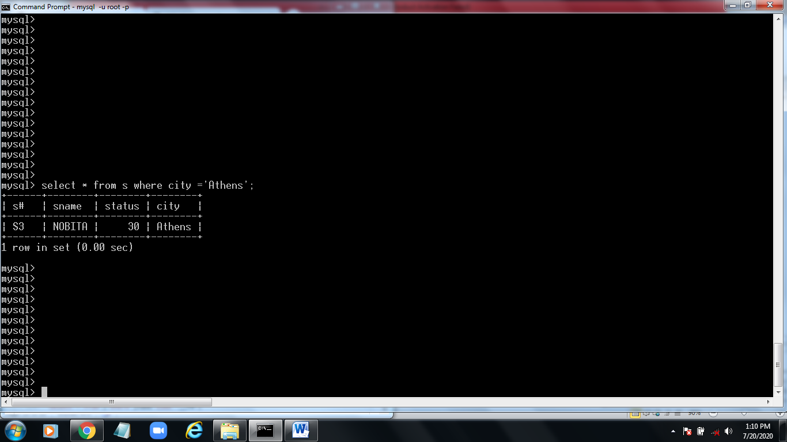11.** Display all the Partnames with the weight between 12 and 14 (inclusive of both).**select * from p where weight between 12 and 14;**

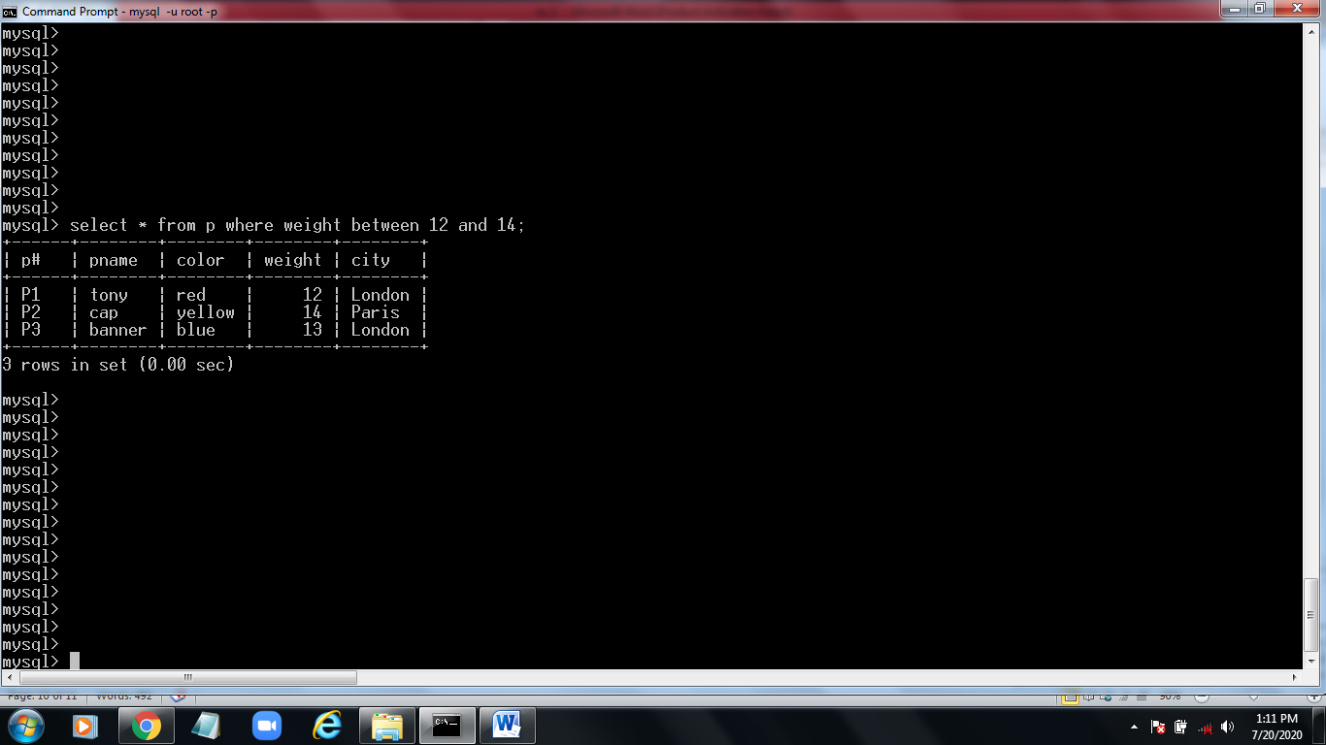

**12.** Display all the Suppliers with a Status greater than or equal to 20.

**select * from s where status >= 20;**

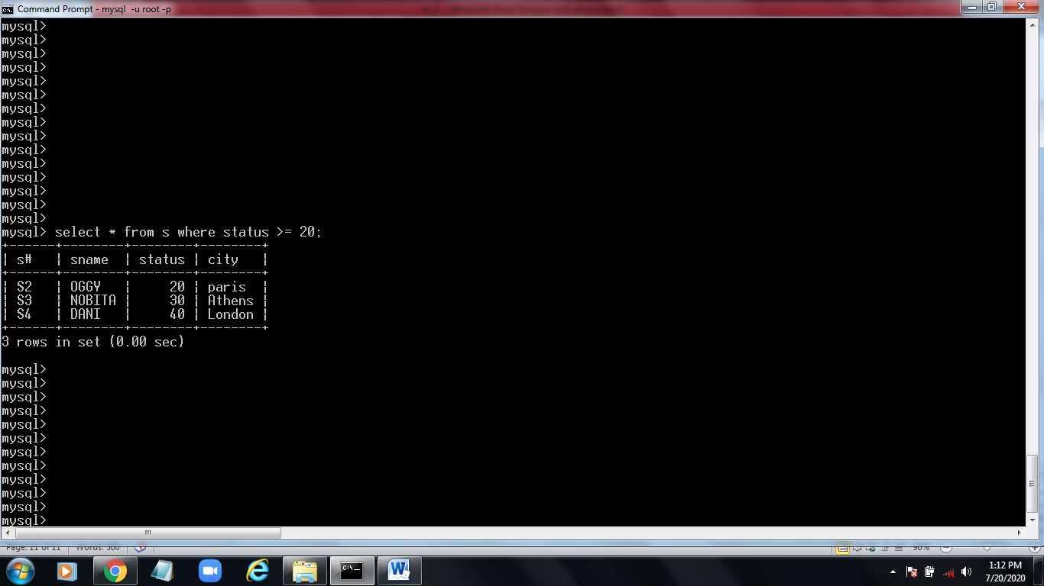

**13.** Display all the Suppliers except the Suppliers from London.

**select * from s where city!='london';**

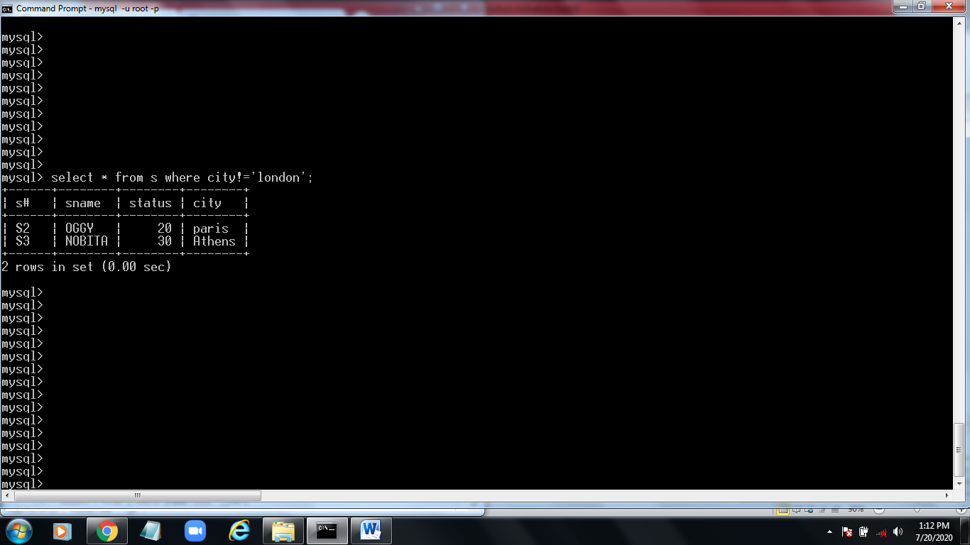

**14.** Display only the Cities from where the Suppliers come from.

**select city from s;**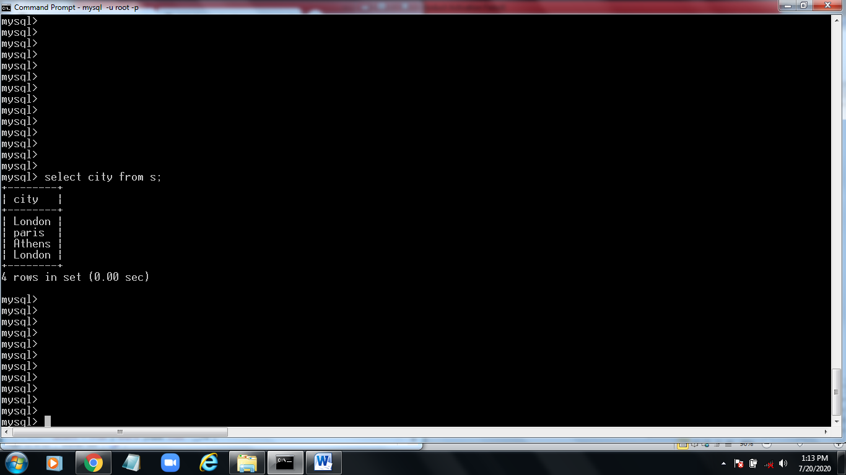

**15.** Assuming that the Part Weight is in GRAMS, display the same in

MILLIGRAMS and KILOGRAMS.

**select weight , weight/1000 as 'Weight in Milligrams', weight*1000 as 'weight in kilograms'from p;**

