# Project Milestones [xrelab]

## Image Classification and Comparison of Large Image datasets using Batch Normalization Vs. Group Normalization

### Project Configuration

* Requirements.txt for the project is @ <https://github.com/sananand007/Xrelab/tree/master/final-project>
* OS – Windows 10, 64bit Environment used – Anaconda Prompt
* Python-3.6.6 with Tensorflow 1.11 🡪 Tensorflow 1.11 with the latest Tensorboard will only work with python 3.6.6
* Remote Environment used – [www.paperspace.com](http://www.paperspace.com) 🡪 This is to run Full Training Data, which cannot be run using just the CPU

**1st week milestone**

* Use and Analyze the DeepSat (SAT-6) Airborne Dataset 🡪 Done
  + Analyze the dataset, load the dataset and create training and test sets respectively
  + Whole dataset consists of Training set of 324000 images , each being 28x28 , and 4 channels
  + Whole dataset consists of Test set of 81000 images , each being 28x28 , and 4 channels
  + Plot some images to check the categories
  + Make sure the labels are One-hot encoded
* Build a Simple CNN Pipeline using tensorflow and tensorboard to Train 🡪 Done
  + I use a CNN pipeline as below to train the model

Conv1 🡪 Max-pool 🡪 Conv2 🡪 Max-pool 🡪 flatten 🡪 dense 1🡪 dropout 🡪 dense2 🡪 Logits

* + Get the Loss, Accuracy, Precision and Recall metrics
  + Log Summaries using tensorflow logging api so that we can visualize using tensorboard
* Log Summaries and Check Using Tensorboard for Performance of the Model 🡪 Done
  + Current Model Plots are as below after some hyperparameter tuning , Plots are made using Tensorboard currently, In the future I plan to use matplotlib
  + I see the Maximum accuracy for the model reached upto nearly 94% based on runs

Parameters used for the Model

* learning_rate=1e-04
* decay_steps=10000
* decay_rate=0.96
* staircase=True
* optimizer = Gradient Optimizer
* training batch size = 512
* Currently only use 1/3rd of the images for trainings, I plan to use the entire set as I add on top of the model for later
* Steps = 2000 steps, with each 200 steps after which we calculate the Loss and evaluate the model on the test set, hence total of 10 Iterations of 200 steps each

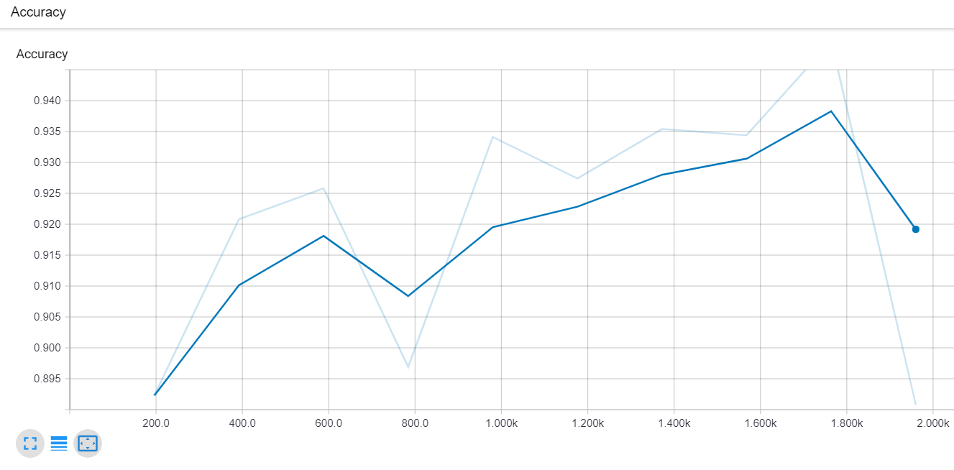

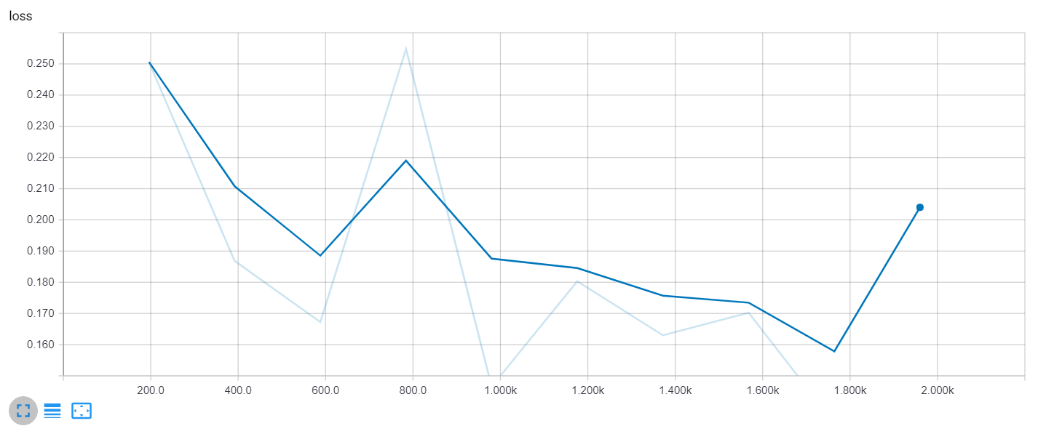

For complete Jupyter Notebook - [Github](https://github.com/sananand007/Xrelab/tree/master/final-project), [Dataset](https://www.kaggle.com/crawford/deepsat-sat6)

**2nd week milestone**

* **Use Batch Normalization on the dataset, and compare while using Group Normalization based on recent paper**
* **Start comparing performance with other large datasets**