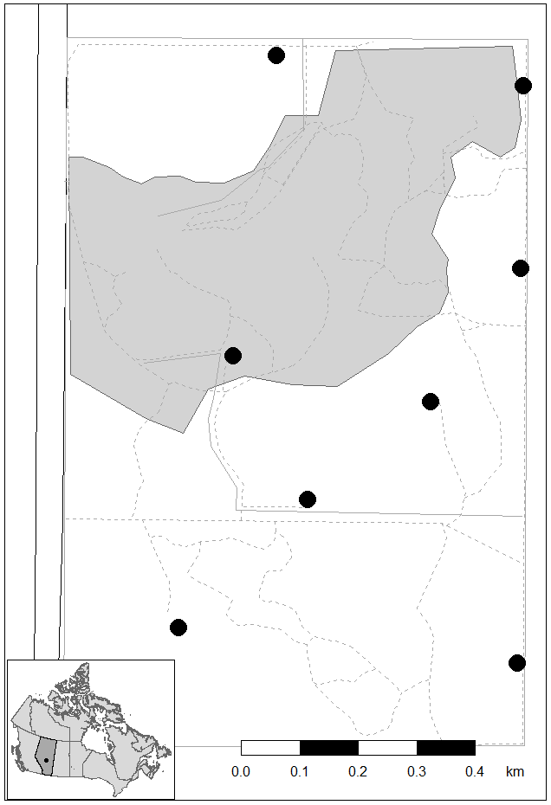
Figure S1: Map of the study area at the University of Alberta Botanic Garden, Alberta, Canada (53° 24' N, 113° 45' W, 0.97 km²). The black dot in the inset map represents the location of the field site within Alberta (dark shaded area), Canada. Garden limits are shown by solid grey lines; grey shaded area represents the public visitors’ area and the managed horticulturist gardens, and dotted grey lines represent walking pathways within the garden. Feeder locations are represented by black circles. West of the garden, the black lines on the left border of the map represent Alberta Highway 60.

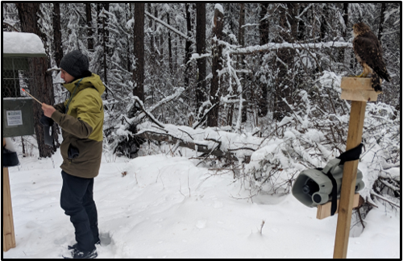
Figure S2. Example of representative acoustic+visual treatment set up for the experimental manipulations of perceived predation risk, showing the merlin mount placed on a pole 3 m from the feeder, and speaker (Shockwave, FoxPro) hanging below the mount. Note, for treatments involving no visual cues, the pole and wood block (but not merlin mount) would still be present, and for treatments involving no playbacks, the speakers would still be present but would not broadcast sound. In this way, treatments without visual and/or acoustic cues controlled for the non-biological components associated with the treatments. In this photo, the observer (JDAT) is seen registering his PIT tag at the feeder to log the start of a treatment period. Photo by Jan Wijmenga.
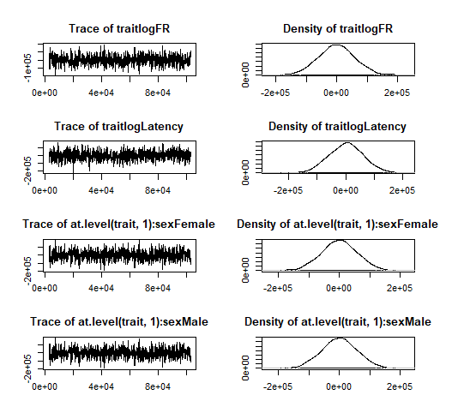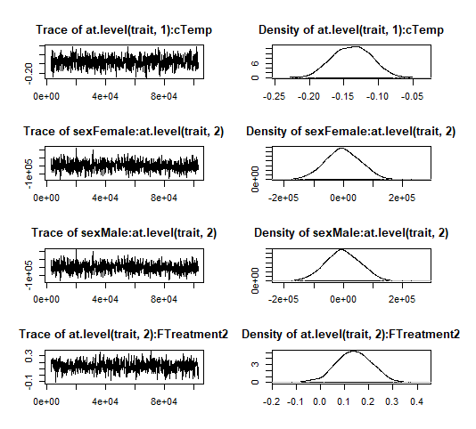
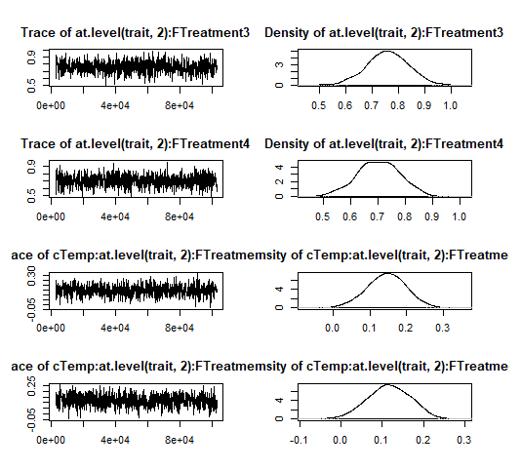
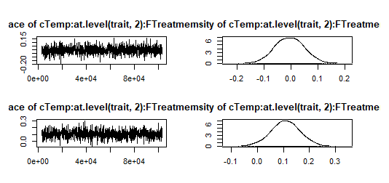
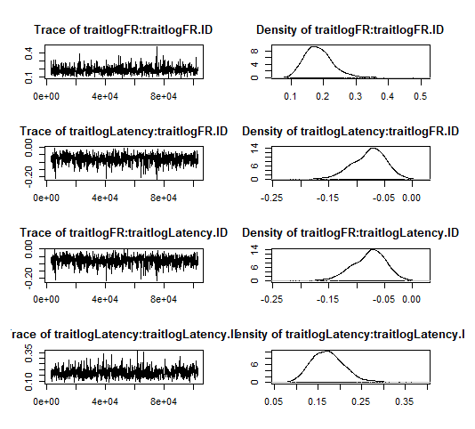
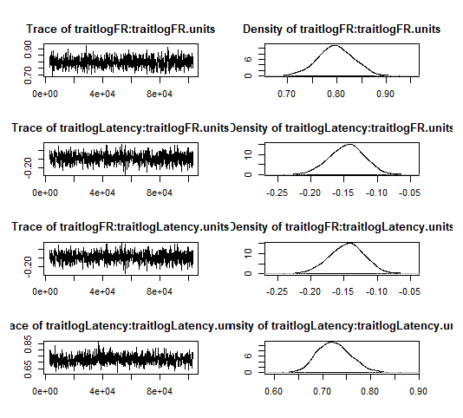
Figure S3: Posterior plots used to assess model convergence of bivariate MCMCglmm model described in the main text. Three chains were run to assess model stability. These plots are for a representative chain.

