Electronic Supplementary Material (ESM)

Visual cues of predation risk outweigh acoustic cues: a field experiment in black-capped chickadees

DOI: 10.1098/rspb.2020.2002

Josue David Arteaga-Torres^{1*}; Jan J. Wijmenga¹; Kimberley J. Mathot^{1, 2}

1. Department of Biological Sciences, University of Alberta, Edmonton, Alberta, Canada
2. Canada Research Chair in Integrative Ecology

*Author for correspondence: arteagat@ualberta.ca

Appendixes and supplementary material
Appendix S1. Change of batteries and Data processing of SD cards from RFID antennas 3
Appendix S2. Mobbing calls preparation 5
Appendix S3. Latency to resume feeding and feeding rate from RFID readings 7
Supplementary tables 9
Supplementary Figures 14

Appendix S1. Change of batteries and data processing of SD cards from RFID antennas

During visits to the feeder, we used a PIT tag assigned to each field technician to register the exact time of arrival to change the battery of the antenna. The exact time at which we used the tag was recorded in a field notebook. We confirmed that the antenna was working and with sufficient battery by observing a red-light flash on in the antenna when it recorded the tag. This tag recording was referred as “End” time because it was signifying the end of a recording period.
Once this was confirmed, we ejected and reinserted the SD card from the antenna to save all the data collected by the antenna onto the SD card. Then, we ejected the SD card and proceeded to replace it with an empty SD card. Next, we proceeded to change the battery of the antenna by unplugging the extension to the external battery and replacing the current battery with a fully charged battery.
Once the battery was changed, we confirmed that the antenna was working normally by recording another tag reading and getting a visual confirmation with the red light. This record was referred to as the “Start” time because it signified the start of a recording period.
This procedure was repeated when the experimental trials were performed. There was recording of a tag upon arrival, another tag recorded as the treatment began, another tag at the end of the trial, and finally a tag recorded at the moment that we left the feeder in which the trial was performed. This allowed us to record the total time with human disturbance at the feeder.
All the information from feeder visits (by both observers and birds) was stored in a .txt file that was processed by copying the information into a Microsoft Excel spreadsheet. Data registered were date, time, and PIT tag hex code.
We calibrated the antenna’s internal clock by subtracting the time manually recorded using the observer PIT tags from the time recorded by the antenna. For each SD card, we calculated the time drift by comparing the “Start” time of tag to the “End” time of the tags. This difference was never greater than one minute at any point over the 4-day period between visits, hence we did not adjust the times recorded by the antennas. In one case, the data at one of the feeders was not collected for a period of 4 days due to failure of the battery connection; this event was excluded from the analysis.
From the automatically registered visit data, we were able to calculate the inter-visits intervals of each individual to each feeder for every day the experiment was done. This was done by determining the difference in time between two recorded visits to the antenna.

Appendix S2. Mobbing call preparation

In order to get the BCCH mobbing calls, we performed the visual treatment in another chickadee population. We presented merlin mounts at 3 m distance from sunflower seed feeders previously installed in Emily Murphy Park (53° 31' 50" N 113° 31' 35" W) and Hawrelak Park (53° 31' 43" N 113° 32' 53" W), Edmonton, Alberta, that were being used as part of another study [1]. In February 2018, we presented each of the 6 merlin mounts once each at 6 different feeders and locations, and we recorded the mobbing calls using an Automatic Recording Unit (ARU): the model Song Meter SM3 for birdsong recordings from Wildlife Acoustics Inc., Massachusetts, USA. All the sound files were then cleaned using version 2.3.0 of Audacity® free recording and editing software (Audacity® [2]).
The first step was cropping all the files, removing any sound that was below 1.25 kHz in order to reduce the ambient noise. Then, using the “Noise Reduction” tool, we selected a portion of the recording without mobbing calls to use as a reference of the environmental noise. After the sound files were cleaned from the original recordings, we cropped each section of continuous mobbing calls, splitting them into different files following any pause longer than 2 seconds. Each smaller sound file was grouped according to the merlin mount that was originally used to create the mobbing response from the wild BCCH.
A total of 80 unique files ranging from 2 to 20 seconds in length (average= 9.58 SD= 4.55) were created and grouped by the location at which they were recorded. For the experiment, the mobbing calls were randomly selected and played in a loop for one minute, and then followed by a clip of random silence ranging from 60 to 180 seconds in duration to avoid habituation. Repeating this pattern for one hour for each sequence file, there were 20 minutes of mobbing calls and 40 minutes of silence in total for each hour the speakers were playing the files.
The sound files are available through an Open Science Framework digital repository (https://osf.io/4xa6w/) or at Dryad Digital Repository (https://doi.org/10.5061/dryad.ksn02v72h).

Appendix S3. Latency to resume feeding and feeding rate from RFID readings

Using video recordings captured at the experimental feeders in mid-October 2018, we were able to determine and adjust the readings from the RFID readers to define what comprises a true visit to the feeder. From a set of videos recorded at 4 different feeders (a total of 3 hours and 59 minutes of footage), we received 425 RFID readings, all of which were observed in the video recordings. From the 425 readings, 72 were duplications of registries from minor movements of the birds at the antennas connected to the RFID readers. All the duplications happened within 5 seconds. Therefore, we excluded any inter-visits intervals shorter than 5 seconds from all the RFID recordings to filter out duplicated readings. We calculated latency to resume feeding as our proxy to risk-taking behaviour [3]. The latency was determined as the difference in time, measured in seconds, from the start of an event (either human disturbance at the feeder or the start of a treatment during the experimental days) to the time of the first visit for each individual. Then we filtered out individuals that were not present at the feeders within an hour before the start of any treatment. This was done to ensure that birds included in our analyses had been present in the vicinity of the feeder during the 1-hour treatment period, and therefore, likely to have been exposed to the experimental treatment. We used the latency of this individuals for the analysis. For the birds that did not return on the same day, we assigned them a maximum latency score equivalent to if they had returned at civil twilight (then end of the foraging period). Finally, for the birds that did return in the same day, we counted the number of visits within 20 minutes after the first recorded visit to the feeder once the experiments had started and multiplied by three to estimate feeder visits/hour. We used the first 20 minutes following a visit return because we wanted to estimate the short-term (i.e., immediate) feeding rate response to our treatments.
To evaluate the effect of temperature, treatment and their interaction on feeding rates, we constructed linear mixed effects models that were identical to those constructed for latency to resume feeding (i.e., contained the same fixed and random effects), with one exception. We included the additional fixed effect of latency to resume feeding (centered and standardized), to control for variation in feeding rates that may have been due to differences in hunger resulting from differences in the duration of feeding interruptions. Results of these analyses are presented in Table 1 of the main text. Additionally, we performed the same analysis for latency with a dataset that comprised all individuals that visited the feeders after the experiment started regardless if they were present or not before the start of the experiment. We did these analyses to confirm that there was no bias on the results due to the filtering of individuals. Results of these additional analyses are present in the ESM Table S2 in this document.

Appendixes references
[1] Congdon, J.V., Hahn, A.H., Campbell, K.A., Scully, E.N., Yip, D.A., Bayne, E.M. & Sturdy, C.B. 2020 Acoustic discrimination of predators by black-capped chickadees (Poecile atricapillus). Animal Cognition. (doi:10.1007/s10071-020-01364-5).
[2] Audacity®. software is copyright © 1999-2018 Audacity Team.
[3] Mathot, K.J., Nicolaus, M., Araya-Ajoy, Y.G., Dingemanse, N.J., Kempenaers, B. & Grémillet, D. 2015 Does metabolic rate predict risk-taking behaviour? A field experiment in a wild passerine bird. Funct Ecol 29, 239-249. (doi:10.1111/1365-2435.12318).

Supplementary tables
Table S1. Chronogram showing the order of the treatments and details about the different equipment used in each one.
Date | Feeder | Replicate | Day | Time | Observer | Treatment | Mount# | Speaker# | Track#
2018-12-04 | 09 | 1 | 1 | 9:30 | Josué | Visual | 5 | 2 | 0
2018-12-04 | 14 | 1 | 1 | 11:00 | Jan | Control | 0 | 2 | 0
2018-12-04 | 02 | 1 | 1 | 12:30 | Josué | Acoustic | 0 | 1 | 7
2018-12-04 | 10 | 1 | 1 | 14:00 | Jan | Acoustic & Visual | 3 | 1 | 2
2018-12-06 | 12 | 1 | 2 | 9:30 | Josué | Visual | 3 | 2 | 0
2018-12-06 | 09 | 1 | 2 | 11:00 | Josué | Acoustic | 0 | 1 | 5
2018-12-06 | 11 | 1 | 2 | 12:30 | Josué | Acoustic & Visual | 1 | 2 | 5
2018-12-06 | 02 | 1 | 2 | 14:00 | Josué | Control | 0 | 1 | 0
2018-12-08 | 16 | 1 | 3 | 9:30 | Josué | Control | 0 | 1 | 0
2018-12-08 | 10 | 1 | 3 | 11:00 | Josué | Acoustic | 0 | 1 | 5
2018-12-08 | 04 | 1 | 3 | 12:30 | Josué | Visual | 6 | 1 | 0
2018-12-08 | 02 | 1 | 3 | 14:00 | Josué | Acoustic & Visual | 6 | 2 | 3
2018-12-10 | 16 | 1 | 4 | 9:30 | Jan | Visual | 4 | 2 | 0
2018-12-10 | 11 | 1 | 4 | 11:00 | Jan | Acoustic | 0 | 2 | 4
2018-12-10 | 04 | 1 | 4 | 12:30 | Jan | Control | 0 | 2 | 0
2018-12-10 | 12 | 1 | 4 | 14:00 | Jan | Acoustic & Visual | 5 | 1 | 5
2018-12-12 | 16 | 1 | 5 | 9:30 | Josué | Acoustic | 0 | 2 | 1
2018-12-12 | 14 | 1 | 5 | 11:00 | Josué | Visual | 2 | 1 | 0
2018-12-12 | 4 | 1 | 5 | 12:30 | Josué | Acoustic & Visual | 6 | 1 | 3
2018-12-12 | 10 | 1 | 5 | 14:00 | Josué | Control | 0 | 1 | 0
2018-12-14 | 10 | 1 | 6 | 9:30 | Josué | Visual | 3 | 2 | 0
2018-12-14 | 12 | 1 | 6 | 11:00 | Josué | Acoustic | 0 | 2 | 8
2018-12-14 | 14 | 1 | 6 | 12:30 | Josué | Acoustic & Visual | 1 | 2 | 8
2018-12-14 | 11 | 1 | 6 | 14:00 | Josué | Control | 0 | 2 | 0
2018-12-16 | 02 | 1 | 7 | 9:30 | Jan | Visual | 4 | 1 | 0
2018-12-16 | 14 | 1 | 7 | 11:00 | Jan | Acoustic | 0 | 1 | 7
2018-12-16 | 09 | 1 | 7 | 12:30 | Jan | Control | 0 | 2 | 0
2018-12-16 | 16 | 1 | 7 | 14:00 | Jan | Acoustic & Visual | 5 | 1 | 2
2018-12-18 | 04 | 1 | 8 | 9:30 | Josué | Acoustic | 0 | 1 | 2
2018-12-18 | 12 | 1 | 8 | 11:00 | Josué | Control | 0 | 1 | 0
2018-12-18 | 11 | 1 | 8 | 12:30 | Josué | Visual | 2 | 2 | 0
2018-12-18 | 09 | 1 | 8 | 14:00 | Josué | Acoustic & Visual | 4 | 1 | 6
2018-12-28 | 02 | 2 | 1 | 9:30 | Josué | Control | 0 | 1 | 0
2018-12-28 | 12 | 2 | 1 | 11:00 | Josué | Visual | 5 | 2 | 0
2018-12-28 | 14 | 2 | 1 | 12:30 | Josué | Acoustic & Visual | 1 | 2 | 5
2018-12-28 | 10 | 2 | 1 | 14:00 | Josué | Acoustic | 0 | 1 | 5
2018-12-30 | 09 | 2 | 2 | 9:30 | Josué | Control | 0 | 1 | 0
2018-12-30 | 04 | 2 | 2 | 11:00 | Josué | Acoustic & Visual | 6 | 1 | 2
2018-12-30 | 02 | 2 | 2 | 12:30 | Josué | Acoustic | 0 | 2 | 7
2018-12-30 | 14 | 2 | 2 | 14:00 | Josué | Visual | 5 | 2 | 0
2019-01-01 | 09 | 2 | 3 | 9:30 | Josué | Visual | 4 | 1 | 0
2019-01-01 | 12 | 2 | 3 | 11:00 | Josué | Control | 0 | 1 | 0
2019-01-01 | 10 | 2 | 3 | 12:30 | Josué | Acoustic & Visual | 2 | 1 | 1
2019-01-01 | 14 | 2 | 3 | 14:00 | Josué | Acoustic | 0 | 2 | 2
2019-01-03 | 16 | 2 | 4 | 9:30 | Josué | Acoustic & Visual | 6 | 1 | 5
2019-01-03 | 10 | 2 | 4 | 11:00 | Josué | Control | 0 | 2 | 0
2019-01-03 | 09 | 2 | 4 | 12:30 | Josué | Acoustic | 0 | 2 | 6
2019-01-03 | 04 | 2 | 4 | 14:00 | Josué | Visual | 5 | 2 | 0
2019-01-05 | 12 | 2 | 5 | 9:30 | Jan | Acoustic & Visual | 4 | 2 | 3
2019-01-05 | 16 | 2 | 5 | 11:00 | Jan | Control | 0 | 2 | 0
2019-01-05 | 11 | 2 | 5 | 12:30 | Jan | Acoustic | 0 | 2 | 8
2019-01-05 | 10 | 2 | 5 | 14:00 | Jan | Visual | 4 | 2 | 0
2019-01-07 | 11 | 2 | 6 | 9:30 | Josué | Acoustic & Visual | 1 | 2 | 5
2019-01-07 | 16 | 2 | 6 | 11:00 | Josué | Acoustic | 0 | 2 | 1
2019-01-07 | 02 | 2 | 6 | 12:30 | Josué | Visual | 2 | 2 | 0
2019-01-07 | 04 | 2 | 6 | 14:00 | Josué | Control | 0 | 1 | 0
2019-01-09 | 11 | 2 | 7 | 9:30 | Josué | Control | 0 | 2 | 0
2019-01-09 | 04 | 2 | 7 | 11:00 | Josué | Acoustic | 0 | 2 | 6
2019-01-09 | 02 | 2 | 7 | 12:30 | Josué | Acoustic & Visual | 1 | 1 | 4
2019-01-09 | 16 | 2 | 7 | 14:00 | Josué | Visual | 1 | 2 | 0
2019-01-11 | 11 | 2 | 8 | 9:30 | Josué | Visual | 3 | 1 | 0
2019-01-11 | 12 | 2 | 8 | 11:00 | Josué | Acoustic | 0 | 2 | 2
2019-01-11 | 14 | 2 | 8 | 12:30 | Josué | Control | 0 | 1 | 0
2019-01-11 | 09 | 2 | 8 | 14:00 | Josué | Acoustic & Visual | 2 | 2 | 4
2019-01-21 | 04 | 3 | 1 | 9:30 | Josué | Acoustic | 0 | 1 | 3
2019-01-21 | 14 | 3 | 1 | 11:00 | Josué | Control | 0 | 1 | 0
2019-01-21 | 10 | 3 | 1 | 12:30 | Josué | Acoustic & Visual | 3 | 2 | 3
2019-01-21 | 12 | 3 | 1 | 14:00 | Josué | Visual | 1 | 1 | 0
2019-01-23 | 10 | 3 | 2 | 9:30 | Jan | Acoustic | 0 | 2 | 7
2019-01-23 | 12 | 3 | 2 | 11:00 | Jan | Acoustic & Visual | 4 | 2 | 5
2019-01-23 | 09 | 3 | 2 | 12:30 | Jan | Control | 0 | 2 | 0
2019-01-23 | 02 | 3 | 2 | 14:00 | Jan | Visual | 2 | 1 | 0
2019-01-25 | 16 | 3 | 3 | 9:30 | Josué | Acoustic | 0 | 1 | 1
2019-01-25 | 12 | 3 | 3 | 11:00 | Josué | Control | 0 | 2 | 0
2019-01-25 | 14 | 3 | 3 | 12:30 | Josué | Visual | 4 | 2 | 0
2019-01-25 | 02 | 3 | 3 | 14:00 | Josué | Acoustic & Visual | 1 | 1 | 7
2019-01-27 | 11 | 3 | 4 | 9:30 | Josué | Acoustic | 0 | 2 | 3
2019-01-27 | 14 | 3 | 4 | 11:00 | Josué | Acoustic & Visual | 2 | 2 | 2
2019-01-27 | 09 | 3 | 4 | 12:30 | Josué | Visual | 1 | 2 | 0
2019-01-27 | 16 | 3 | 4 | 14:00 | Josué | Control | 0 | 2 | 0
2019-01-29 | 11 | 3 | 5 | 9:30 | Josué | Control | 0 | 1 | 0
2019-01-29 | 16 | 3 | 5 | 11:00 | Josué | Visual | 3 | 1 | 0
2019-01-29 | 09 | 3 | 5 | 12:30 | Josué | Acoustic | 0 | 2 | 6
2019-01-29 | 04 | 3 | 5 | 14:00 | Josué | Acoustic & Visual | 4 | 2 | 6
2019-01-31 | 10 | 3 | 6 | 9:30 | Josué | Visual | 5 | 2 | 0
2019-01-31 | 12 | 3 | 6 | 11:00 | Josué | Acoustic | 0 | 2 | 4
2019-01-31 | 09 | 3 | 6 | 12:30 | Josué | Acoustic & Visual | 2 | 2 | 4
2019-01-31 | 04 | 3 | 6 | 14:00 | Josué | Control | 0 | 2 | 0
2019-02-02 | 10 | 3 | 7 | 9:30 | Josué | Control | 0 | 1 | 0
2019-02-02 | 02 | 3 | 7 | 11:00 | Josué | Acoustic | 0 | 1 | 1
2019-02-02 | 16 | 3 | 7 | 12:30 | Josué | Acoustic & Visual | 3 | 1 | 6
2019-02-02 | 11 | 3 | 7 | 14:00 | Josué | Visual | 4 | 1 | 0
2019-02-04 | 02 | 3 | 8 | 9:30 | Jan | Control | 0 | 1 | 0
2019-02-04 | 14 | 3 | 8 | 11:00 | Jan | Acoustic | 0 | 2 | 8
2019-02-04 | 04 | 3 | 8 | 12:30 | Jan | Visual | 6 | 2 | 0
2019-02-04 | 11 | 3 | 8 | 14:00 | Jan | Acoustic & Visual | 3 | 1 | 1
2019-02-14 | 04 | 4 | 1 | 9:30 | Josué | Acoustic & Visual | 3 | 1 | 4
2019-02-14 | 14 | 4 | 1 | 11:00 | Josué | Visual | 3 | 1 | 0
2019-02-14 | 10 | 4 | 1 | 12:30 | Josué | Control | 0 | 1 | 0
2019-02-14 | 12 | 4 | 1 | 14:00 | Josué | Acoustic | 0 | 1 | 8
2019-02-16 | 11 | 4 | 2 | 9:30 | Jan | Visual | 5 | 1 | 0
2019-02-16 | 14 | 4 | 2 | 11:00 | Jan | Acoustic | 0 | 1 | 3
2019-02-16 | 12 | 4 | 2 | 12:30 | Jan | Control | 0 | 2 | 0
2019-02-16 | 09 | 4 | 2 | 14:00 | Jan | Acoustic & Visual | 1 | 1 | 7
2019-02-18 | 09 | 4 | 3 | 9:30 | Josué | Visual | 5 | 2 | 0
2019-02-18 | 04 | 4 | 3 | 11:00 | Josué | Acoustic | 0 | 2 | 2
2019-02-18 | 11 | 4 | 3 | 12:30 | Josué | Control | 0 | 2 | 0
2019-02-18 | 12 | 4 | 3 | 14:00 | Josué | Acoustic & Visual | 2 | 1 | 5
2019-02-20 | 04 | 4 | 4 | 9:30 | Josué | Control | 0 | 2 | 0
2019-02-20 | 02 | 4 | 4 | 11:00 | Josué | Visual | 2 | 1 | 0
2019-02-20 | 10 | 4 | 4 | 12:30 | Josué | Acoustic | 0 | 1 | 7
2019-02-20 | 11 | 4 | 4 | 14:00 | Josué | Acoustic & Visual | 4 | 1 | 5
2019-02-22 | 02 | 4 | 5 | 9:30 | Josué | Control | 0 | 1 | 0
2019-02-22 | 10 | 4 | 5 | 11:00 | Josué | Visual | 5 | 1 | 0
2019-02-22 | 14 | 4 | 5 | 12:30 | Josué | Acoustic & Visual | 4 | 2 | 3
2019-02-22 | 16 | 4 | 5 | 14:00 | Josué | Acoustic | 0 | 2 | 3
2019-02-24 | 02 | 4 | 6 | 9:30 | Josué | Acoustic & Visual | 3 | 1 | 2
2019-02-24 | 16 | 4 | 6 | 11:00 | Josué | Visual | 2 | 1 | 0
2019-02-24 | 09 | 4 | 6 | 12:30 | Josué | Control | 0 | 2 | 0
2019-02-24 | 11 | 4 | 6 | 14:00 | Josué | Acoustic | 0 | 1 | 4
2019-02-26 | 10 | 4 | 7 | 9:30 | Josué | Acoustic & Visual | 4 | 2 | 1
2019-02-26 | 02 | 4 | 7 | 11:00 | Josué | Acoustic | 0 | 1 | 1
2019-02-26 | 16 | 4 | 7 | 12:30 | Josué | Control | 0 | 2 | 0
2019-02-26 | 04 | 4 | 7 | 14:00 | Josué | Visual | 2 | 1 | 0
2019-02-28 | 12 | 4 | 8 | 9:30 | Josué | Visual | 1 | 2 | 0
2019-02-28 | 16 | 4 | 8 | 11:00 | Josué | Acoustic & Visual | 5 | 2 | 6
2019-02-28 | 09 | 4 | 8 | 12:30 | Josué | Acoustic | 0 | 1 | 4
2019-02-28 | 14 | 4 | 8 | 14:00 | Josué | Control | 0 | 1 | 0

Table S2. LMM model results for latency to resume feeding including 1) dataset filtered to include only birds that were present in the 1 hour prior to the treatment. Birds that did not resume feeding that day were assigned a maximum latency equal to civil twilight (i.e., the end of the foraging period), 2) dataset including all birds regardless of whether they were present prior to the treatment (not filtered). This dataset only comprised birds that did return (true latency)
 | LMM Log (LRF seconds)  Filtered + max latency | LMM Log (LRF seconds)  Not filtered + true latency
Fixed Effects | β (95% CI) | β (95% CI)
Sex ª | 0.03 (-0.33, 0.30) | 0.02 (-0.27, 0.30)
Treatment
Control | 6.60 (6.17, 6.96) | 6.71 (6.39, 7.03)
Acoustic | 6.67 (6.40, 7.16) | 6.89 (6.58, 7.21)
Visual | 7.74 (7.38, 8.12) | 7.71 (7.45, 8.09)
Both | 7.61 (7.23, 7.99) | 7.61 (7.32, 7.94)
Temperature ^{b}
Temperature by Control | 0.24 (0.03, 0.36) | 0.21 (0.08, 0.37)
Temperature by Acoustic | 0.17 (0.00, 0.31) | 0.30 (0.16, 0.44)
Temperature by Visual | 0.02 (-0.12, 0.19) | 0.06 (-0.07, 0.20)
Temperature by Both | 0.21 (0.05, 0.38) | 0.20 (0.01, 0.30)
Random Effects | σ (95% CI) | σ (95% CI)
Individual N=79 | 0.32 (0.20, 0.54) | 0.30 (0.19, 0.48)
Feeders N=8 | 0.08 (0.02, 0.40) | 0.04 (0.01, 0.30)
Replicate N = 4 | 0.00 (0.00, 0.11) | 0.00 (0.00, 0.02)
Residual N=1009;1197 | 1.53 (1.43, 1.71) | 1.44 (1.32, 1.57)
Repeatability ^{c} | σ (95% CI) | σ (95% CI)
Individuals | 0.18 (0.13, 0.27) | 0.18 (0.11, 0.25)
ª: Intercept was calculated using centred Sex as males -0.5 and females 0.5
^{b}: Mean daily temperature, grand mean centred and divided by 2 SD.
^{c}: Adjusted repeatability estimated after taking into account fixed effects.

Supplementary Figures
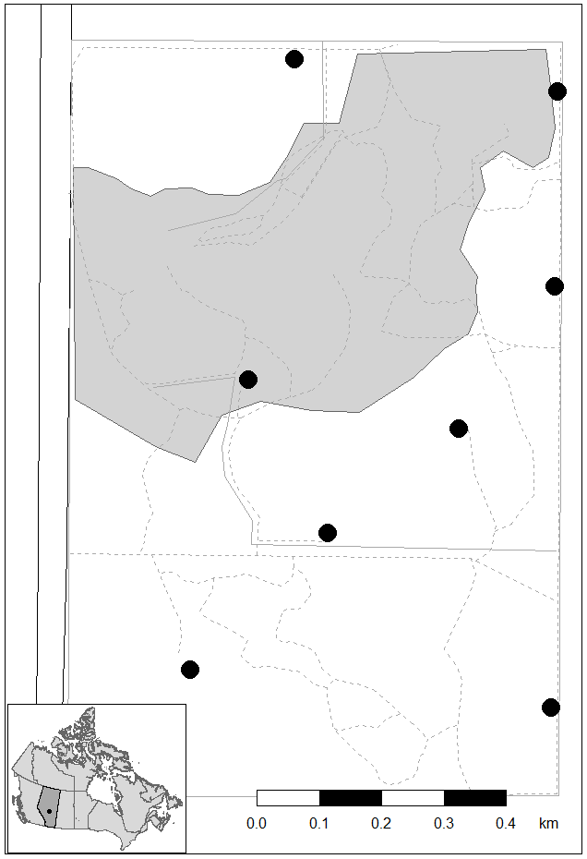
Figure S1. Map of the field site at the University of Alberta Botanic Garden, Alberta, Canada. (53° 24' N, 113° 45' W, 0.97 km²). The black dot in the inset map represents the location of the field site within Canada. Garden limits are shown by solid grey lines; dotted grey lines represent walking pathways within the garden. Feeder locations are represented by black circles. West of the garden, the black lines represent the Devonian Highway (Alberta Highway 60), used to access the garden, and the grey shaded area represents the public visitors’ area and the managed horticulturist gardens.

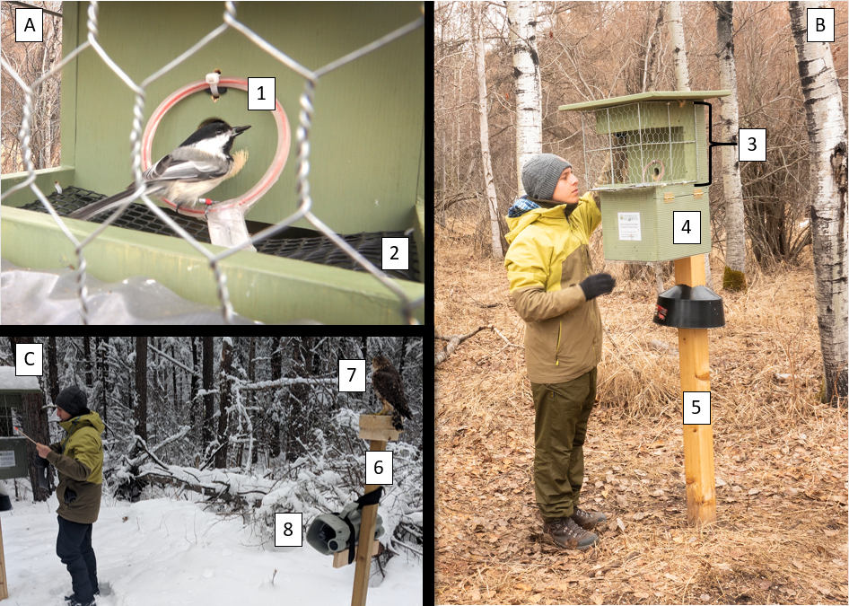
Figure S2. Feeder set up and detailed information of the feeder. A) Close up of a marked chickadee taking a seed out of the feeder. 1: RFID antenna reader. 2: 10 mm x 10 mm mesh covering over a hollow bottom. This allowed discarded seeds to pass through the mesh into the hollow bottom. This trapped discarded seeds rather than allowing them to fall on the ground below the feeder, preventing birds from feeding on the ground instead of the feeder and having foraging events go undetected. B) Overall visualization of the feeder setup. JAT next to the feeder. 3: Wire mesh to protect the feeder and prevent small mammals and other larger birds from accessing the seeds. 4: Side access door to the battery and RFID readers’ storage compartment. 5: Base pole of the feeder. All feeders were installed at the same height with the seed hole at approximately 1.60 m. C) Example of an acoustic+visual treatment and overview of the set-up. 6: Experimental pole. 7: Merlin mount. 8: Speaker broadcasting chickadee mobbing calls. © A and B: Megan A. Westervelt; C: Jan Wijmenga

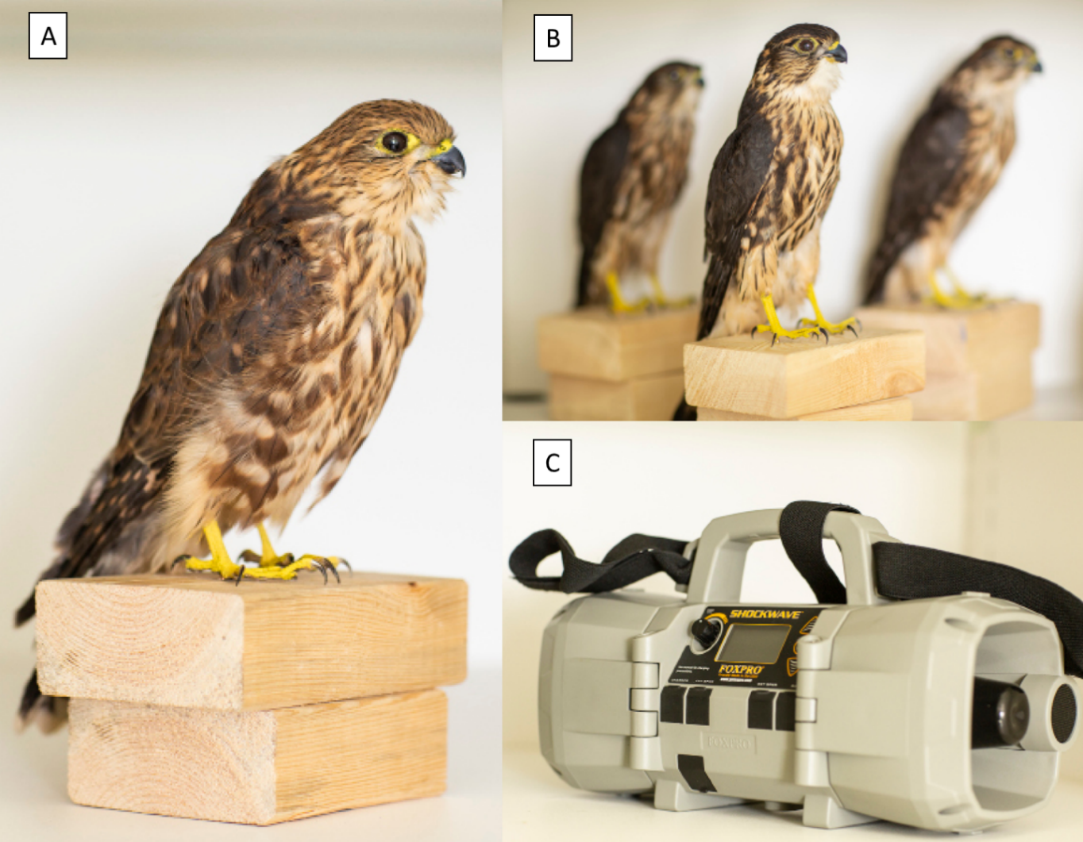
Figure S3. A) Photograph of one of the merlin mounts used for the treatment trials as visual cue. B) View of three other mounts used in the experimental trials. C) Photograph of one of the speakers used in the trials as an acoustic cue broadcasting mobbing calls created for the experiment. © Megan A. Westervelt

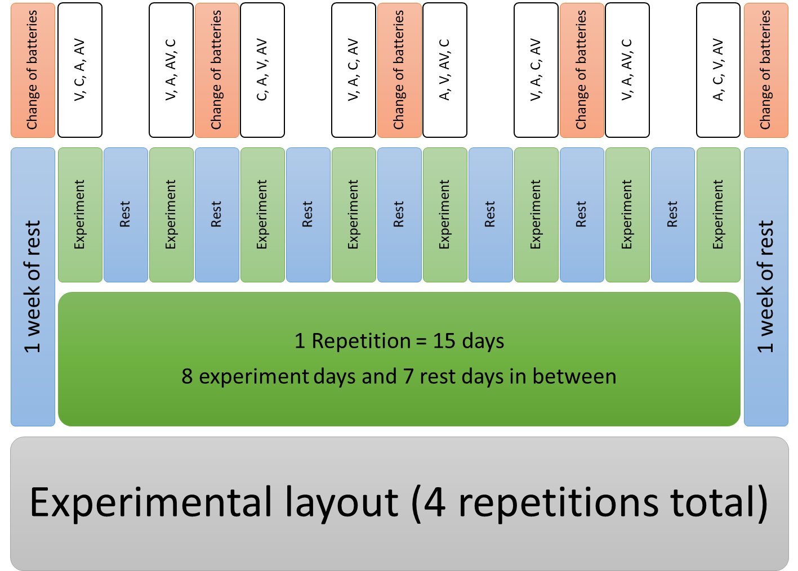
Figure S4. A schematic representation of an experimental replicate. In total, there were 4 replicates of the experimental period and one week of rest in between replicates. Small green boxes represent days on which the simulated presence of a predator was carried out with audio and visual cues. The white boxes represent the various treatments applied at each feeder, which were assigned at random. Blue boxes represent days on which there were no experiments carried out. All the red boxes represent days on which SD cards and batteries for the RFID readers were changed.

