Cloud Computing Assignment

Assignment # 01
LAB TITLE: Git, Gitea, GitHub, Git LFS, and GitHub Pages

Name | SANA NOOR BHATTI
Registration Number | FA24Bl-SE-022
Section | B
Semester | Fifth (V)
Course Code | SE-665
GitHub Username | sananoorbhatti

Instructor: Engr. Waqas Saleem
Task 1 – Gitea Setup and Repository

  - Gitea Installation and Running Containers

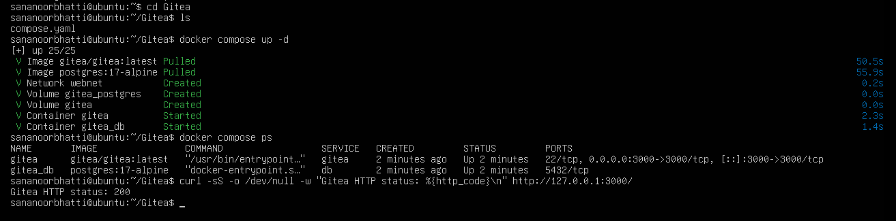

Gitea and PostgreSQL were verified as running through Docker Compose, and the HTTP response confirmed that Gitea was accessible.

  - Pushing the Local Repository to Gitea

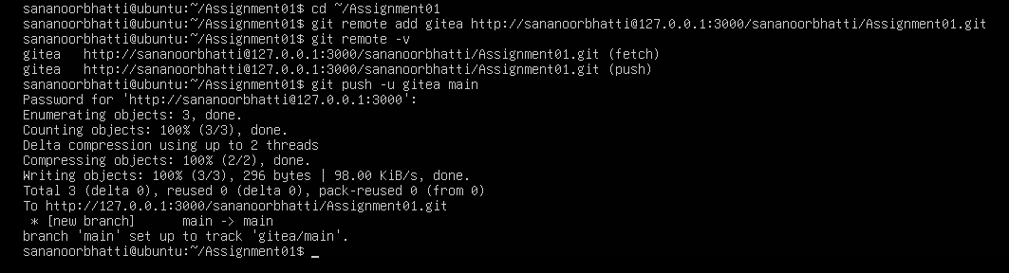

The local Git repository was connected to Gitea using a remote, and the main branch was pushed successfully.

1.3 Gitea Repository Verification
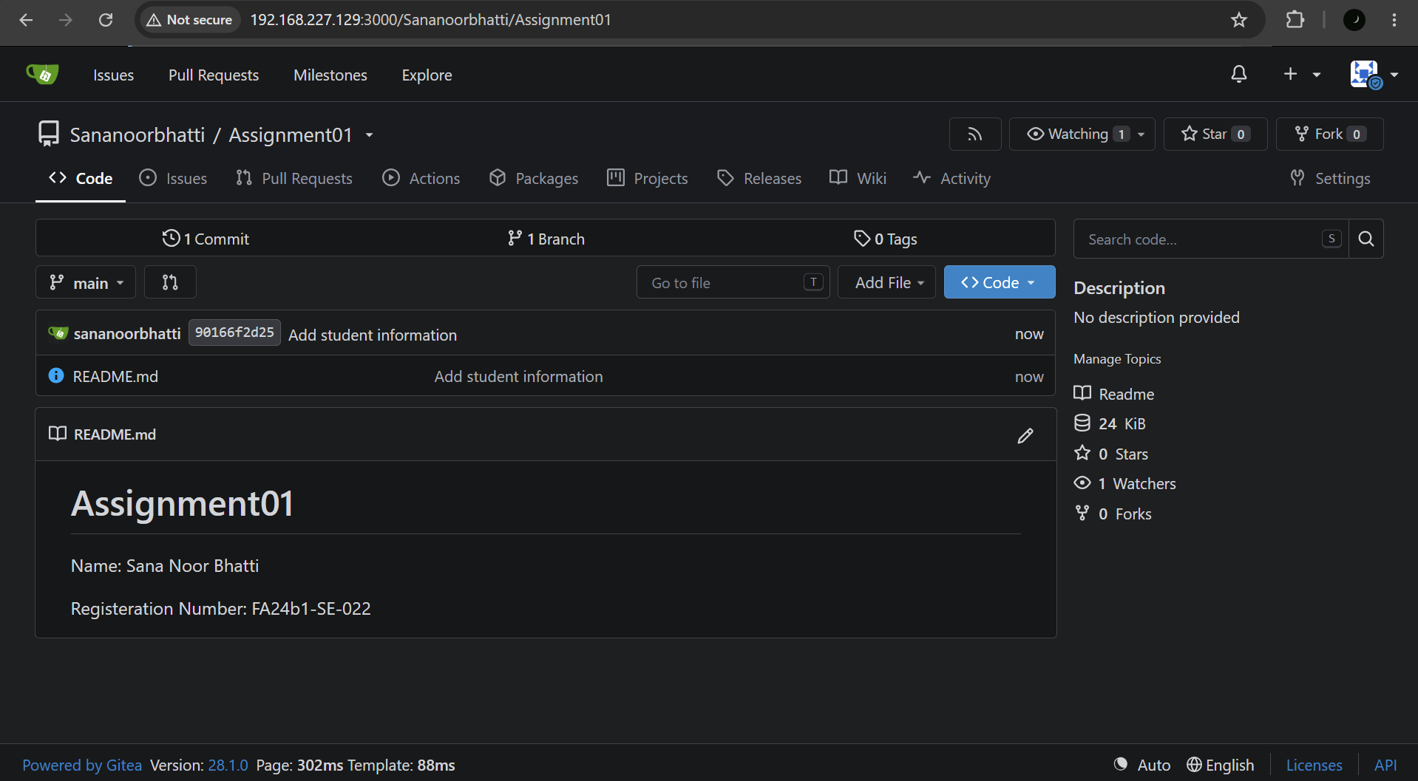

The public Assignment01 repository was verified on Gitea, showing the project README and repository contents.

Task 2 – GitHub Repository and Remotes

2.1 Configuring Gitea and GitHub Remotes

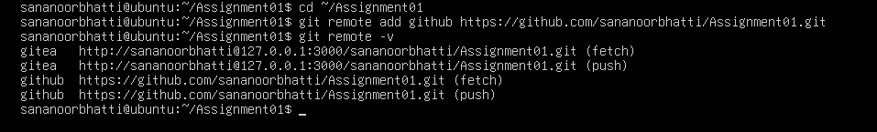

Separate remotes named gitea and github were configured and verified using the git remote -v command.

2.2 Pushing the Repository to GitHub

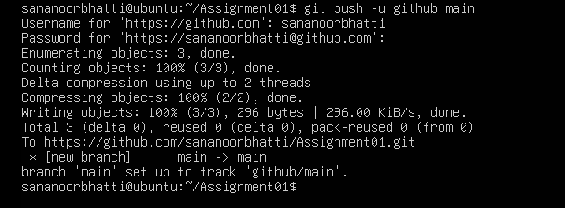
The local repository was pushed to the public GitHub Assignment01 repository, successfully uploading the main branch.

2.3 GitHub Repository Verification

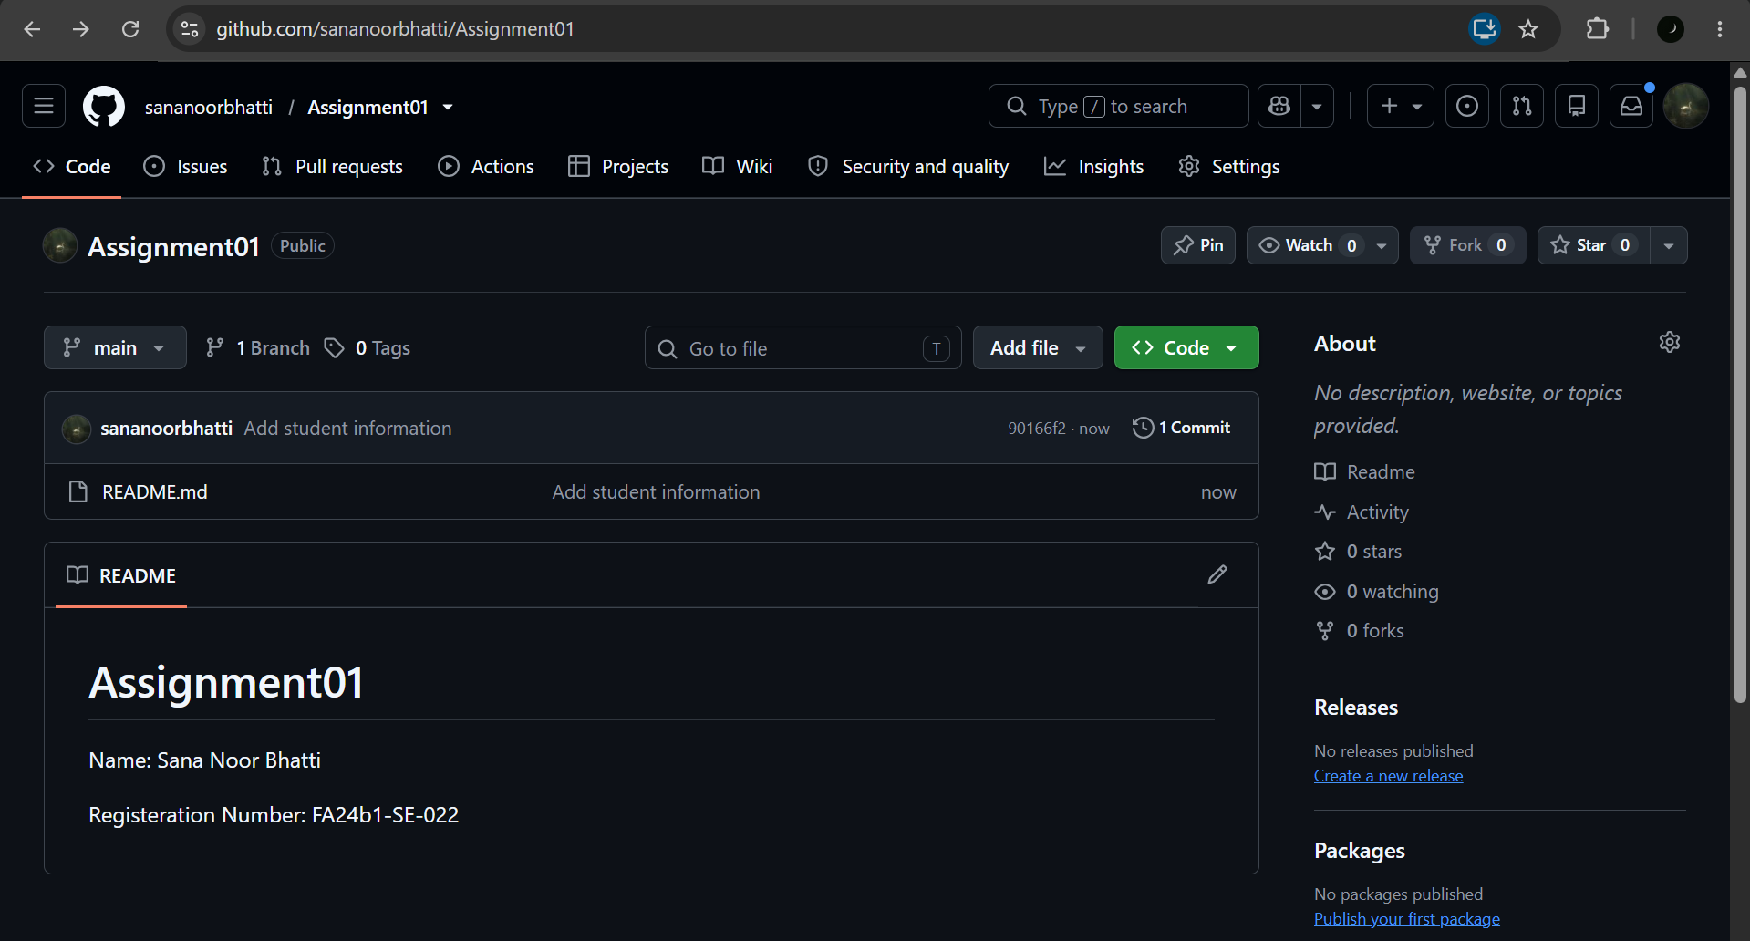

The GitHub repository was opened to verify that the README and project contents were uploaded correctly.

Task 3 – Git Large File Storage (Git LFS)

3.1 Installing and Configuring Git LFS

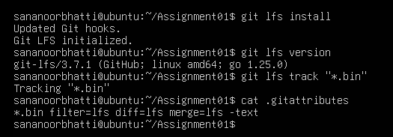

Git LFS was initialized, and the .gitattributes file was configured to track files with the .bin extension.

3.2 Tracking Large Binary Files

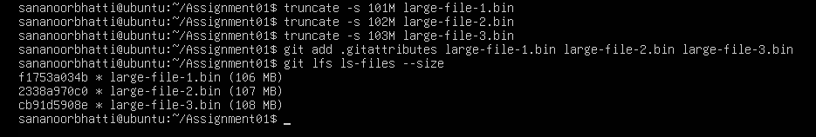

Three large binary files were created, staged, and verified using git lfs ls-files --size to confirm that Git LFS was tracking them.

3.3 Pushing Git LFS Files to GitHub

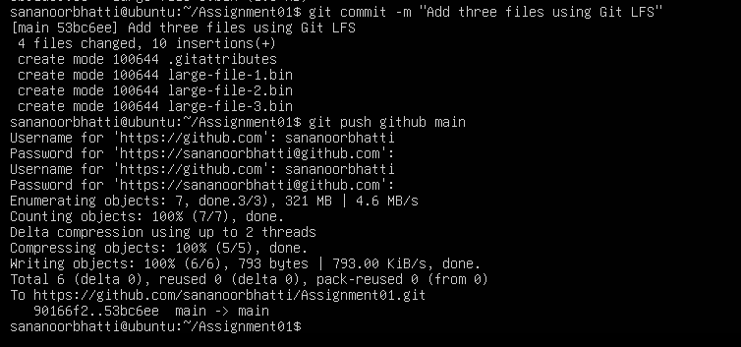
The large files were committed and pushed to GitHub, and the Git LFS upload completed successfully.

Task 4 – GitHub Pages Portfolio

4.1 Portfolio Repository and Website Files

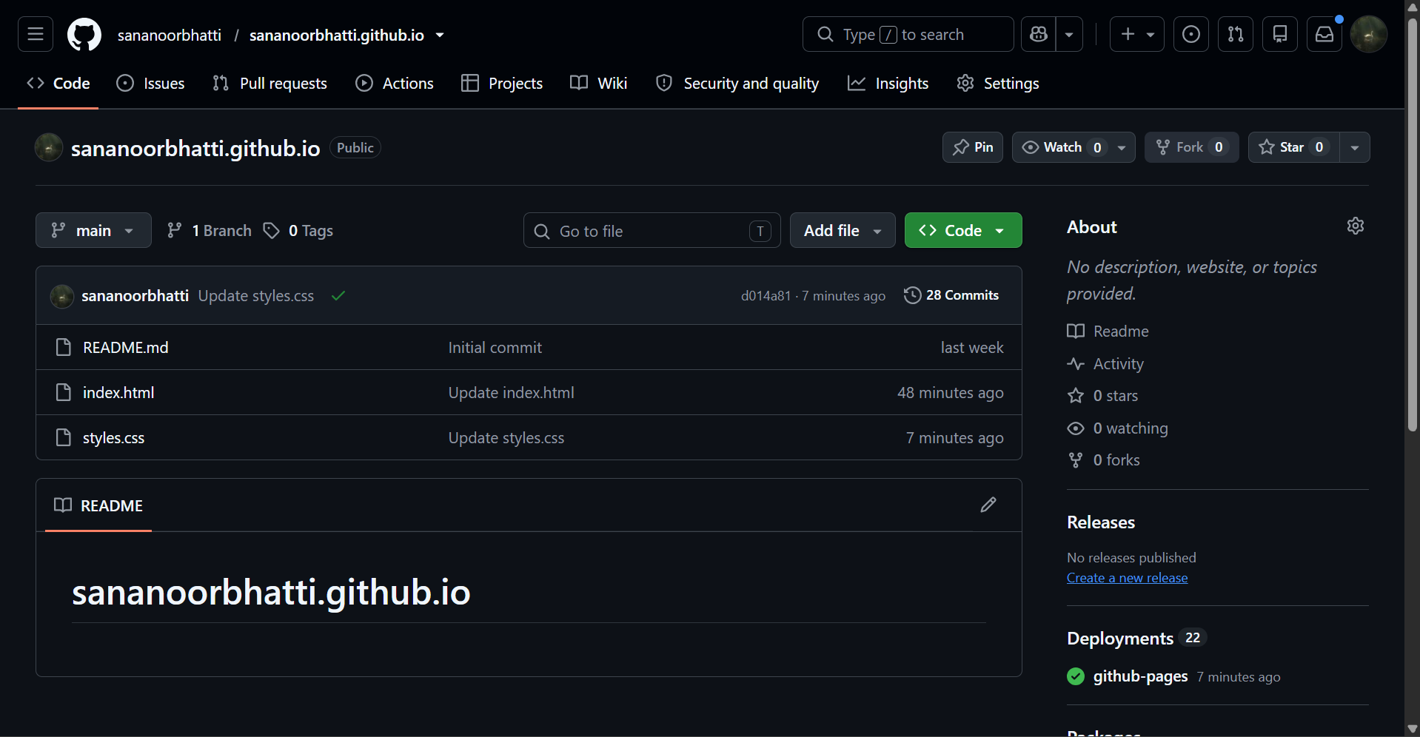

The sananoorbhatti.github.io repository was configured with the portfolio's index.html and styles.css files.
4.2 GitHub Pages Deployment Configuration

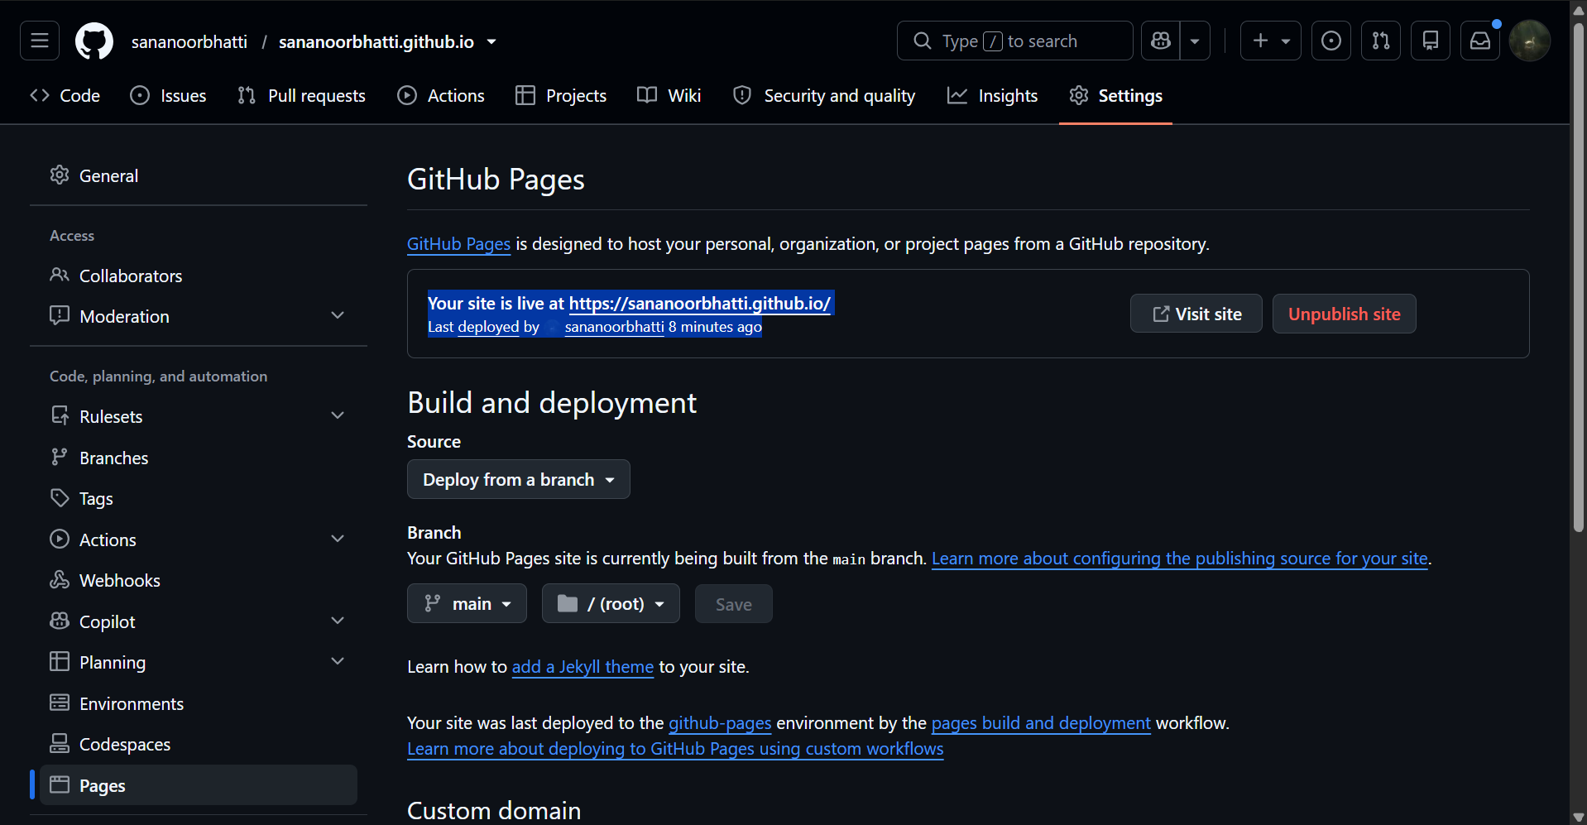

GitHub Pages was configured to deploy the portfolio from the main branch using the / (root) directory. The deployment status confirmed that the website was successfully published.

4.3 Live Portfolio Website

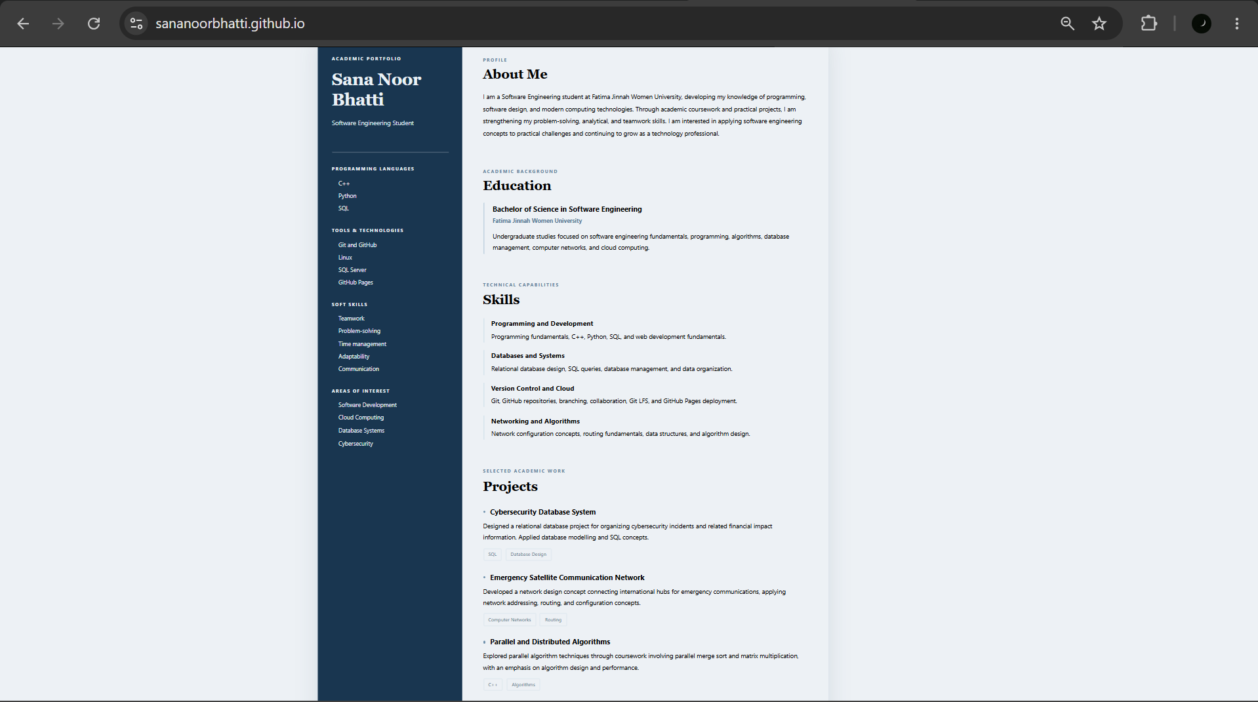

The portfolio website was opened successfully at https://sananoorbhatti.github.io/, displaying the About Me, Education, Skills, and Projects sections.

~ Assignment 01 Executed

