**ECE:5820/CS:5820, SELT**

**Fall 2020**

**Fourth Homework Assignment**

**Due Date: Tuesday, Oct. 6 by 11:59 p.m.**

**Important Note:** This assignment involves adding functionality to the Rotten Potatoes application and deploying the enhanced app to a cloud-based hosting service called Heroku. **See"2020_Fall_HW4_InstructionsForDeployingToHeroku" for more details.** Don't wait until the last minute to push your assignment to Heroku for the first time. We will be grading this assignment by exercising your deployed app. If your app is not successfully deployed, we will not be able to grade it.

**Introduction:**

For this assignment you will add a simple login-based authentication mechanism to Rotten Potatoes. This mechanism will use a session cookie to keep the user logged in until she/he explicitly logs out or deletes the cookie from the browser. The user will be able to sign up for an account by supplying a unique user-ID and an e-mail address. For now, the user will not need to supply a password. Later in the semester, we will discuss management of secure passwords and other security issues related to authentication and session management.

**Part 1: Add a User model to Rotten Potatoes:**

Let's begin by adding a User model to Rotten Potatoes. You should first generate a new migration for the users database table. The users table should have the following attributes:

* string - user_id
* string - email
* string - session_token
* timestamps – (anonymous)

The ‘timestamps’ attribute is an internal mechanism, and it will not be associated with a symbol.

The attributes user_id, email, and session_token should all be strings. The session_token will be a randomly-generated string that will be used in later portions of the assignment. Using the rake db:migrate utility, apply the migration to the database.

Then define the User model class in the file app/models/user.rb. It will be empty for now, but we will add a method to it in the next part of the assignment.

**Part 2: Implement routes, controller and views for the User model:**

Create the basic CRUD routes for your UsersController in config/routes.rb. Although we will use only two of the routes, it will not hurt to generate them all.

Next, we will add a button to allow users to sign up for an account. This button should be added to app/views/layouts/application.html.haml so that it is visible on all pages of the app. For now, link the button to the new_user_path. Use the rails button_to helper to create this button. When you are done, the Rotten Potatoes homepage should look like this:



Next, create the app/views/users directory to hold the view associated with your UsersController#new action-i.e. new.html.haml . This view should display a form like the following:



You can refer to app/views/movies/new.html.haml for an example of creating a form view.

Now, you will need to implement the UsersController actions new and create. The new action simply renders the view: app/views/users/new.html.haml, while the create action must add the new user to the User model, using the data supplied by submission of the Sign-up form.

There are several important issues with the UsersController#create action. First, we want to insure that user-IDs are unique. Hence, before adding the new user to the database, the create action should check to see if an entry with this user_id already exists in the database. If so, the user should be directed to select a different user_id, as shown below: (Note: we do NOT require that e-mail addresses are unique.)



If the user account is successfully created, the user should be directed back to the Rotten Tomatoes home page, and a flash message of the form:

'Welcome <user-ID>. Your account has been created'

should be displayed.

A second issue with the UsersController#create action involves the session_token attribute. The session_token is a random string that will be used in the next part of the assignment to uniquely identify sessions. The session_token for a given user is assigned at the time the user is added the database. The token is generated by a call to the Ruby method:

SecureRandom.base64

In accordance with the philosophy of thin controllers, you should place the functionality to generate the session_token into the User model. In particular, you should define a method User::create_user! that takes as its parameter a hash with keys :user_id and :email. The method should add a third hash pair for the :session_tokenand then call the ActiveRecord::create! method to add the new user to the database. (Note that create_user! will be a class method of User.)

The UsersController#create method can now call this method, passing the params hash as an argument, to add a new user to the model.

To test the new functionality, fire up rails server and add several users via the web browser. Also, verify that your code properly checks for duplicate user-IDs. Now use rails console to look at the contents of the User model to verify that the users have been properly added to the database.

**Part 3: Adding Login/Logout functionality and managing the session:**

Let's begin by adding a SessionsController and associated routes for login/logout. This controller will be a little different than others that we have seen in that it is *not* associated with its own Model. The SessionsController will have three actions: new, create and destroy. Actions new and create will be associated with establishing a new login session while destroy will handle logout.

Since the nature of these actions is a little different from standard CRUD, we will define custom routes for them by adding the following entries to config/routes.rb:

match '/login', to: 'sessions#new', via: :get

match '/login_create', to: 'sessions#create', via: :post

match '/logout', to: 'sessions#destroy', via: :delete

Now run rake routes. You should see something like the following:



Now create a view for the sessions#new action in app/views/sessions/new.html.haml This view will display a login form (nearly identical to the Sign-up form) that looks like:



The "login to my account" button should link to the login_create_path and the "Sign-up for an account" link should link to the new_user_path.

Modify the UsersController#create action so that it redirects to the login_path rather than the movies_path.

Finally, change the button in app/views/layouts/application.html.haml so that it links to the login_path.

Note the overall effect of the above changes: When a user clicks the "Login/Sign-up" button she/he is taken to the Login page. If the user does not have an account, he/she can click the link on the Login page to be taken to the Sign-up page. Once the user has successfully signed up for an account he/she will be directed back to the Login page. After successful login, and after logout, the user is directed back to the Rotten Potatoes home page.

Now we are ready to implement the session management. We'll start by explaining the desired functionality. When a registered user signs in, the user will be identified by user_id in the User model. If the user_id is not found in the database or the supplied email address does not match the one in the database, the user should be redirected to the login_path with a flash message indicating an invalid user-id/e-mail combination.

If login is successful, the user's session_token, from the database, should be stored into the session cookie, as follows:

session[:session_token] = user.session_token

And the user should be redirected to the homepage (movies_path) with a message indicating successful login, as shown below:



Note that, in addition to the login message, the button has now changed from "Login/Sign-up" to "Logout". The message and "logout" button should continue to appear on all pages until the user logs out. When the user logs out (clicks the "Logout" button) the login message should disappear and the button should revert to "Login/Sign-up". Note that when the button displays "Login/Sign-up" it should be linked to the login_path. When it shows "Logout" it should be linked to the logout_path.

So, how do we make this magic happen? Well, first we can note that, since we want the button and login message to appear on all pages, they must be dynamically generated in app/views/layouts/application.html.haml. Now, each controller action can set an instance variable @current_user, based on the value of the session_token in the session cookie, something like:

@current_user ||= session[:session_token ] && User.find_by_session_token(session[:session_token])

Then, the application.html.haml view can use this instance variable to generate the appropriate button and or message, in the following fashion (note that @current_user will be nil if the user is not logged in, since there will be no session token in the cookie)

-if !@current_user

CODE HERE TO GENERATE SIGN_UP/LOGIN BUTTON

-else

CODE HERE TO GENERATE MESSAGE (using @current_user) AND LOGOUT BUTTON

However, there is a serious DRYness issue here since @current_user needs to be set by every MoviesController action. Fortunately, Rails provides a solution in the form of a mechanism called a before_filter. If the following line is placed at the beginning of the MoviesController class:

before_filter :set_current_user

it will cause the method set_current_user to be executed prior to executing any of the MoviesController actions. The set_current_user method can then be defined to set the @current_user instance variable as described above. Since the set_current_user method could conceivably be needed by other controllers, it is convenient to define this method in the parent class ApplicationController so that it will be inherited by all controllers. We will find additional uses for controller filters later in the semester.

Finally, we need to implement the logout functionality--i.e. the SessionsController#destroy action. This method should do the following:

* reset the session
* redirect to the homepage (movies_path)

Congratulations, you are done!! Of course, our simple login mechanism is not very secure since it doesn't utilize password protection. Later in the semester we will revisit the authentication process and introduce additional security measures. We will also look at some gems that help with login/logout and session management.

**Important Additional Instructions:**

It is essential that you follow these instructions EXACTLY or we will not be able to grade your submission:

1. The Sign up/Login button element must have id 'signupLogin'. Do NOT specify a :confirm option for this button.
2. The Log Out button element must have id 'logout'. Do NOT specify a :confirm option for this button.
3. For the Sign-up page:

The User-ID field must have id 'signupUser'

The E-Mail field must have id 'signupEmail'

The "Create my account" button must have id 'signupCreate'

1. For the Login page:

The User-ID field must have id 'loginUser'

The E-Mail field must have id 'loginEmail'

The "Login to my account" button must have id 'login_submit'

The "Sign-up for an account" link must have id 'signup'

1. All flashes must have class 'flashMessage'

Below are two examples, illustrating how to add ids to HTML elements in haml

Example 1: Specifying 'add_title', 'add_rating', and 'add_submit' ids for elements on the new.html.haml page of Rotten Potatoes

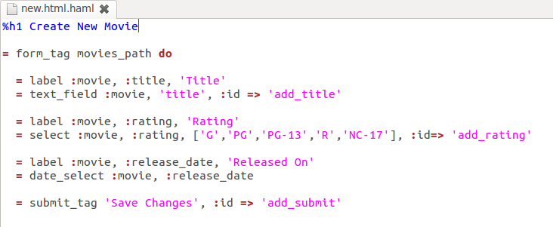

Example 2: Adding 'delete' id for "Delete" button and 'to_edit' and 'back_to_movies' ids to respective links on the show.html.haml page of Rotten Potatoes. (Note: do NOT specify the :confirm option for your Signup/Login or Logout buttons.)

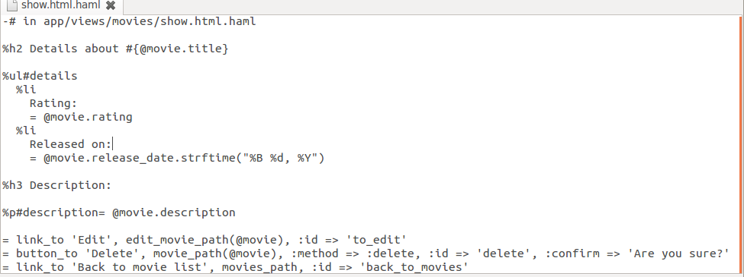

**Be sure to check the page sources for your app to double-check that all of your elements have the correct class/id. We will not regrade assignments that fail because of incorrect id/class attributes.**

**Submission Instructions (Be sure to follow these instructions *exactly!*):**

Deploy your completed assignment to Heroku. We will be testing your deployed app on Heroku so it is e**ssential** that you successfully deploy your app to Heroku. The Heroku URI for your deployed app must be added to the GRADING.json file in your github assignment **where**:

GRADING.json

{

"heroku_url": "http://blah.blee.boo/myapp",

"instructions": "Change the string associated with heroku_url to your heroku application url to be graded."

}

Where the string <http://blah.blee.boo/myapp> is replaced with your URL.