Q1: Create a user group and assigned that group with the read-only access policy EC2 and S3 service.

1. Created the user exam_user and attached the policy for that user for EC2 and S3 bucket

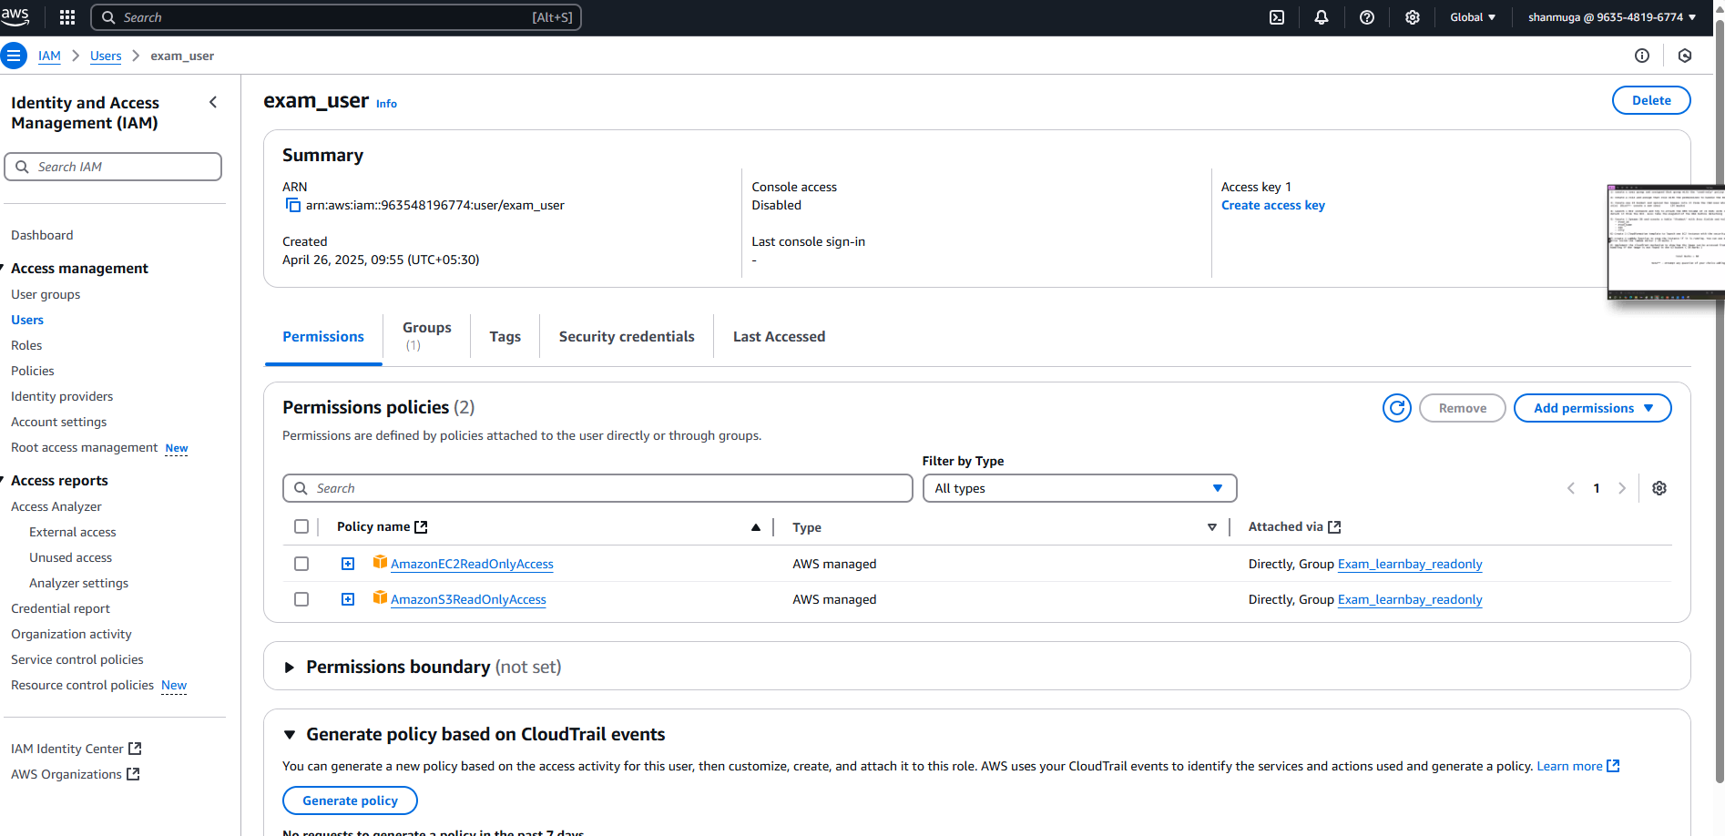

1. Created the user group and assigned the above user to this group:

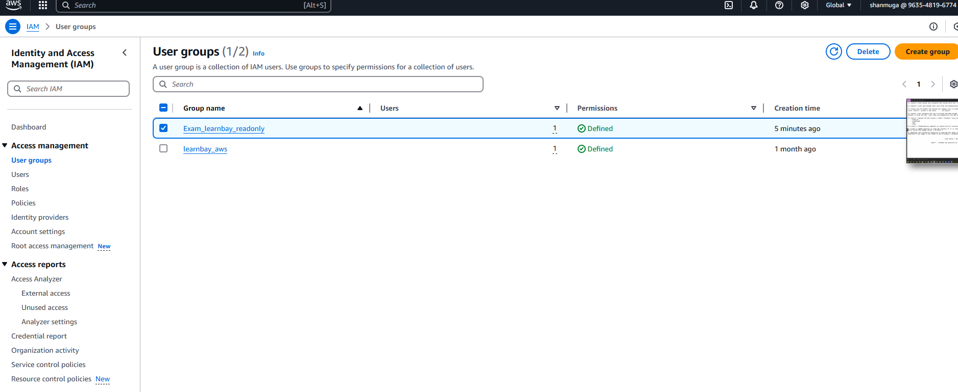

Q2: Create the Roles and Assing that roles with the permission to handle the RDS and EC3 features only

1. Create the Roles called EXAM_CUSTOM_POLICY_EC2 , which has all the access releated to EC2 , START , STOP 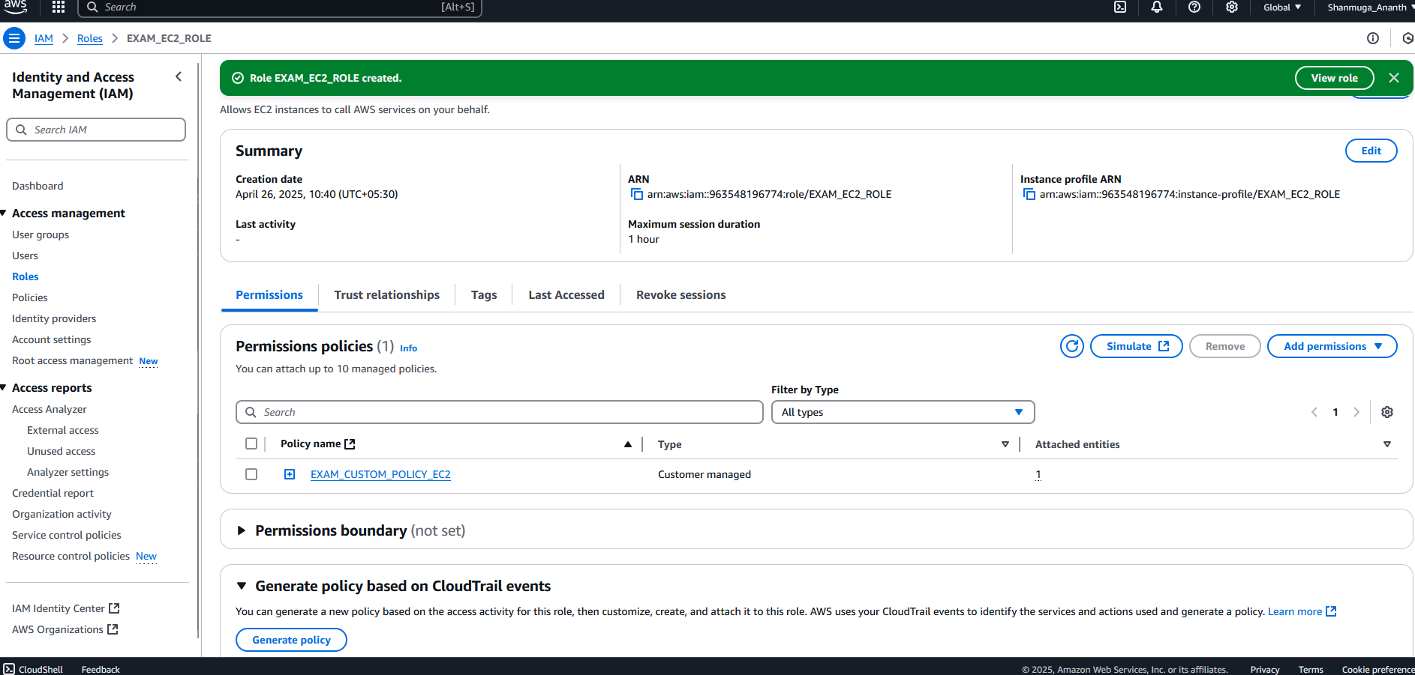

Custom Managed Roles: For the EC2 with full functionality.

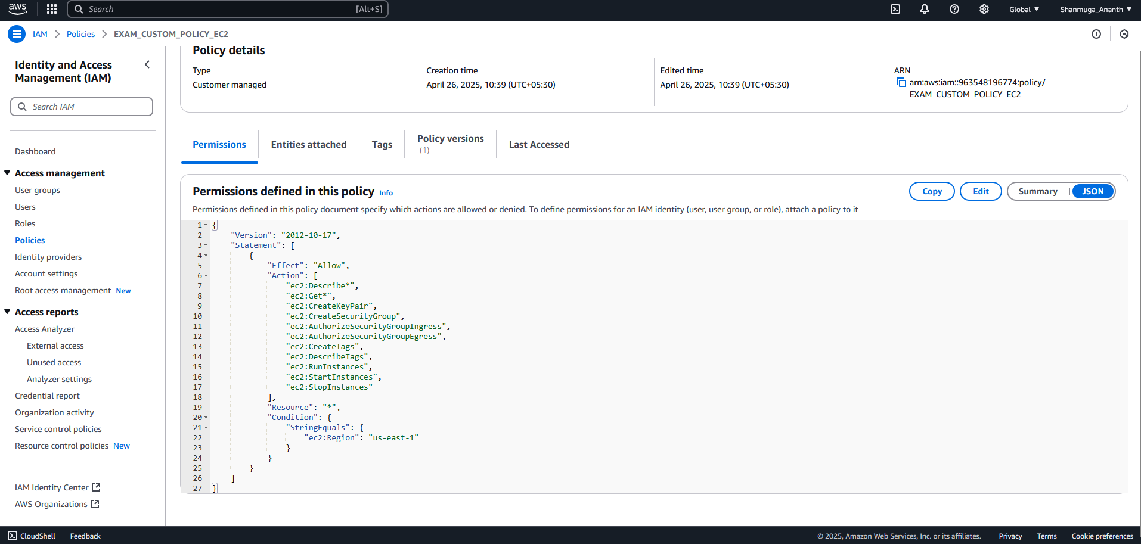

1. Create the AWS Managed Role RDS and policy for the group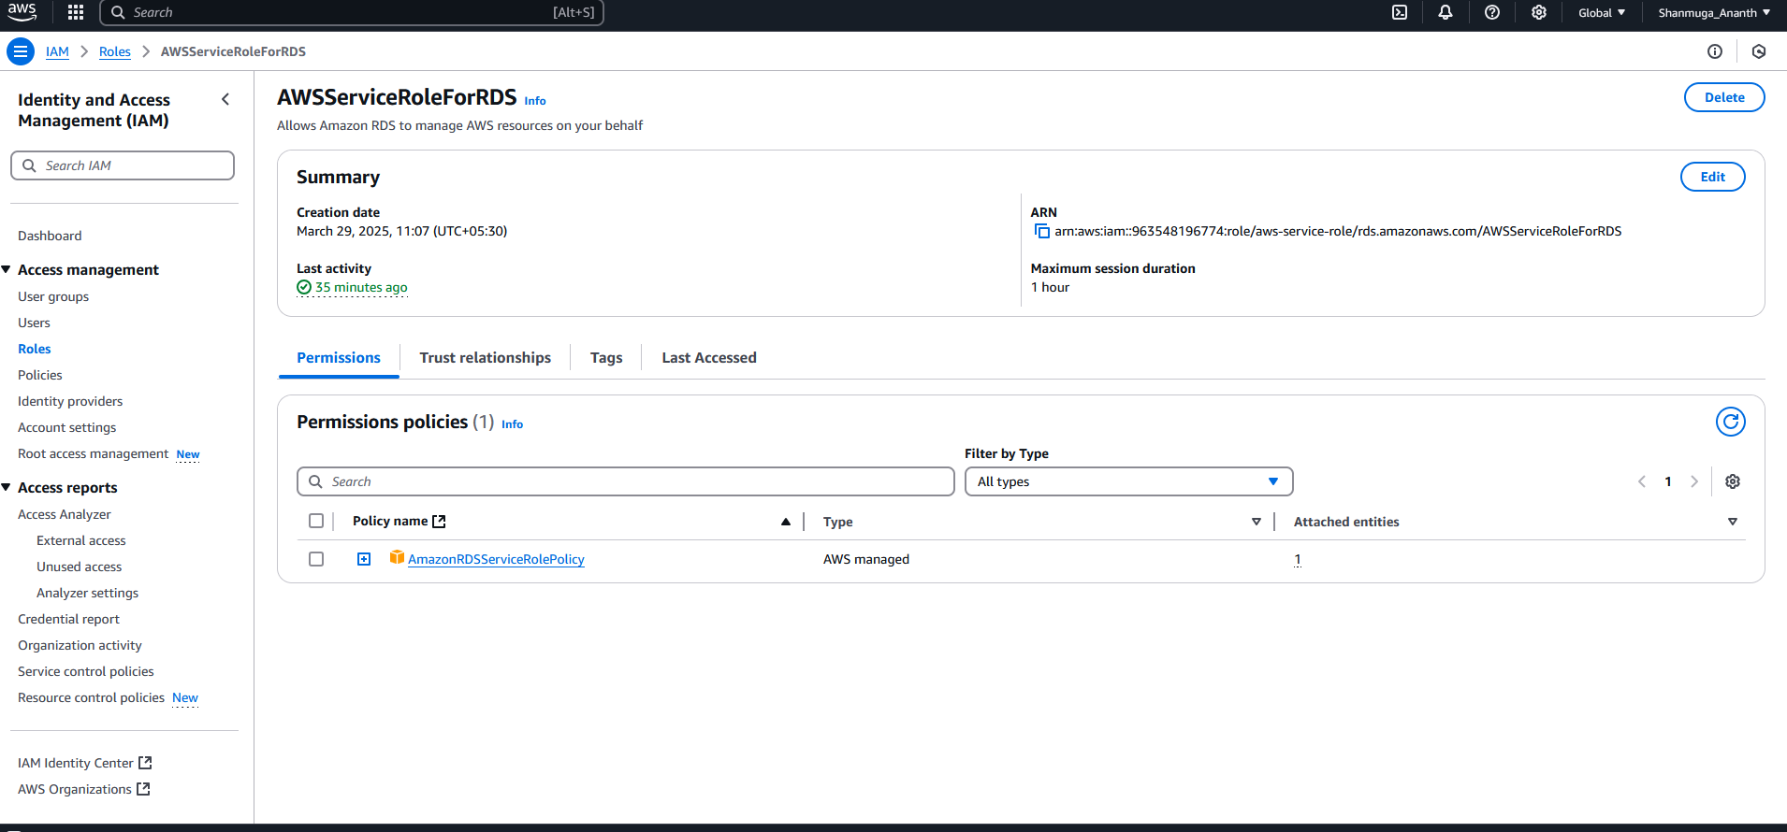

Q3. Create the S3 Bucket and upload two images into it for the new IAM users who has only the permissions of IAM.

Create the NEW IAM USER only for uploading the image in S3 bucket

<https://963548196774.signin.aws.amazon.com/console>

User_upload

Account@02

