**Exercise:3** Guided Capstone - Step Six

**Steps**

1. Write a 1-2 page report summarizing your recommendations for Big Mountain Resort. Be sure to include the figures you created to back up your recommendations
2. Title this document "Guided Capstone Project Report"
3. Add your project report to your GitHub repo Guided Capstone folder
4. Submit a link to the folder below

================================================================================================================================

**Guided Capstone Project Report**

Intro: Big Mountain Resort, a ski resort located in Montana. Big Mountain Resort offers spectacular views of Glacier National Park and Flathead National Forest, with access to 105 trails. Every year about 350,000 people ski or snowboard at Big Mountain. This mountain can accommodate skiers and riders of all levels and abilities. These are serviced by 11 lifts, 2 T-bars, and 1 magic carpet for novice skiers. The longest run is named Hellfire and is 3.3 miles in length. The base elevation is 4,464 ft, and the summit is 6,817 ft with a vertical drop of 2,353 ft.

Big Mountain Resort has recently installed an additional chair lift to help increase the distribution of visitors across the mountain. This additional chair increases their operating costs by $1,540,000 this season.

Now the question has been asked to what are the prices to be set to increase the profit and for that what are the predictions to choose the optimal price this season.

For a dataset (ski_data.csv) provided that consist of 330 resorts including Big Mountain and their features like Name, Region, state, Terrain Parks, Skiable Terrain, no of days opened last year, weekday price and weekend price.

So, a A linear regression model is built. Response variable of this model is price of adult tickets during the weekend. The model chosen to predict the AdultWeekend Price is using the follow columns from the dataset: vertical drop, trams, fast Eight, fast Sixes, fast quads, quad, triple, double, surface, total chairs, Runs, Terrain Parks, LongestRun mi, SkiableTerrain ac, Snow Making ac, daysOpenLastYear, yearsOpen, averageSnowfall, AdultWeekday, AdultWeekend, projectedDaysOpen, NightSkiing_ac, clusters.

Here prediction is done for Big Mountain Resort adult weekend price column. The actual adult weekend price of Big Mountain Resort is $81 dollars. And the model predicted a value of $87 and with additional lift $89 . The R-Squared of this model is 0.41. And the mean absolute error value is 13.347578.

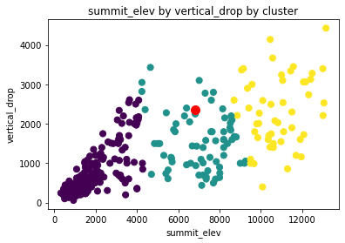

Fig 1:. Mountain resorts can be grouped by their summit elevation, BMR lays in the middle segment between 4,000 and 9,000 ft

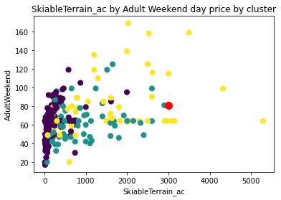

Fig 2: Weekend day ticket seems to be under-priced by 81%. There is profit by raising weekend day pass price to at least $87.

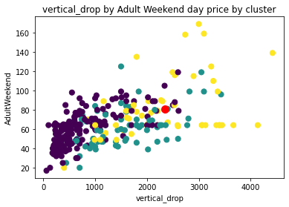

2. Weekend day ticket seems to be under-priced by 81%. There is profit by raising weekend day pass price to at least $89 by including chairlift.

The variables present in the dataset moderately explain the outcome of the response variable (AdultWeekend). Raise permanently weekend and weekday ticket prices by $ 87 or $2.87 with chairlift. This increase in adult weekend price will not fully compensate the operational cost as we see there is less response between the features and the response variable.

Therefore, to compensate the investment in this equipment, resort should consider opportunities in decreasing the maintenance cost of the chair lifts.