**USERINFO:**

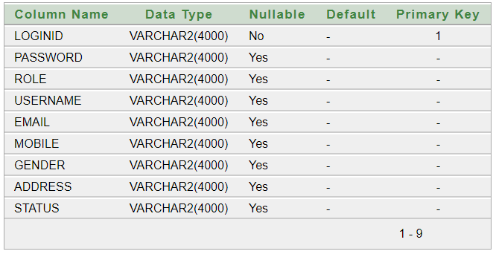

**CANDIDATEDETAILS:**

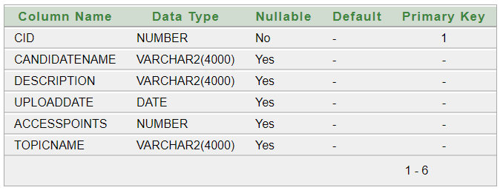

**HISTORY_TABLE:**

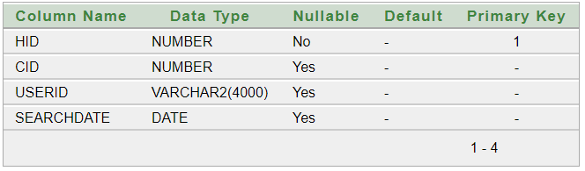

**POSITIVE:** 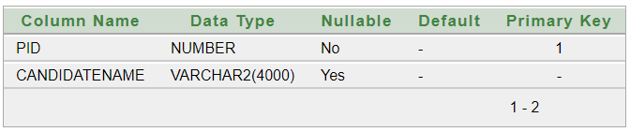

**NEGATIVE:**

